De Zalmhaven
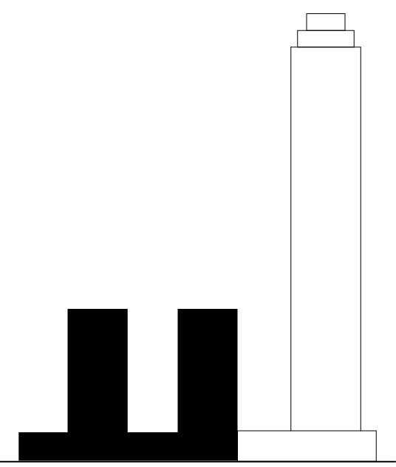
Dam & Partners Architecten (high-rise tower)
KAAN Architecten (mid-rise towers and plinth)

Location: Gedempte Zalmhaven, Houtlaan, Rotterdam, Netherlands
Client: Zalmhaven CV (AM, Amvest)

Mid-rise towers and plinth:

Architect: KAAN Architecten (Kees Kaan, Vincent Panhuysen, Dikkie Scipio)
Project team: Allard Assies, Michael Baas, Sebastiaan Buitenhuis, Cristina Gonzalo Cuairán, Cecilia Dobos, Paolo Faleschini, Michele Guidobaldi, Marlon Jonkers, Jan Teunis ten Kate, Wouter Langeveld, Katarzyna Seweryn, Floris Sikkel, Maria Stamati, Aldo Trim, Yiannis Tsoskounoglou, Niels Vernooij

Programme: 196 apartments, 33 townhouses, 457 parking spots, roof garden

Design phase: 2015 – 2018
Construction phase: 2018 - 2021
Completion: 2021

GFA: 49.000 sqm
Building costs: 65M euros

General contractor: Koninklijke BAM Groep, Bunnik
Structural engineer: Zonneveld Ingenieurs, Rotterdam / BAM Advies & Engineering, Bunnik
MEP engineer: Techniplan Adviseurs, Rotterdam / BAM Advies & Engineering, Bunnik
Building physics advisor: Peutz, Zoetermeer
Fire safety engineer: Peutz, Zoetermeer
Acoustics advisor: Peutz, Zoetermeer
Financial advisor: IGG Bointon de Groot, The Hague
Parking advisor: Omega, Putten
Landscape designer: Mostert de Winter, Breda
Mechanical engineer: Steboma Ventilatietechniek, Beverwijk
Electrical installation engineer: Bectro Installatietechniek, Amersfoort
Plumbing engineer: Giesbers Installatiegroep, Rotterdam
Parking ventilation: HC PS, Waalwijk
Sprinkler installation: ULC Installatietechniek, Utrecht
Window frames: Byldis Facades, Veldhoven
Facade cladding: Aldowa, Rotterdam / M.C. Kersten, Amsterdam
Metal works: Voortman, Rijssen
Precast concrete: Geelen Beton, Wanssum / Dycore Vloeren, Oosterhout
Internal doors and windows: Berkvens, Someren / Daloc / HSE, Zaandam
Interior walls: Eurogips, Moordrecht
Roofing: Oranjedak, Zwijndrecht
Ceilings: Murre de Visser Afbouw, Middelburg / VAB Afbouwgroep, Volendam
Painting and wall coverings: VAB Afbouwgroep, Volendam
Elevators: Mitsubishi Elevator Europe, Veenendaal
Façade maintenance installation: ASC Group, Etten-Leur
Natural stone: van Stokkun Natuursteen, Venlo

