Dứa House: A Minimalist Living Space with Family Connection through Split-Level Design and Skylights
The 63m² house is home to three generations. It tells the story of a young couple who work remotely and live with their parents, seeking a home that reflects their unique personality and offers a fresh perspective on living spaces.
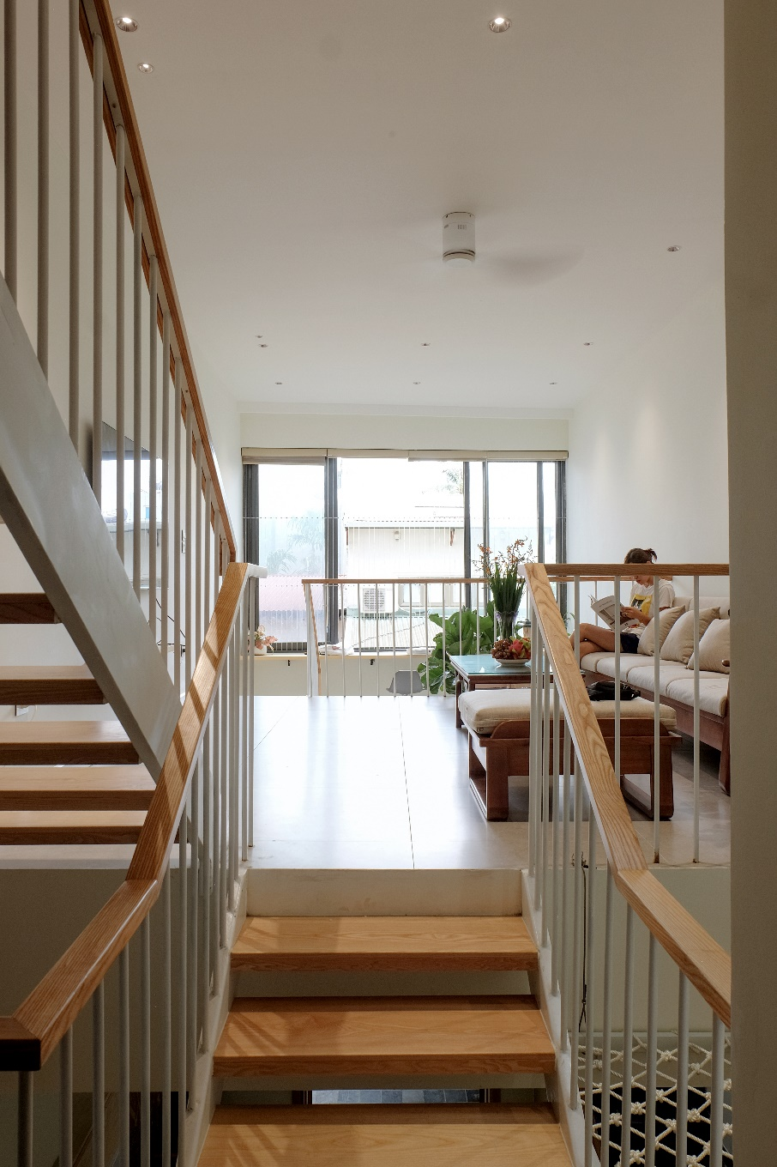
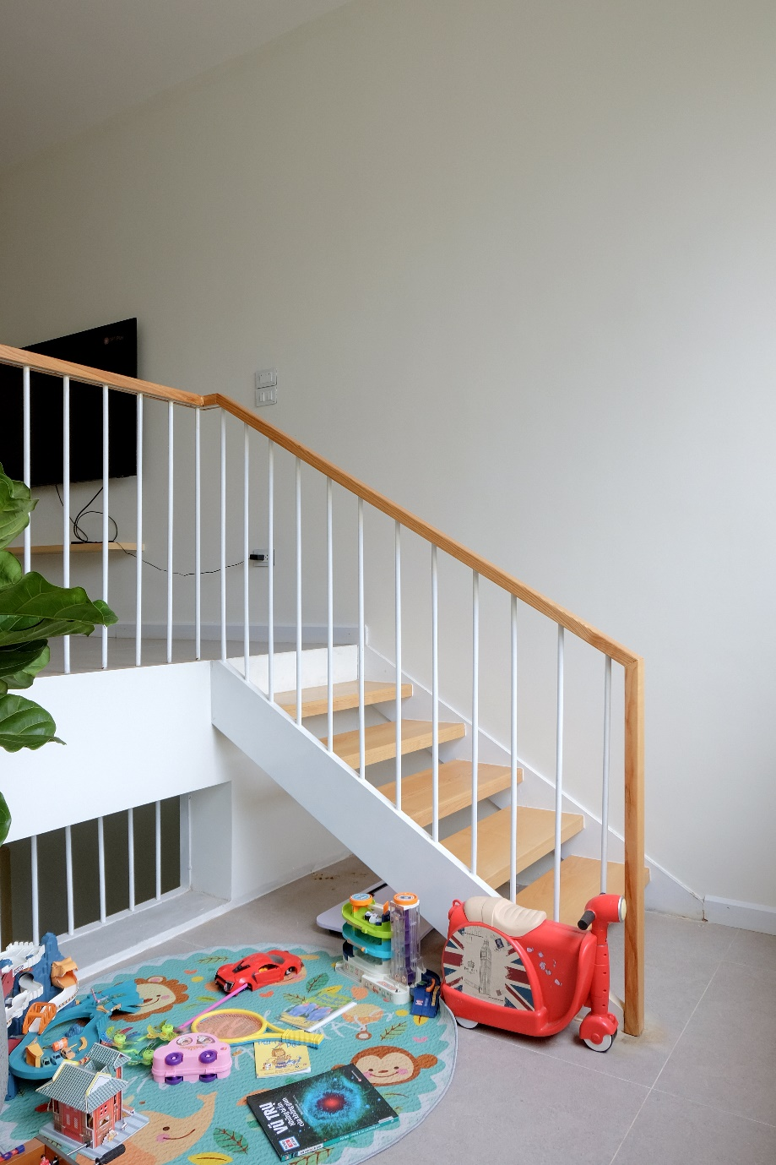

From the very first site survey, the design team identified the two key challenges of the plot: air circulation and natural lighting.
These issues, however, became an interesting topic and a source of inspiration for the design team. The solution was to integrate a skylight and split-level floors to address these challenges effectively.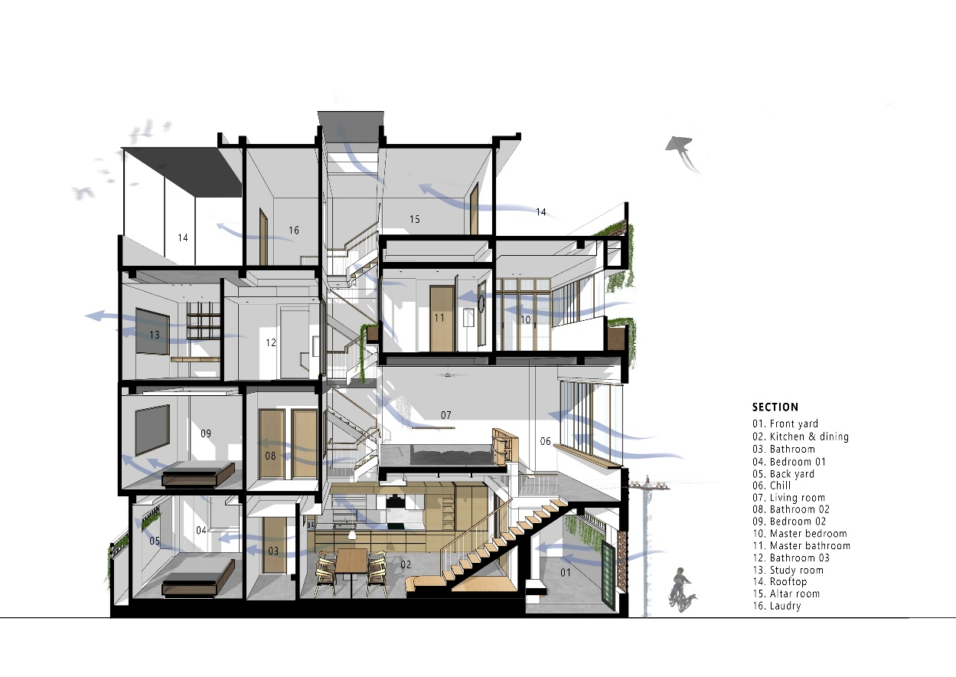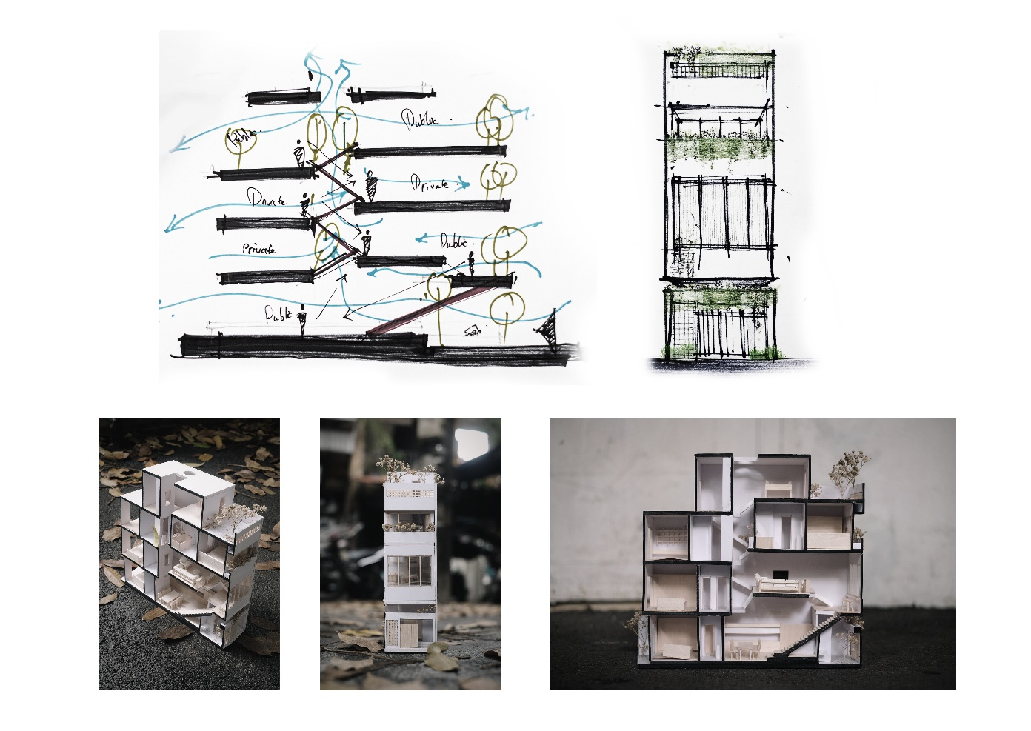
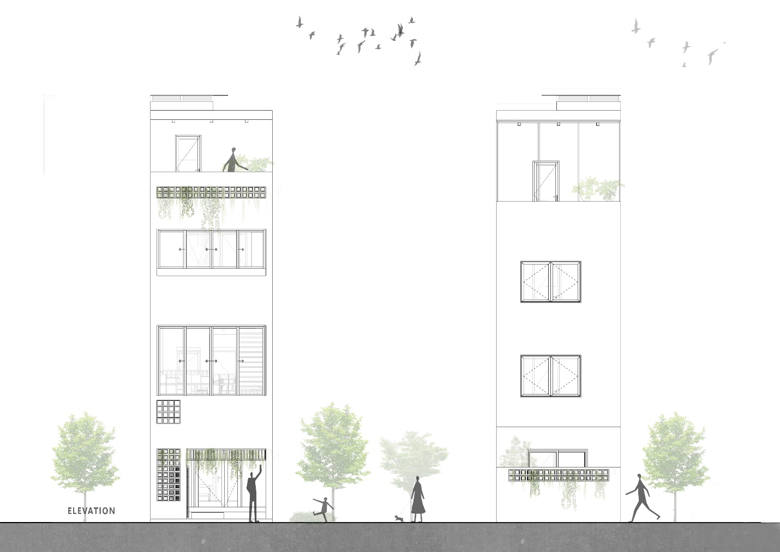
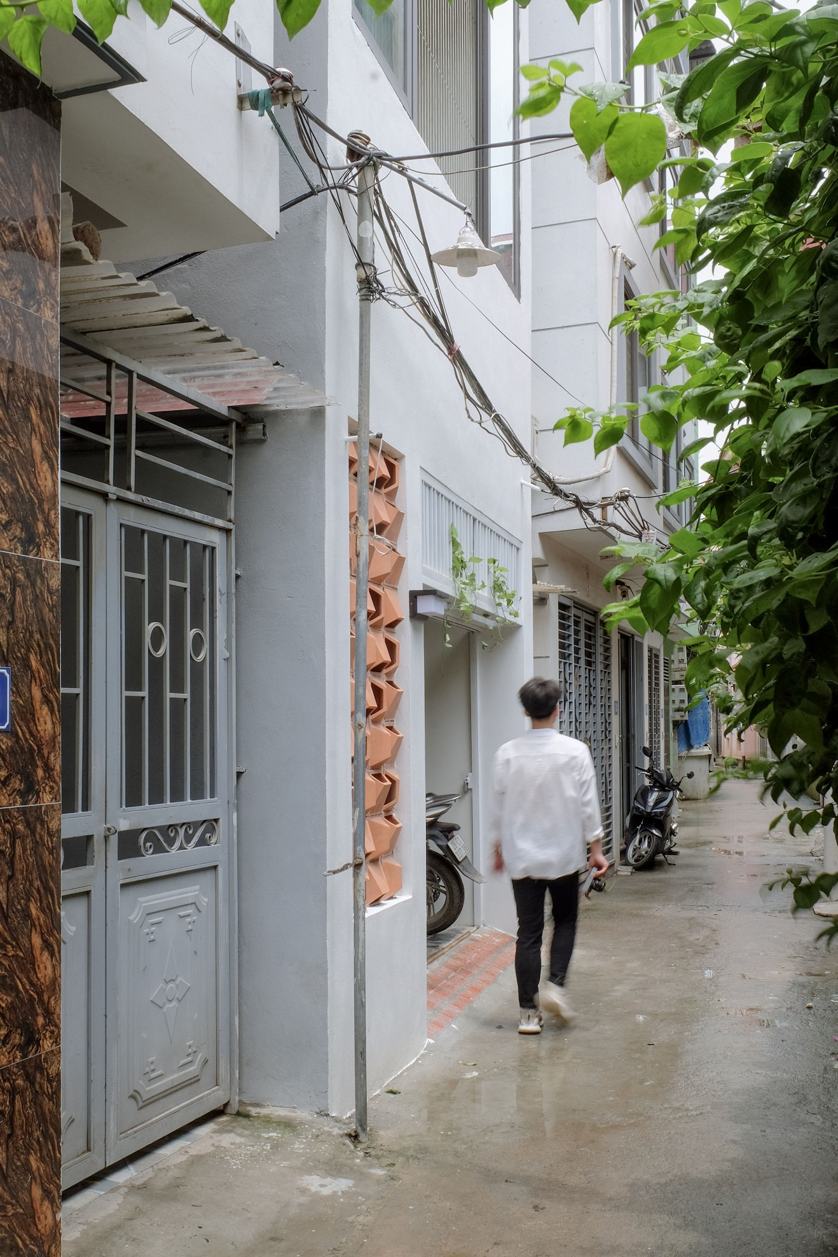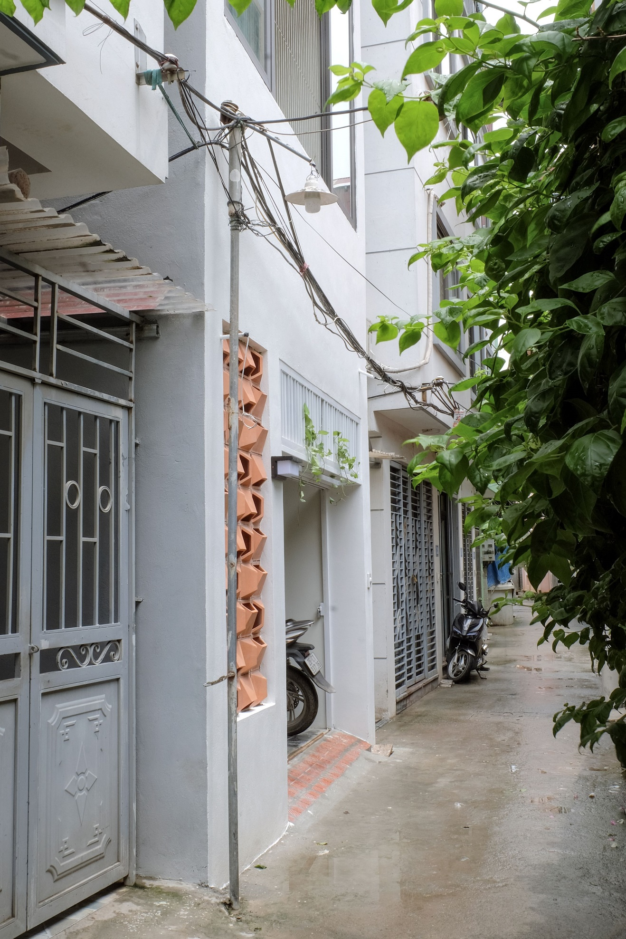
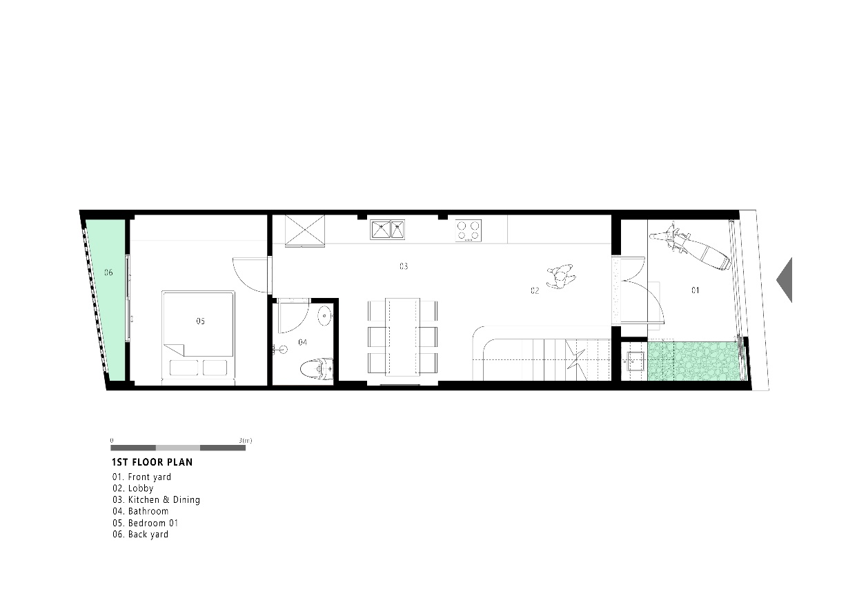

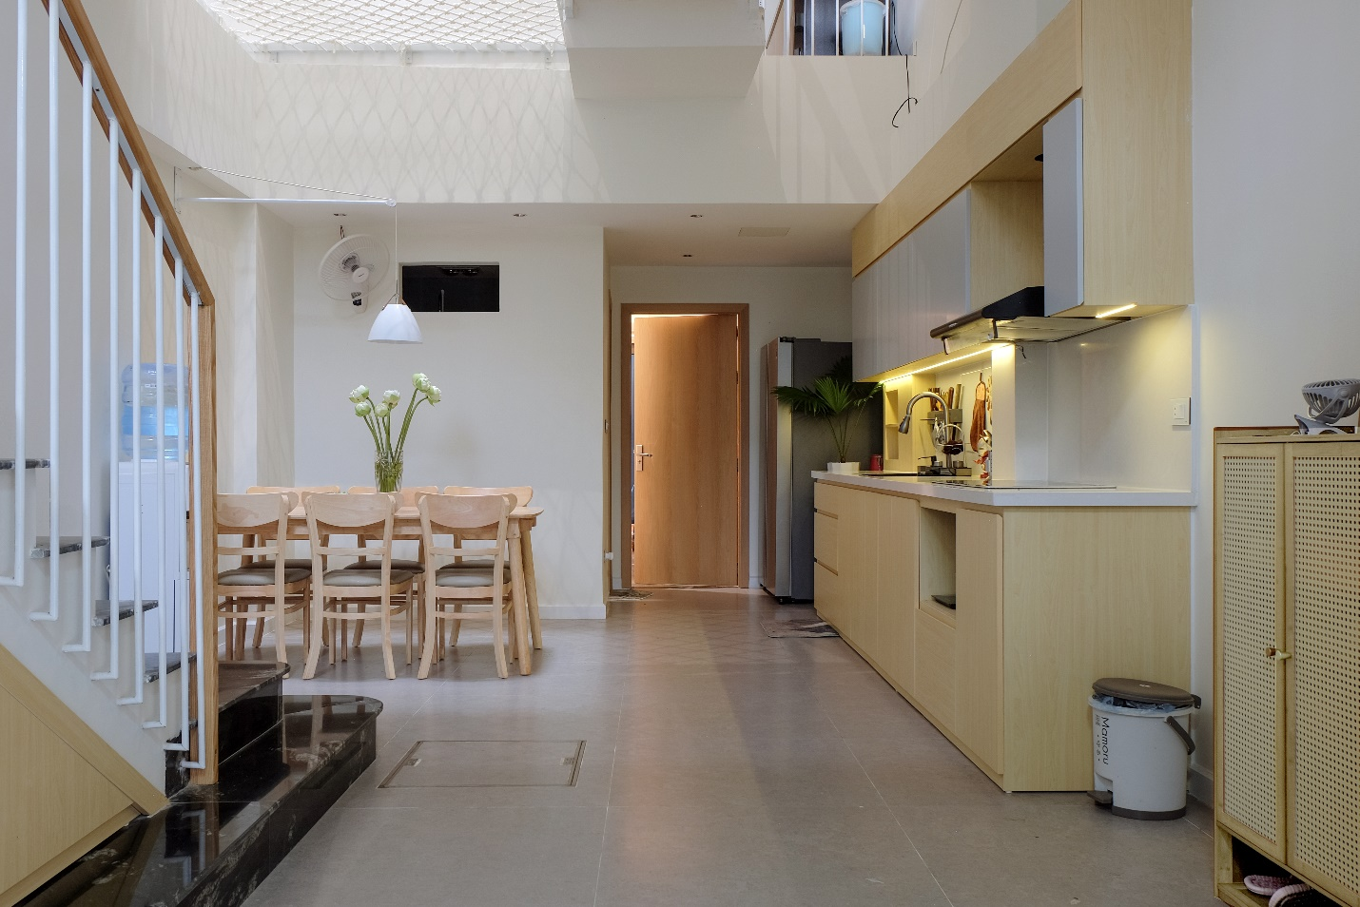
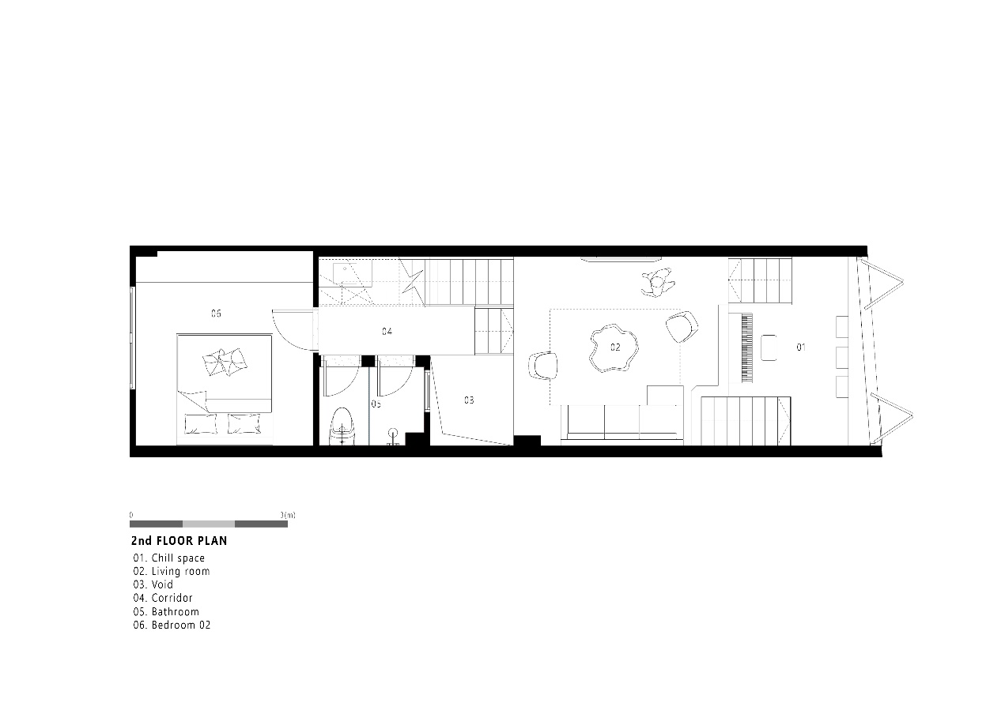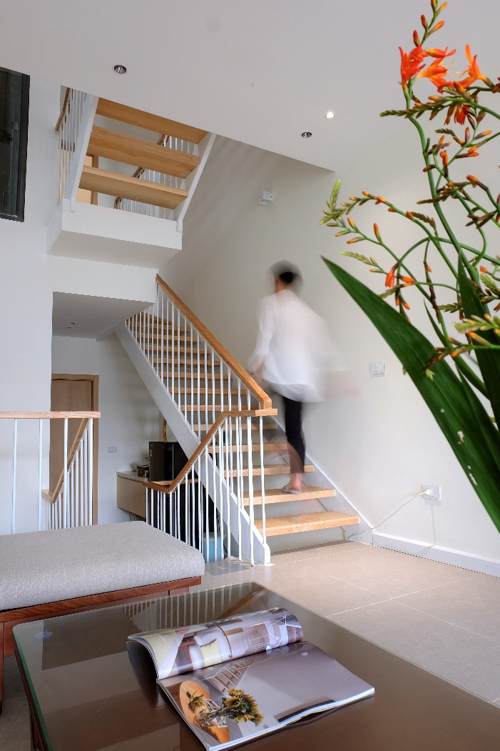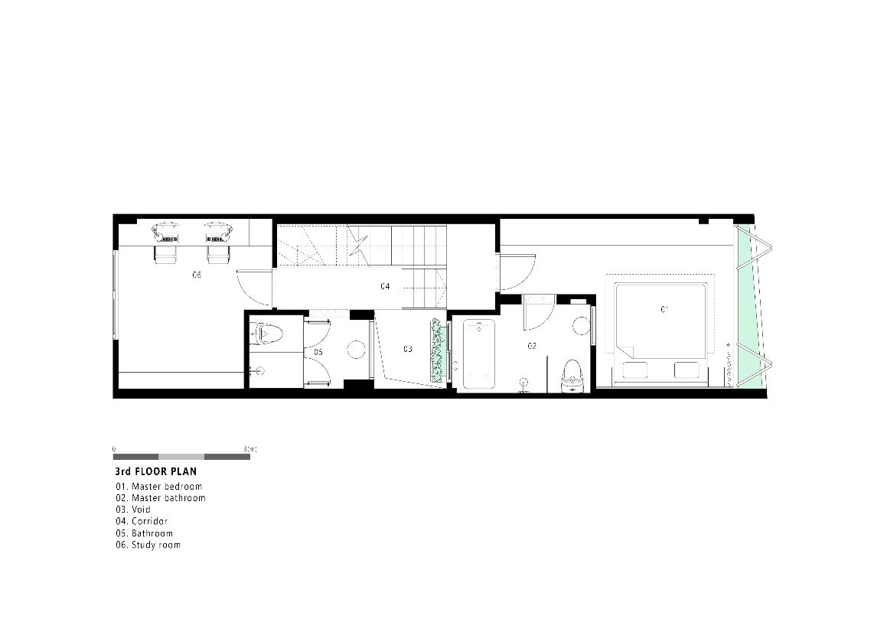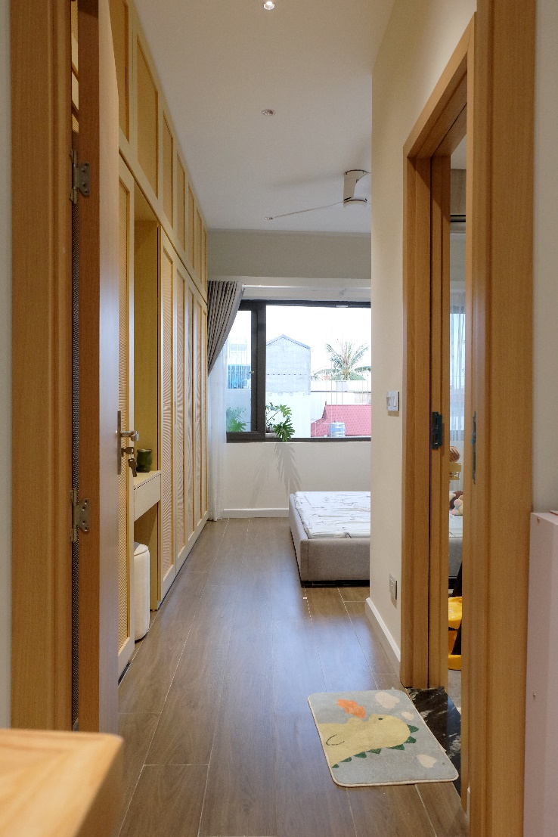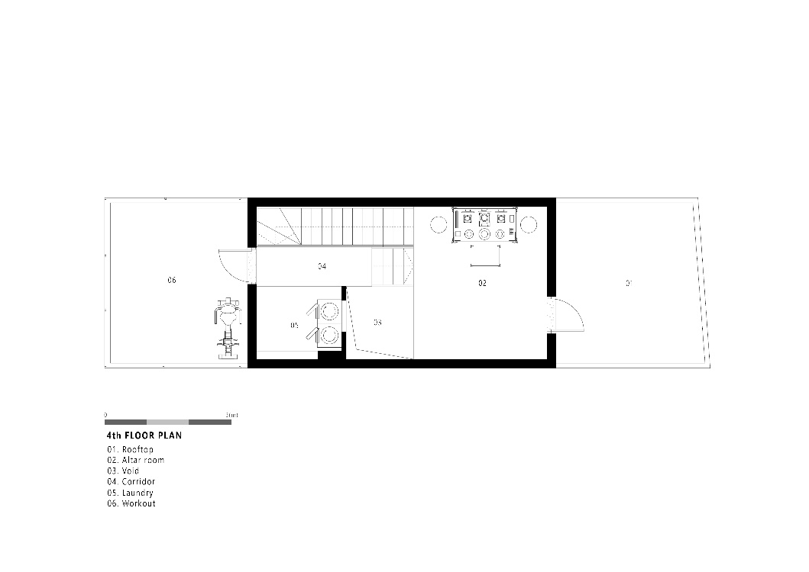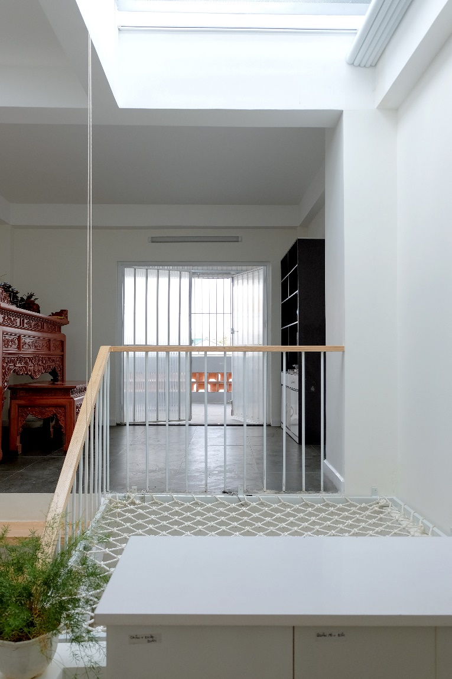
The “Less is More” philosophy was applied to create a simple yet comfortable and optimized interior space, especially in the split-level areas. The open design allows for better family interaction and connection.
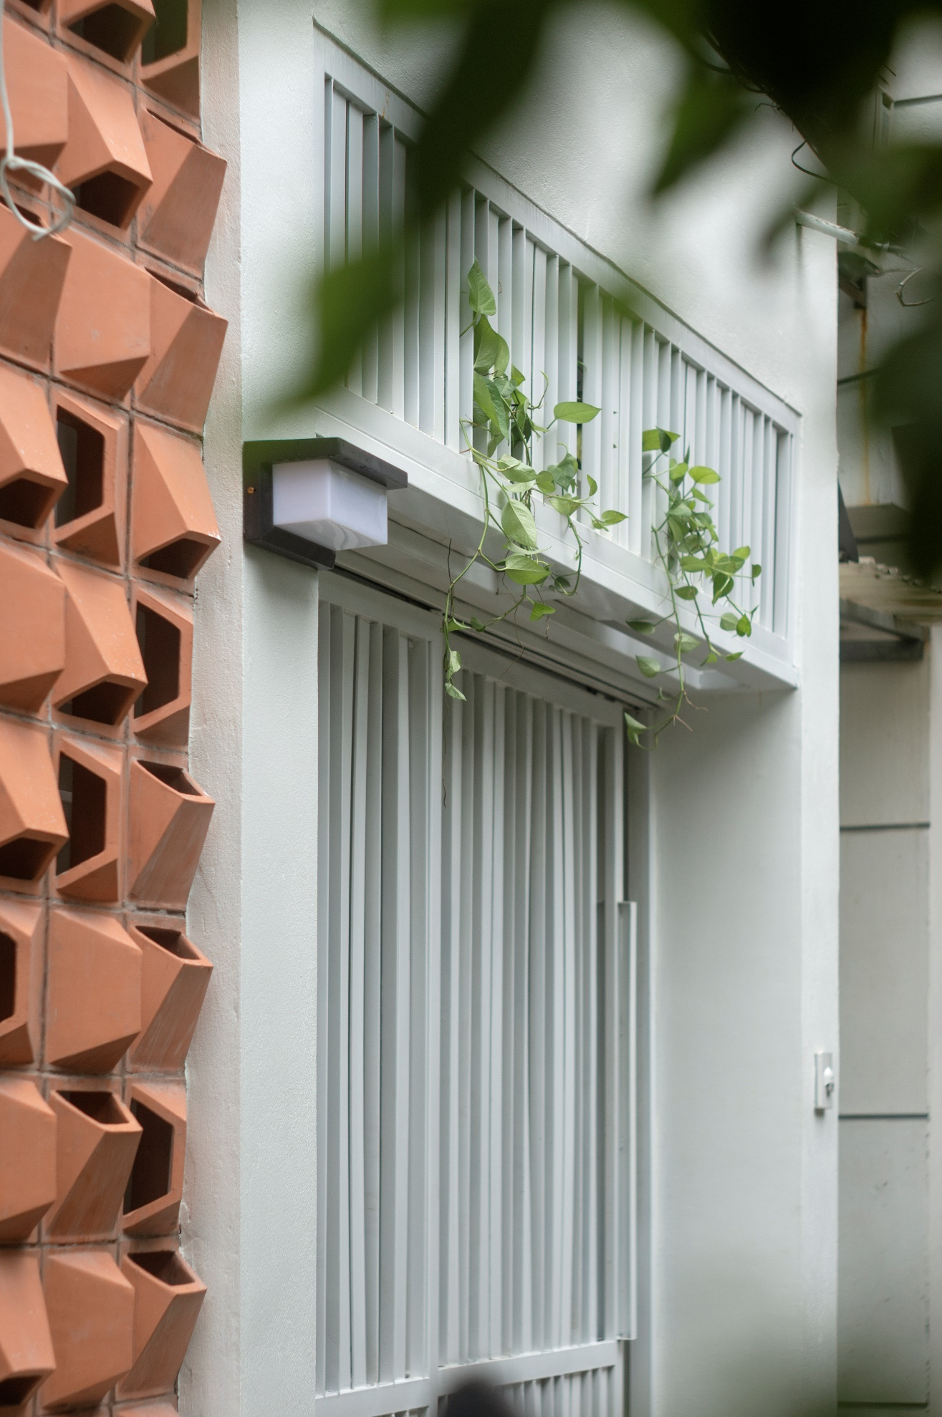
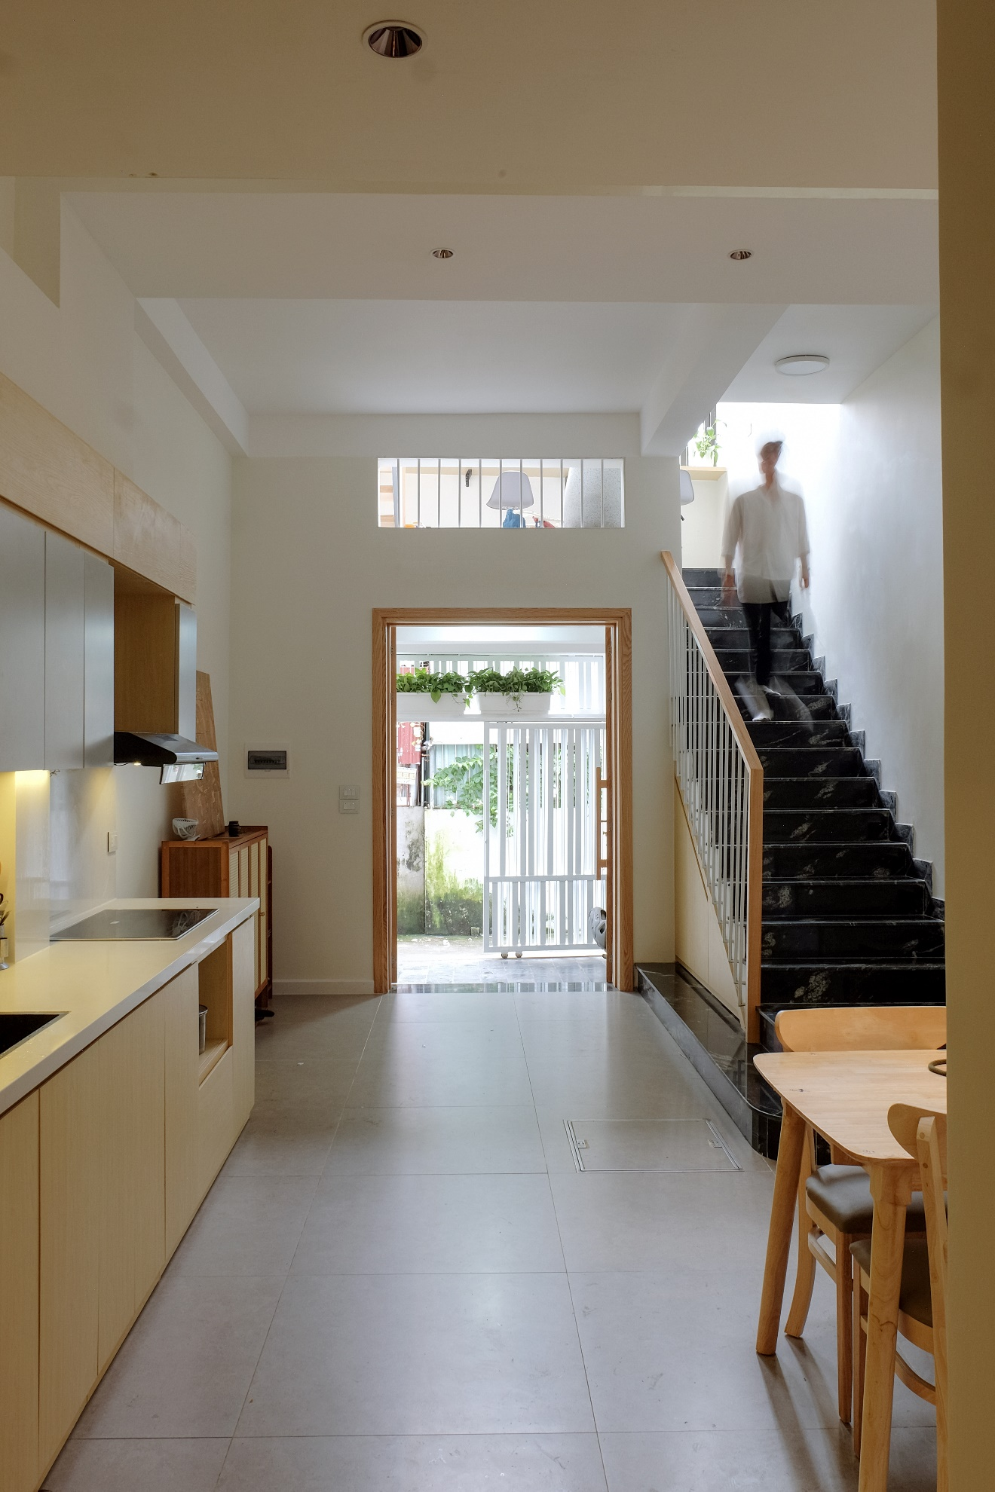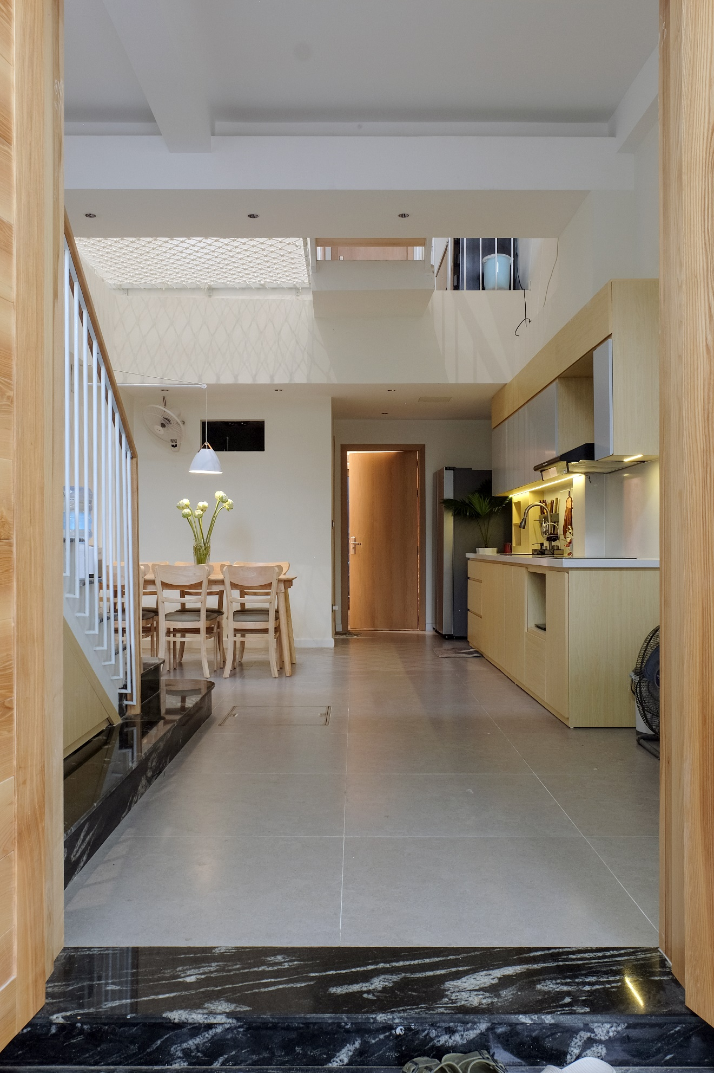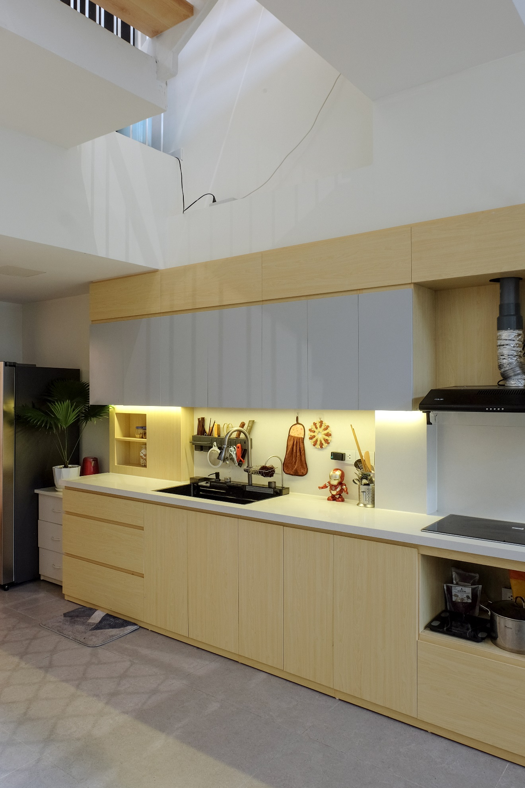
Unnecessary elements were removed to maintain a clean, organized space. This includes minimizing decorative items, bold colors, and patterns.
The use of light, neutral tones, a hallmark of minimalism, was fully embraced in this design.
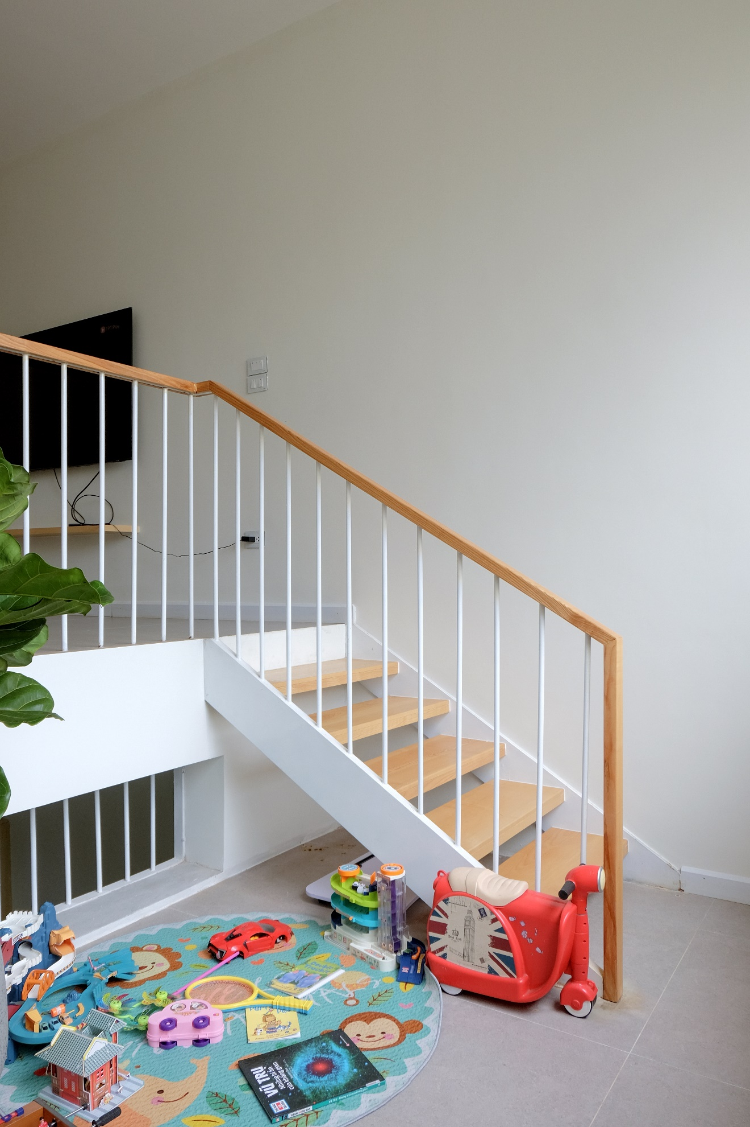
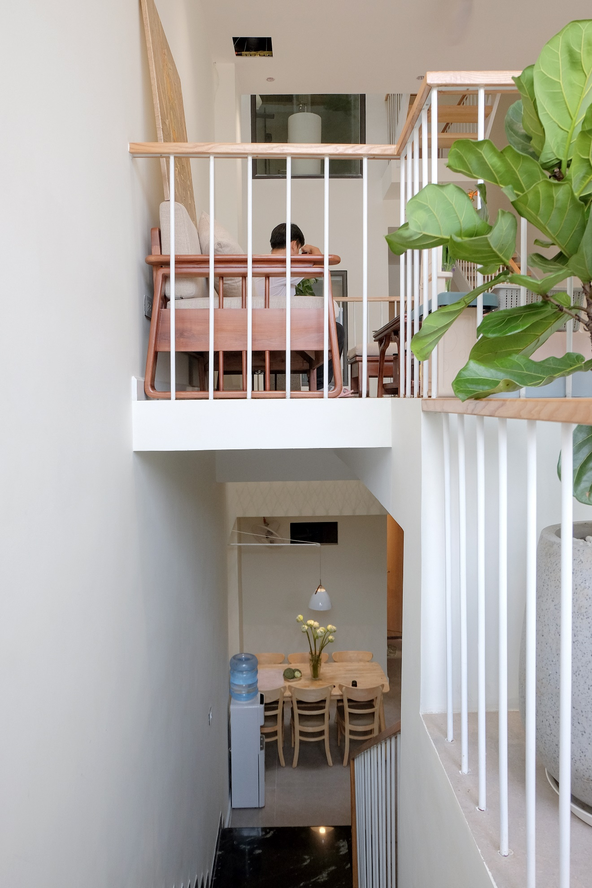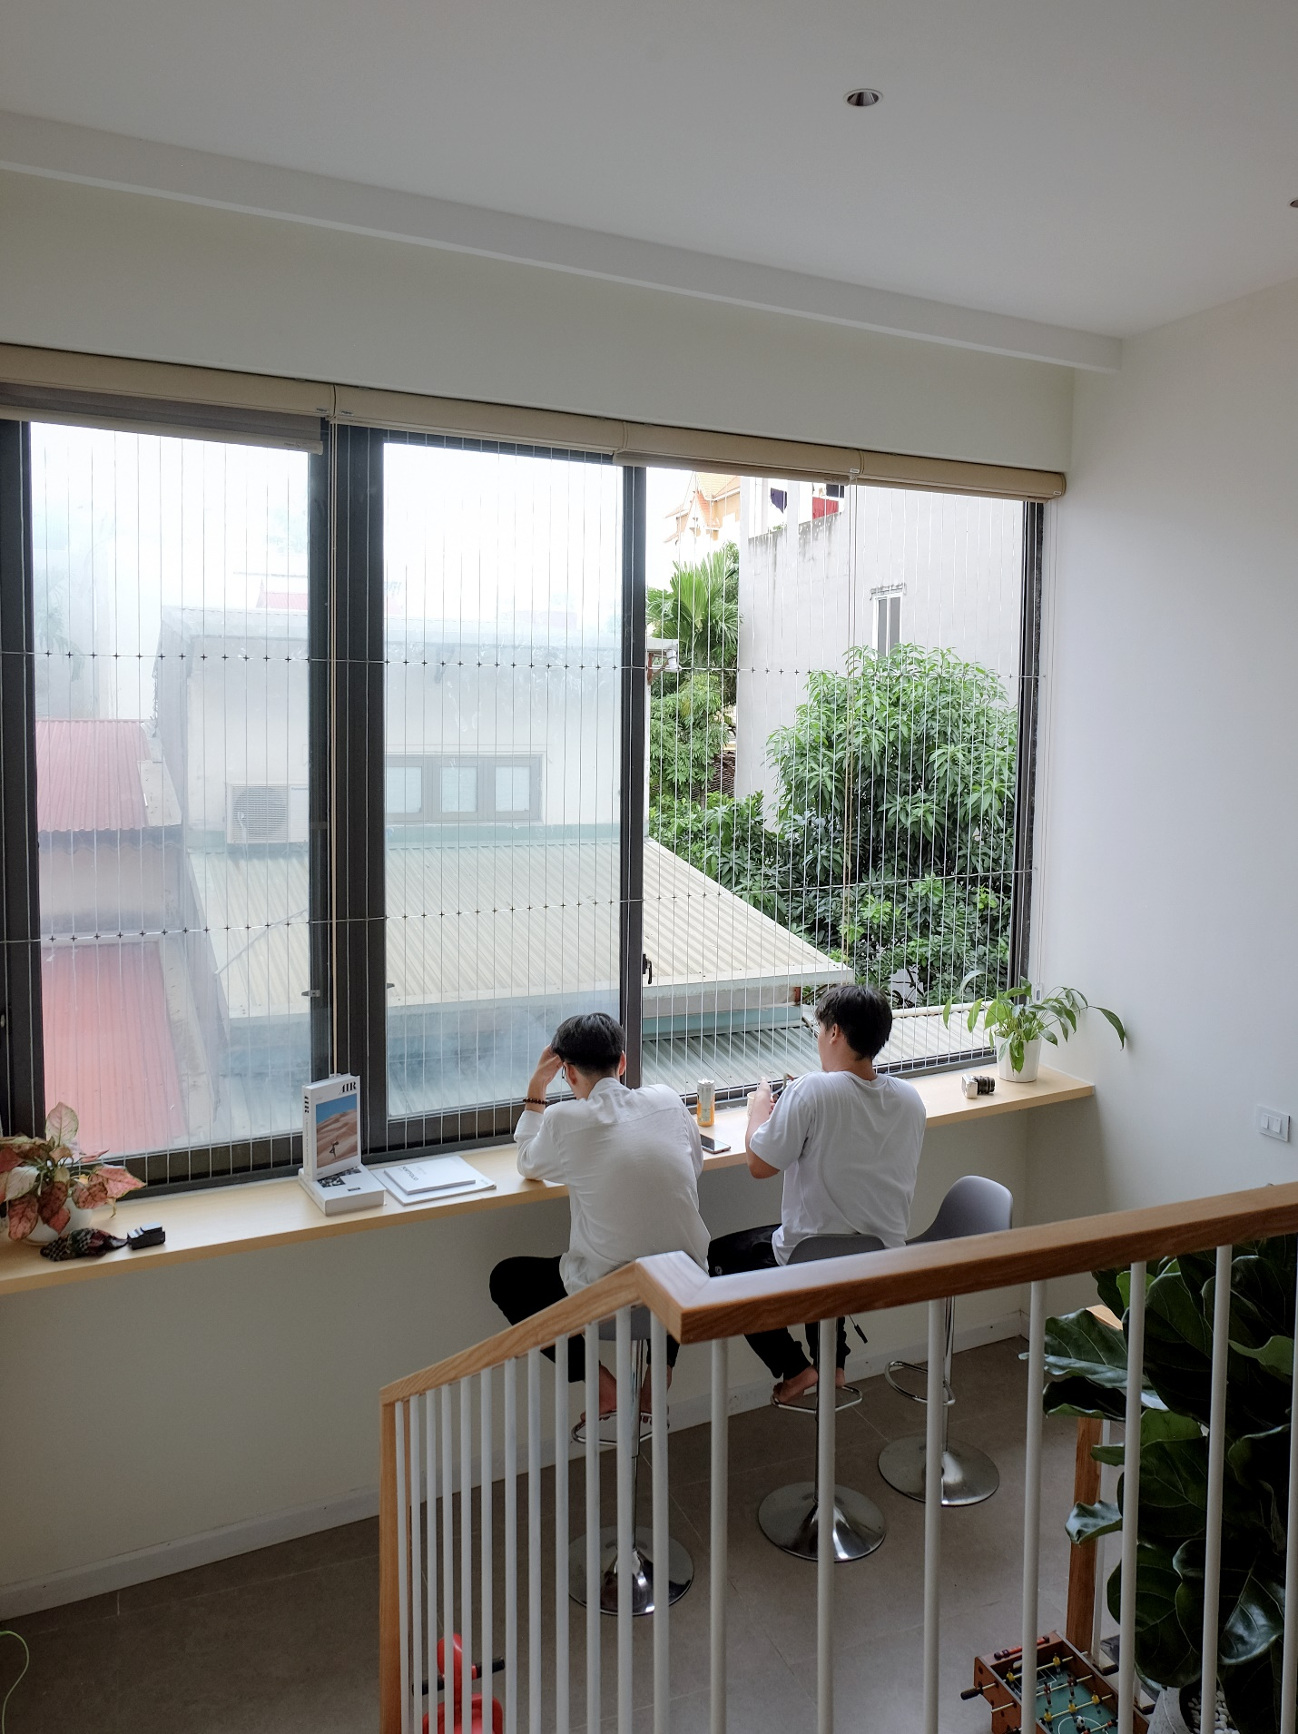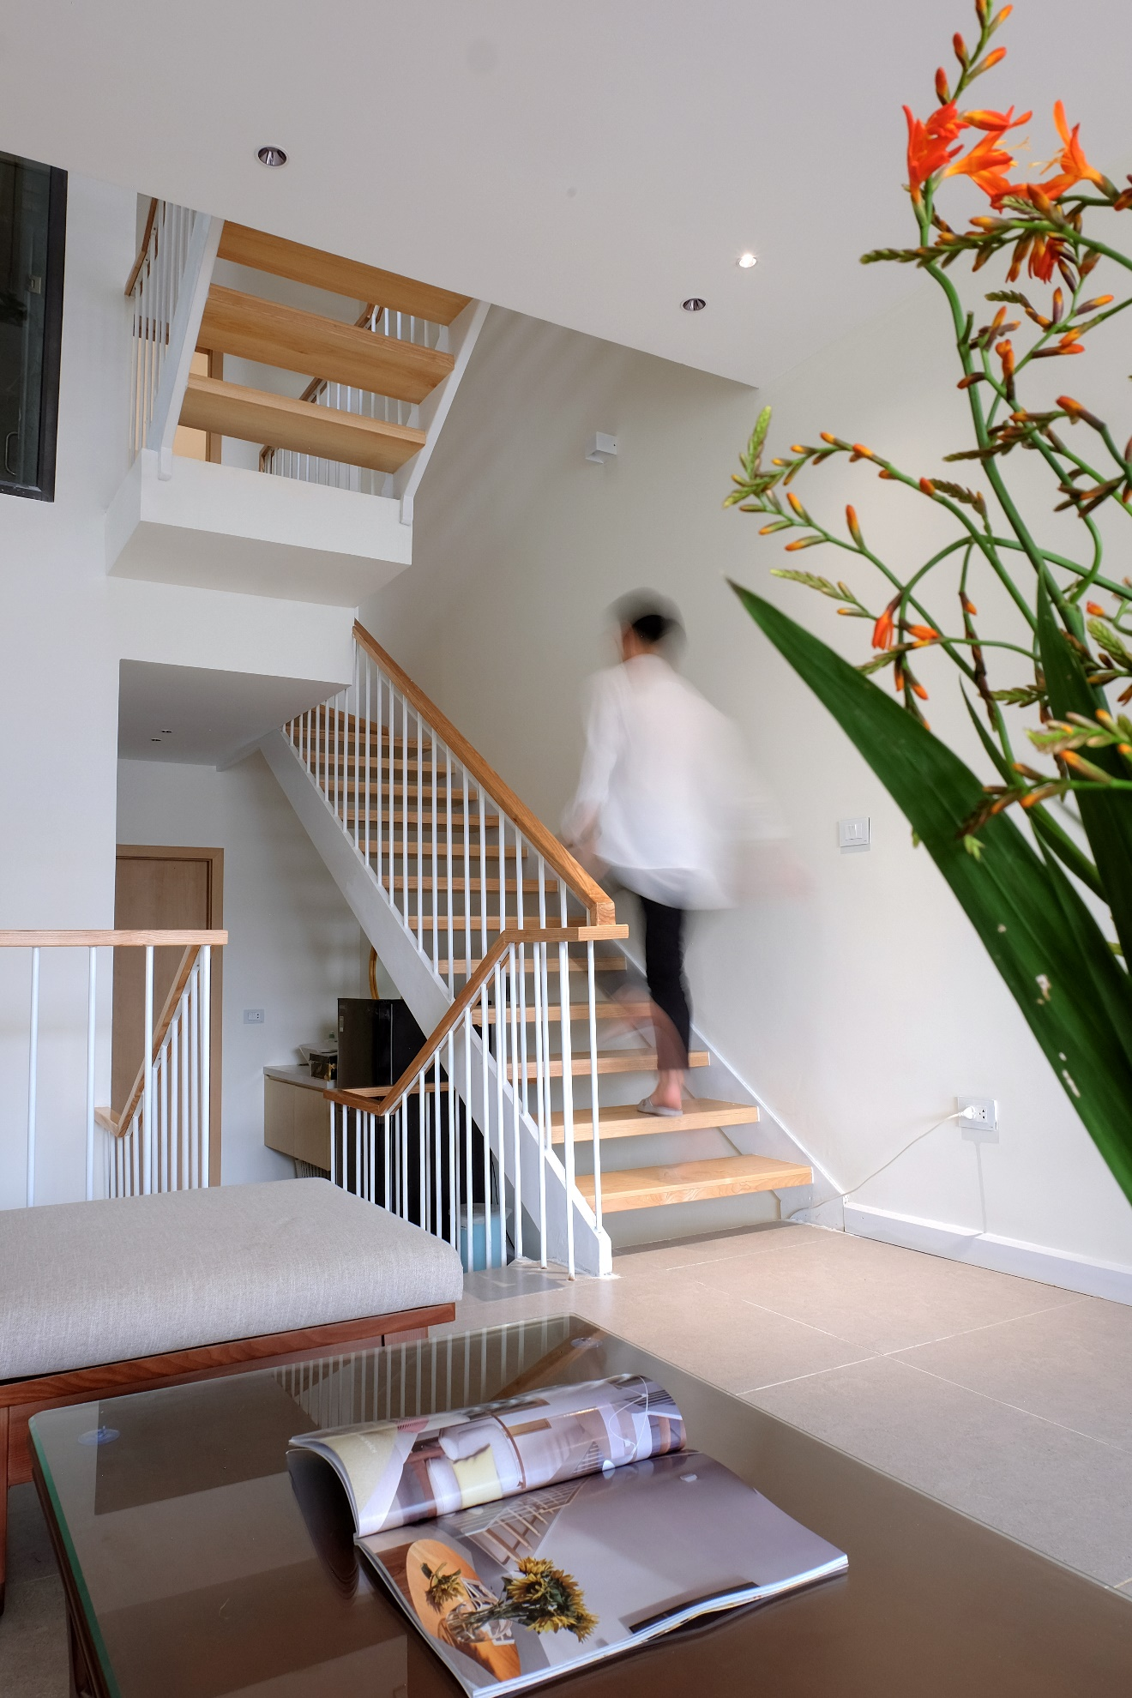
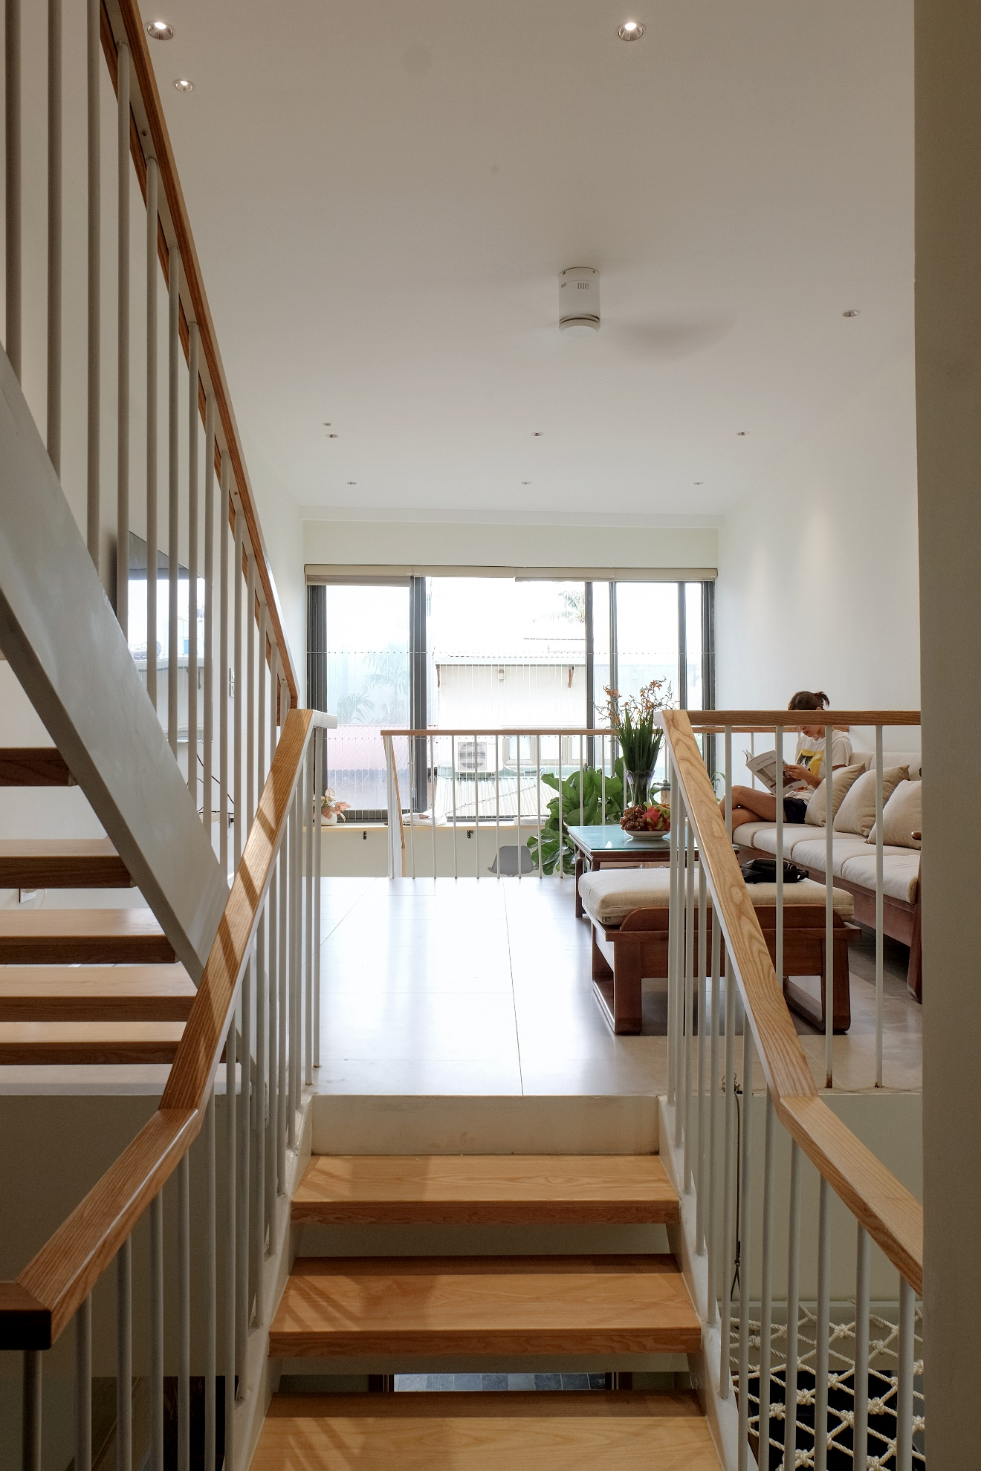
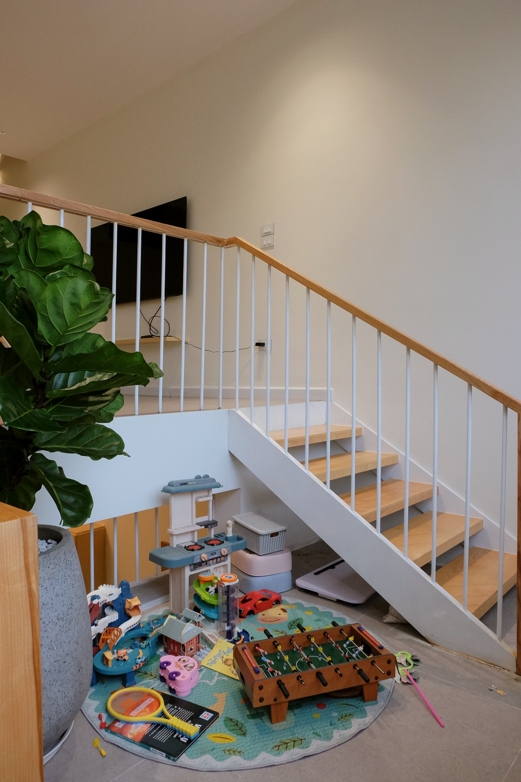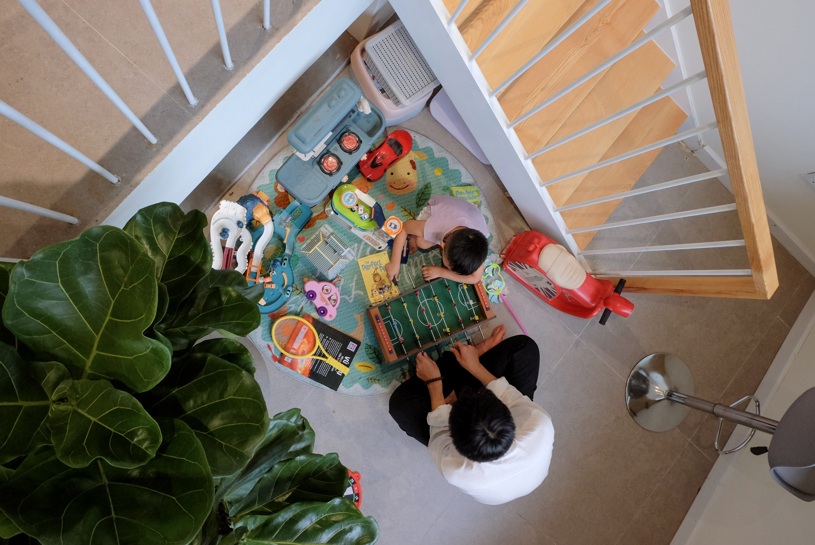
In today’s modern lifestyle, people often live isolated within their own spaces, lacking the connection within a family. Thus, the design of the house prioritizes connection, bringing people closer together.
By using split-level floors, private and communal spaces are linked through the skylight and glass partitions, as well as partial walls. These intentional design choices create an open and connected space.
The arrangement of the house creates a unique experience of deep family connection that is difficult to achieve with traditional designs. With the split-level floors, parents can easily observe and engage with their children as they play or go about their daily activities.

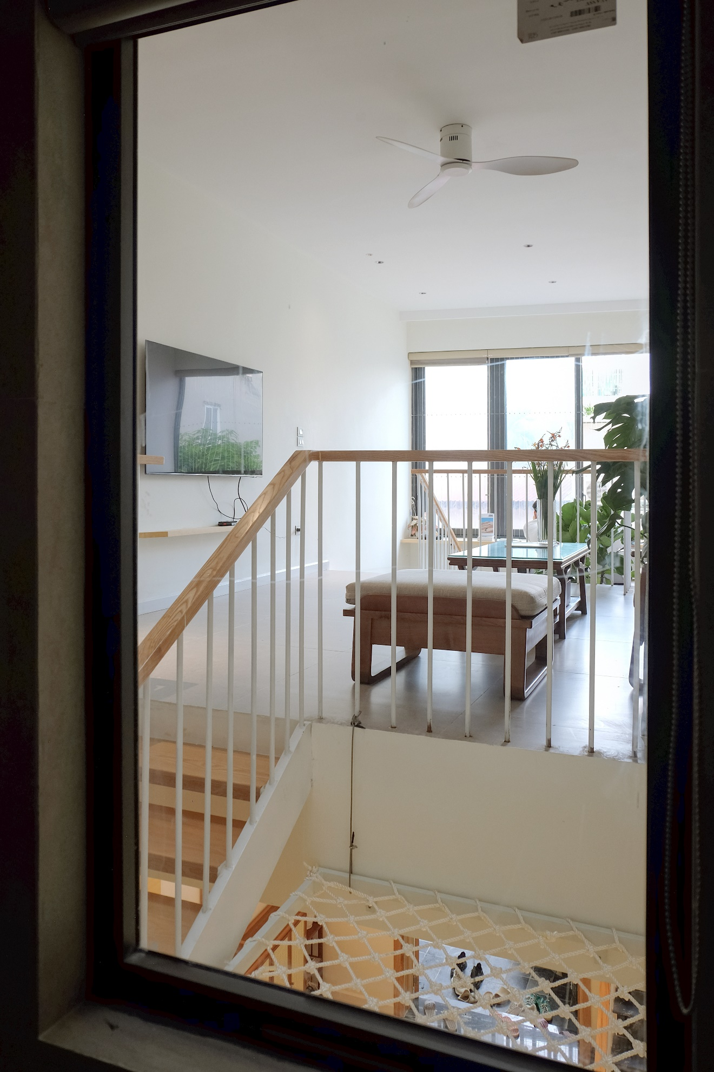
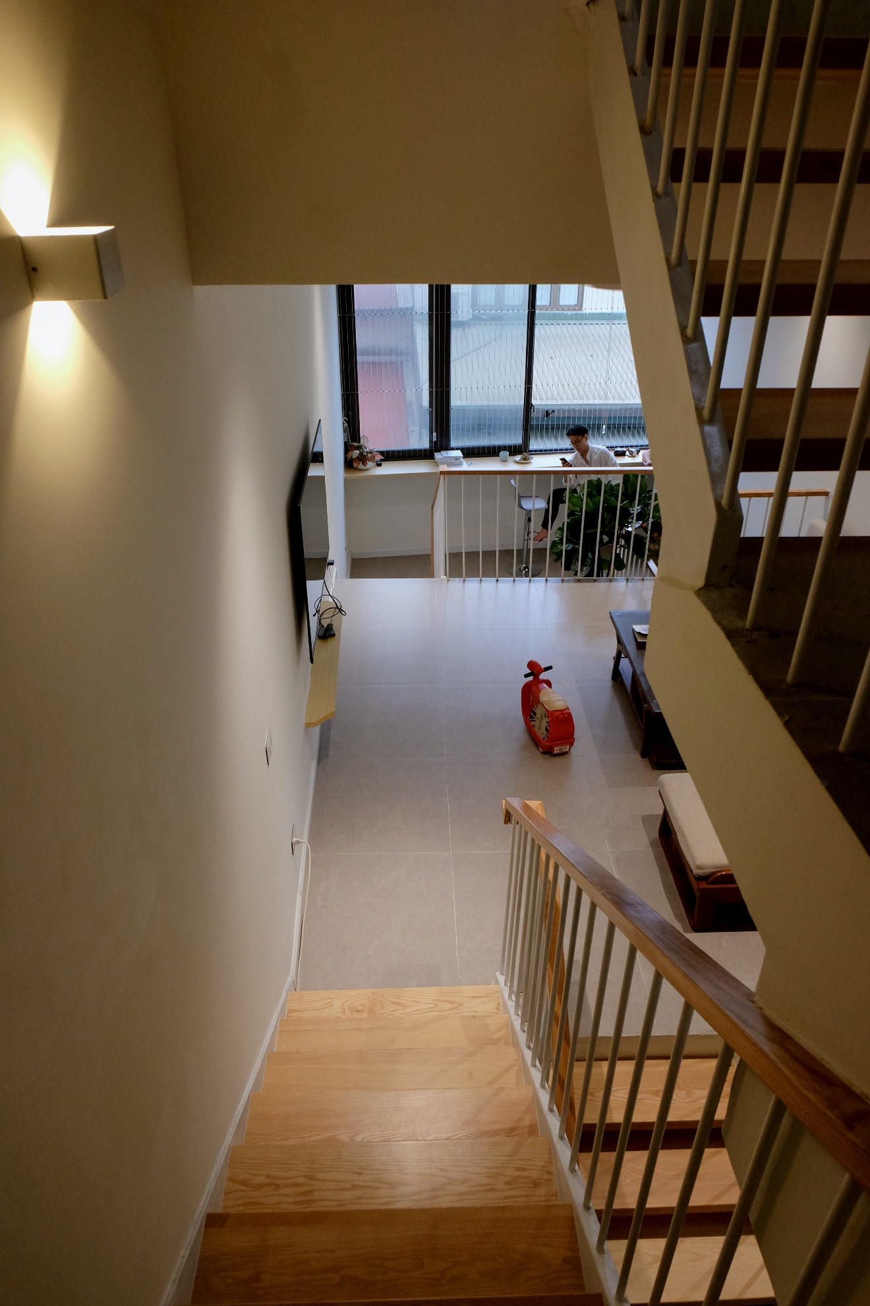
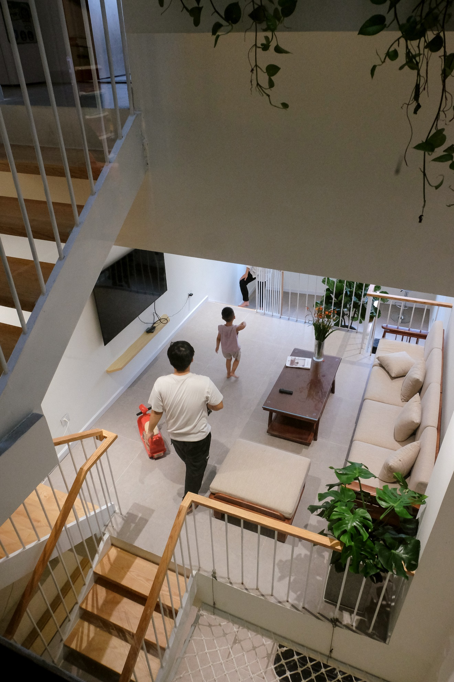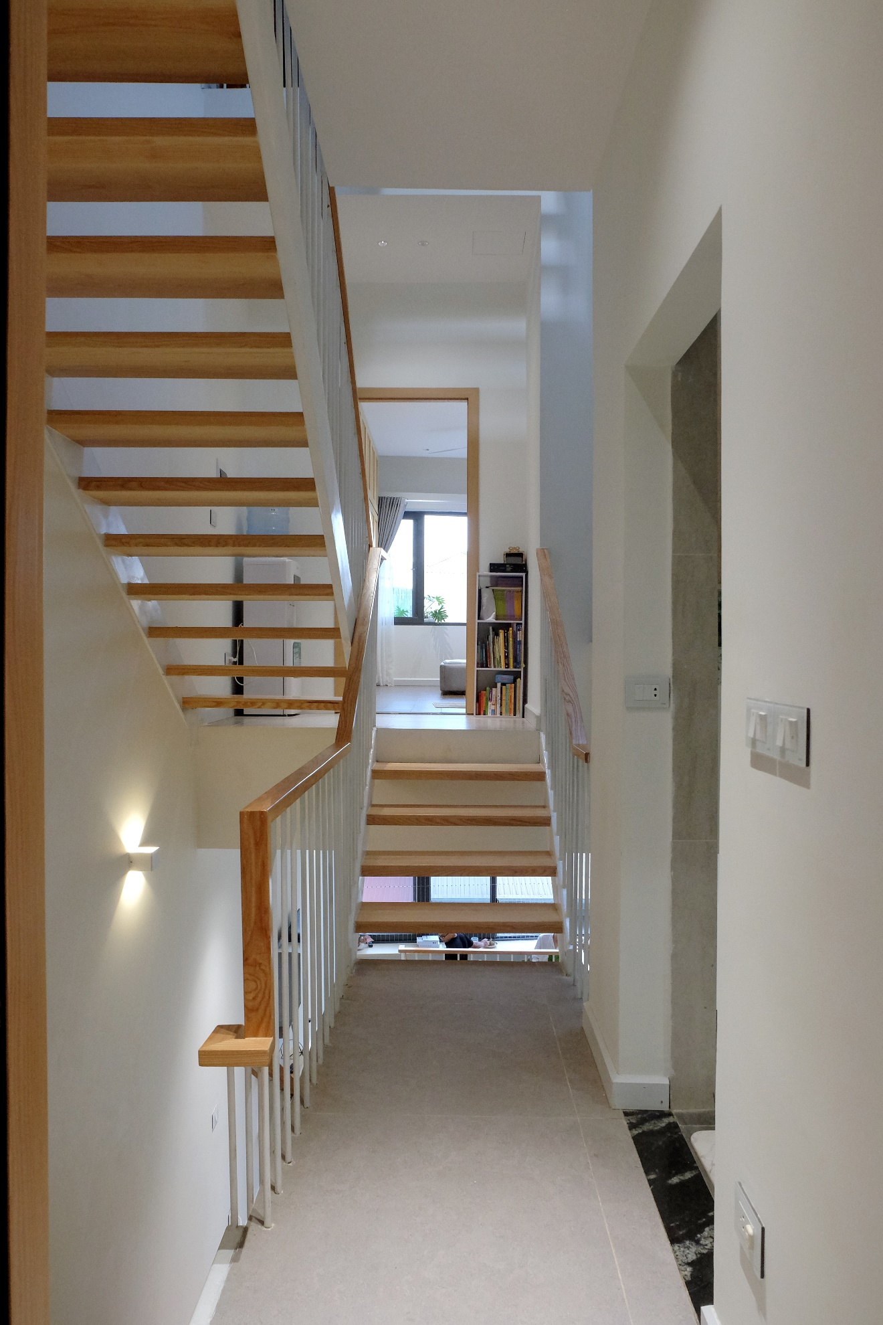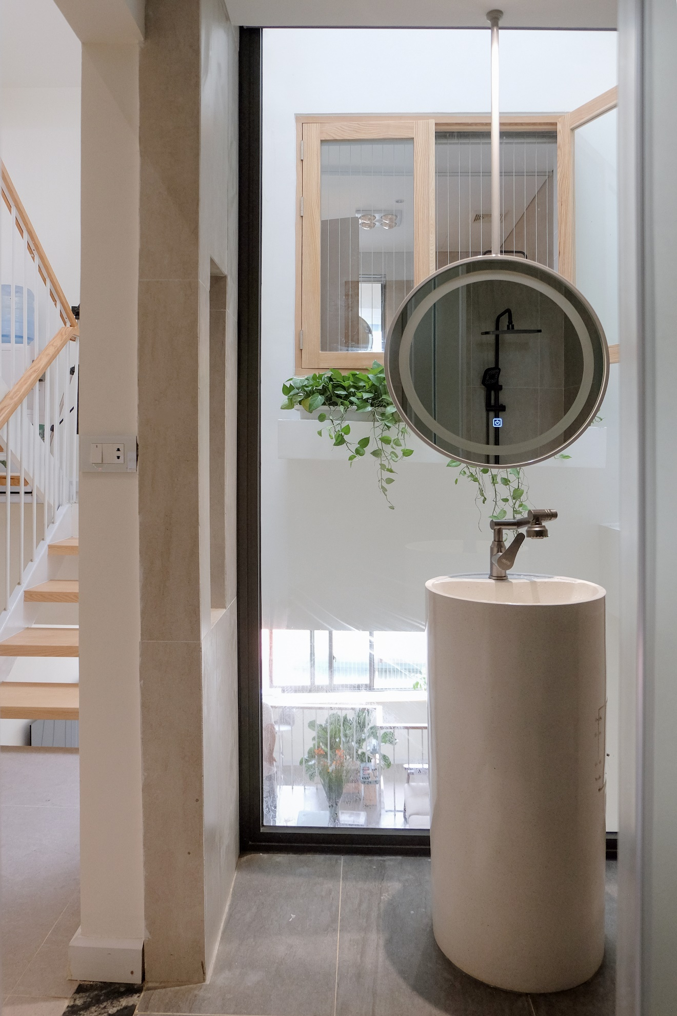
In this project, we carefully calculated the right amount of sunlight to illuminate the space. Natural light is considered in relation to the sun’s cycle, and every detail was used by the architects to achieve both the intended lighting and aesthetic effect.
Windows are designed to ensure that early morning sunlight doesn't shine directly on the occupants' faces.
The amount of light entering the house is balanced, preventing it from being too harsh or glaring, while allowing the feeling of the sun’s natural movement within the home.

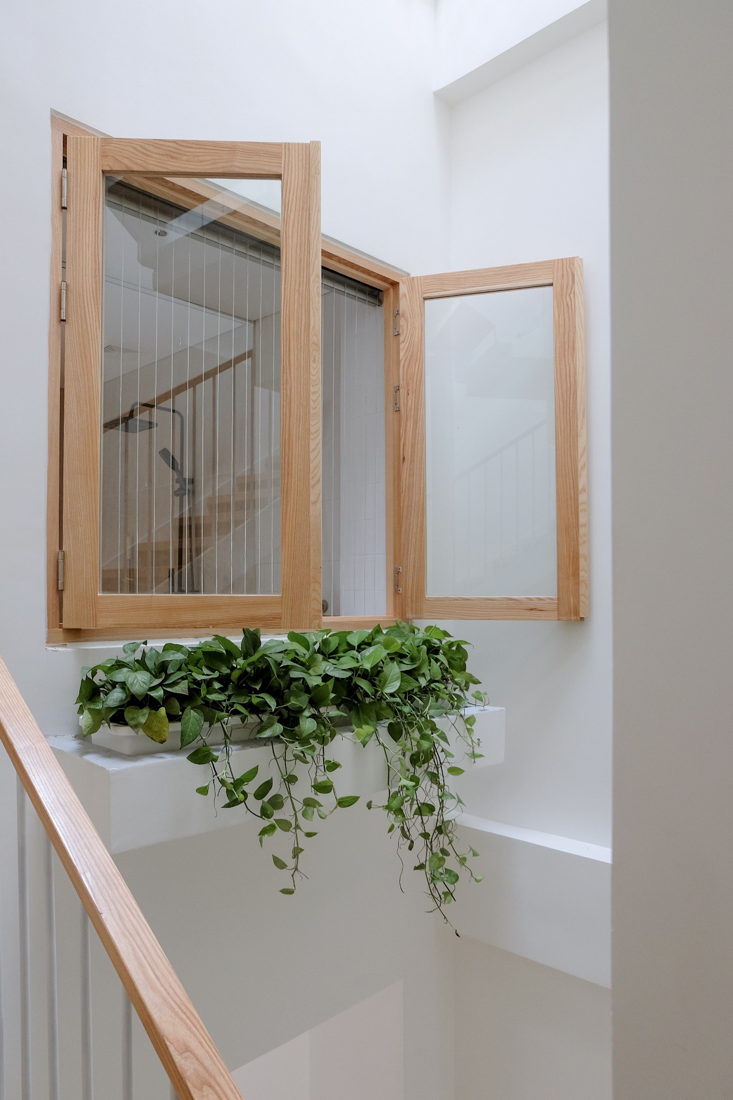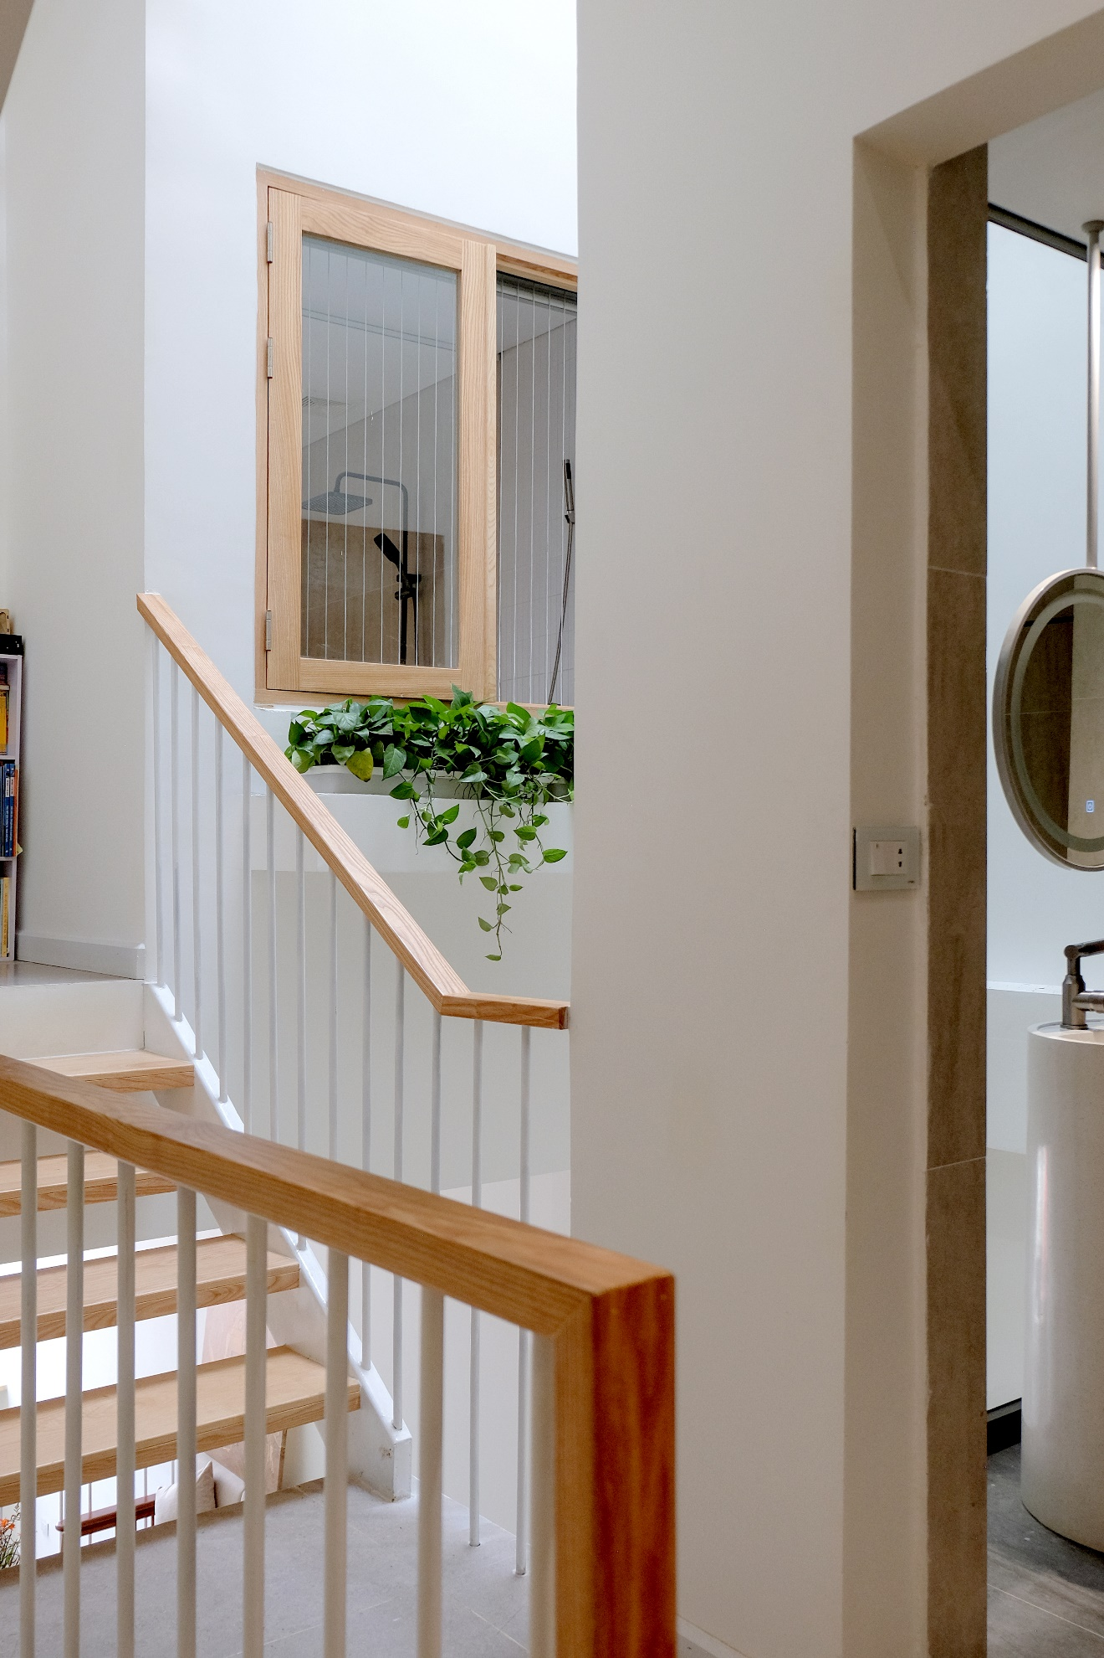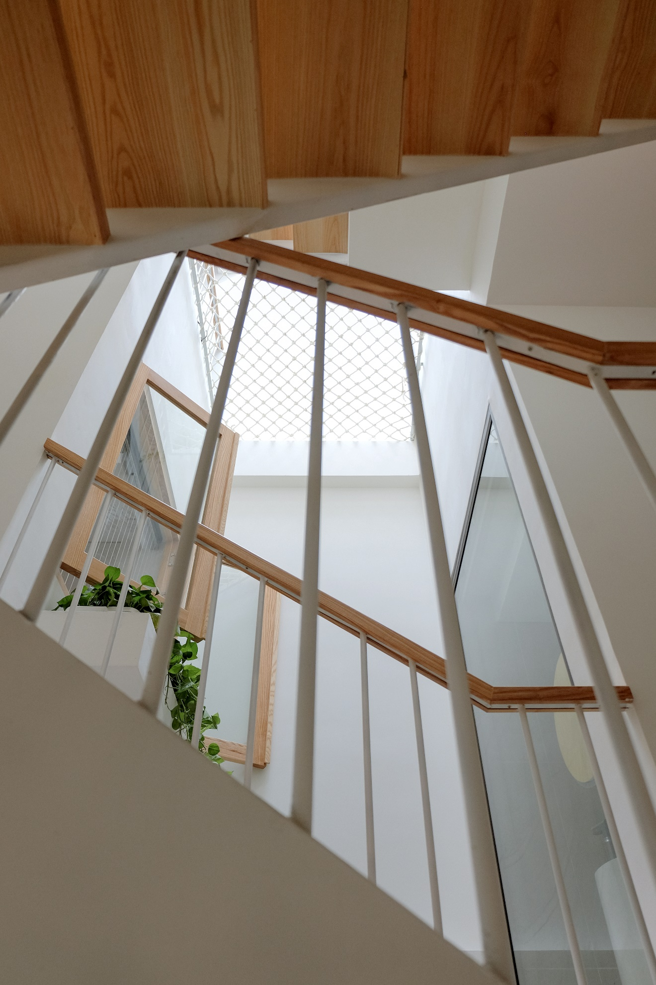
The skylight serves two main purposes: bringing in natural light and promoting air circulation.
Though not large, it allows natural light to penetrate almost every room in the house.
In addition to providing light, the skylight also enables airflow, keeping the rooms cool and the common spaces comfortable without the need for air conditioning, even in both hot and cold seasons.

