The surprising transformation of a bank branch into two flats of 50m2

- And this is how Clap Design devised the interior design of this place to give it a new use in Madrid from the firm Re-aviva

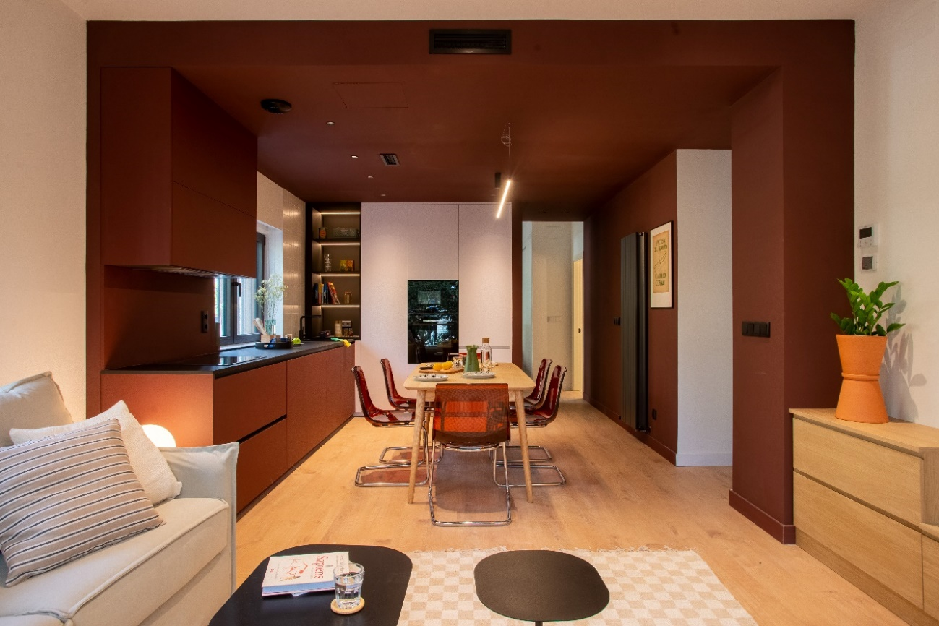

2024, February-. The interior design and architecture studio Clap Design has carried out the comprehensive renovation of the premises at street level – previously a bank branch – to transform it into two apartments, in the area of Puerta del Hierro (Madrid). The location belongs to Re-aviva Smart Building, a firm expert in rehabilitating abandoned real-estate to transform them in residences.

Fluidity and multifunctionality of the spaces

The fluidity of the spaces is determined by Clap Design’s design for both homes, which each have an area of 50 square meters.

With the point of enriching the space as much as possible, an open space system was created. This way, the multifunctionality of the living room is expressed, independently of the time of the day, as a studio, a space for sports, or a comfortable place to live, alone or in company. An ambiguous and versatile home.

The areas connect with each other through a system of color stripes, this allows the fluid circulation in between the areas. This also creates a feeling of spaciousness and dynamism. This stripe system, idealized by Clap Design, allows a great flexibility in the use given to the space, which can adapt to different necessities and everyday situations.

The decision for the color maroon

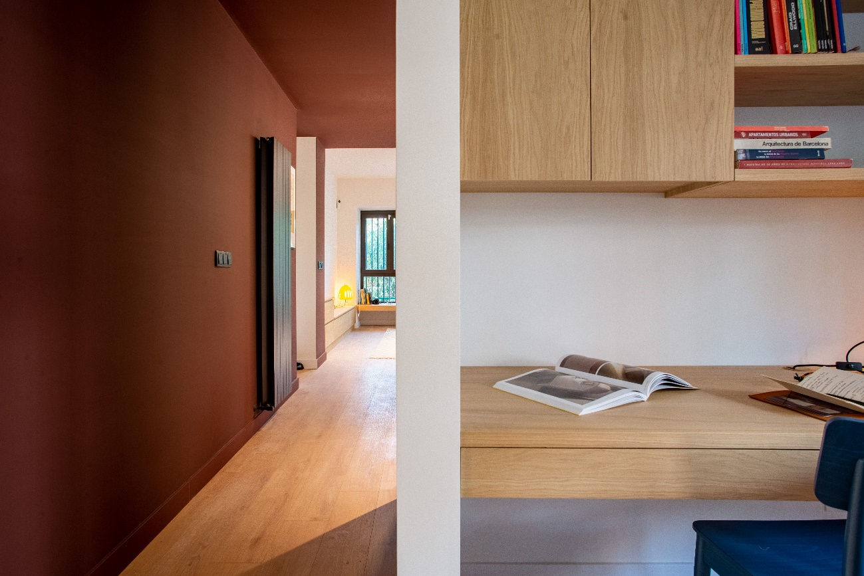

“The space is designed to solve the emotional needs that our homes should have” the team of Clap Design explains. The maroon stripe works as an element of union and contrast, creating different states of emotion. In an orderly way, the maroon clothes the walls, ceiling and even the kitchen furniture, in a way that envelops you in its comfort.

On the other hand, the natural wood plays the main character role. The light wood of the tailored furniture and the flooring harmonize with the white walls and contrast with the intensity and strength of the marron color.

The tailored furniture, designed by Clap Design for this project, has allowed the optimization of the space and emphasizes the feeling of amplitude. Low cabinets for storage, peripheral benches under the window, studio tables stuck to the wall… very useful and distinct pieces that complement each other with hints of the design from different furniture and illumination brands (Vitra, Kartell, Kave Home…).

From a cold bank branch to two cozy households

Nowadays no one would say that these two households, warm and cozy, were in the past a frigid bank branch.

With this integral remodeling, we have reached the objective of the firm Re-aviva, which seeks to recover the unused real estate of Madrid and turn it into a better place to live. Clap Design, a design and architecture studio, designs the real estate from scratch, from the choice of the place, architectural project, to the furnishing, to allow people and brands to have a place that represents them, defining their space in an attractive, functional and emotional way.

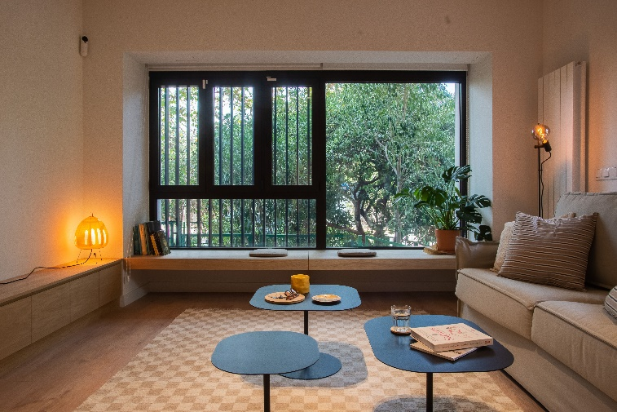
Spatial project made by:

Clap! Design – composed by: Raquel Jiménez, Pilar Morejón, Yolanda Reyes, Ioanna Kalyvioti, Manuel Simón y Rocio Sanchidrian.

Photography:

Cristóbal and Marta – Sales de Plata

Art Directors:

Rocio Sanchidrian and Yolanda Reyes

About Clap Design:

Founded by the architects Pilar Morejón y Raquel Jiménez, the architecture and interiors studio Clap Design creates special spaces through design, makes people and brands have their own representative space, defining their image in an attractive way and making their day to day easier.

“In Clap! we understand design from the aesthetic and functionality point of view, trying to create unrepeatable atmospheres which are adapted to the personality of each client and business. We use the design as a tool to optimize spaces and give attractive and practical solutions, always looking to go one step further, until we find a way to make everything fit”.

www.clapdesign.es

