【Title1】Crafting a "Concept Car" for Future Architecture - AUDI "Make the Energy Visible" e-tron GT Touring Exhibition

【Title2】Exploring the Future of Architecture with AUDI - AUDI "Make the Energy Visible" e-tron GT Touring Exhibition

【Title3】AUDI "Make the Energy Visible" e-tron GT Touring Exhibition - a Journey of Endeavor in Exploring the Future
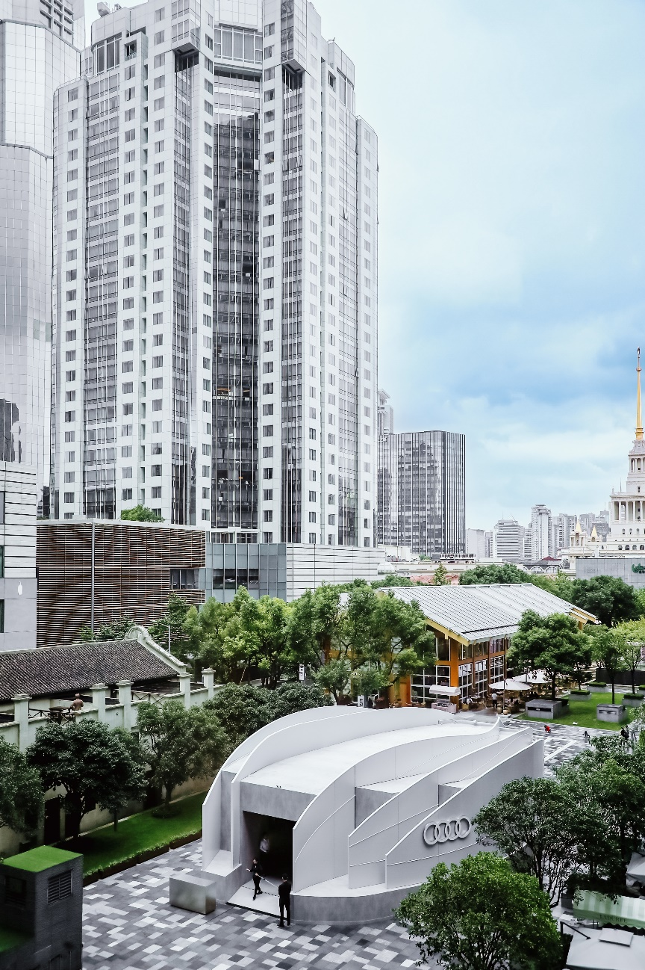
© FAW-Audi & Bazaar Art

Keywords: #Digital Media # Art Installation # Urban Sculpture # Emotional Resonance

House of Progress is an experience space with a strong sense of user perception that Audi has been creating globally in recent years, serving as a platform to communicate the brand's progressive philosophy. The touring exhibition of "Make the Energy Visible" e-tron GT is jointly organized by FAW-Audi & Bazaar Art and planned by THEMiS. Through the creativity of artists, designers and architects, it aims to share the progressive idea that "the Future is an Attitude."

Taking inspiration from the familiar natural forms of human beings, SODA shapes the appearance of this pavilion with the energy of airflow, combined with the strong expression of dynamic digital media, presenting a building with vitality. The art pavilion is like a movable urban sculpture, traversing the bustling downtown of Shanghai, then arriving at the banks of West Lake in Hangzhou over a month.

MAKE THE ENERGY VISIBLE

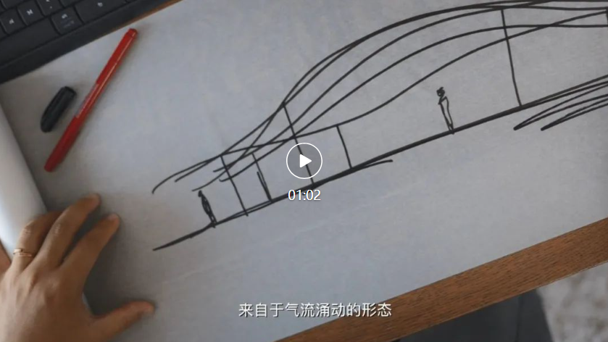
Rather than remaining unchanged or eternal, architecture can adapt and evolve. Energy is an intangible force that manifests itself through tangible vehicles.
▲ Advertising Video of the Exhibition
© FAW-Audi & Bazaar Art

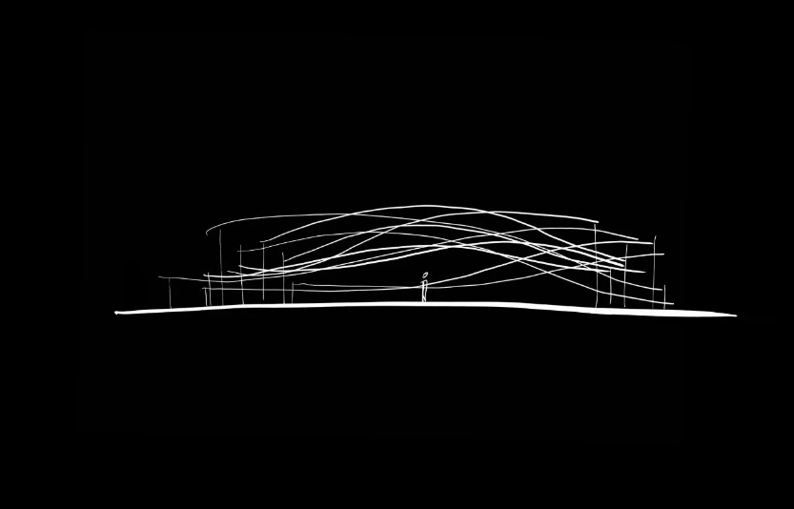
Audi e-tron GT exhibition is a pioneering way of showcasing art. By exploring the process of artistic shaping, "energy" can be seen, felt, and known in different ways. As architects, SODA collaborated with Audi in pushing the boundaries of innovation - whether it be envisioning the future of architecture or crafting a "concept car" that serves as a muse for future architectural endeavors.
▲Design Sketch of the Main Installation © SODA

For SODA, the "energy" of design is the power to move people through spatial experience. By using elements such as scale, form, color, dynamics, media, interaction, etc., to stimulate the power of emotional resonance in people. SODA believes that the best way to stimulate resonance is to create through natural forms deeply ingrained in human genes.

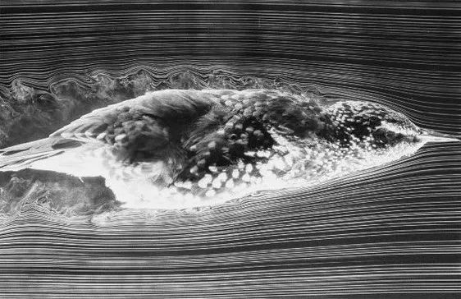
In this project, we draw inspiration from "airflow", "energy", "speed" and "form". As we explore the connections between these elements, we discover more clues that lie behind them.
▲ the Flight Dynamics of Birds

Birds are the fastest-moving creatures in nature, and their body shape is intricately linked to their flight speed. The shape, size, obliquity, and flapping speed of their wings all play a crucial role in determining their flying capabilities. As a bird flaps its wings, it generates downward airflow that provides the lift necessary for flight. Through evolution, birds have developed a streamlined body shape to minimize air resistance. It can be argued that the form of a bird represents nature's optimal solution for efficient flight.
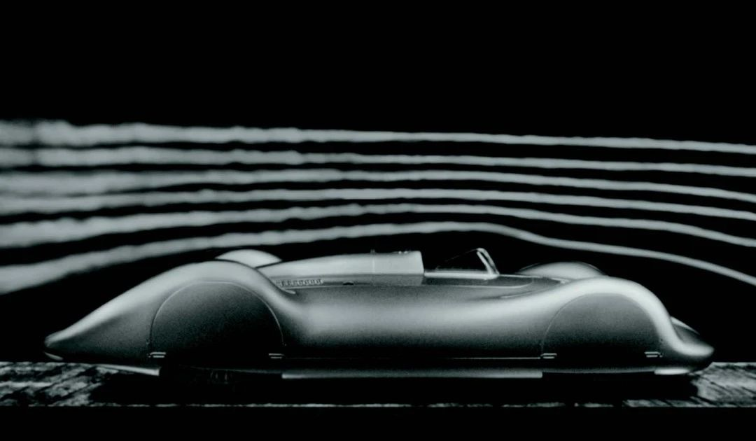
In the realm of automobile design, the foundation of aerodynamics was laid in the early twentieth century, coinciding with a deeper public understanding of fluid mechanics including Ludwig Prandtl’s analyses that significantly impacted the automotive industry. Knowledge from aviation engineers was integrated into car design to optimize airflow dynamics. This era saw the emergence of numerous outstanding works, leading car enthusiasts to recognize the critical role of minimizing wind resistance in achieving top speeds.
▲ A historical photograph of the Auto Union Type C Stromlinie (German for “streamline”) racing car in the wind tunnel. It expresses Audi's profound styling sensibility. ©AUDI AG
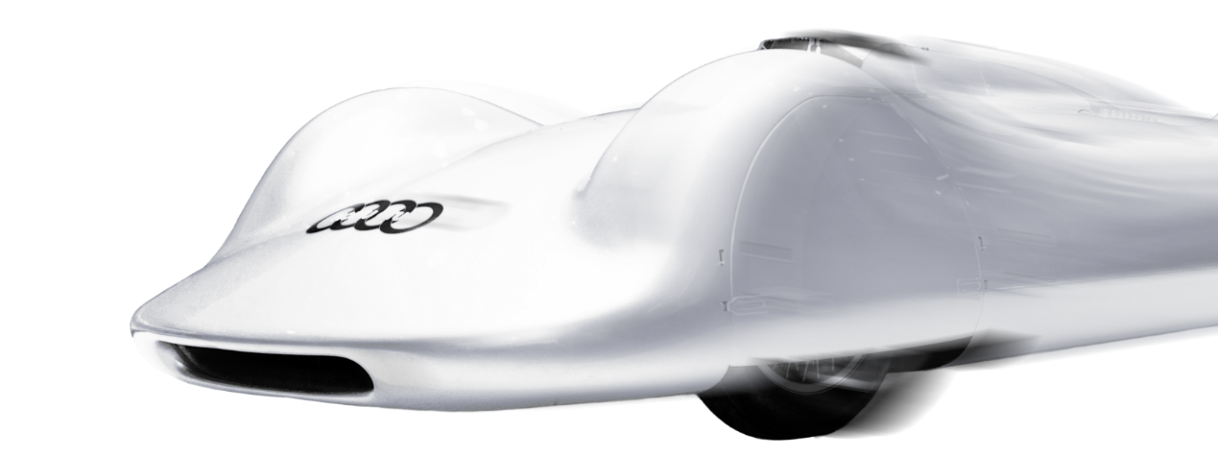
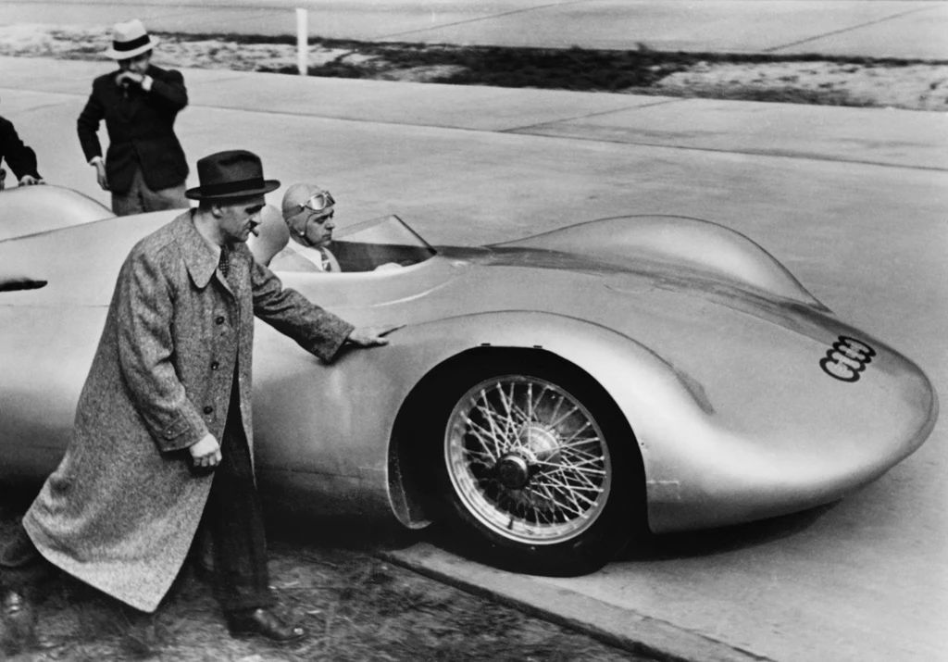
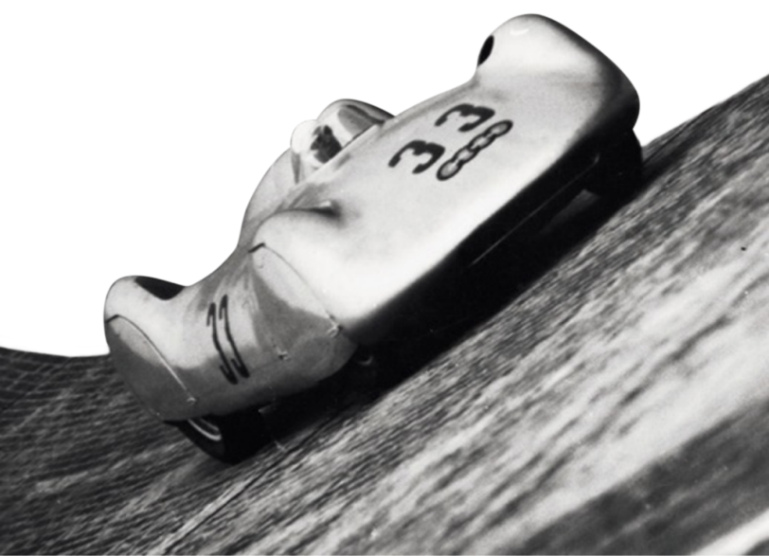

This racing car, born in the 1930s, etched a remarkable milestone in human history, tearing through the Frankfurt to Darmstadt highway at a mind-boggling speed of 406.3kph, while the aircraft at that time had speeds between 200-300kph. Inside Audi's illustrious history, this world's pinnacle technological masterpiece narrates the inspiring tale of Audi's groundbreaking advancements in aerodynamics.
▲ Structure Design © SODA

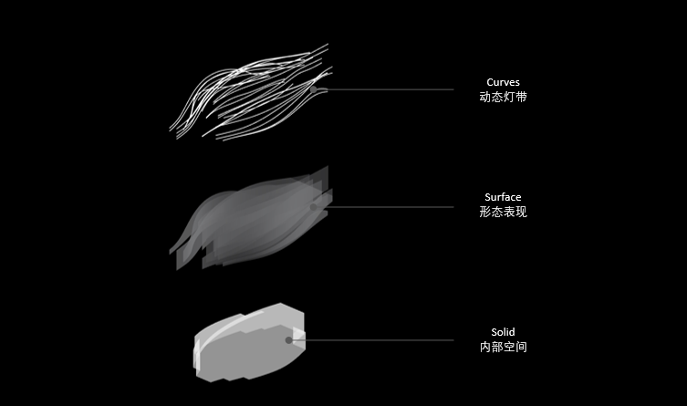
▲ Explosion Diagram © SODA

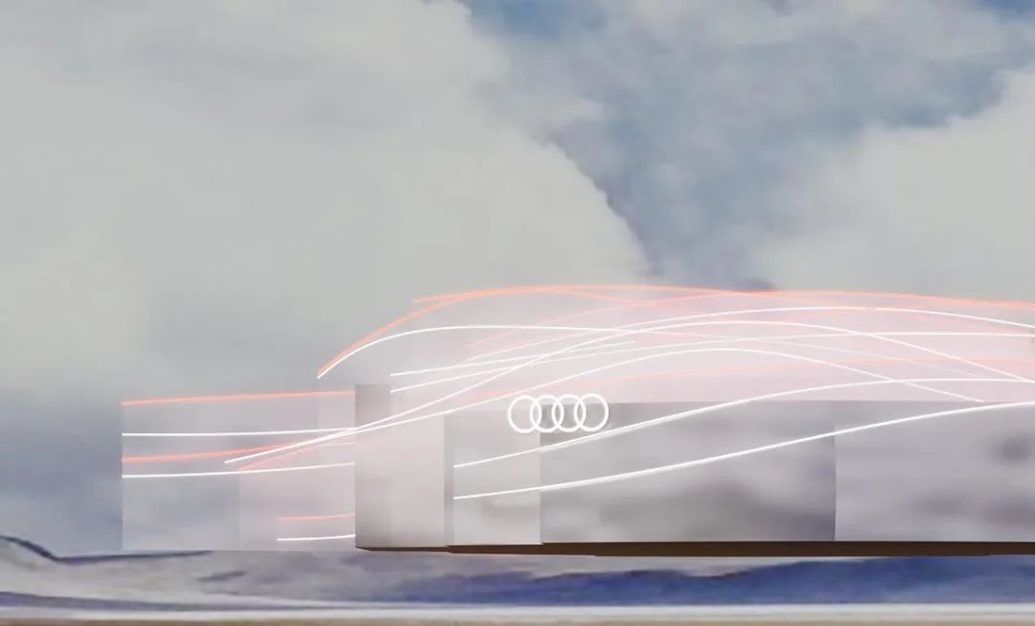
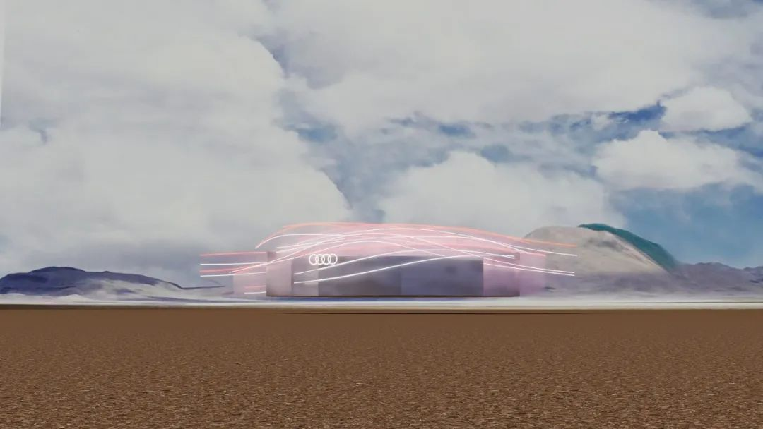
Audi is unveiling its cutting-edge design aesthetics for pure electric vehicles. Starting from the excellent aerodynamic design of the Audi e-tron GT, we adopted a blend of digital and real approaches to transform the surging shapes of airflow into tangible art for viewers to appreciate. Here, the architecture is a way to express the beauty of dynamic energy, with curved surface entities capturing the beauty of airflow and dynamic light effects interpreting the tension of speed.
▲ Rendering © SODA

▲ Dynamic Digital Media Effect © SODA

EMOTIONAL RESONANCE

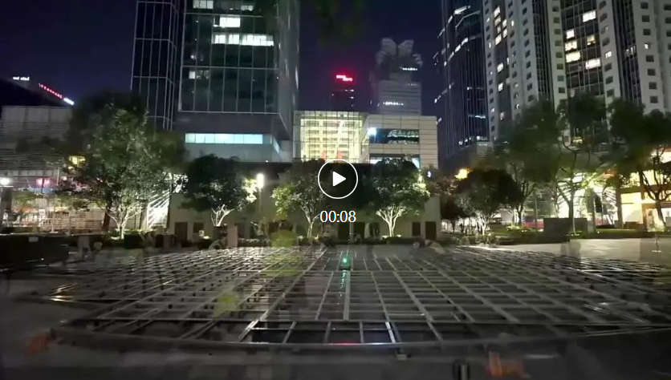
Whether it is the aesthetic elaboration of forms and lines or the innovative implementation of new technologies and materials, the primary and ultimate objective that we pursue in our creative endeavors is to evoke a sentimental resonance deep in people's hearts.
▲ On November 2023, the Art Pavilion was completed at Jing An Kerry Centre, Shanghai © FAW-Audi & Bazaar Art
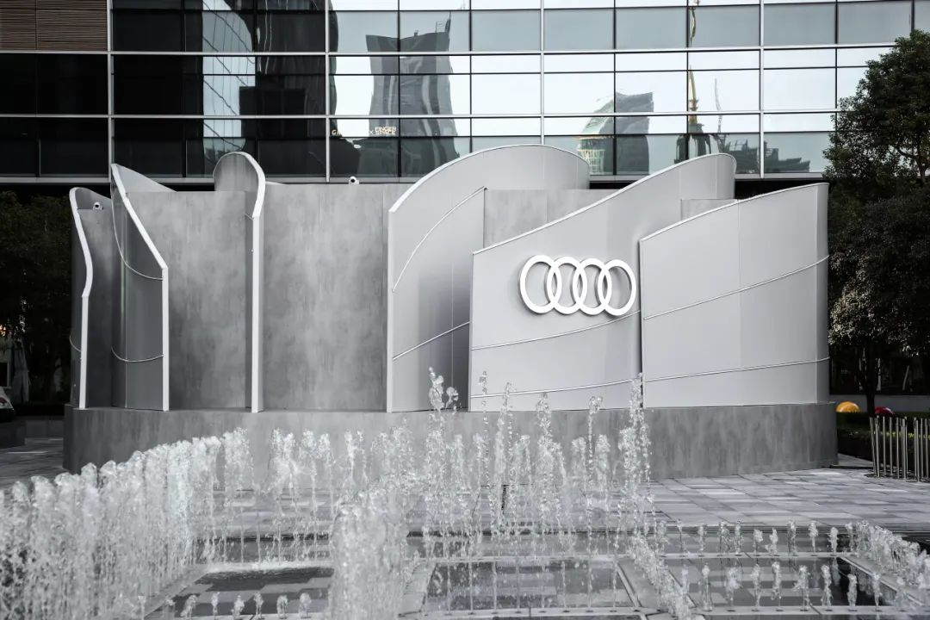
▲ Appearance of the Pavilion
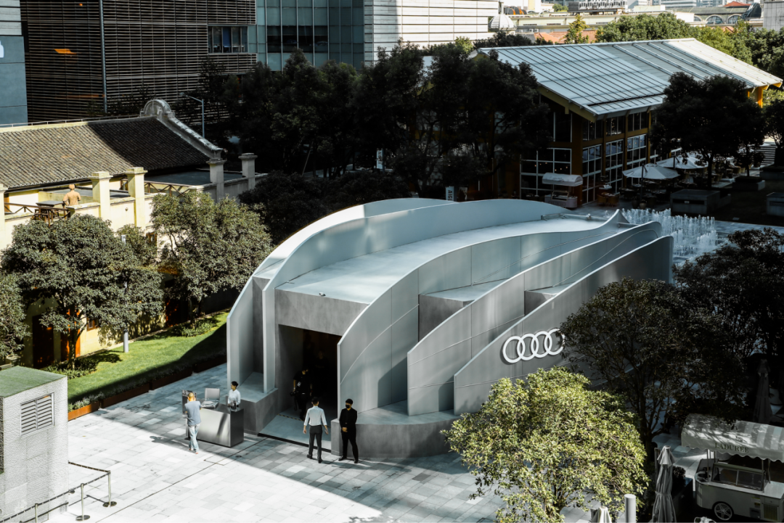
© FAW-Audi & Bazaar Art
▲Bird View of the Pavilion
© FAW-Audi & Bazaar Art

In this project, architecture acts as a medium between the art space and the urban context. Therefore, our goal is to craft a structure that resembles a striking sculpture within the cityscape, drawing attention from afar with its futuristic form and vibrant energy, thus evoking a connection to the overarching theme of the exhibition.

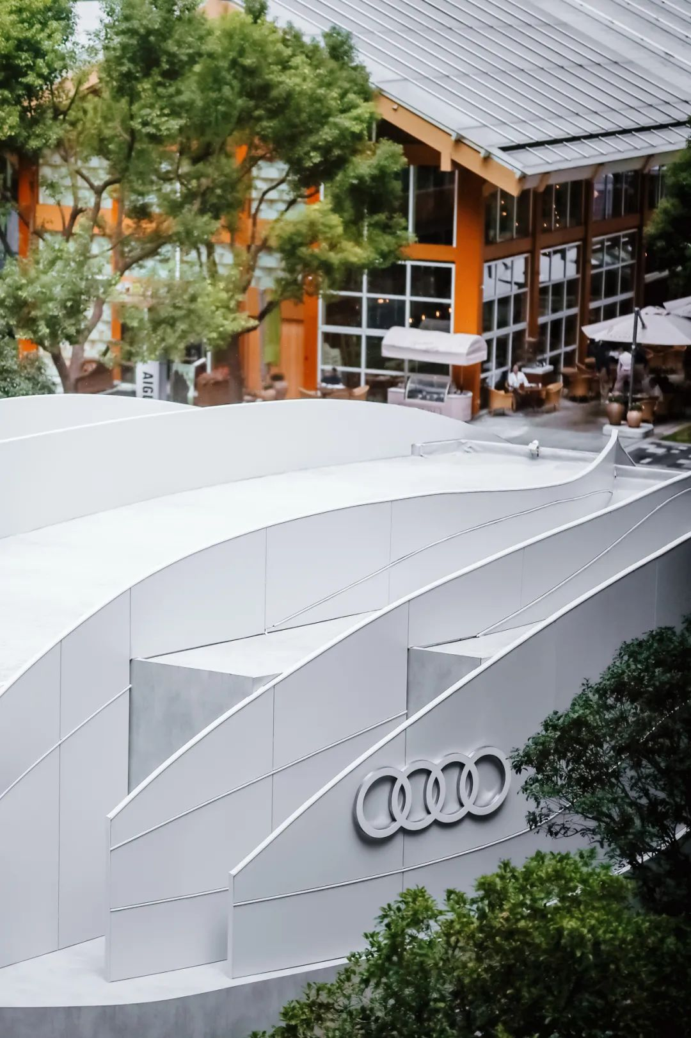
▲ Bird View of the Pavilion
© FAW-Audi & Bazaar Art

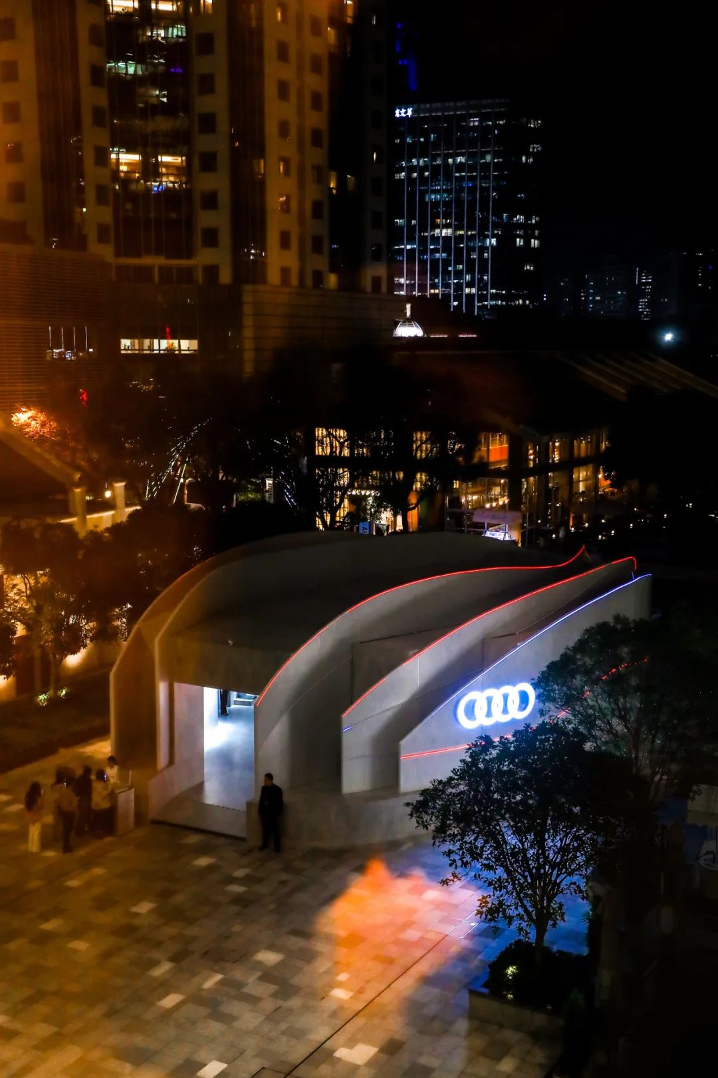
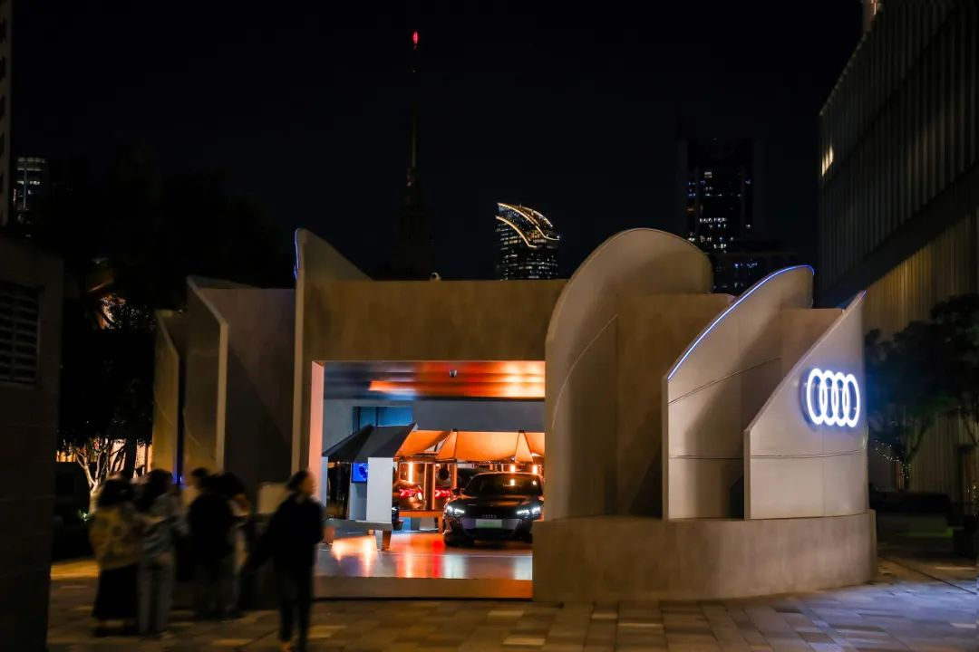
▲ Pavilion in the Night View
© FAW-Audi & Bazaar Art

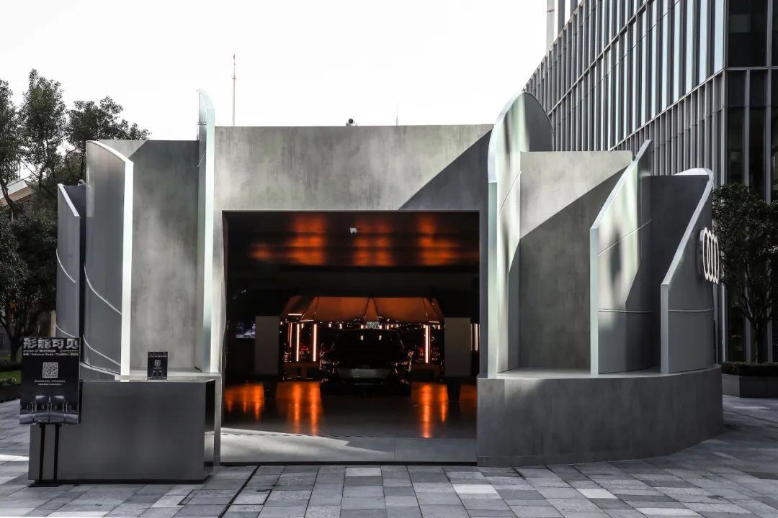
▲ Entrance of the Pavilion
© FAW-Audi & Bazaar Art

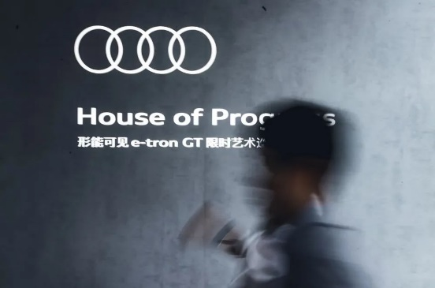
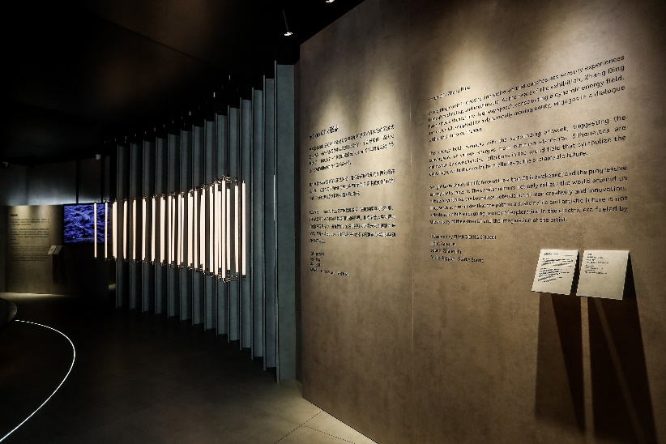
Upon stepping into the exhibition hall, the predominant color scheme of the space seamlessly extends the neutral grey tones of the city streets, fostering a clean and tactile ambiance that harmonizes with the modern artworks showcased. The dynamic impact of the art pieces is accentuated through a synergy of form, light, and sound. As a result, the spatial design is meticulously curated to align with the artworks, ensuring a cohesive integration from the forms to the ambient lighting. In a highway like environment, when dynamic shapes, images, and refracted light and shadow intertwine and converge, it is like the superposition and reconstruction of building images outside the window when speeding on urban roads at night.
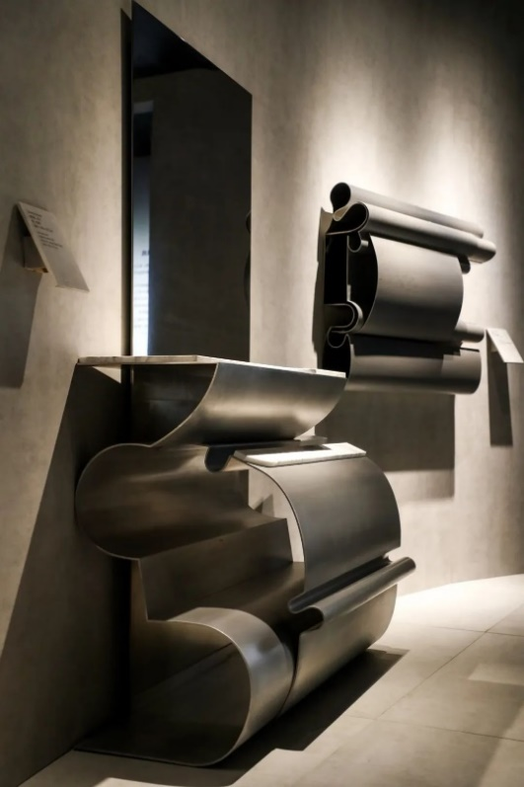
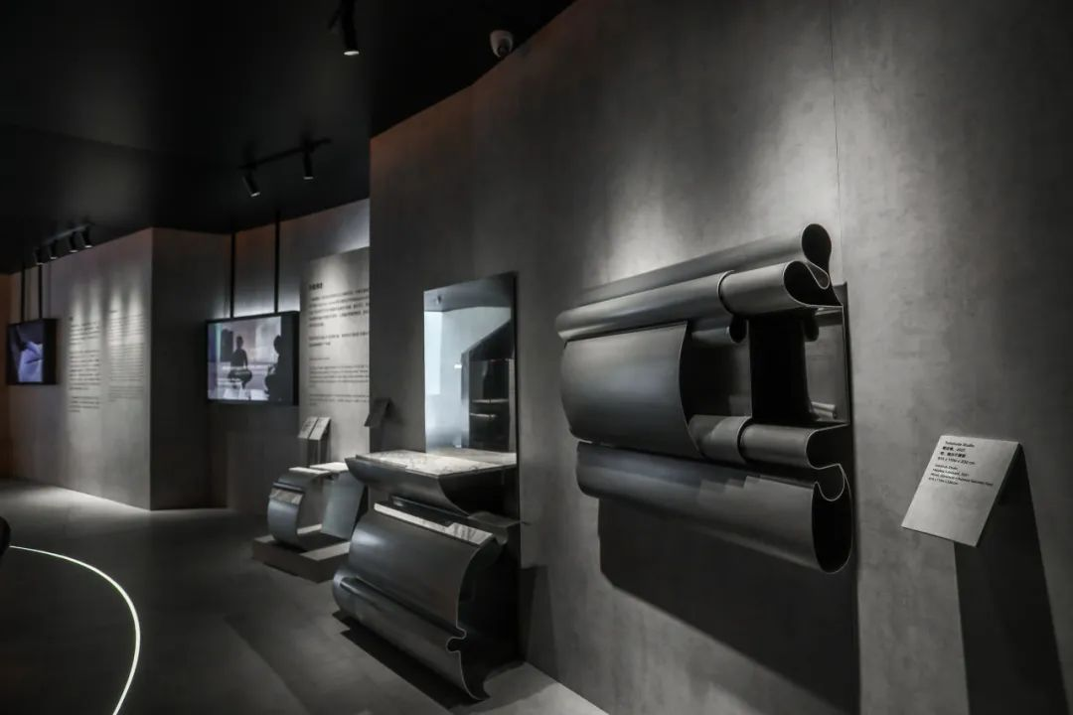
The artists and designers involved in this exhibition endeavored to interpret the core concept of 'manifesting tangible enterprising energy' through diverse creative approaches.

▲「The Energy Metamorphosis」 by Todomuta Studio © FAW-Audi & Bazaar
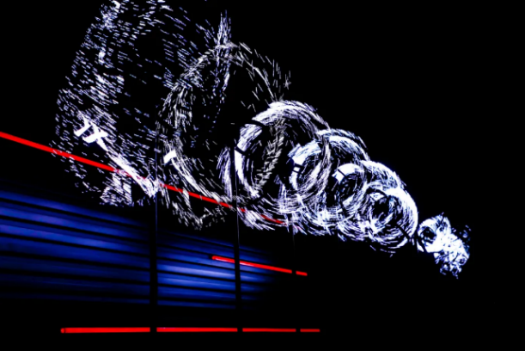
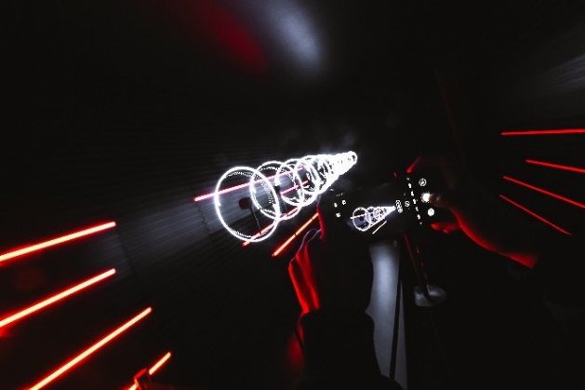
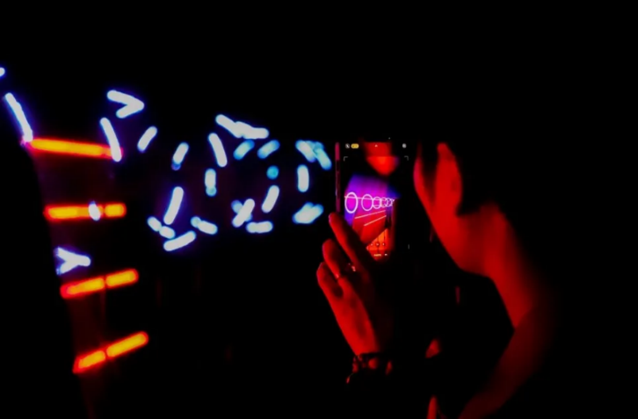
The Energy Metamorphosis delves into the interplay of form and function Todomuta Studio presents a functional art collection called “Massless”. The artists harness the power of heat to render heavy metals remarkably malleable, unveiling the fluidity and lightness of life while seamlessly merging with their textures.

「The Energy Resonance」by TUNDRA © FAW-Audi & Bazaar Art
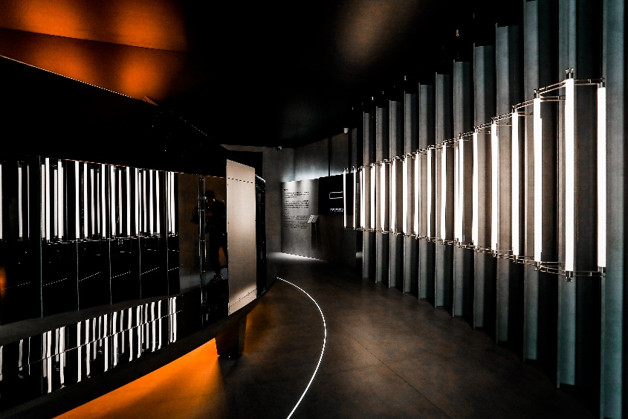
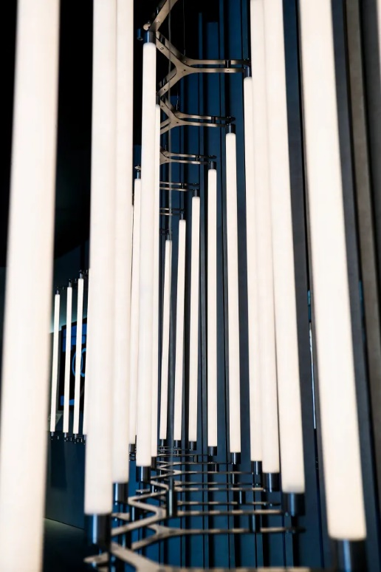
The Energy Resonance seeks to create landscape where sound and vision resonate harmoniously using algorithm technology. It explores the emotional resonance in the context of future digital technologies.

▲「The Energy Circularity」 by Liechao CAI © FAW-Audi & Bazaar Art
The “Mazha Lighting System 3.0”transforms the a simple lighting installation rationally, poetically, utilizing a matrix and modular structure to create scenes that evolve with the morphology of space, culminating in an arching lighting installation. Sustainable Design is not only about the use of materials but also about ideology. Sustainable Design leads the way for future design trends and explores the aesthetic boundaries of sustainable thinking.

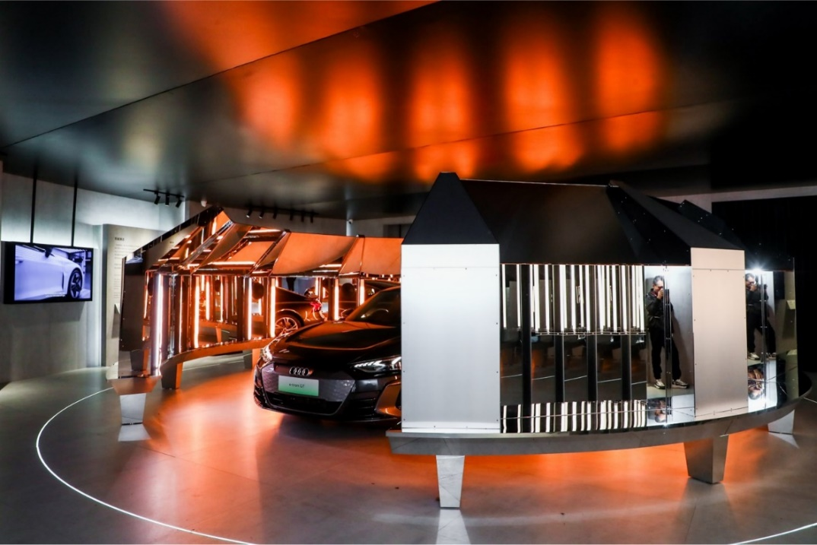
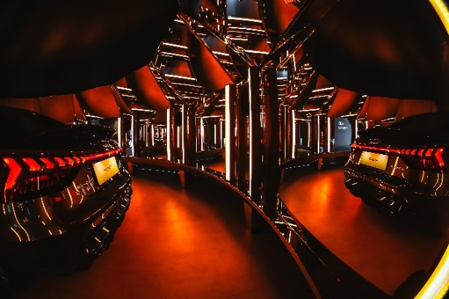
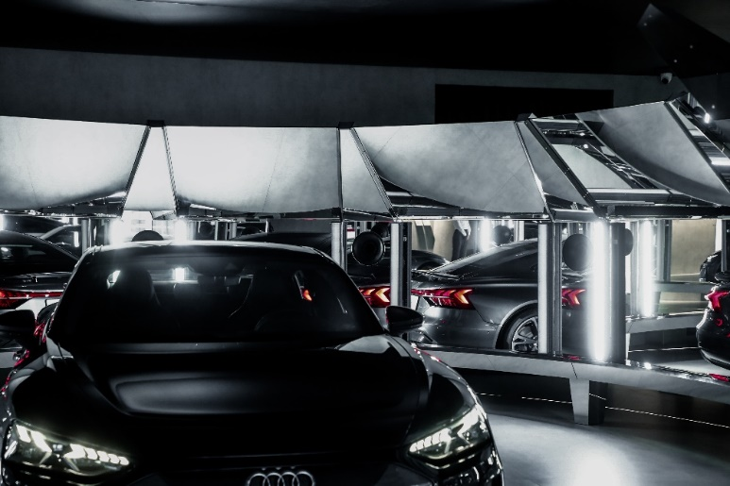
▲e-tron GT × Ding ZHANG © FAW-Audi & Bazaar Art
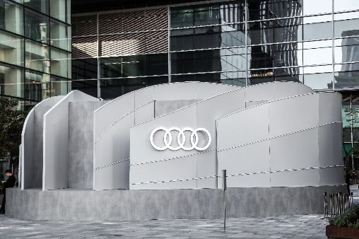
Ding ZHANG excels in creating immersive art that emphasizes sensory experiences through technology and multimedia At the heart of the exhibition. Zhang Ding has crafted a theater-like “highway space”, constructing a dynamic energy field. The e-tron GT, sculpted like a dynamically moving entity, engages in a dialogue within this mirrored theater.

COMMONALITY of INNOVATION

The e-tron GT is a striking example of the merging worlds of design, art and architecture. This elegant vehicle blurs the lines between form and function, envisioning a future where buildings can also move and transform in the cityscape.
▲West Lake at a Glance
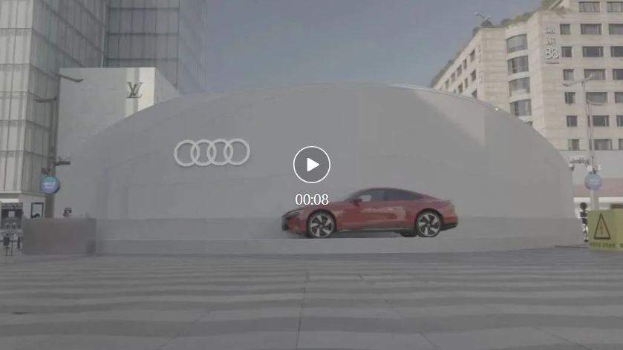
© FAW-Audi & Bazaar Art
▲ Façade
© FAW-Audi & Bazaar Art
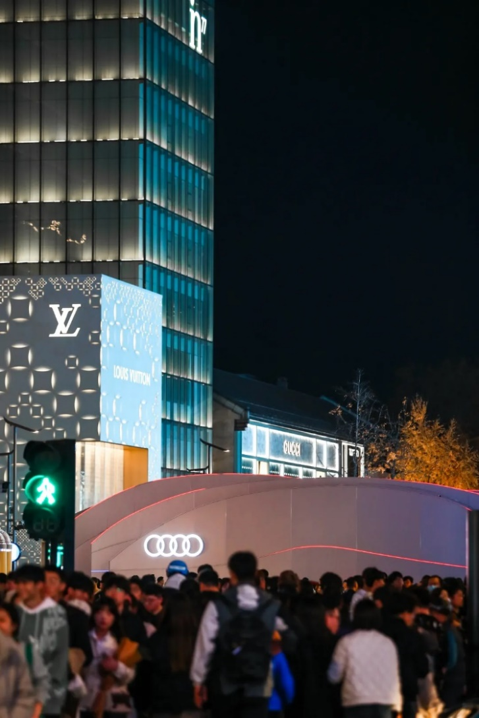
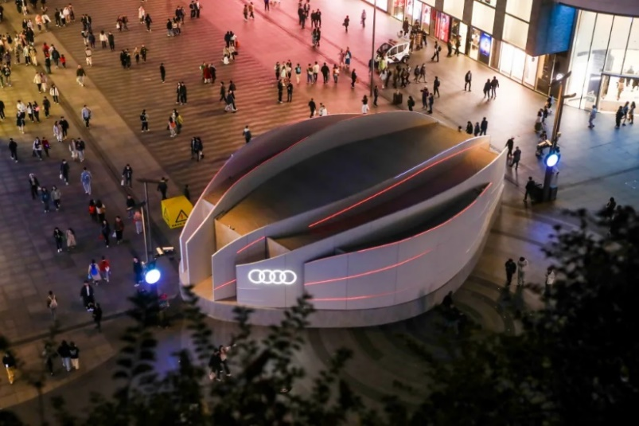
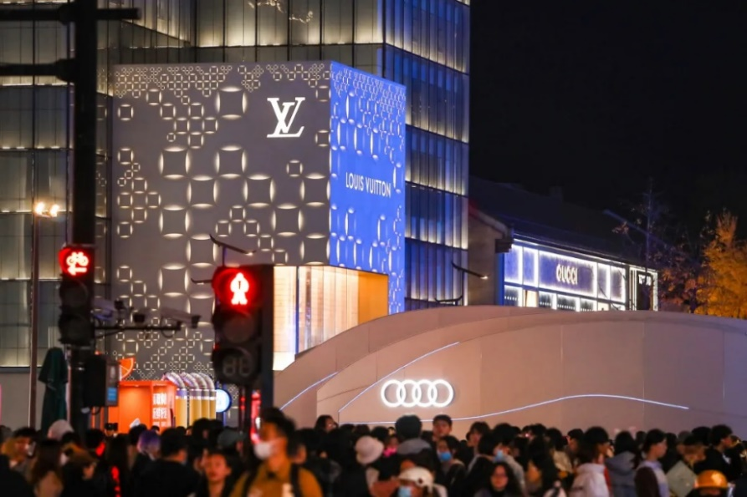
▲ in the Bustling Hangzhou Hubin Pedestrian Street, the Art Pavilion Continued to Attract a lot of Attention
© FAW-Audi & Bazaar Art
SODA’s partner and chief designer Yuan Jiang believes that a car is a moving space and architecture that can even be considered as an extension of our living space. If we agree that the work of a designer is studying the relationship between people and space, comfortable materials and safe structures, it becomes challenging to tell whether their work objects are automobiles or buildings.
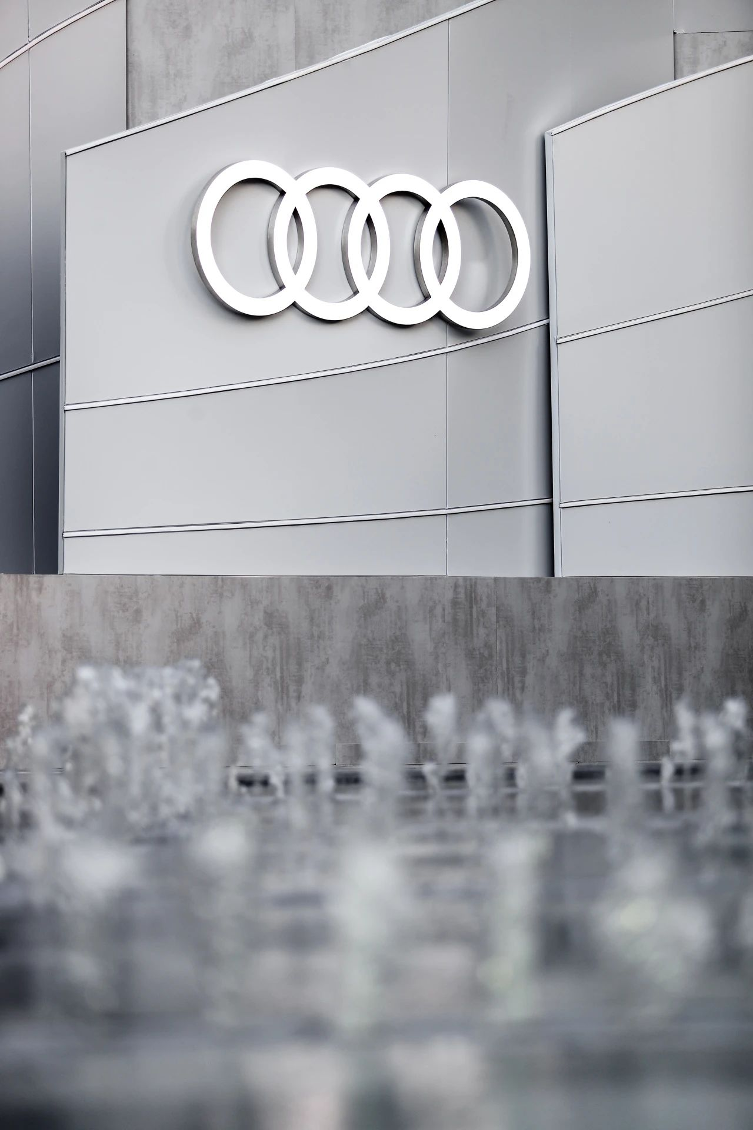
▲Detail of the Pavilion Surface
© FAW-Audi & Bazaar Art

▲The Pavilion under the Ever-changing Luminous
© FAW-Audi & Bazaar Art

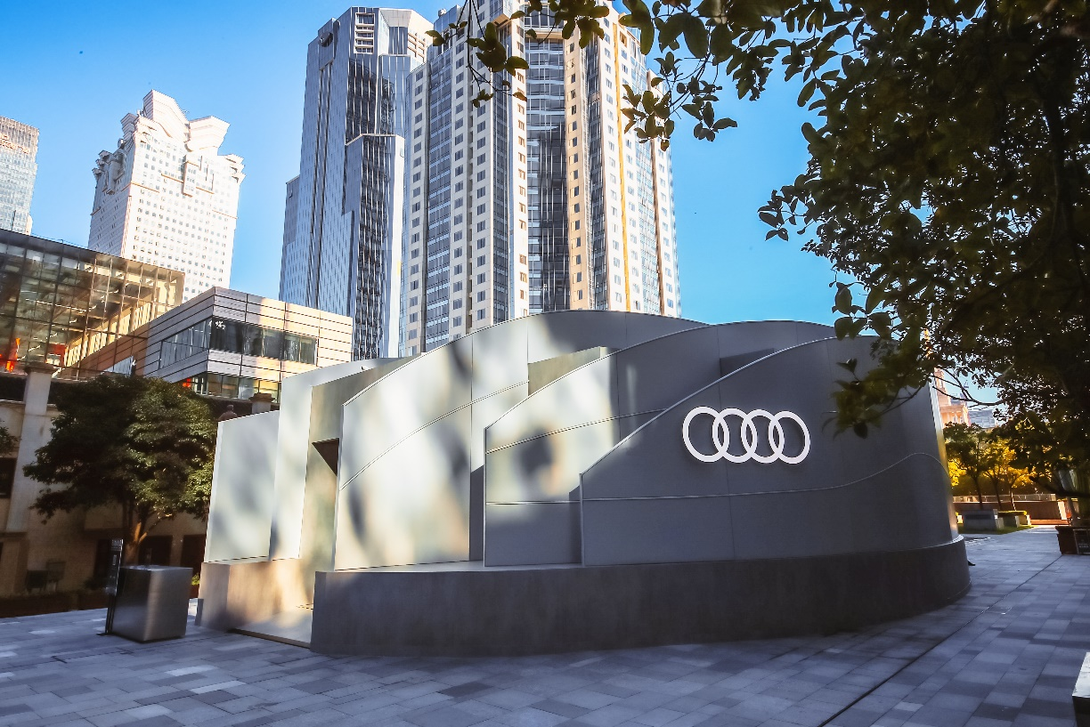
In SODA's vision, architecture will be dynamic in the future. As society becomes more digitalized, smart, and interactive, buildings that serve as the foundation of human life need to adapt to the changes and explore new ways of existence, explore itself deeper meaning of existence.
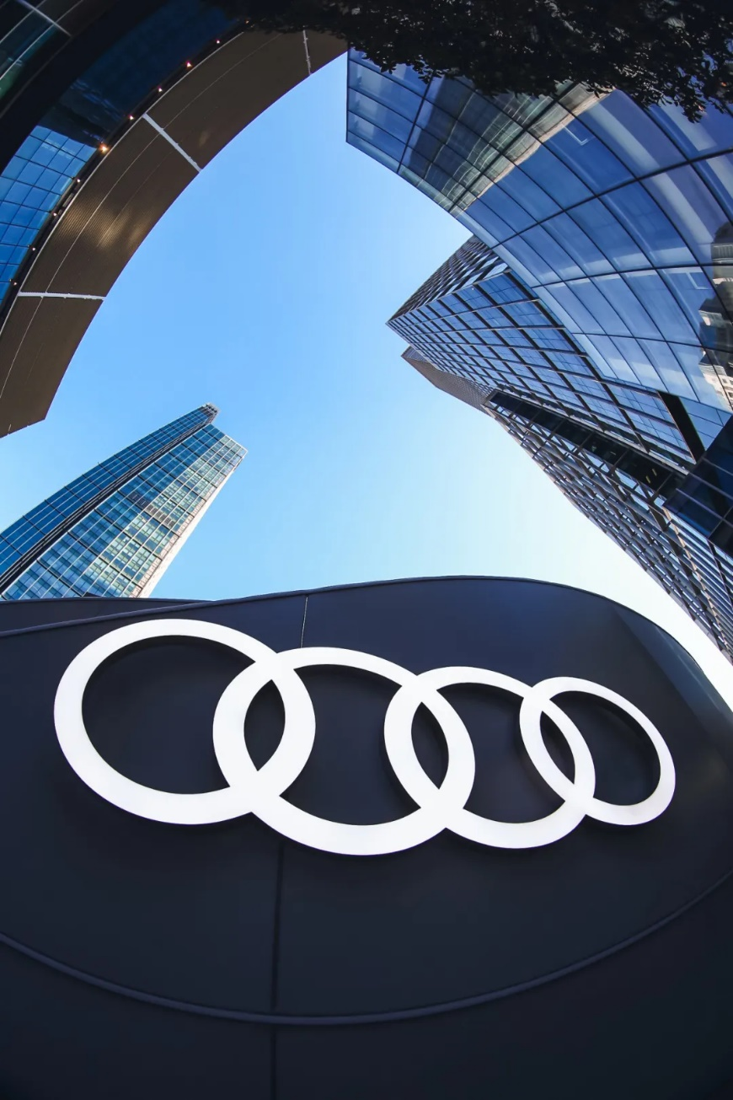
© FAW-Audi & Bazaar Art

By placing the focus on people, our design goal is to create human-centered experiences that integrate all aspects of human senses with smart and digital technology, while maintaining the full-sensory texture that we have been familiar with for thousands of years. This is the most important direction for our future design. We aspire to transform the mechanical nature of the digital world into warmth and vividness through a comprehensive sensory presentation, so that people can not only enjoy the convenience and efficiency brought by technology, but also feel the beauty and reality of life.

For Audi, this collaboration represents an exchange and exploration of art and design. The Audi “House of Progress” e-tron GT Exhibition is an innovative way to showcase this symbiosis between function and aesthetics, aiming to inspire a sustainable framework and cultivate a future that is both human-centered and remarkable.
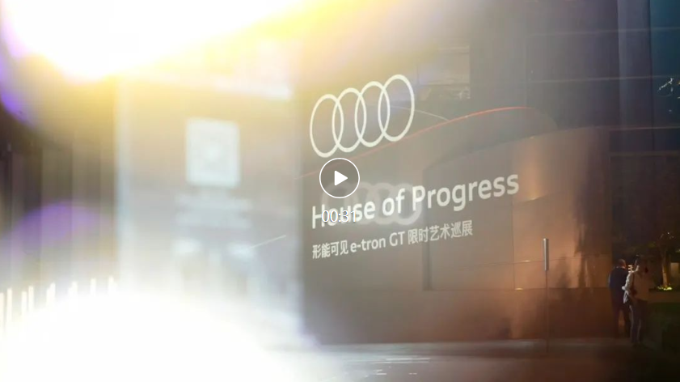
▲. Dialogue and Exploration of Art and Design Aesthetics
© FAW-Audi & Bazaar Art

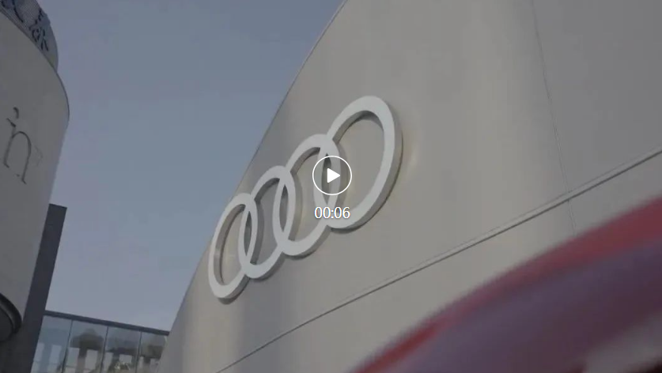
▲. The exhibition in Hangzhou came to an end, the exploration journey for future never stops.
© FAW-Audi & Bazaar Art
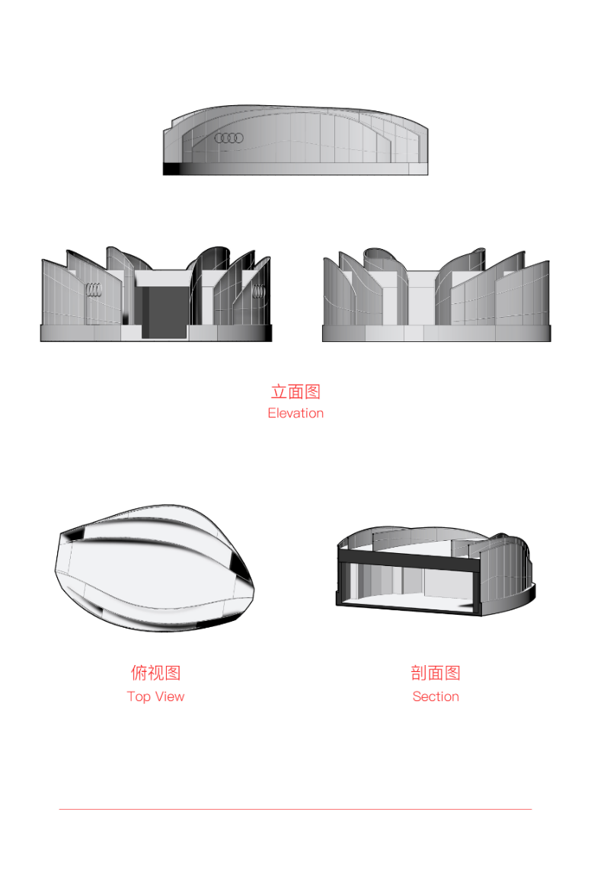
© SODA

Project Information
Project：AUDI “Make the Energy Visible” e-tron GT Exhibition
Project Location: Shanghai / Hangzhou
Gross Area: 300m²
Jointly Organized by: FAW-Audi & Bazaar Art
Planned by: THEMiS
Participating Artists: Ding ZHANG, Todomuta Studio, TUNDRA, Liechao CAI
Participating Architect: Yuan JIANG
Design Studio: SODA Architects
Design Team: Yue HE, Xueying ZHANG, Hanwei LI, Jiansheng DONG, Maosen SANG, Jiao YANG, Xue WANG, Ying WANG
Main Material: Light steel keel, lightweight soft film, concrete slab, programmable multimedia lighting system
Design Time: May. – Oct. 2023
Completion Year: Oct. 2023 for Shanghai / Nov. 2023 for Hangzhou
Written by: Yi GAO
Photo and Video Provided by: THEMiS
Contact: office@soda.archi

