News Fact 1:
A review of the renovation and reopening, the new building and interior by Maurice Mentjens. Recognition of this project by numerous press coverage, including by Archello.
The Weert municipal museum reopened its doors on 3 May 2022, after extensive renovation, restoration and refurbishment. Under the name Museum W, the museum strikes a new substantive course with a renewed arrangement of the permanent collection and an exhibition programme with contemporary art and design.
Museum W is located in the oldest town hall (16th century) of Weert, on the Markt. The national monument was partly provided with a spectacular facade that was given a golden skin by being coated with Tecu®Gold. The museum also received a totally revamped interior. The façade, new interior and furnishings were designed by Limburg designer Maurice Mentjens.
For this renovation, Museum W was the only museum in the Netherlands to receive the honourable mention 'Archello's Best Projects of 2022'. This label for exemplary projects in architecture and design is awarded every year by Archello, the platform for architecture and design. It honours architects and designers for their inspiring work.
Archello reviewed 3,000 new construction projects from 2022, spread all over the world. Of these, six museums were recognised by Archello as 'Best of 2022'. Besides Museum W, these are The Museum of Ethnography in Budapest, Museum of Modern Aluminum in Thailand, LIKNON in Samos, New Museum in New York and the Robot Science Museum in Seoul.
A description of Museum W can be read on Archello's website: https://archello.com/nl/project/new-museum-w
The golden facade as an architectural eye-catcher
The Netherlands Board of Tourism & Conventions (NBTC) launched a new video titled New Dutch / Dutch Design in October 2022 to promote the destination Netherlands. For the video, filming took place in Amsterdam, Rotterdam, Tilburg, Eindhoven and at Museum W in Weert. The video will be shared to the international press via the NL Toolkit on Holland.com of the Rijksdienst voor Ondernemend Nederland (RVO) and NBTC's content channels and media database.

Watch the promotional video here:

News fact 2:
The revamped museum, the opening exhibition by Job Smeets and its follow-up with the Telling Stories exhibition attracted 14,634 visitors to Weert last year. Visitors quickly found the museum en masse, and four months after the successful opening, Museum W already welcomed its 10,000th visitor.
Our museum visitors came mainly from the provinces of Limburg, North Brabant and Gelderland (Museumkaart data). More than 37% of visitors came from the Weert region. Especially the opening exhibition by Job Smeets and the renovated building were the reason to come to the museum. The accessibility and hospitality were highly appreciated by our visitors.
Museum W organises two temporary exhibitions a year and in the beautifully renovated former Council Chamber, the place that was the centre of power of the city for centuries, you can view small exhibitions of contemporary art from the collection twice a year. Special video artworks are shown on the LED screens in the facade of Museum W.
In Museum W, you follow a cultural-historical route along important life themes that every human being, no matter who you are or where you come from, is or will be confronted with. Such as the body you have and what you can do with it, the family you are born into, the region and the power structures you grow up in. The stories and examples you are given, the work you do, the relaxation you seek, the festivals you celebrate and the impact of illness, suffering and ultimately death.
A total of 10 life themes have been developed in the collection presentation: Body, Family, Power & Splendour, Weert, Faith, Stories, Saints & Heroes, Work & Leisure, Suffering & Death and Feast.

The opening exhibition FOREVER ENDEAVOUR provided by Job Smeets & Studio Job
from 3 May to 30 October 2022
Besides works from its own collection, Studio Job also presented works from the museum's collection and from third parties. Various lenders were approached for this purpose. The entire concept was developed by Job Smeets in consultation with the museum. It turned out to be a surprising exhibition in which especially the many dozens of design drawings from the studio stood out. These covered most of the walls like a form of wallpaper. The exhibition was Studio Job's most personal presentation to date, with the artist literally letting himself be seen inside the head.

Exhibition Telling Stories
from Friday 18 November 2022 to Sunday 16 April 2023
The autumn exhibition Telling Stories was provided by artist duo Martin and Inge Riebeek and photographer and columnist Rob Moorees. Martin and Inge Riebeek showed a selection of video portraits from their extensive project The Essential in two total installations. In doing so, they connected with some themes from the museum's permanent collection display, and also added some collection objects to their installations. Rob Moorees selected over a hundred archive photos from The Hague's Spaarnestad Photo Archive, writing a column for 31 of them. In doing so, Moorees also sought to connect to the themes of the permanent collection display. Together, the video portraits and photo selection show stories by and about people from all corners of the world. Not the big stories marked by influential people and important events, but small, often personal narratives take centre stage.
Visitor figures 2022
Paying 2403
Museum card/ ICOM 4314
Golden Ticket 5503
Special guests 154
Visitors Outdoor Project 750
18- 1510
Numbers of visitors 2022 14,634
The museum provided 30 group tours.

News fact 3:
A selection of press articles and visitor comments (pages 23 and 24 in the annual report) substantiate the positive feedback we received.
- Architecture and interiors:
Archello, Bouwwereld, PI Magazine, Metropolis USA, Object International, VT Wonen, Eigen Huis & Interieur and Octogon HU.
- Art and culture:
Tableau, ZOUT Magazine, BPD Cultuurfonds, Financieel Dagblad, Dagblad De Limburger, Katholieke Nieuwsblad, De Volkskrant and Eindhovens Dagblad.
- Tourism and Lifestyle:
Columbus Magazine, De Bourgondiërs (RTL), Plezier + Passie (RTL), Limburg Magazine, NS screens in the Amsterdam/Maastricht train, Dwars door Limburg, Air Europe, Chapeau Magazine and Corriere Della Sera.
The entire press list (with all articles) can be viewed via this QR code (Dropbox): 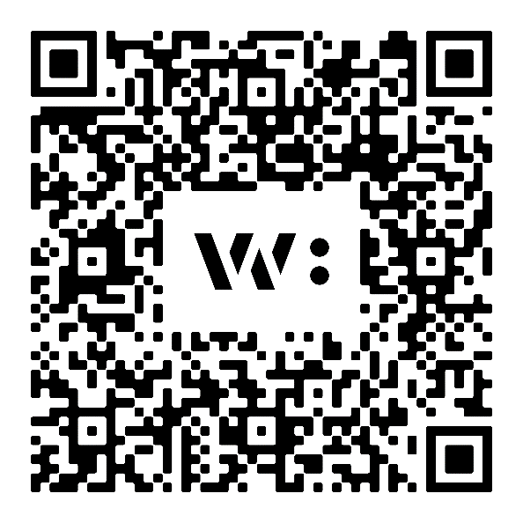

News Fact 4:
Preview of upcoming exhibition: Frans Franciscus, Joyce Overheul and Marjan Laaper.

New exhibition: Adagio Violente - on a pilgrimage with Frans Franciscus
From 13 May to 29 October 2023, Museum W in Weert presents the solo exhibition Adagio Violente - on pilgrimage with Frans Franciscus. Franciscus' oeuvre consists of paintings, ceramics and photography. With his work, the artist shows a broad view of people and society. Francis' art is appealing, sharp, socially relevant and sometimes humorous.
Francis is an artist with a highly developed historical consciousness. He derives his themes from art history, mythological and Biblical stories and current events. He fuses historical lore with contemporary situations in his paintings. In addition, his works are often inspired by classical European painting, for instance by masterpieces by Caravaggio, El Greco and Rubens.
By transforming recognisable scenes from Western visual culture into contemporary works, Francis' work is always contemporary. In his choice of subjects, too, Francis shows commitment and creates space for reflection and a broader view of human beings. Themes such as diversity, gender, climate, social deception and inequality are addressed.
Adagio Violente at Museum W
Francis has been known since the 1990s for his recognisable and figurative paintings in large format. Later, ceramics were added. From 2012, he has also worked together with Rienus Gündel Franciscus. Under the name Franciscus & Franciscus, they gained fame with their highly stylised photographic portrait series. Here, they combine the digital medium of photography with classical portraiture.
Besides older work, Adagio Violente also shows a lot of new work. This new work has not been exhibited in museums before. The exhibition takes you through the world of Francis, with stories that perfectly match the universal life themes in Museum W's collection presentation.
For more information on Francis, visit https://www.museumw.nl/frans-fransciscus-solo.html
Joyce Overheul, period: November 2023 to April 2024:
Joyce Overheul's solo exhibition will open at Museum W in Weert in autumn 2023. Overheul's work deals with inequality, sexism, power relations and the position of women. Textiles, beads and soft colours are recognisable features in her oeuvre. And that is a conscious choice: for a long time, crafts and textile work were not seen as a fully-fledged art form but as a women's hobby. At Museum W, Overheul shows large wall hangings, banners with activist texts on them, and her work also enters into a relationship with some art objects from the museum's collection.
Joyce Overheul previously exhibited at Museum De Fundatie in Zwolle and has been named talent of the year 2023. More information about Joyce's work can be found at https://j-o-y-c-e.com/nl/

Marjan Laaper - Encounter, period: October 2023 - to February 2024
Marjan Laaper specialises in large-scale video projections and video installations. The life cycles of man and nature play an important role in her video work. Everyday phenomena are presented in a poetic way. Starting points in Laapers' work include general human experiences, nature and the perception of everyday life. In this, she seeks tensions between conflicting subjects, such as beauty and danger and the immaterial and the ephemeral. On the LED screens at Museum W, Laaper will show the video work Encounter. The work shows a huge projection of a Bengal eagle owl. The title of the work refers to an encounter with this owl, which the viewer examines and watches with probing eyes.
More information on Encounter: https://www.marjanlaaper.com/files/work/Encounter-NLUS.html

