Project Name: A comfortable living space for urbanite
Project Location: Jiezi Ancient Town, Chengdu, China
Project area: 220m²
Design time: 2022.03
Completion time: 2023.03
Design Firm: DHB Design (www.duheyiheng.com)
Chief Designers: Mark Sun, Yihan Wong
Participating Designer: Tingting Peng
Photography: sy-studio

The second residence, a comfortable living space for urbanite
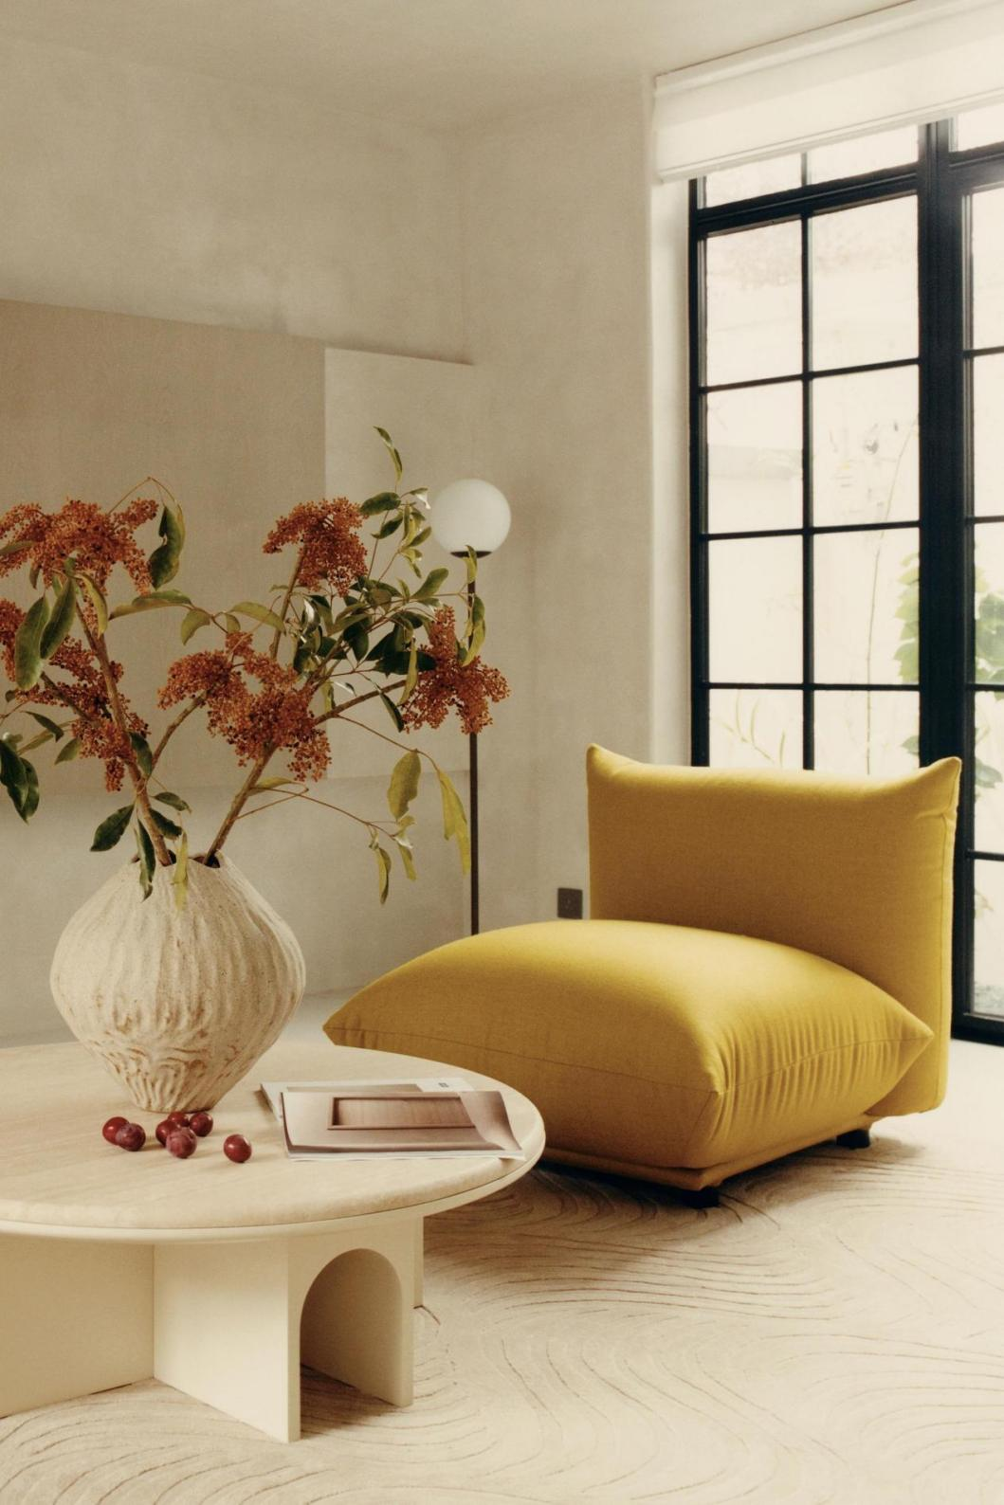

The Japanese architect Yoshihumi Nakamura introduced the concept “igokochi”いごこち, which refers to a comfortable feeling in the home. At home, having a space that is one's own, precious, and comfortable, or being able to find such a space, is extremely important for enjoying the pleasure of living.

In today’s fast-paced and highly mobile society, the first residence served not only as a solution to the complex functional needs of household members, but also endowed with many additional attributes beyond just a place to live. That explains why more and more people choose to live in the countryside rather than downtown, as it serves as a temporary escape from the hustle and bustle and provides a place for them to focus on their true selves.

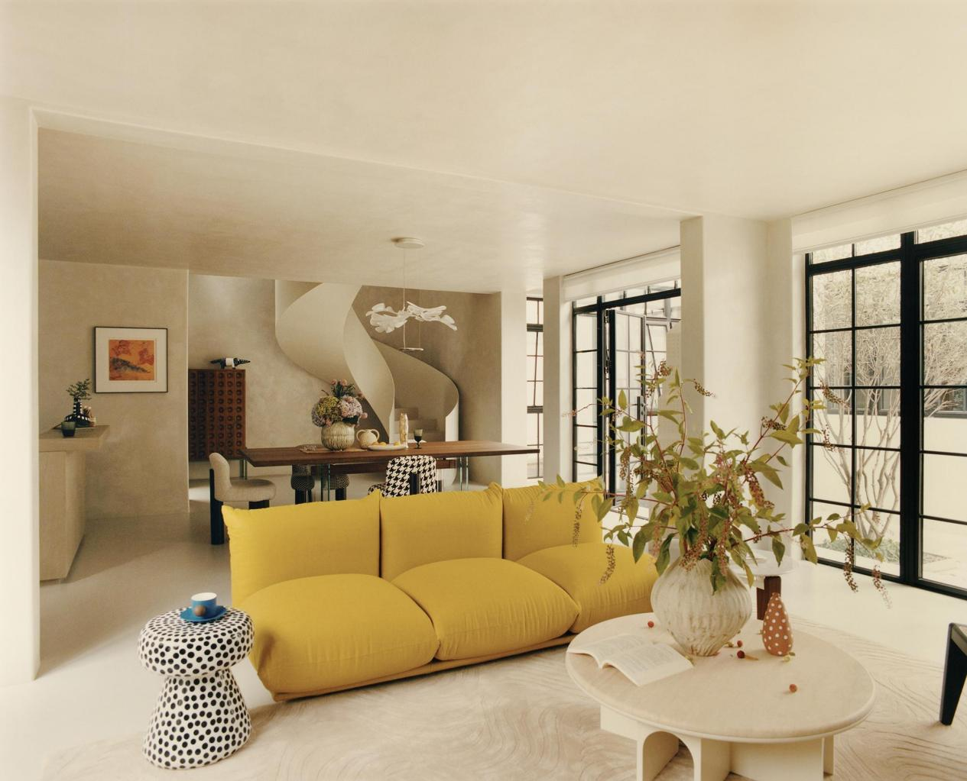

This is the case with our second residence, a villa located in the hortical town of Chongzhou. It is also our second project working with the same house owner. They have known each other for years since the first housing project and have become friends and partners who have supported each other ever since. After extensive communication with the owner about the project, the designer finally simplified the traditional requirements and focused solely on creating a space for family vacation, with uncompromising attention to detail.

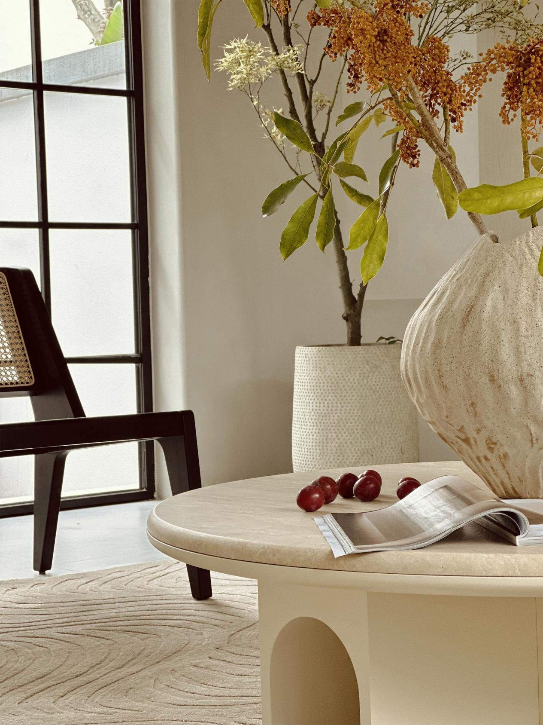
The brilliance of the second residence is the art of "wasting", which is different from the calculated and meticulous approach of the first residence. The spaciousness created by deliberate waste instantly pull people away the mundane everyday and into a vacation state of mind.

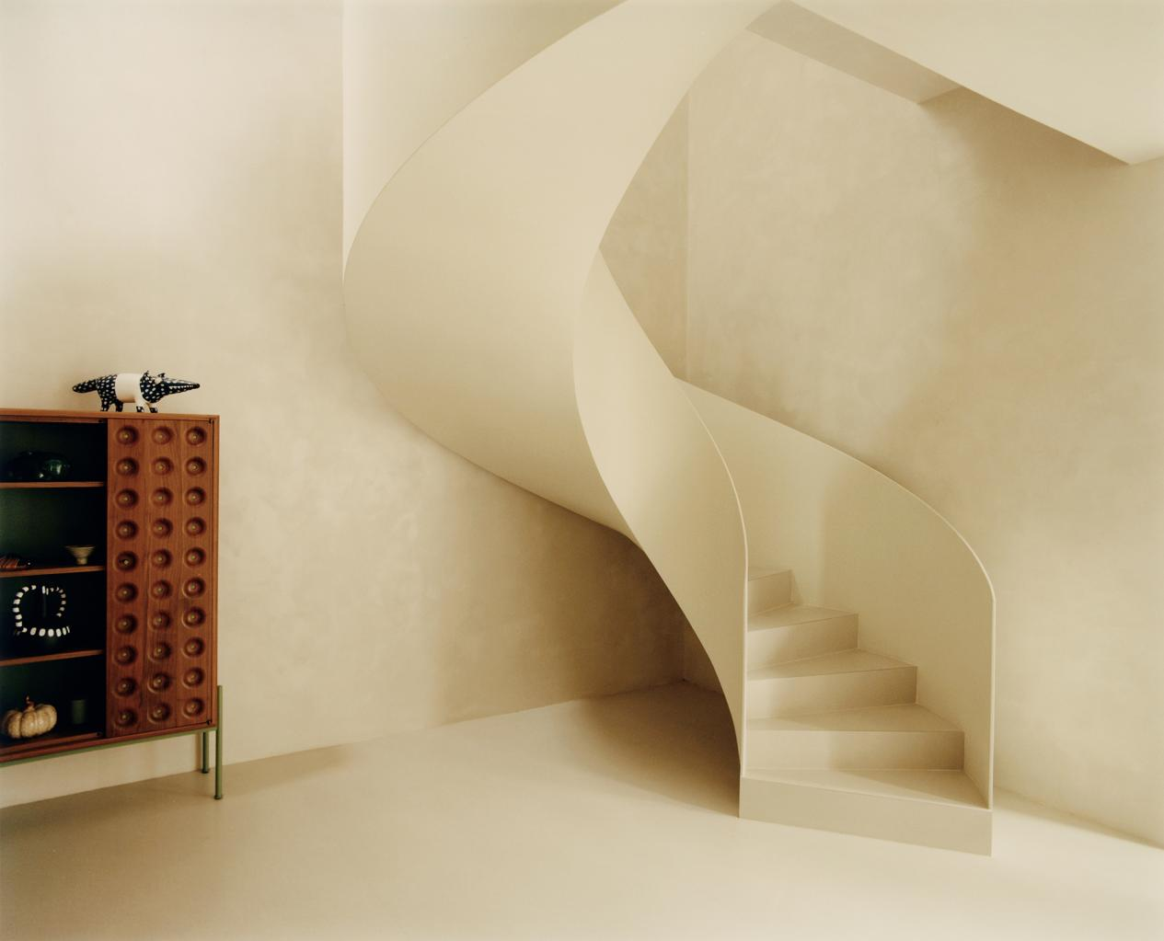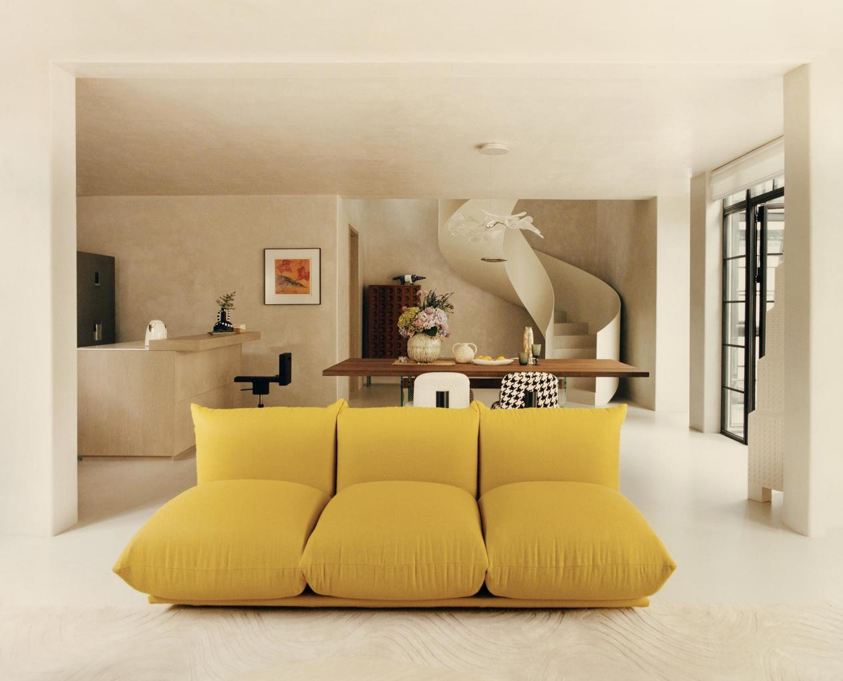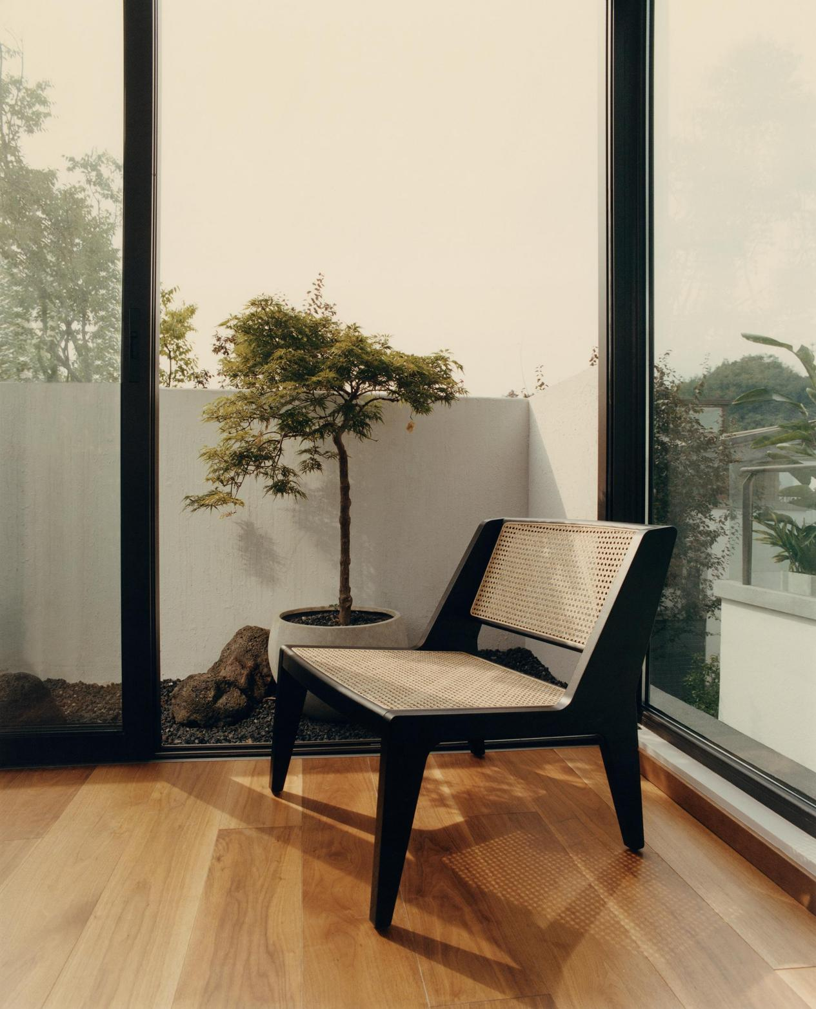

The space is designed to fully incorporate sunlight and scenery, seamlessly intertwining with nature from the moment you step into the house. Every room offers breathtaking views of lush greenery and fresh air to enjoy.

A flexible and ambiguous space that balances functionality and aesthetics within this home is created through bold structural changes. The boundary and position is blurred in this space, while the flexibility endows the space with more possibilities in more dimensions by paying attention to different requirements in different situations. Within this flexible space, both the public and private aspects of the family are accommodated. The sounds of wind, water, and birds replace the noise of the television as the true background music of the home. Family members can invite a few close friends over to chat while cooking and brewing tea. During the free time, they can also dust off household items and trim the plants in the courtyard, enjoying the physical labor and relaxing their minds.

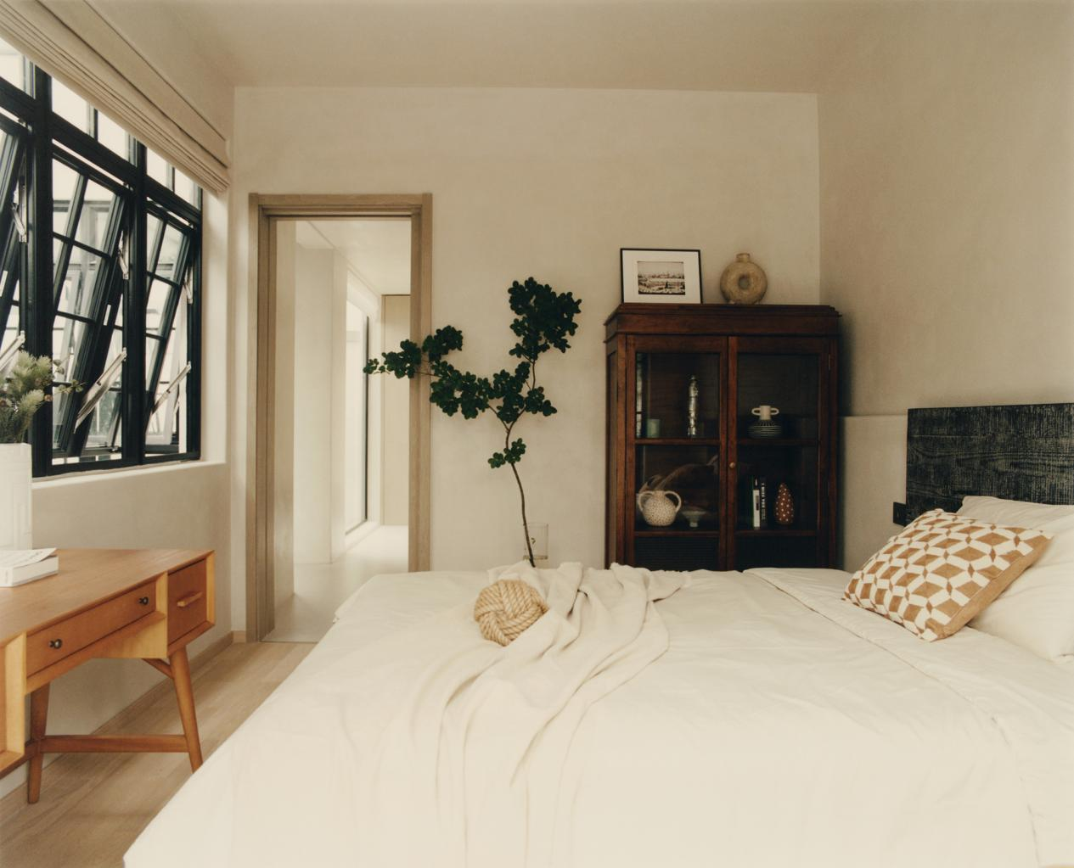

By bringing life closer, children can play safely in their own independent 'secret' base connected to the larger space. This space accommodates all their curiosity and desire to explore as they grow up, accepting them unconditionally to play freely and accompany them as they grow. At this time, the busy homeowners can quietly make a cup of coffee for themselves at the bar, enjoying the rare and undisturbed quality time with children together.

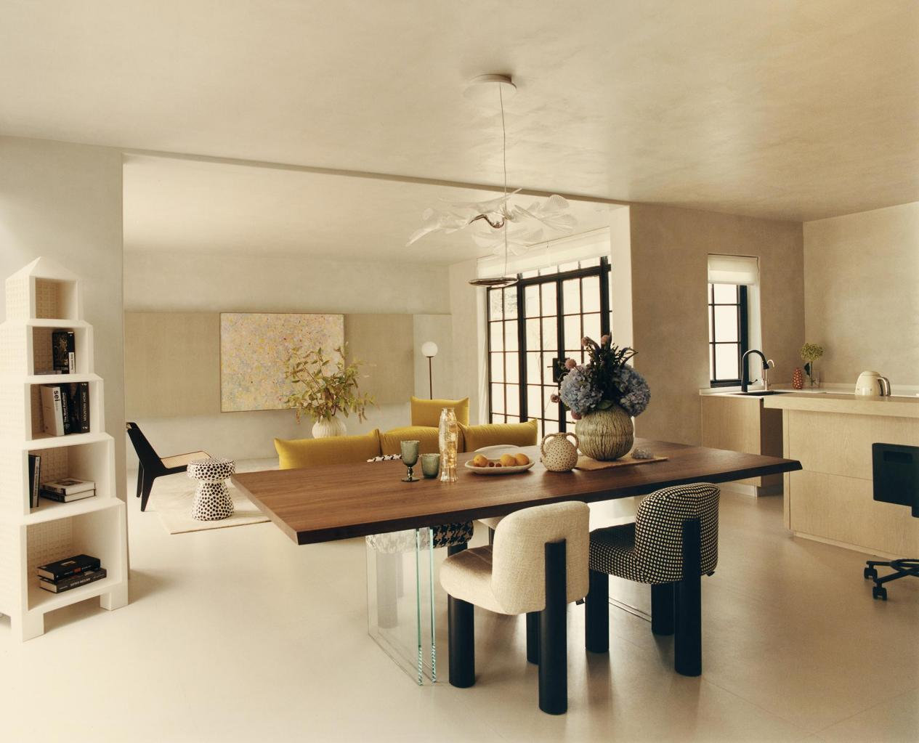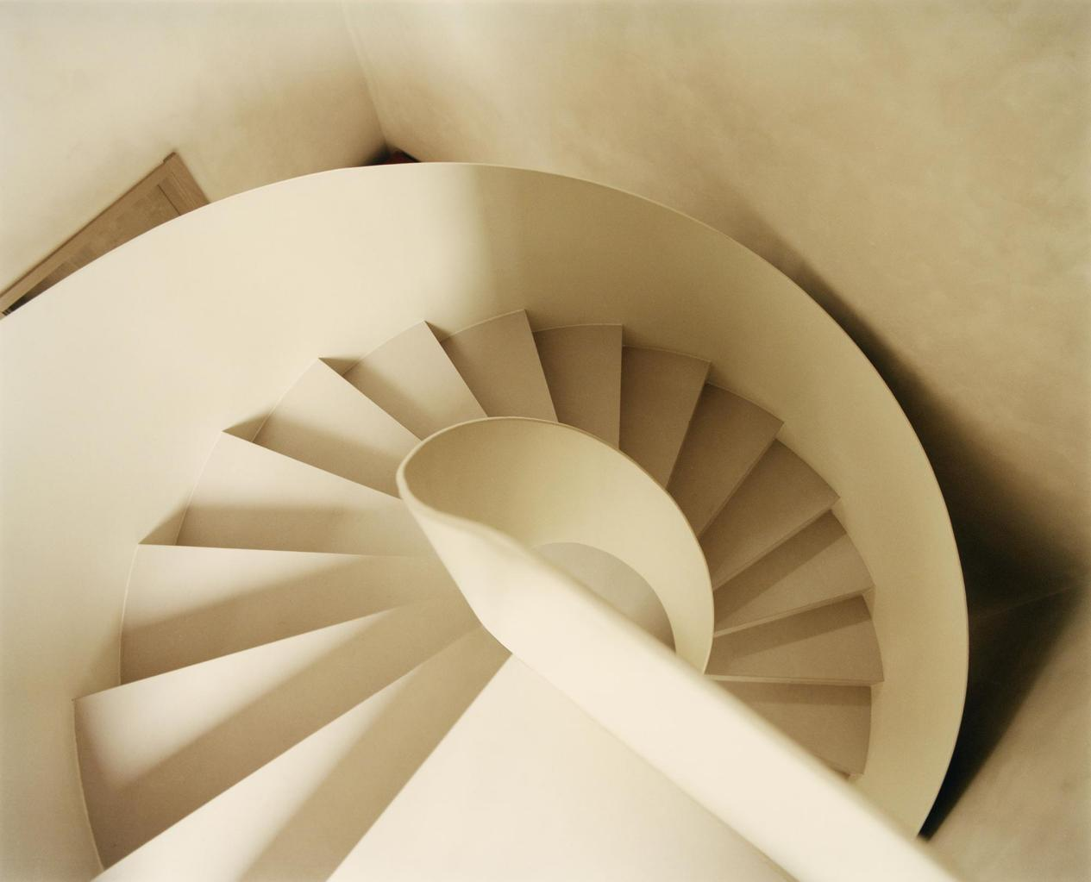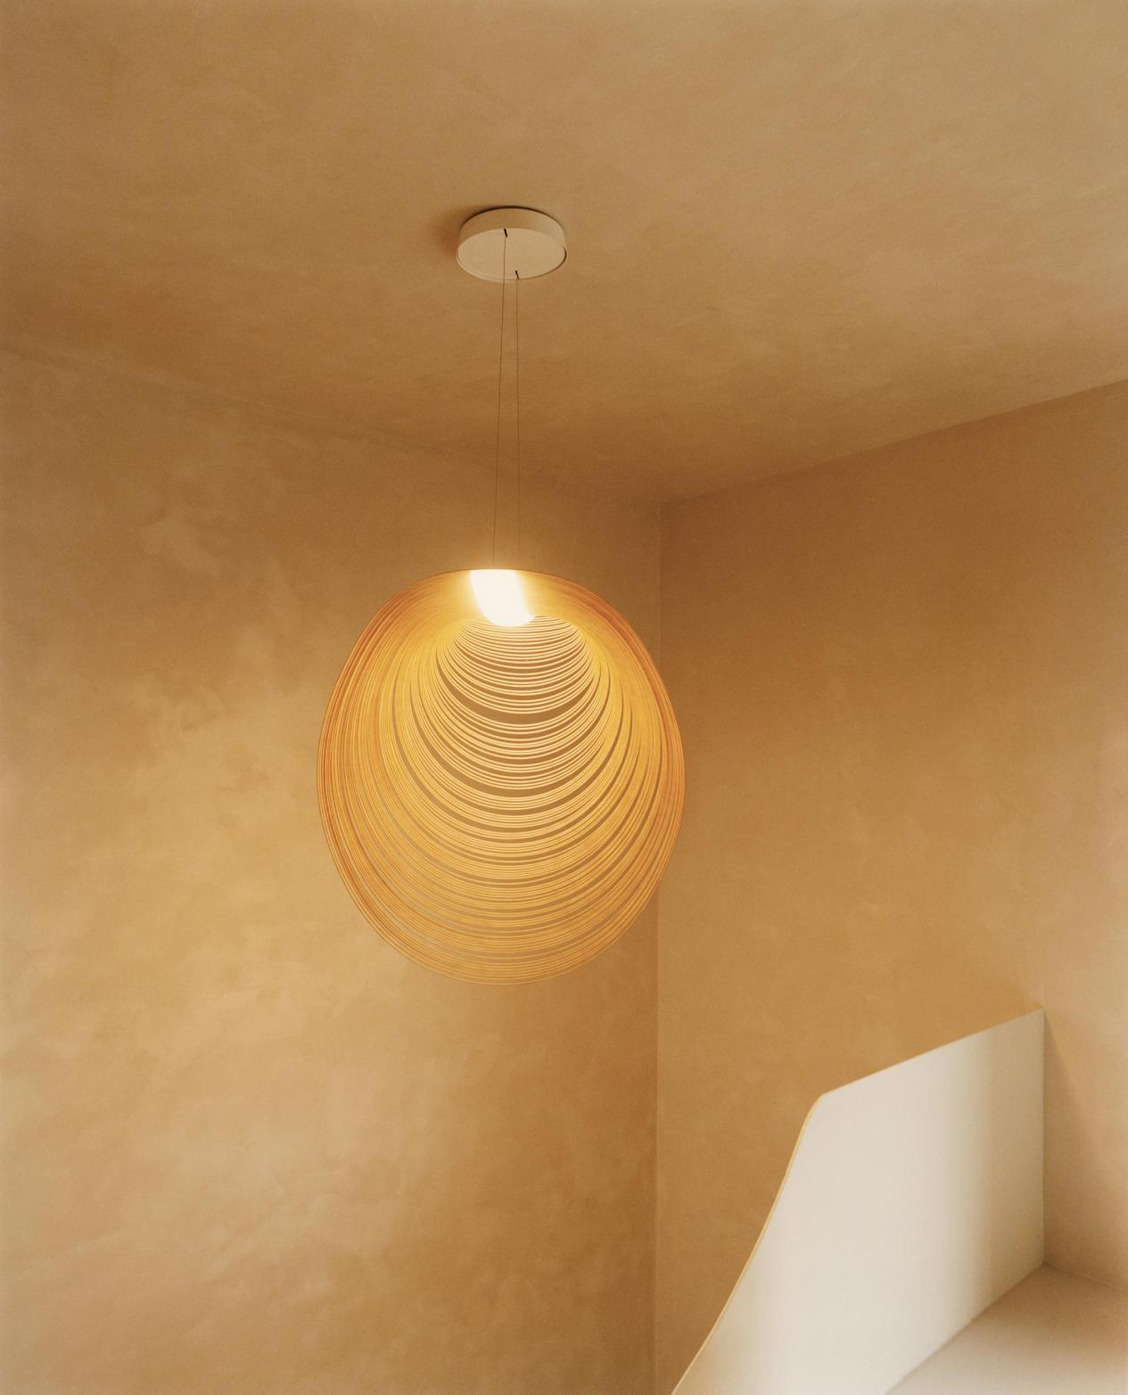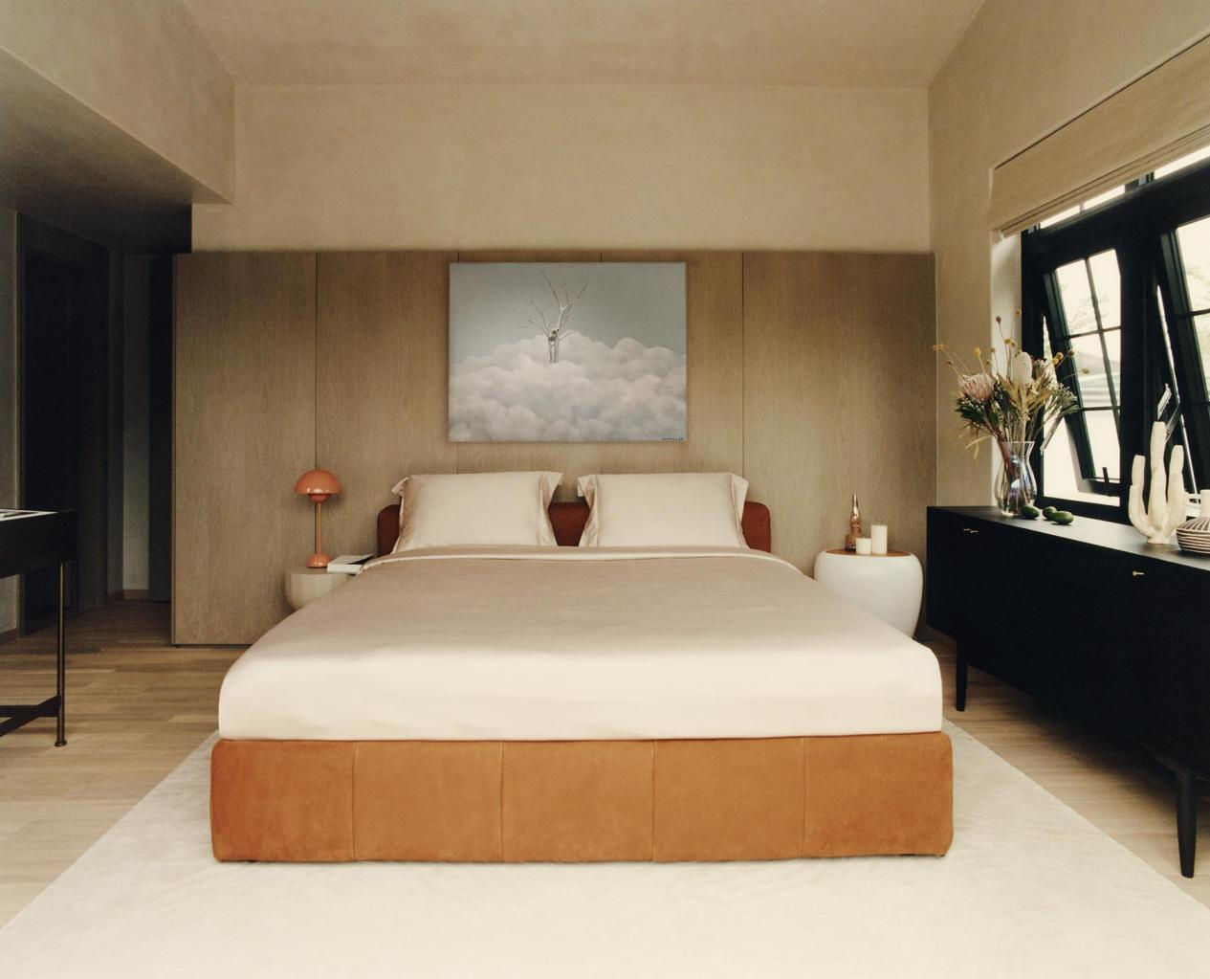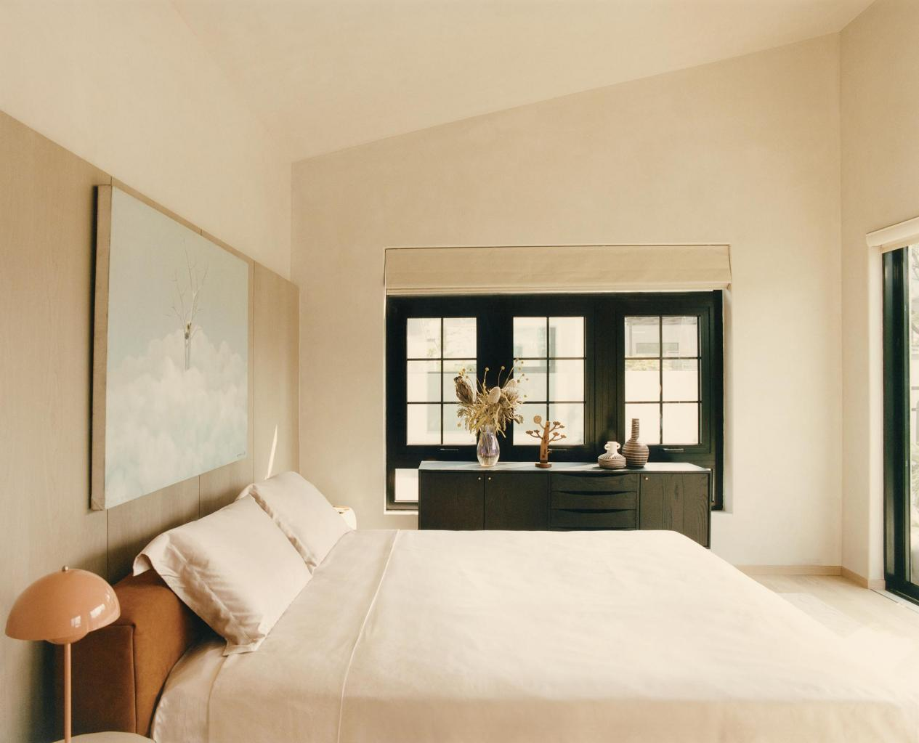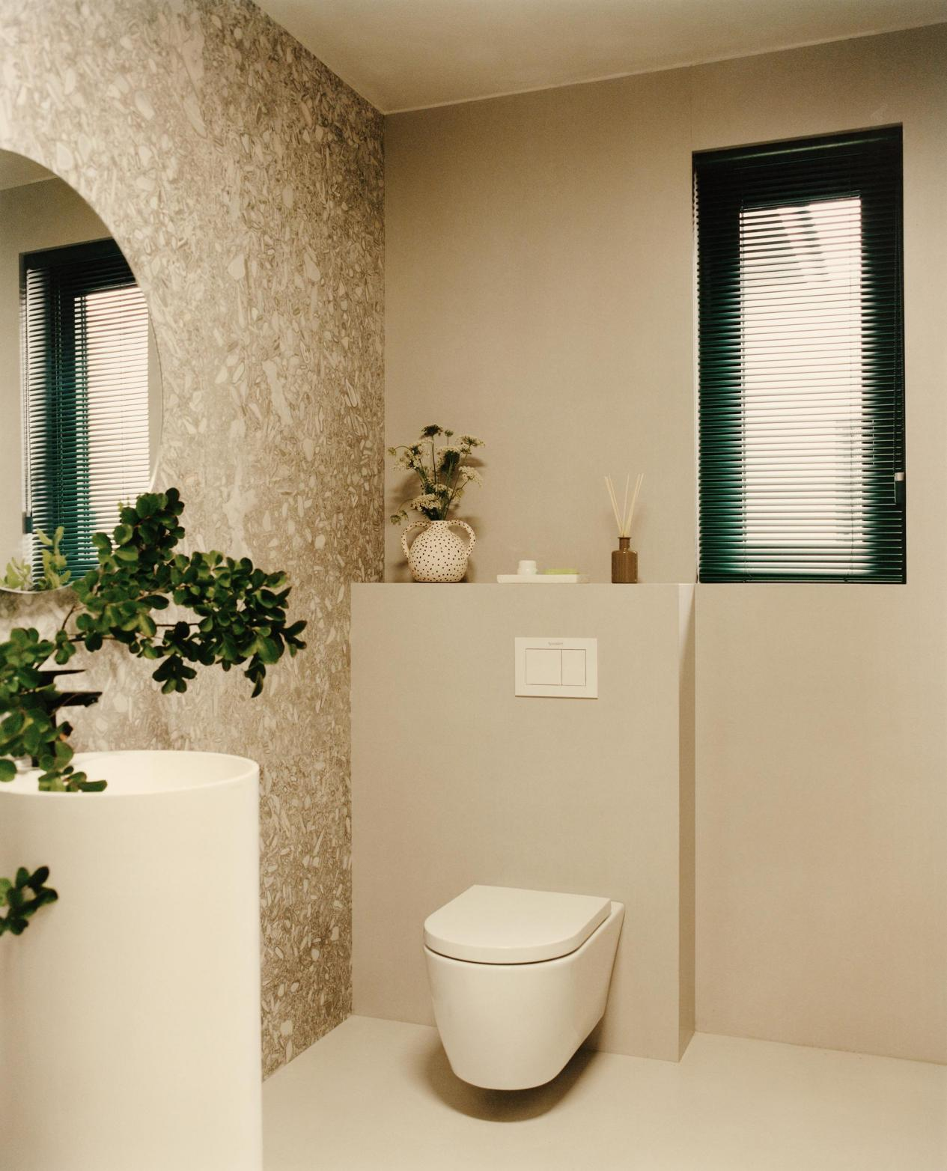

The dynamic curves elegantly connect the upper and lower spaces. Following the spiral staircase from the public area to the resting space, the well-organized hallway creates a sense of ritual and privacy, ensuring a peaceful night’s sleep. From the master bedroom, you can appreciate the scenery directly, with sunlight gently filtering through the trees casting shadows to wake you up gently in the morning.

The designer adopted a large area of warm white, natural textured paint instead of excessive decorative techniques or hard materials, thus, a timeless space was created. The design did not start with any label or defined style, but rather, it aimed to discover the spirit of the second residence that belonged uniquely to the homeowner's personality. Compared to the previous restrained and rigorous vibe of the first one, the designer attempted to create a space that would allow the owners to shed their obligations and responsibilities here. Most importantly, the space offers them a chance to return to their true selves as art and life enthusiasts.

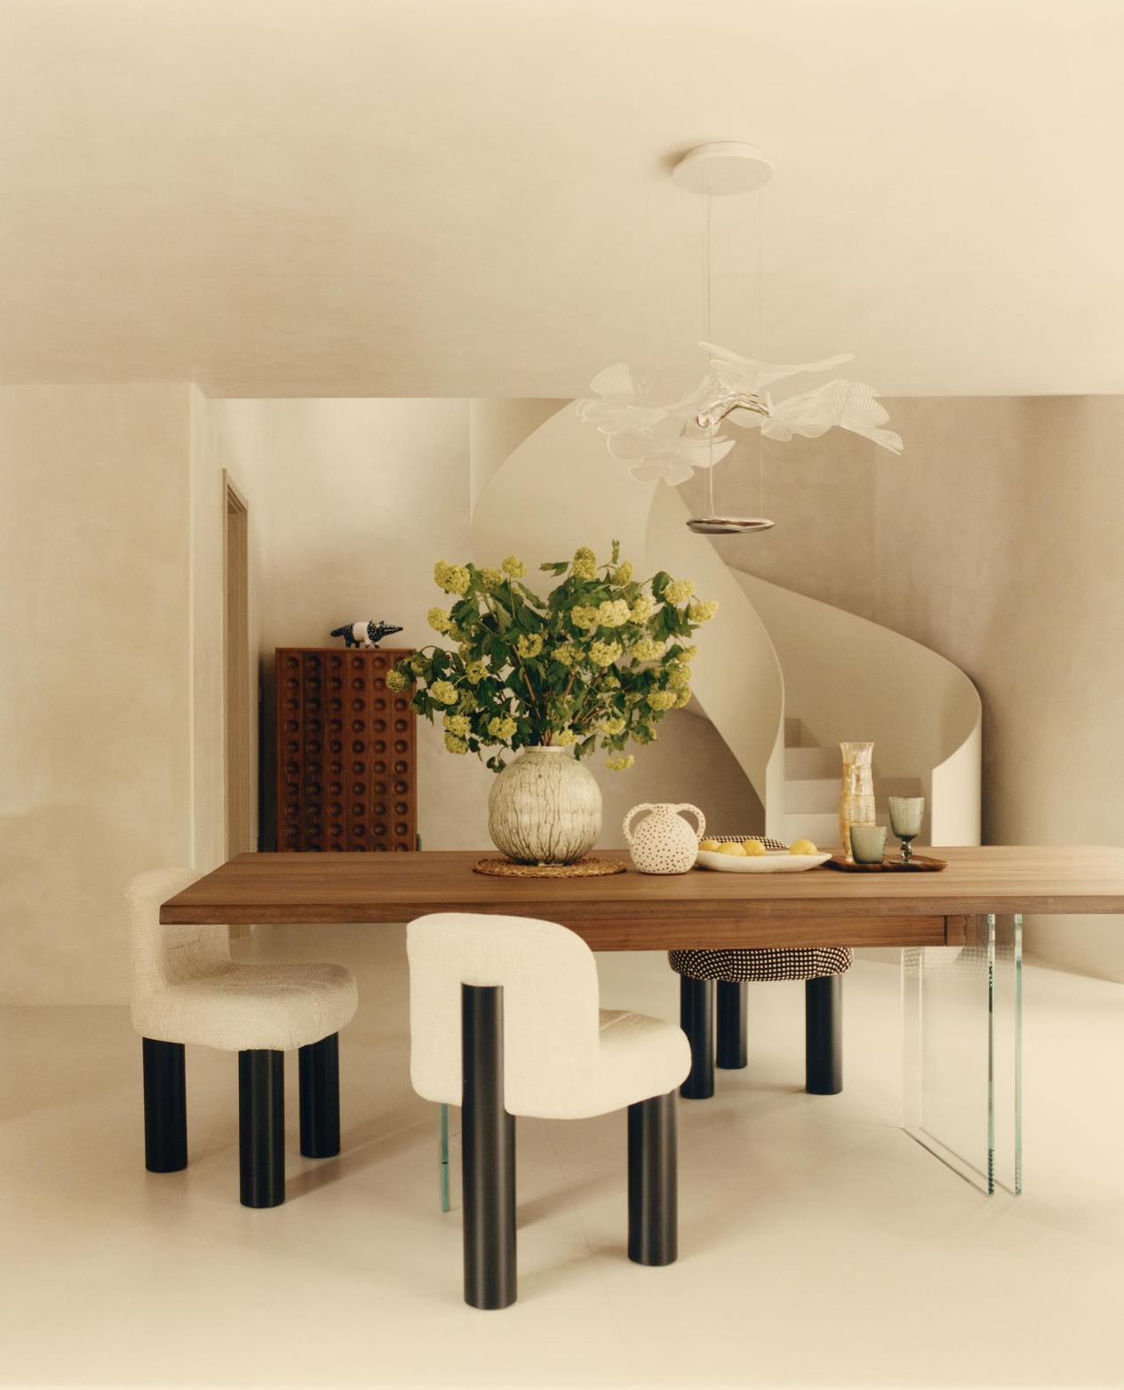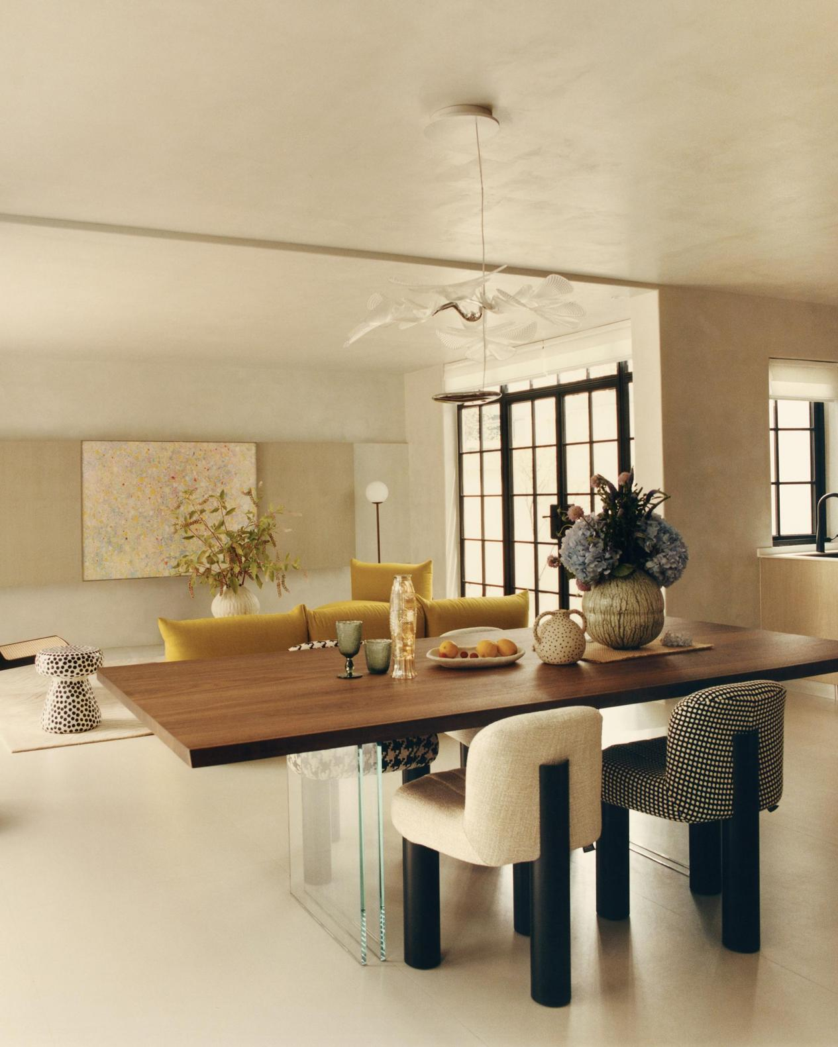
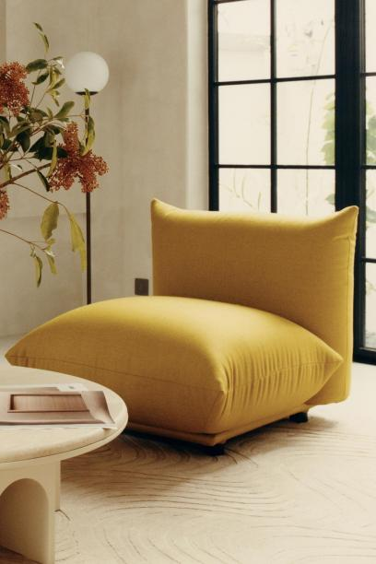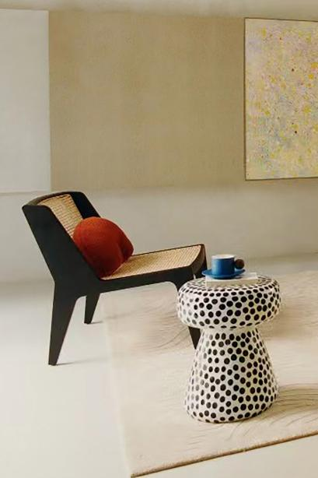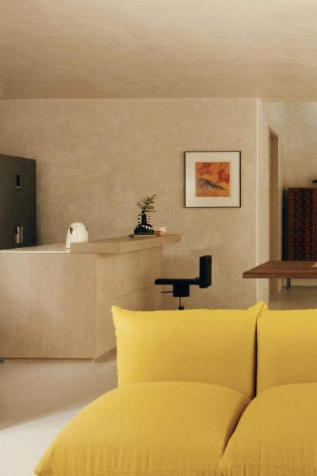

The natural stone bar and vintage wooden dining table create a relaxed and natural atmosphere. The lemon-yellow arflex Marenco sofa adds a touch of playfulness, while the polka dot side table injects a bright and cheerful vacation atmosphere.
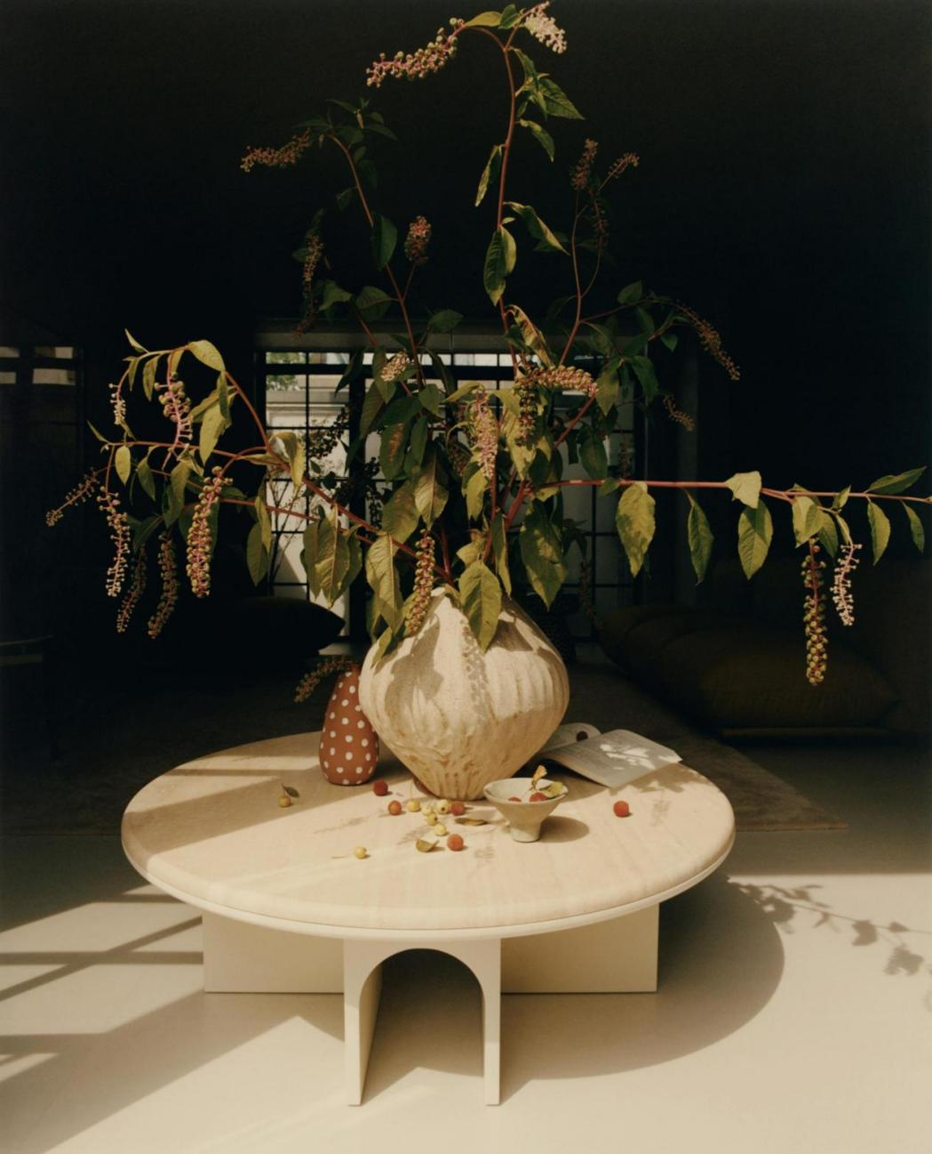
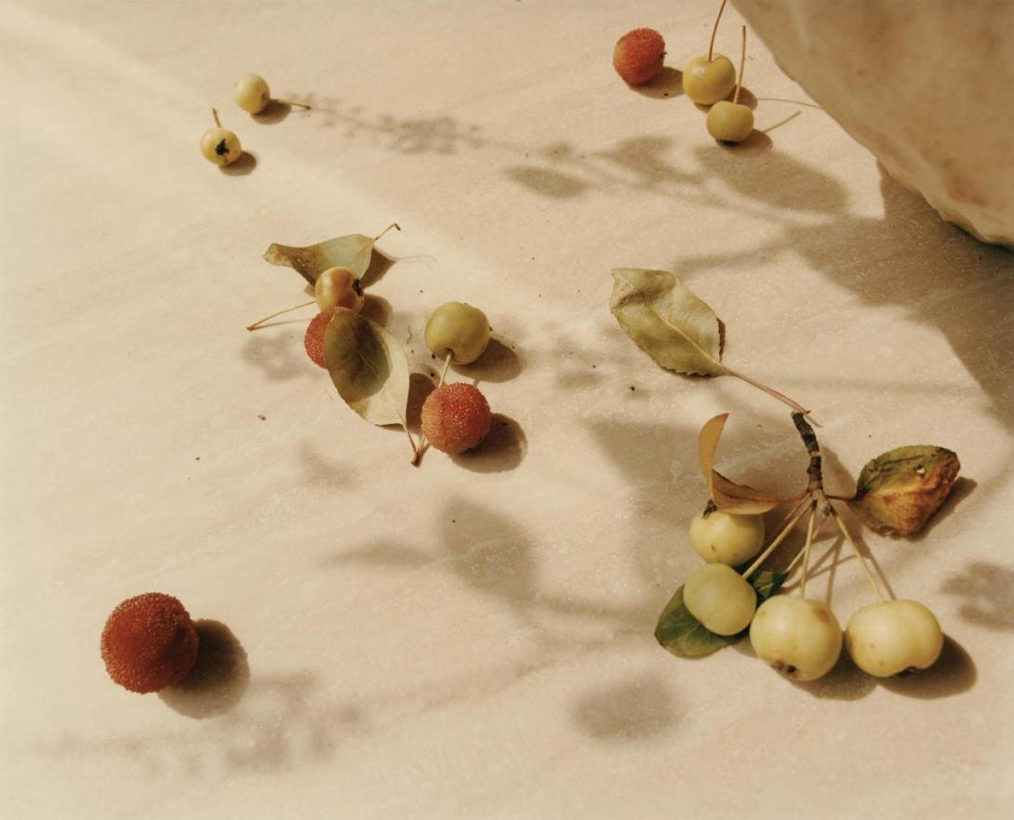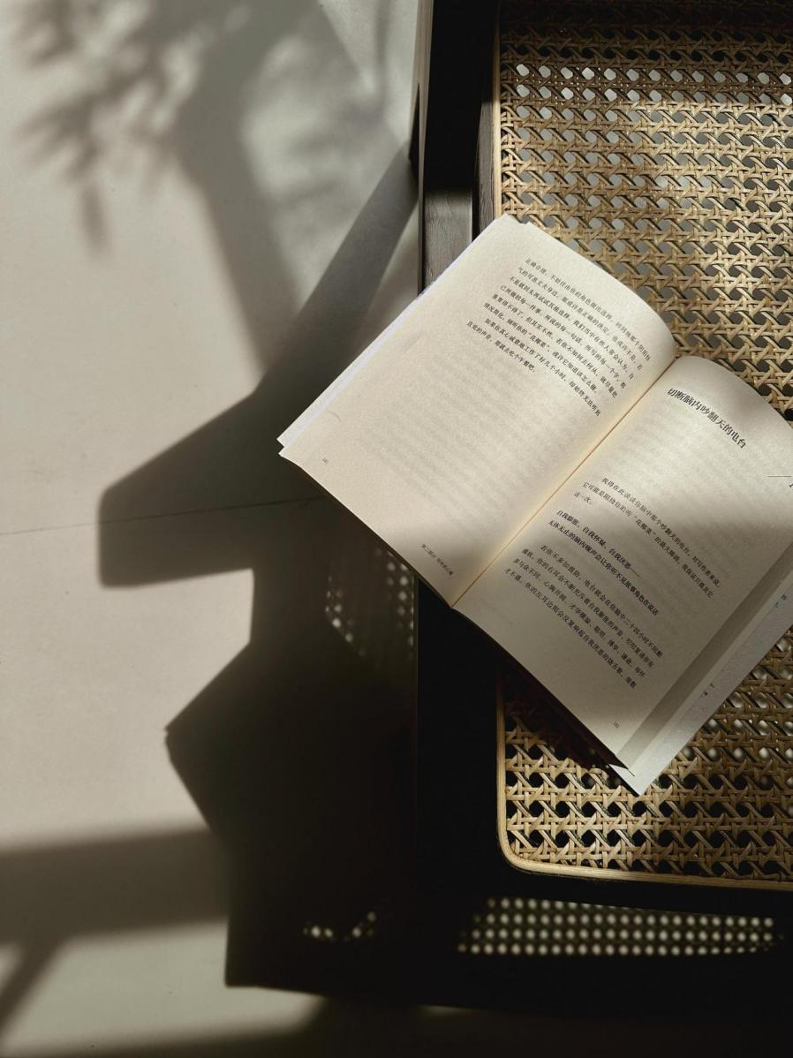

The owner originally intended take it as the second home for occasional vacations, but it seems to have become the true 'home' for the entire family, a place they eagerly anticipate as the real 'home' after a busy week.

On sunny days, sunlight pours into the house through the large black steel doors and windows, quietly casting shadows of every object in the room, as if instantly transported to the charm of Shanghai and the leisure of southern France. On rainy days, you can observe the ancient town shrouded in mist through the window, as if back to the ancient towns of western Sichuan. The seasonal flowers in the courtyard allow them to slow down, opening up their minds and bodies to feel the nature and the changes of the seasons. The natural and warm atmosphere of this home has deeply soothed their tense nerves and tired minds.

（GIF）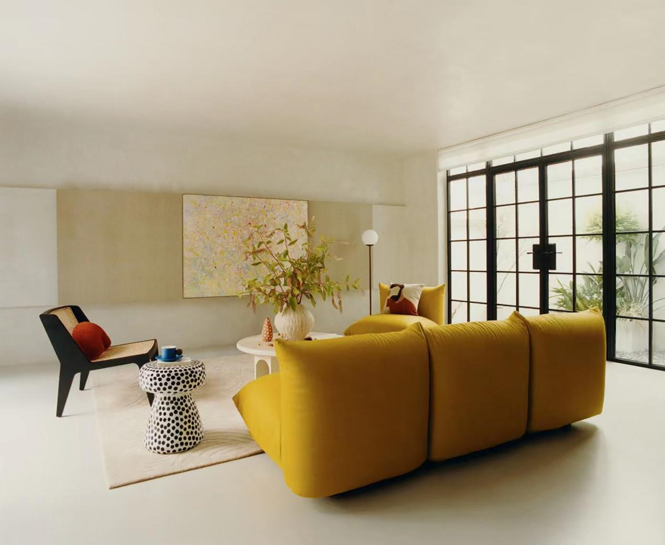

In today's complex and contradictory world, even house has more flexibility than ever before. As more people start to live in their second residence and reconstructing their concept of home, it is no longer a space for living but also an imaginative space where people can experience emotions and social relationships. Just like the painting “Wuxiang” by Xiaoyaozi hanging in the center of the living room, people explore self-expression and poetic expression through the unrestrained use of color while maintaining order.The second and the first residence together redefine the complete meaning of “home”.

