E Studio壹所设计｜九毛九集团办公室

人类何时开始进行不同领域的探索？
1969年，阿姆斯特朗首次登陆月球；
2018年2月，最強火箭？馬斯克「獵鷹重型」搭載特斯拉跑車飛入太空；
2020年，九毛九国际控股有限公司与壹所设计首度合作对九毛九集团联合办公室空间进行探索和尝试。
When did humans begin to explore the territory around them?
1969, Neil Armstrong landed on the Moon for the first time.
2018, February, The SpaceX Falcon Heavy rocket launched into space with Elon Musk's personal Tesla Roadster as its payload.
2020, For the first time, Jiu Mao Jiu Holdings Limited and E Studio partnered up to explore and experiment with the headquarters office space of Jiu Mao Jiu Holdings Limited.
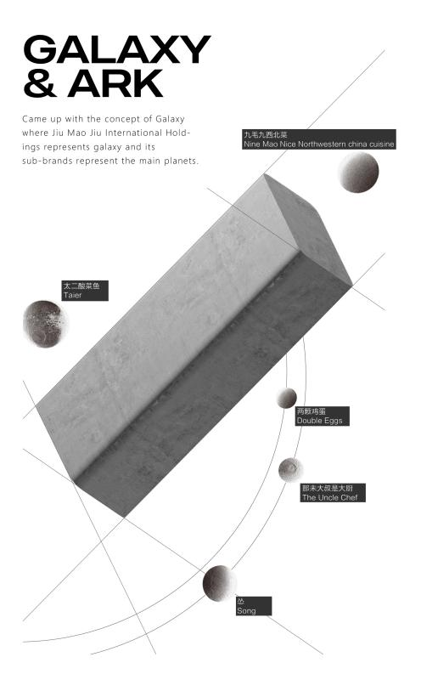
九毛九成立于1995年，在中国拥有逾25年餐饮经营历史，九毛九集团的经营策略以多品牌及多概念策略为基调，除了以经典的“九毛九山西面馆”作起点之外，集团还通过创立不同风格的品牌服务多种客户群，至今，九毛九餐饮集团旗下包括 九毛九、太二、2颗鸡蛋、怂、那未大叔5个品牌。
Jiu Mao Jiu , a Chinese restaurant group with chain management as its core, was established in 1995 and has 25 years of experience in F&B industry in China. The key management strategy of Jiu Mao Jiu Holdings Limited is based on having multiple brands and multiple concepts. Apart from the classic “ShanXi noodle restaurant” as a starting point, the Group has also created few different brands to cater to different levels of consumers. So far, Jiu Mao Jiu Holdings Limited operates 5 brands - Nine Mao Nine , Taier, Double Eggs, Song, The Uncle Chef.
九毛九集团，品牌由旗下各大餐饮子品牌围绕而成。
壹所输入星球概念，把九毛九集团比喻成一个星系，
各大子品牌就是星系里主要星体。愿景打造属于九毛九的宇宙世界，
在“九毛九星系”里，九毛九集团办公空间扮演的是一个“方舟”的角色，展厅内承载所有餐饮品牌星球的数据信息，期望参观者来到此空间可以犹如坐上宇宙方舟，穿梭在九毛九品牌星球之中，众览整个星系。
Jiu Mao Jiu Holdings Limited encompasses different F&B sub-brands. So E Studio came up with the concept of Galaxy where Jiu Mao Jiu Holdings Limited represents galaxy and its sub-brands represent the main planets. The idea is a cosmic world belonging to Jiu Mao Jiu Holdings Limited, where its headquarters space represents an ark and the exhibition hall contains the data of all the F&B sub-brands represented as planets. It is expected that visitors of the headquarters will be “riding on a cosmic ark", shuttle between the Jiu Mao Jiu sub-brands planets, moving around the entire galaxy.

▼地理位置 /LOADTION
位于广州天河区原马场处,旧时广州赛马业的高光时刻，像香港一样，广州也有过“舞照跳，马照跑”的日子。
The project is located in the area that used to be a horse racecourse in Tianhe District, Guangzhou. It used to be the main arena for horse racing and witnessed its glorious moments, the same as in Hong Kong.
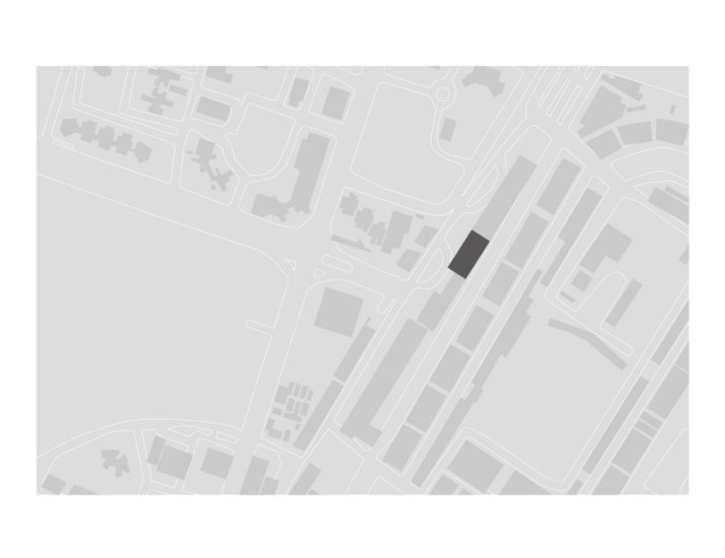
我们希望用简单的形体带来对既定事物的陌生感，大堂入口灵感来自太空人造卫星，从天而降，坐落在九毛九入口处以指引集团方向，守护九毛九的每一颗“星体”......
We hope to reflect the strangeness of the established things through simple forms. The lobby entrance was inspired by a space satellite, floating in the sky. It is located at the entrance of Jiu Mao Jiu International Holdings office space to provide the direction to every “planet”.
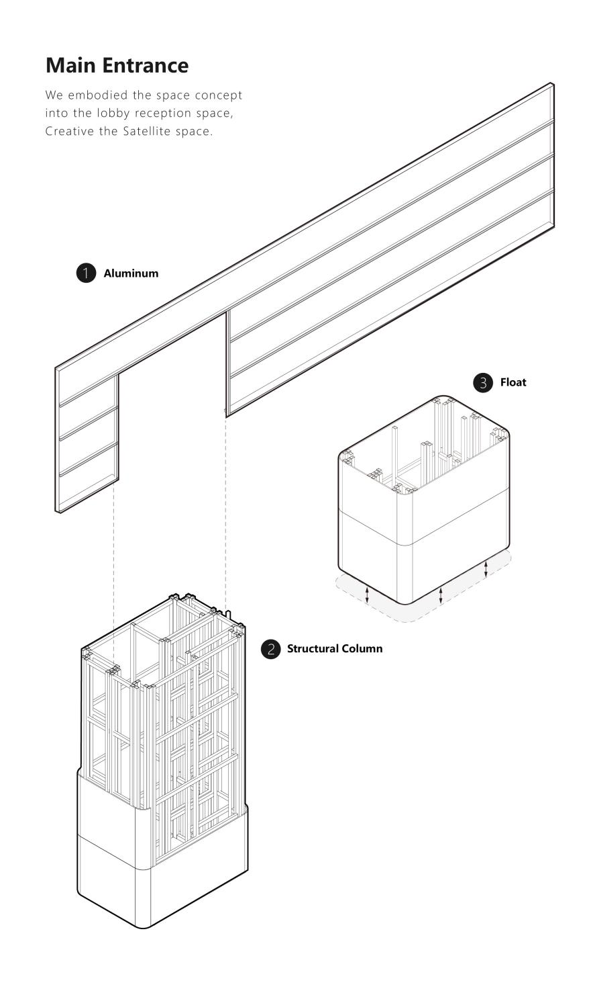
入口外立面的材质我们运用了泡沫铝和石材的穿插，在原有的结构柱体基础上将柱体放大至一个夸张的尺度，泡沫铝在与柱体的穿插中形成“人造卫星”的同时充当二楼办公的挡板。
We used foamed aluminum and stone at the entrance facade. We enlarged the base of the original structural column to an exaggerated scale. The aluminum foam interspersed with the column forms the shape of the satellite and at the same time acts as the barrier to the office on the second floor.

▼入口 /manuscript
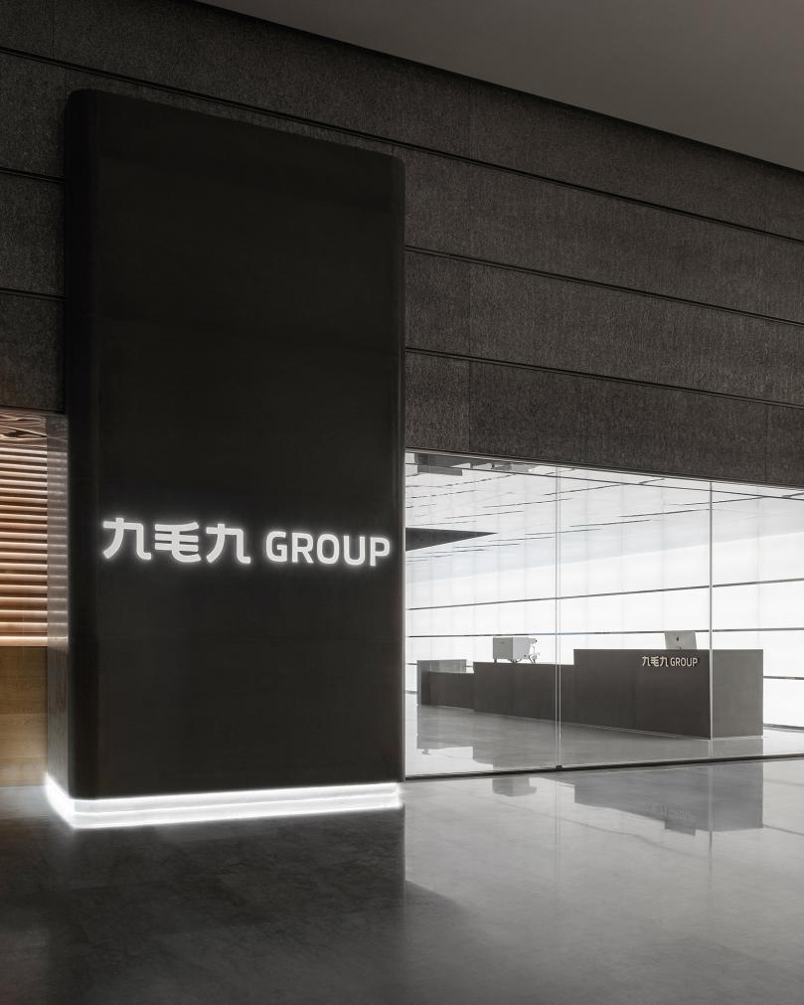
大堂内部首先需要打破层高的束缚，为此我们将镜面不锈钢覆盖在大堂的天花上，使得空间看上去更加的通透，以轴线的无限延展，带来具有冲击力的视觉印象。
The first thing to do inside the lobby was to “break” the space between floors. In order to do this we covered the ceiling of the lobby with mirrored stainless steel, making the space look more transparent, filled with an infinite extension of axes that provide a striking visual impression.
▼前台/Front desk
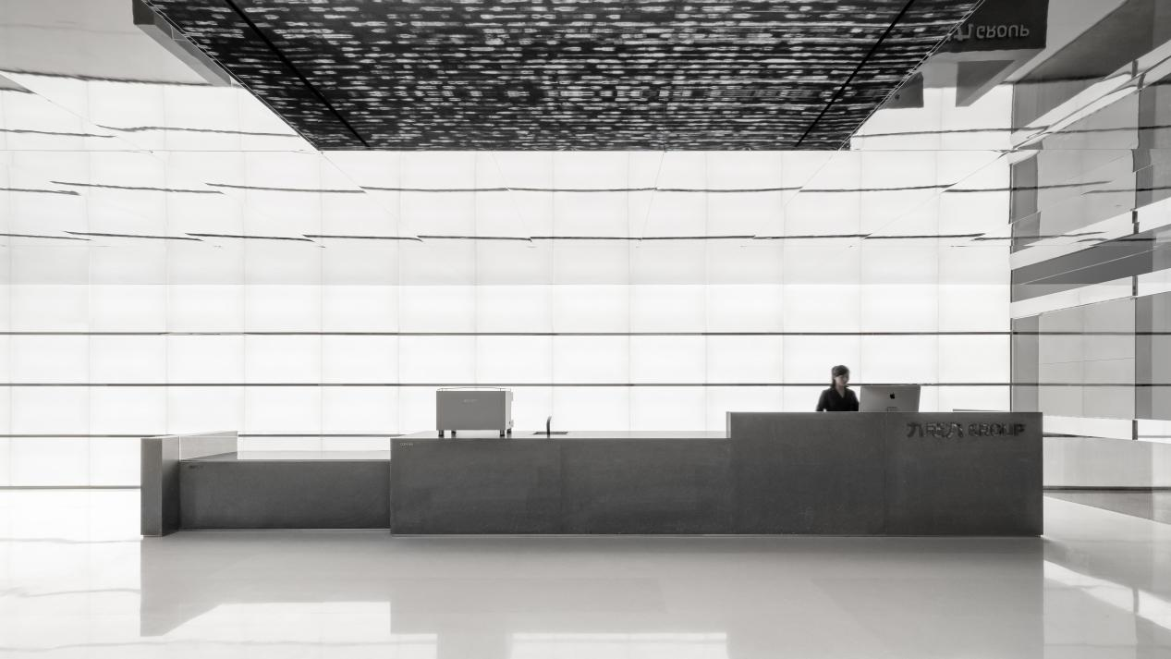
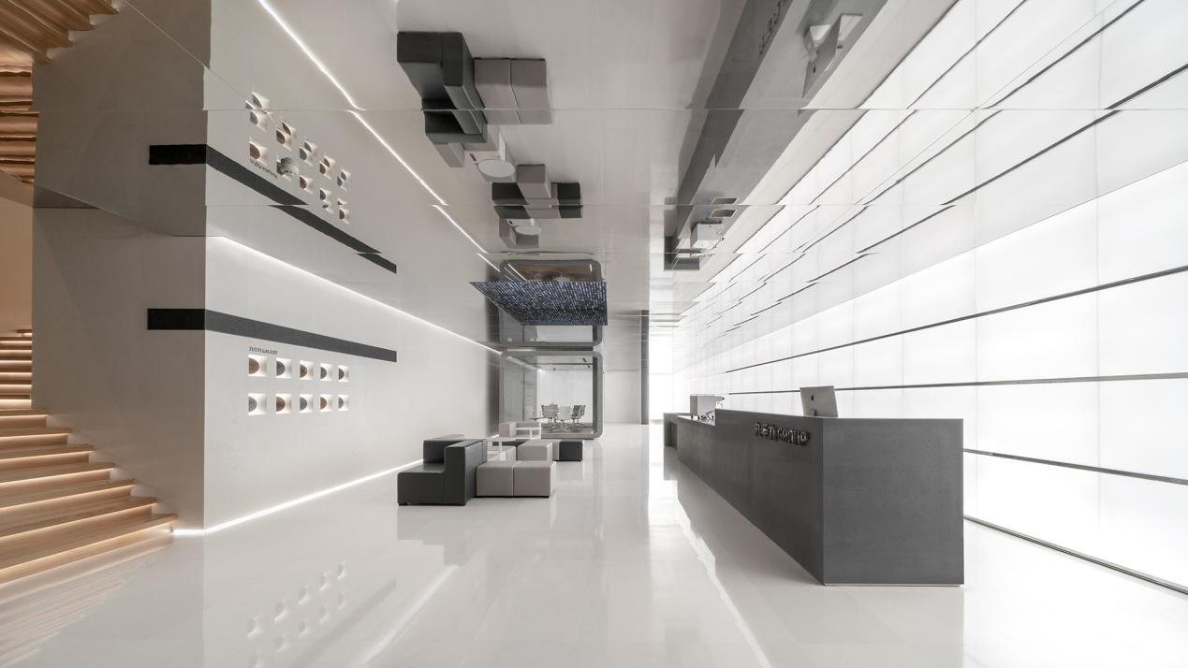
在大堂处置入了一个10米长的石材体块作为接待台，并在整个前台背景墙铺满了亚克力发光模组，使光线本身成为主角而不是媒介，该方式使得观看者的空间感知概念变得扭曲，因为他们所处的环境似乎无穷无尽；天花的镜面不锈钢结合墙面的亚克力发光模组，通过空间延伸以营造出停留在宇宙中的空间站氛围感。
A 10 meter long stone block is used in the lobby as a reception desk. The wall behind the desk is covered with acrylic luminous modules, letting the light stand out and be the center of attention rather than just a medium. In this way, the viewer's perception of space becomes distorted, because the environment seems endless. Mirror stainless steel on the ceiling combined with an acrylic luminous wall visually extends the space and creates the atmosphere of being inside the space station.

▼休息区/Rest area
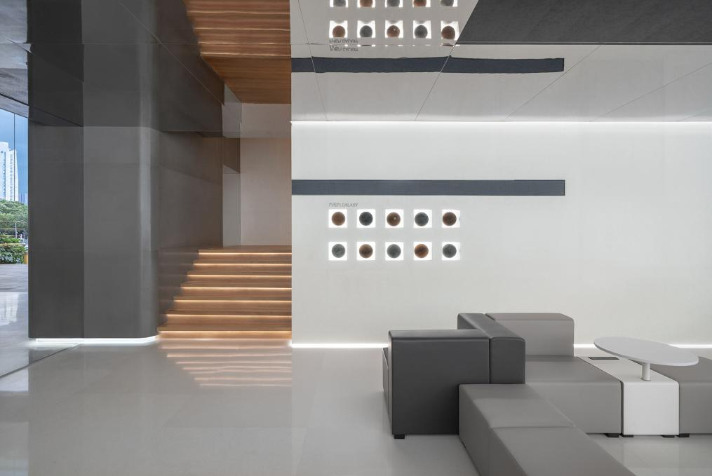
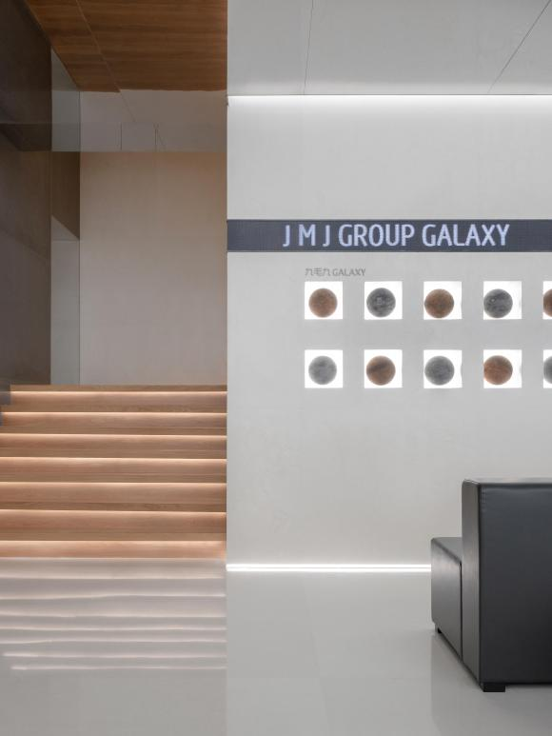
同时我们将“星系”概念融入到空间当中，试图将信息科技与艺术装置融入该项目，呈现出神秘、科幻的空间印象。休息区处，我们将星球微缩后置入墙面作为悬浮球展示，仿佛呈现了一个微缩的宇宙，讲诉着星球的历程。镜面天花凹陷处屏幕展示九毛九文化同时作为黑洞的概念输出，贴合星系主题概念。
At the same time, we integrated the concept of the galaxy into the office space, attempting to integrate information technology and art installations in this project, leaving the impression of mysterious, sci-fi space. In the lounge area, we put the planets on the wall as floating balls, just like the Universe in miniature, telling the story of the planets. The mirror ceiling screen shows the corporate culture of Jiu Mao Jiu as well as the concept of the black hole, which fits the galaxy theme concept.

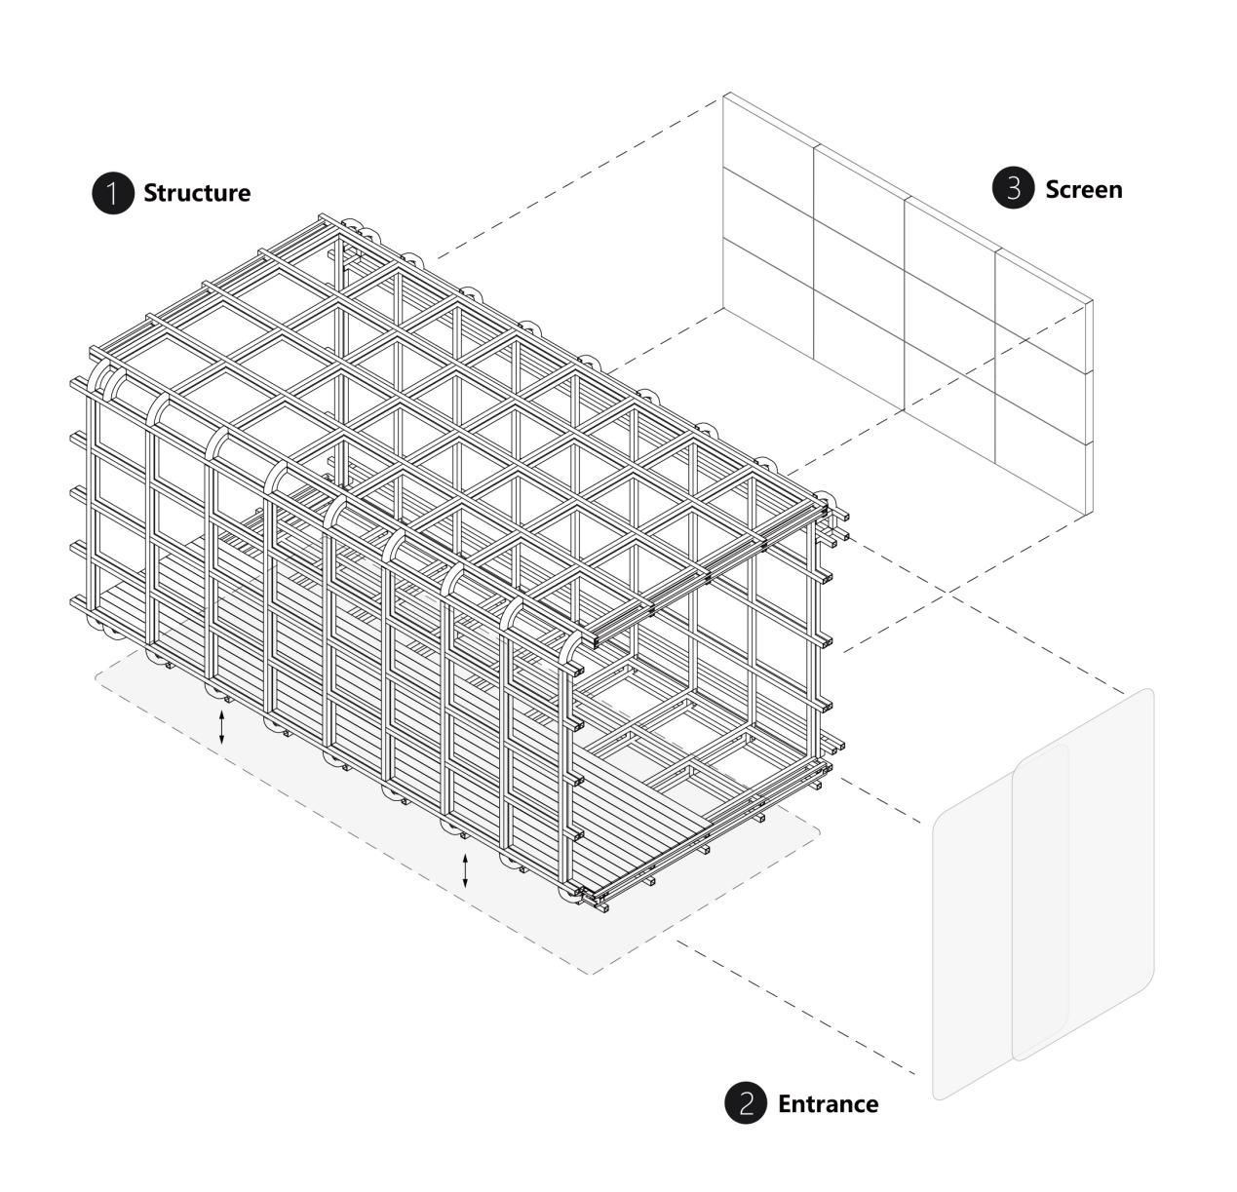
会议接待室以舱体胶囊概念置入在空间里，并结合多媒体影像输出。
壹所通过艺术灵感与科技的融合，創造出超越科技的场景体验，拒绝乏味单一的品牌内容输出，试图通过科技化的多媒体手段将品牌特点可视化，有趣的互动体验延展出品牌的无限想象力。
The conference room is embedded in the space as a capsule and combined with multimedia system.
E Studio created an experience of transcended technology through the fusion of artistic inspiration with science and technology. Rejecting boring, single brand content display, we attempted to visualize the brand's characteristics by means of multimedia technology, providing an interesting, interactive experience into unlimited imagination of the brand.

▼接待区/Reception
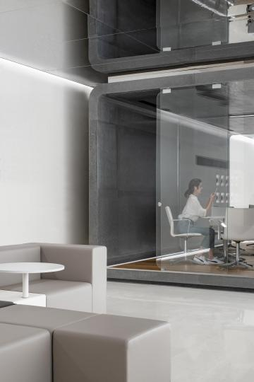
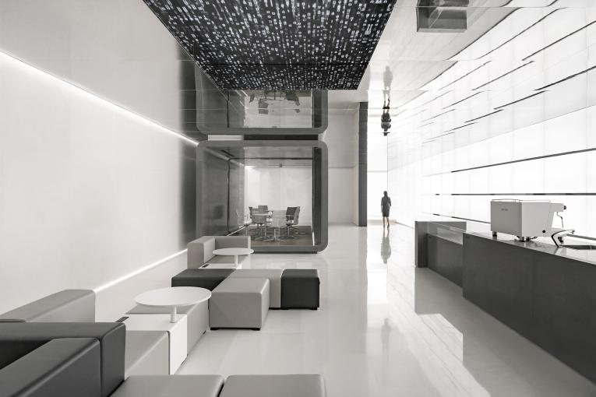
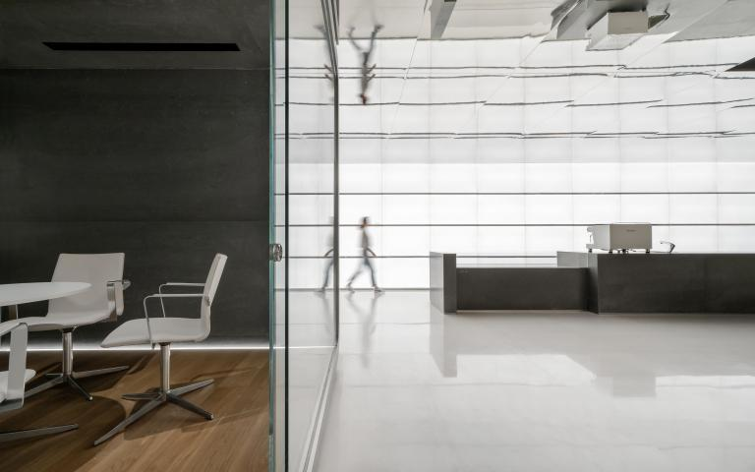
“他们在这种躯壳中漫游于星际之间，他们不再建造宇宙飞船。他们本身已是宇宙飞船。但是“机器实体”的世纪很快又已告终。在他们不断的实验中，他们懂得怎样把知识储存在空间本身的结构里，把思想永久凝聚成光格。他们可以变成辐射性的生物，最终摆脱掉物质的控制。”----------《2001太空漫游》
They wander among the stars in this body, they no longer build spaceships. They are already spaceships. But the age of the “machine body” will be over soon. In their never ending experiments, they know how to store knowledge in the available space, permanently condensing thoughts into lattices of light. They can become radioactive creatures. And finally get rid of the control of matter. —2001 Space Odyssey
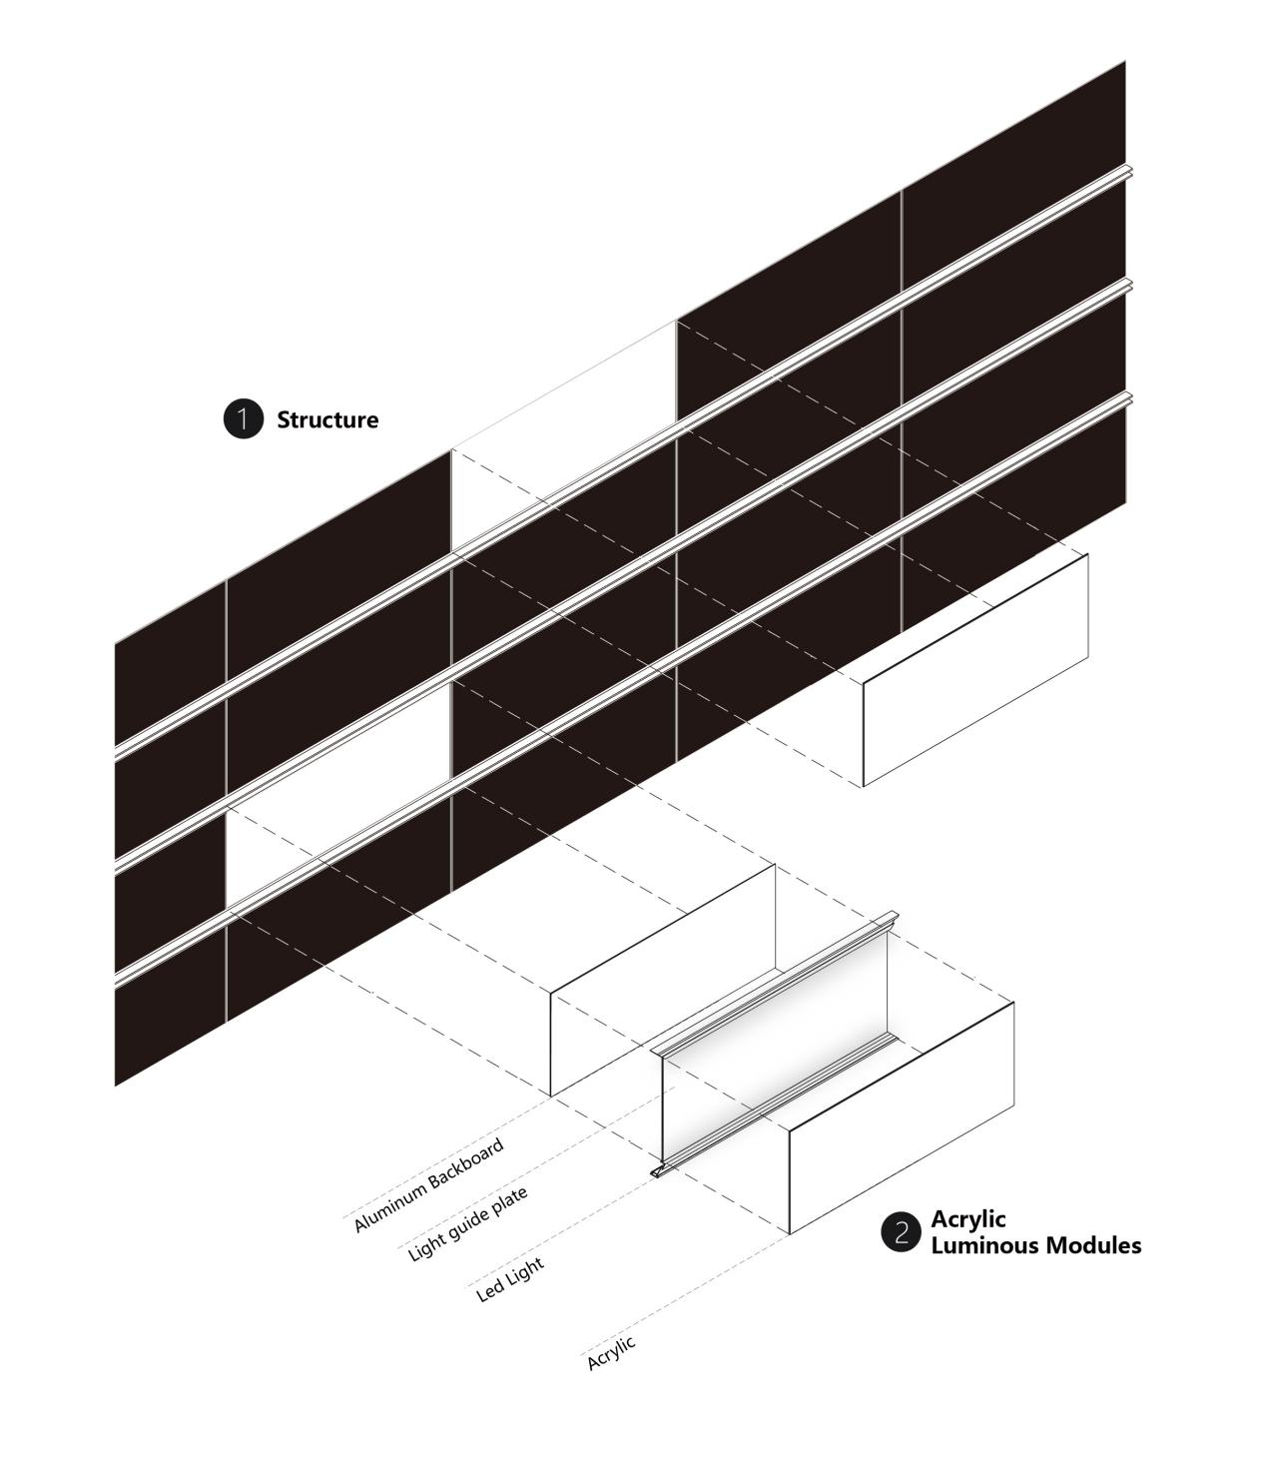
前台背景由88块亚克力发光模组组成，每块都可单独控制明暗且拆卸维修。
The wall behind the reception desk is composed of 88 acrylic luminous modules, the lights on each piece can be individually controlled and each module can be disassembled for maintenance.

▼前台办公区域过渡空间/Front desk
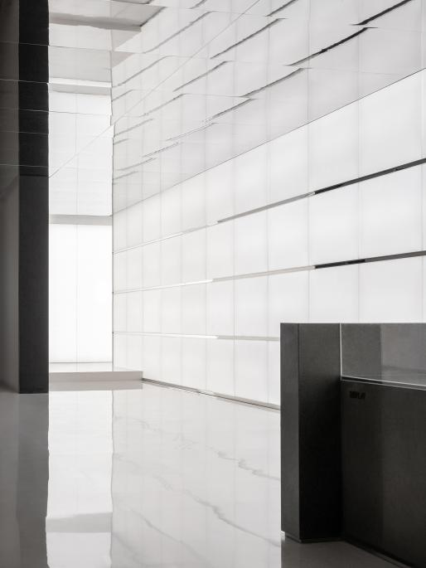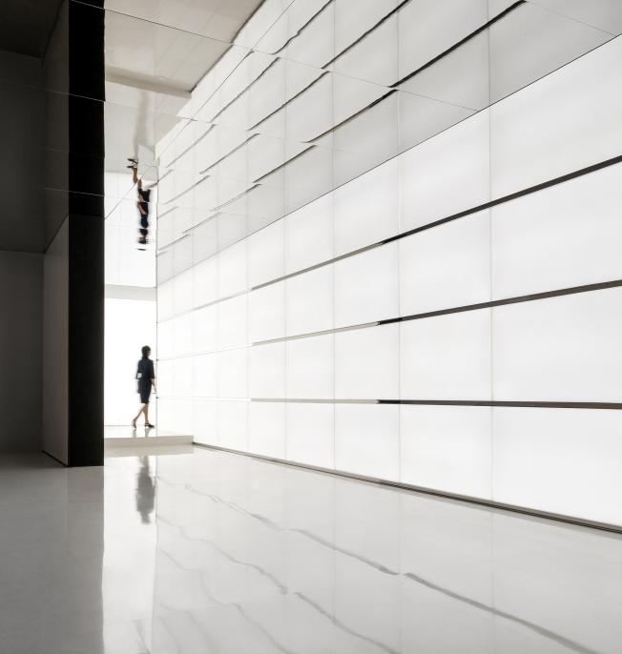
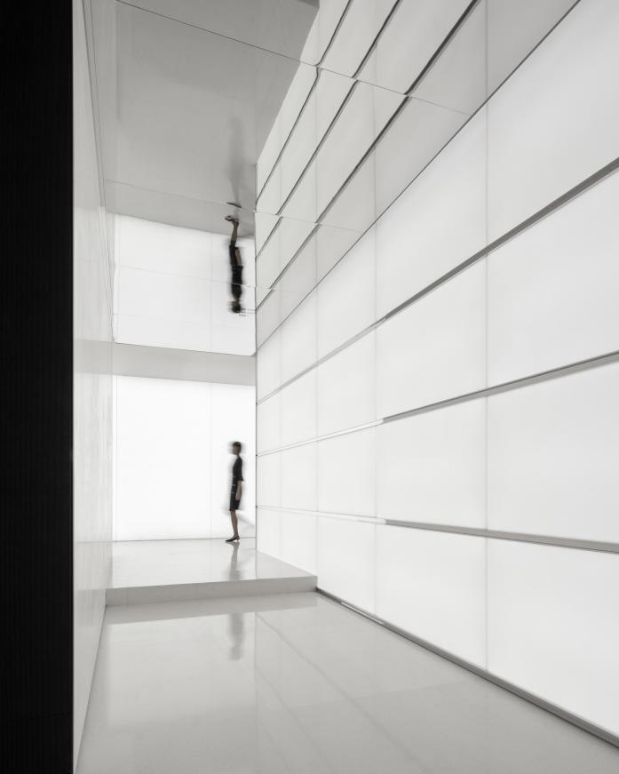
秩序与自由、理智与文明，在大堂通往办公区的通道中运用材质与氛围光的结合，仿佛营造出另一个精神世界。
Order and freedom, reason and civilization, the materials, and the ambient light that we used in the hallway path from the lobby to the working area create another spiritual world.
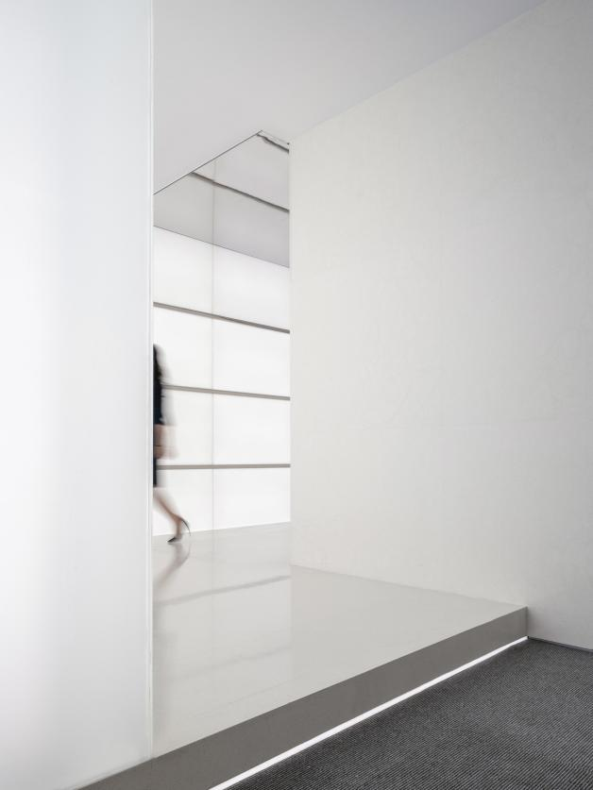
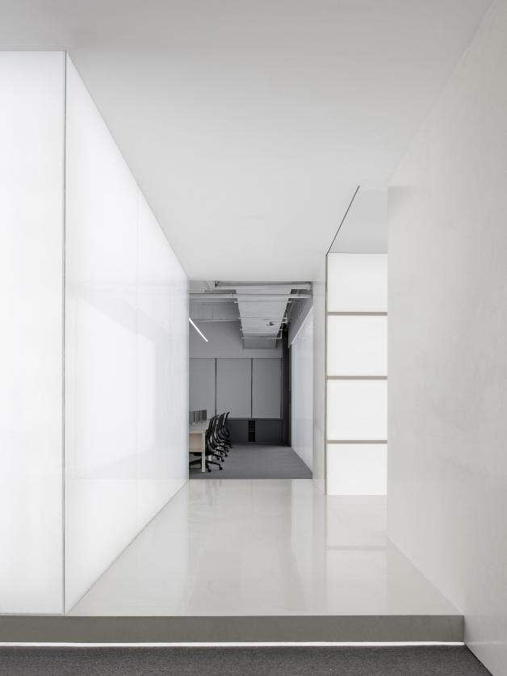

来到一个办公空间，我们想与大堂拉开差距，更加轻松/智能。
Inside the working area, we wanted to distance ourselves from the lobby, adding a more relaxed and intelligent atmosphere.

▼会议室/meeting room
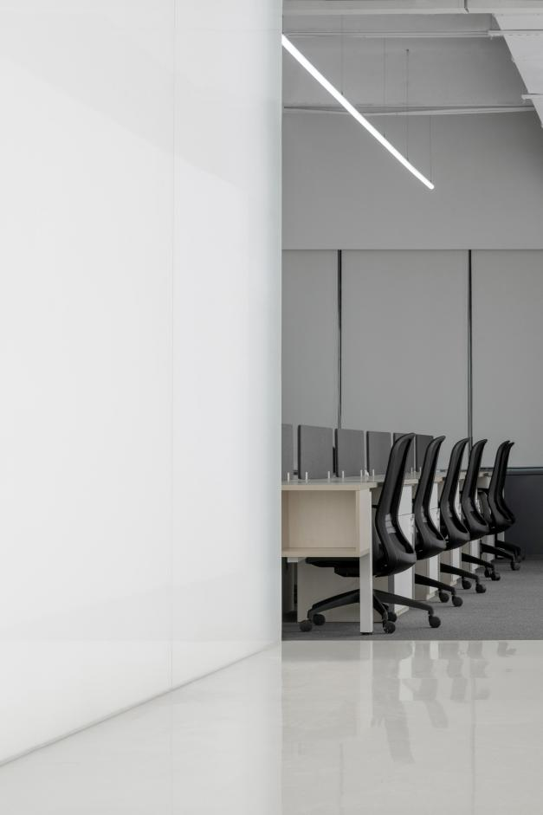
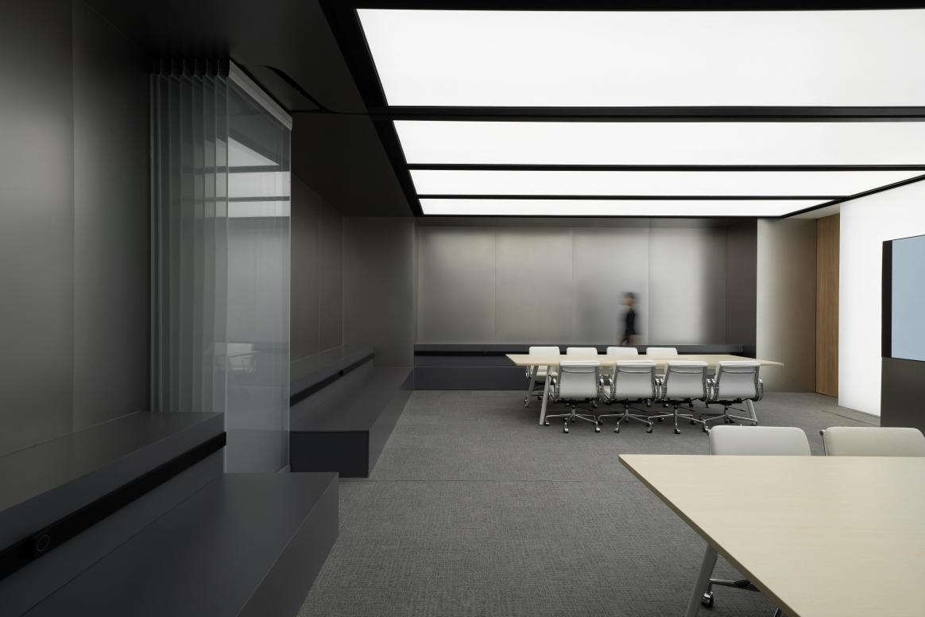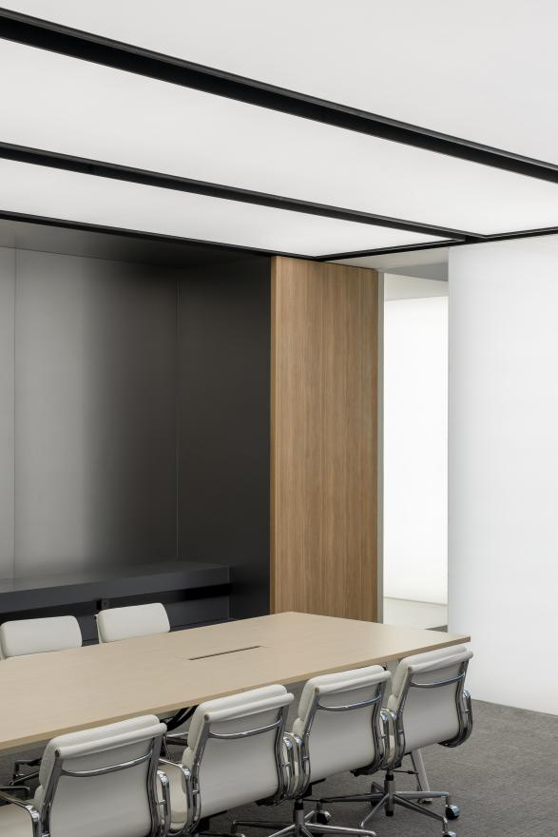
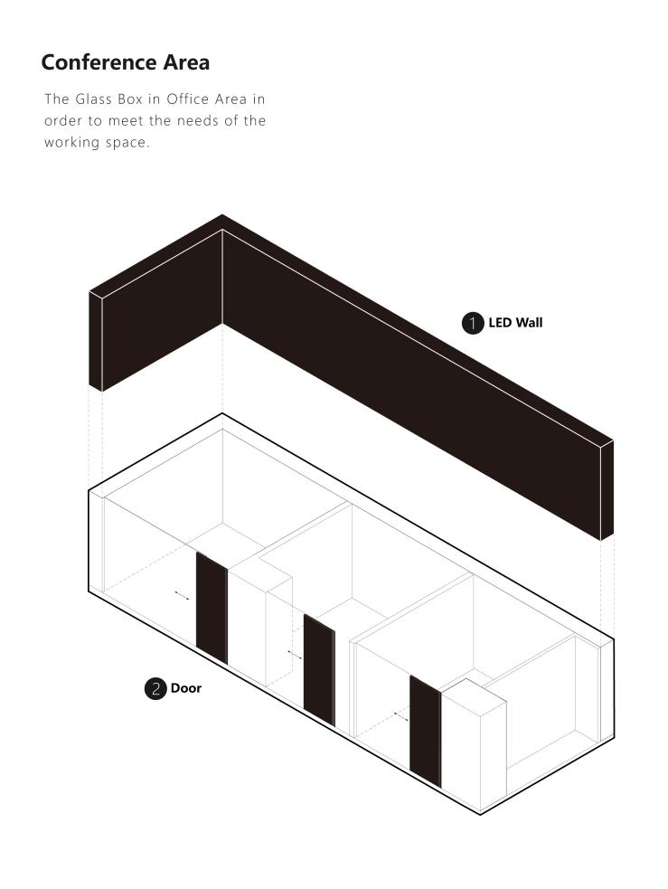
我们置入“玻璃盒子”作为会议室墙体隔断，盒子内部设置灯光，形成大面积的人工照明满足办公所需，也可作为书写的载体。
We placed a glass box as the wall partition for the meeting room, which can also be used for writing, set the lights inside the box in order to meet the needs of the working space.
▼办公区一览/Workspace
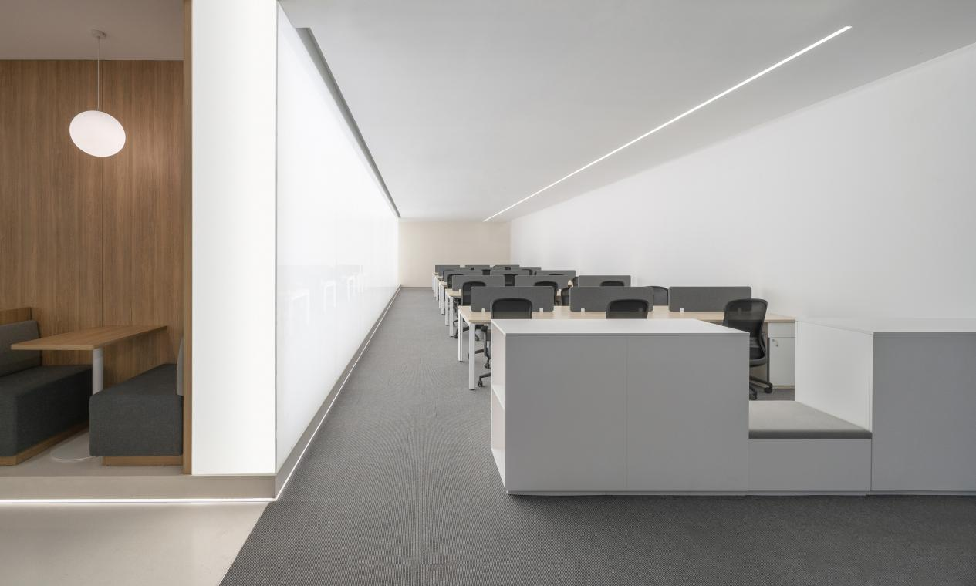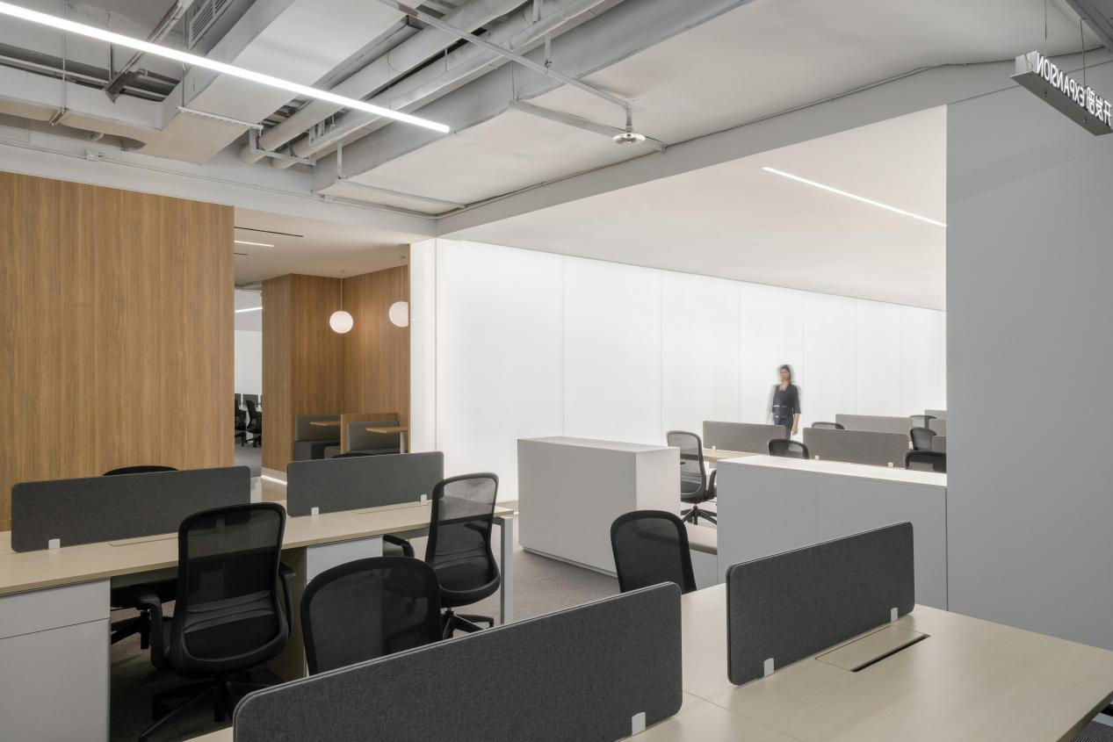

▼办公区一览/Workspace

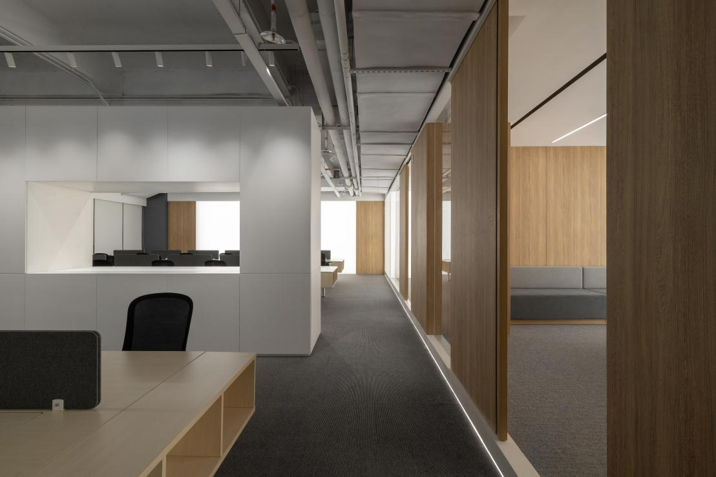
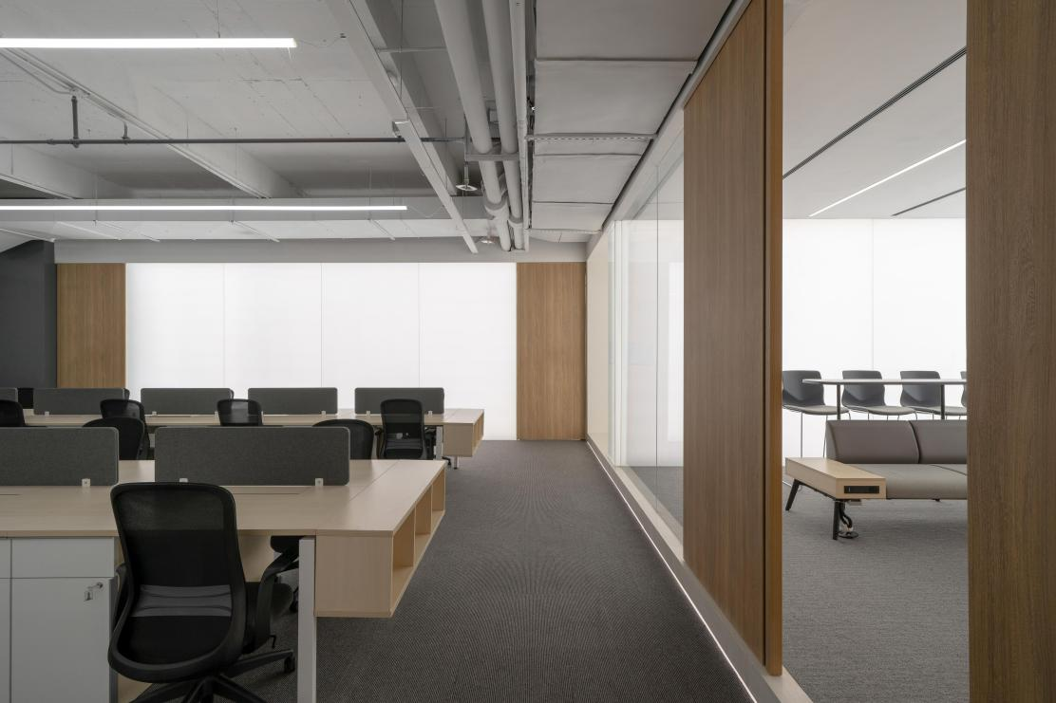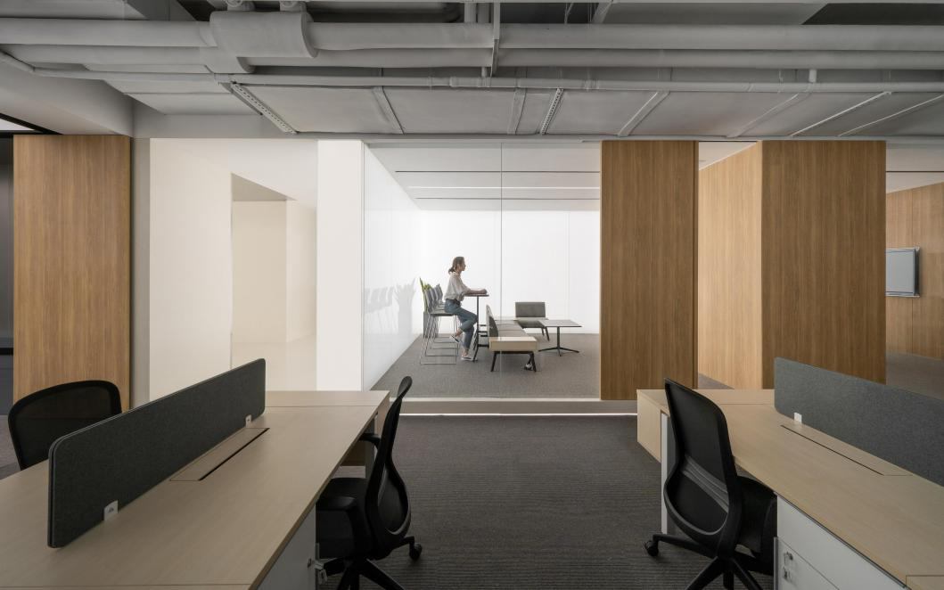
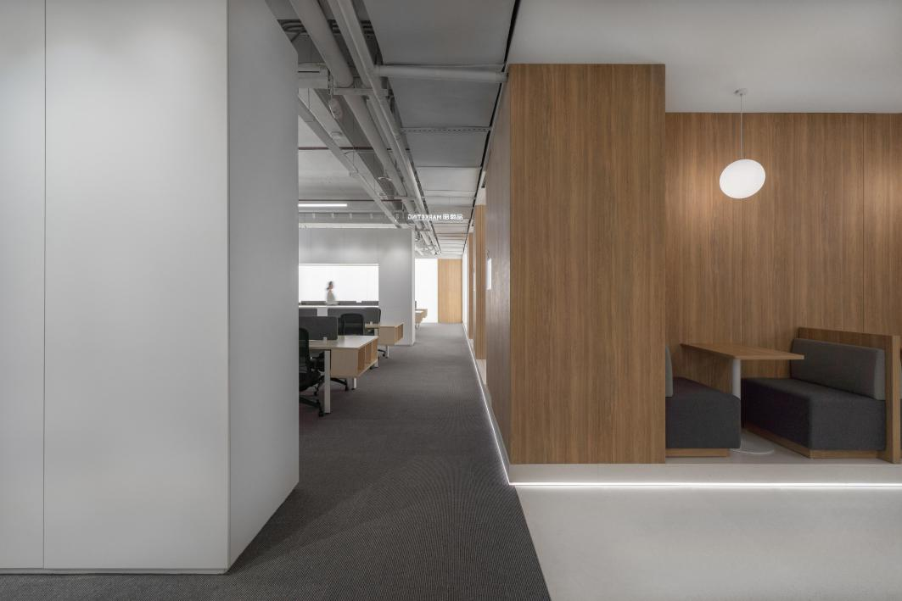
办公内部基本都是开放空间，需要容纳100+的卡位，我们在空间中置入三个柜体将卡位进行分割，柜体通过几何窗口令不同区域的工作者保持自身空间舒适度的同时也保持视线上的情感和需求连接，柜体用不同的几何形体开口形成不同的功能用途，如展示柜、卡座、吧台等.将“工作场所”转变成舒适的“生活空间”，我们希望能够给予空间更多的内部可塑性与可能性，毕竟，“星系”中还有很多“星球”等着九毛九去发现......
The interior of the office is basically an open space with 100+ slots. We put three cabinets in the space to divide the slots. There are windows in the different zones of each cabinet, that let office workers maintain the comfort of having their own space and at the same time keep the much-needed emotional connection between workers.
The entrances of each cabinet are formed in different geometrical shapes that represent different functions, such as display case, deck, bar counter, etc, transforming the workplace into a comfortable living space.
We hope to give the space more internal plasticity. After all, there are many more “planets” waiting to be discovered in the galaxy.

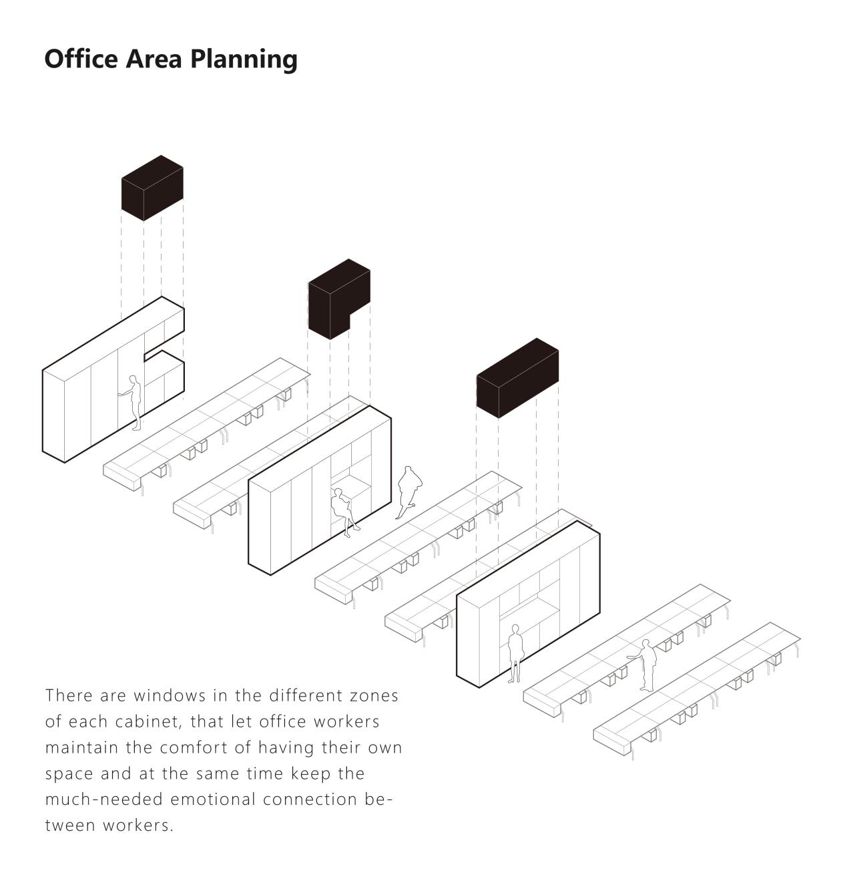
▼办公区一览/Workspace
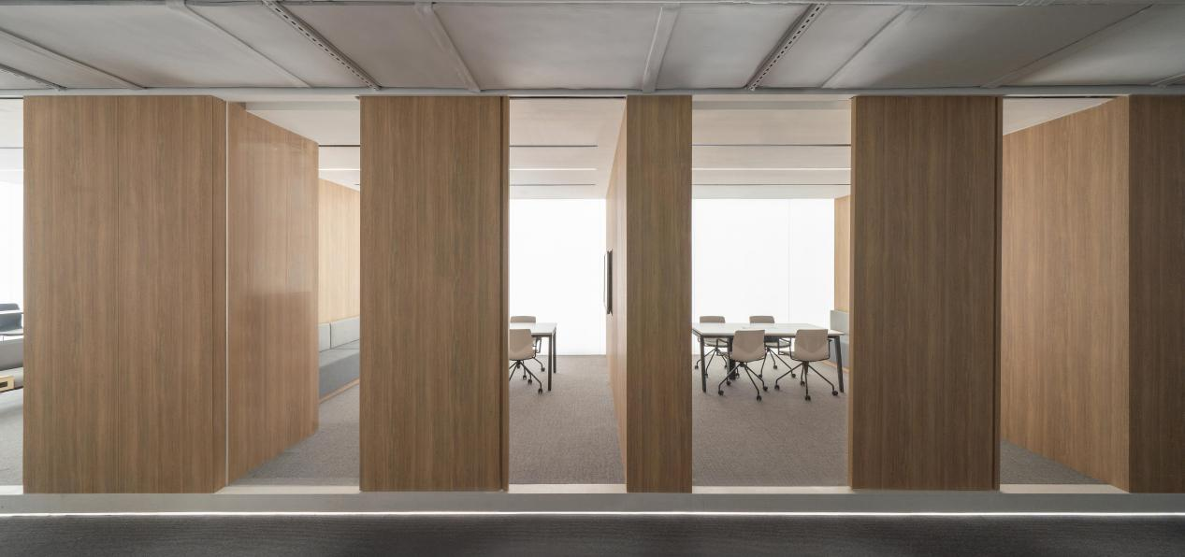

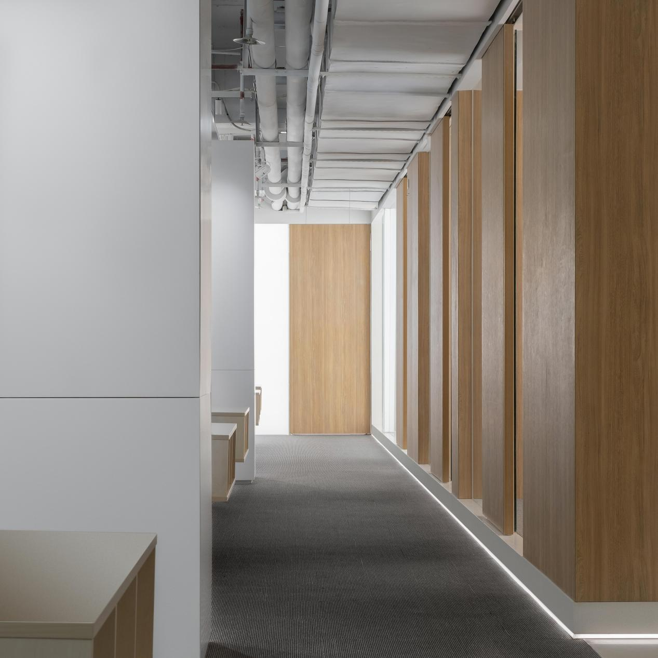
▼办公区其他空间/Workspace
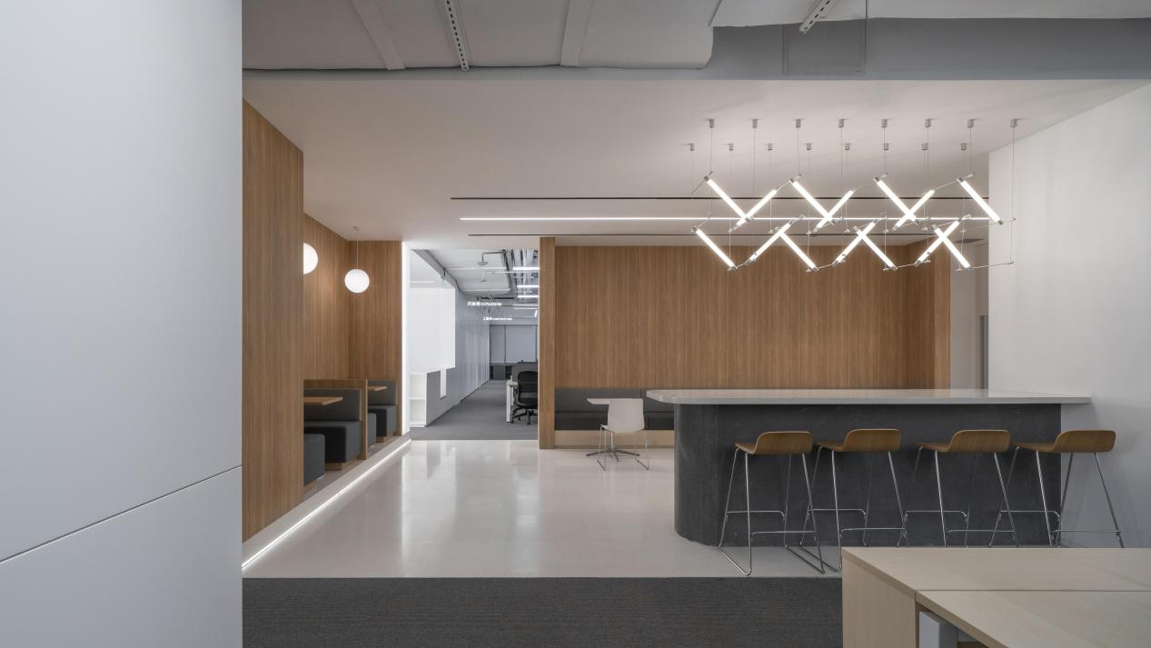

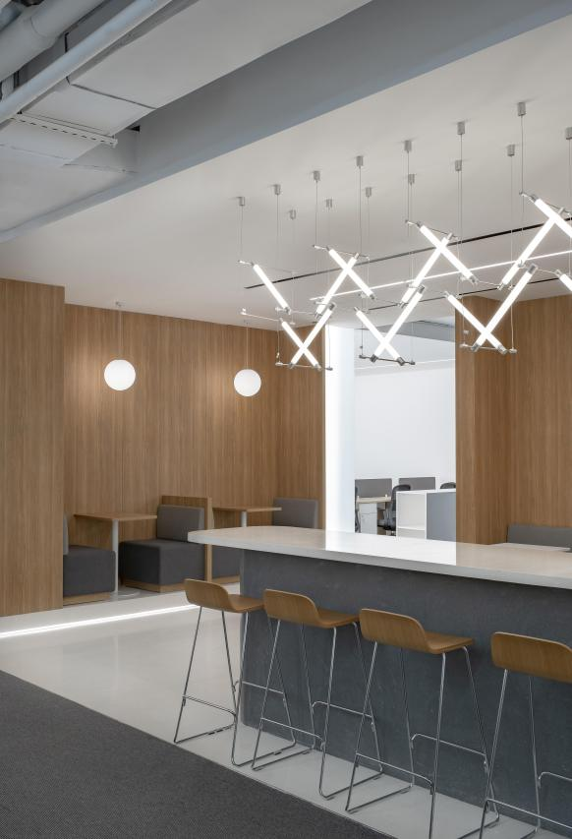
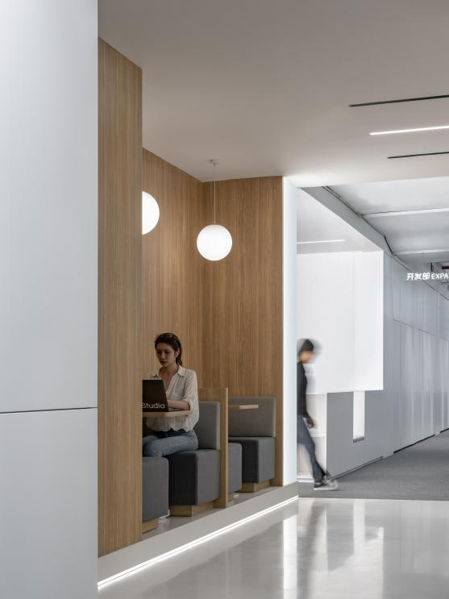

▼空间平面分布/Plan
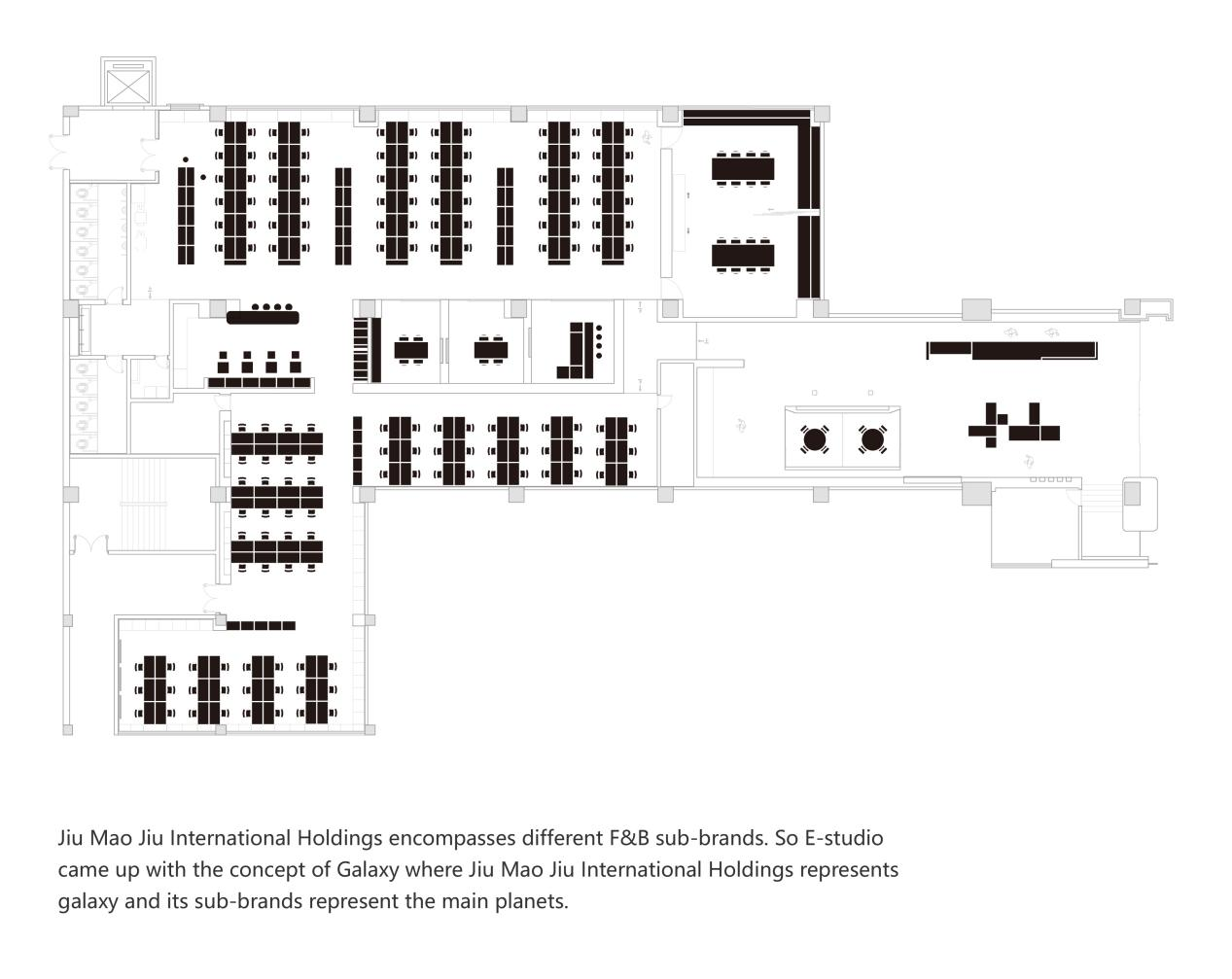

项目名称：九毛九集团办公室
项目地点：中国 广州
项目面积：1500 m²
完成时间： 2020.10
主案设计：范君健、周炫焯
协同设计：郝星云
摄影：张超
Project name: Jiu Mao Jiu Group Office
Project location: Guangzhou, China
Project scale: 1500 m²
Completion time: 2020.10
Interior design: Ken Junjian, Zhou Xuanzhuo
Cooperative design: Hao Xingyun
Photographer: Zhang Chao

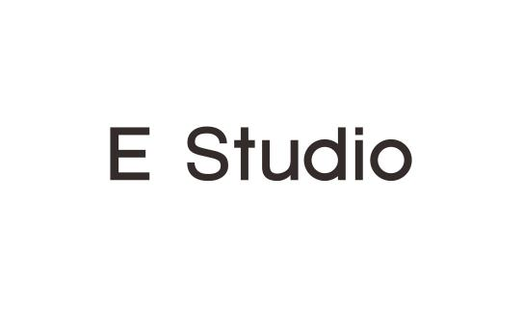
壹所设计工作室（E Studio）由范君健和周炫焯于2018年共同创立，是一家致力于探索商业空间设计的多元化创意服务机构，提供前瞻性的建筑、室内、平面、品牌策划服务。来自不同专业领域的壹所设计团队，擅于运用跨界的设计思维为品牌打造独特的整体形象。
E Studio was founded in 2018 by Ken Junjian and Zhou Xuanzhuo. We are a diversified creative service company dedicated to exploring commercial spaces, providing progressive architecture, interior, graphic design, as well as branding services. E Studio’s design team fuses professionals from different fields who are well-versed in using cross-boundary design thinking to create unique images for the brands.
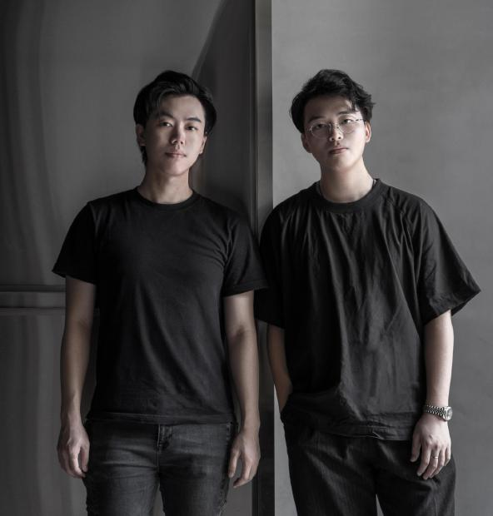
Email : e-studio@foxmail.com
Tel：15999519301 13232366366
www.estudio.guru

E Studio 代表作品

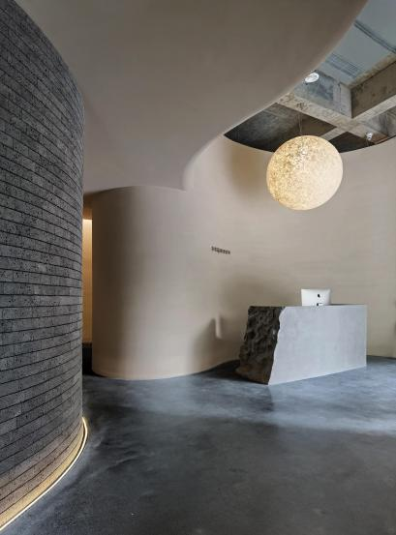
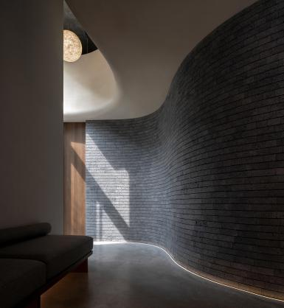
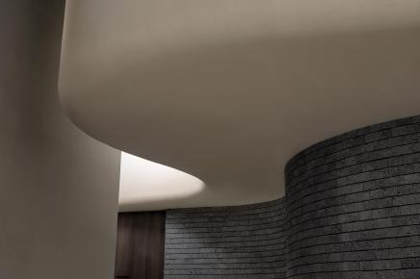
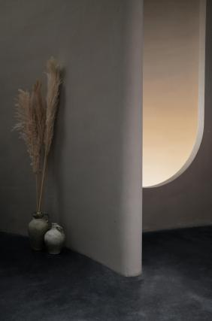
Shuran_舒然养生空间
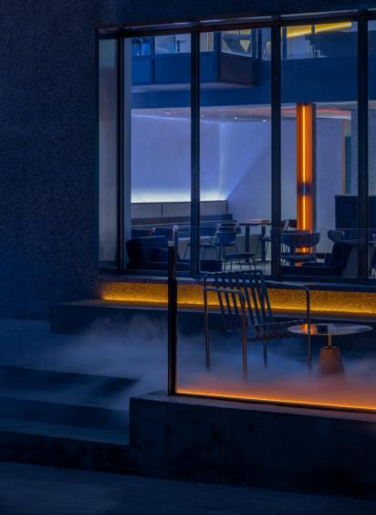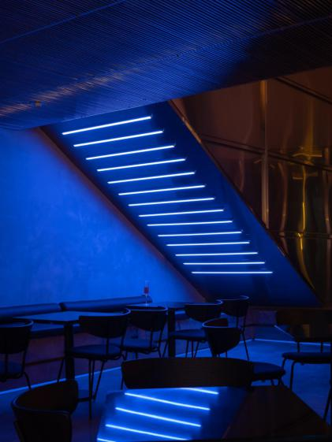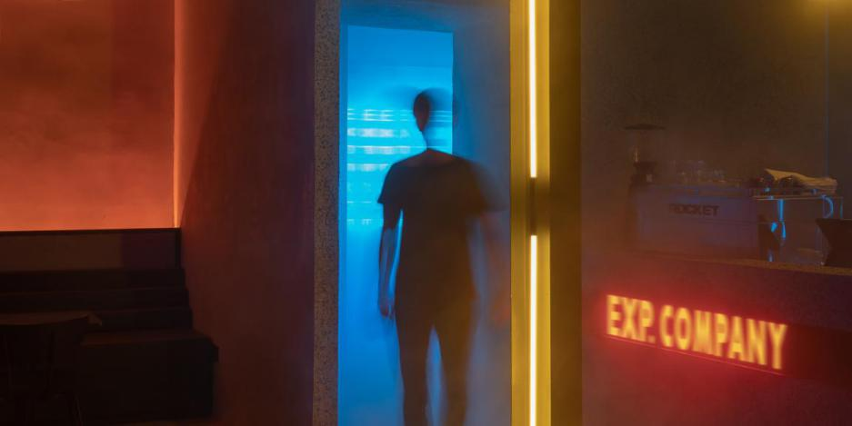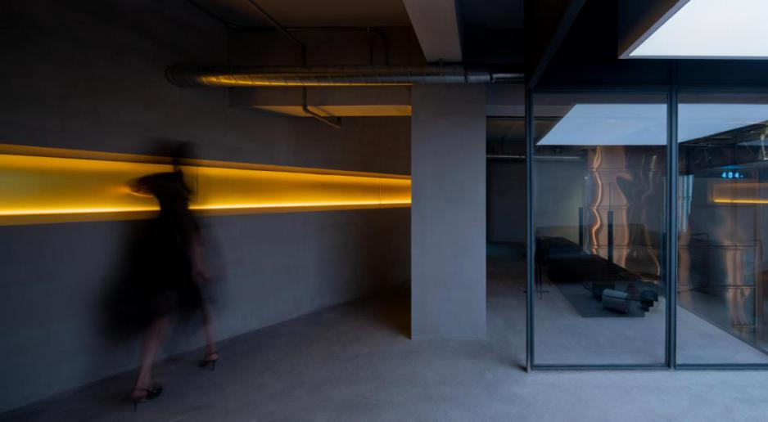

THE EXP. COMPANY BAR

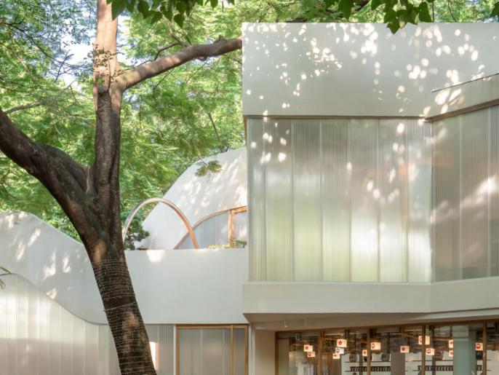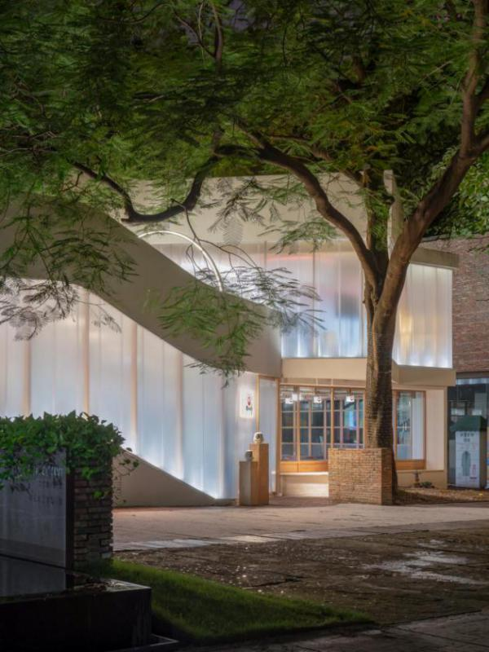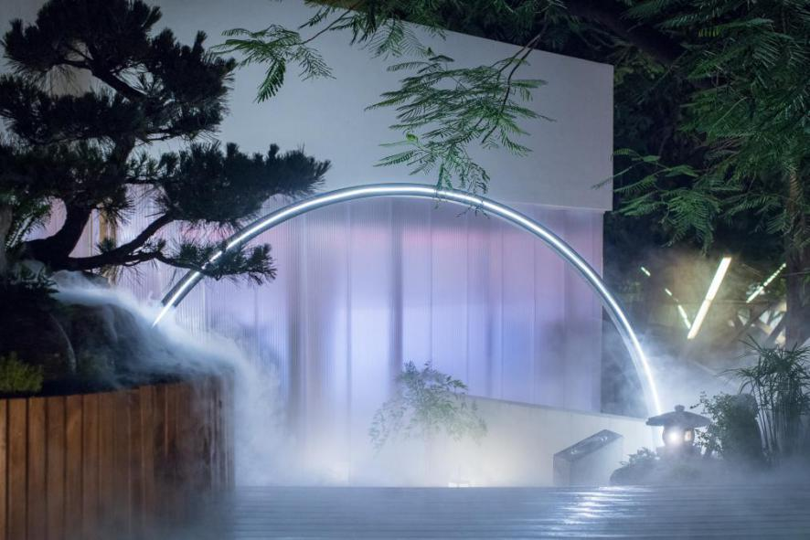
ONMYOJI 阴阳师主题店

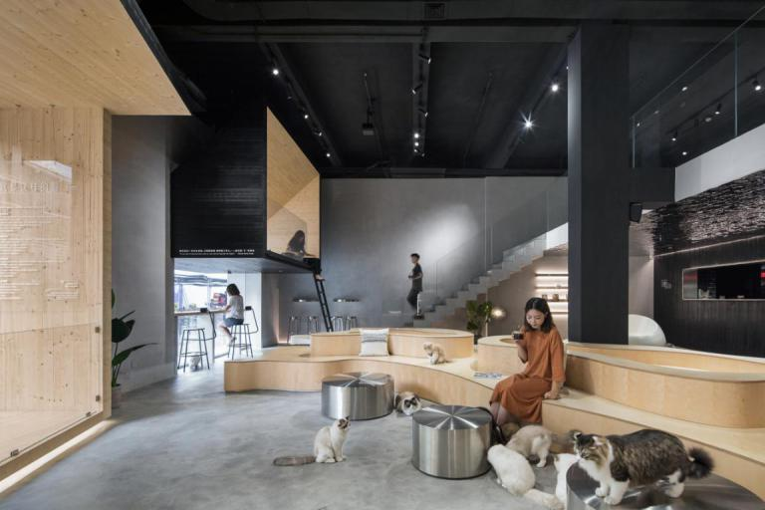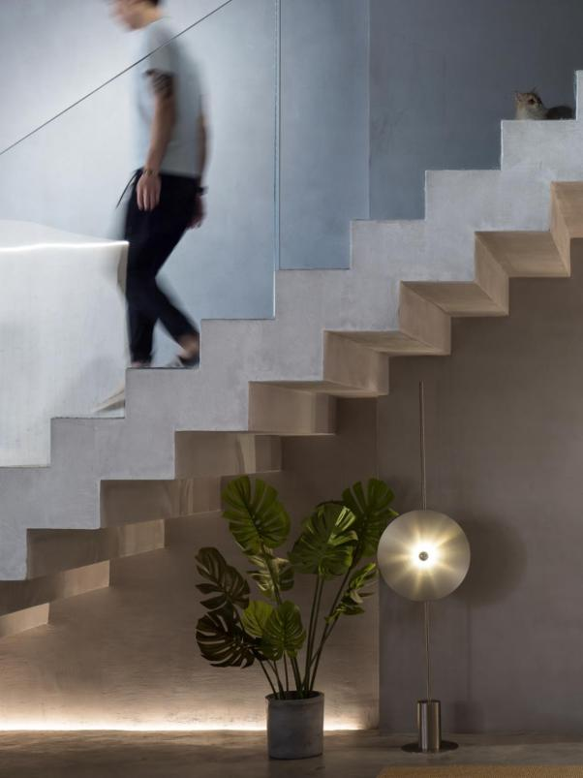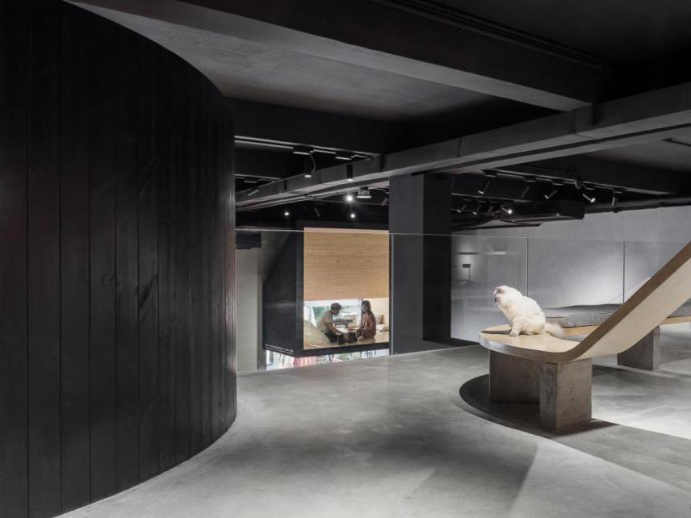
MEOW RESTAURANT 就是这样的喵

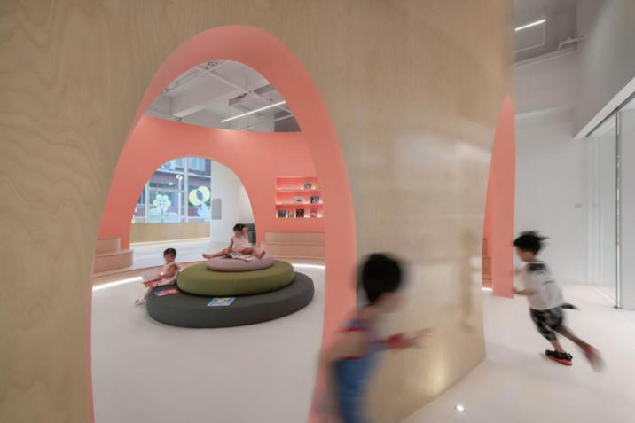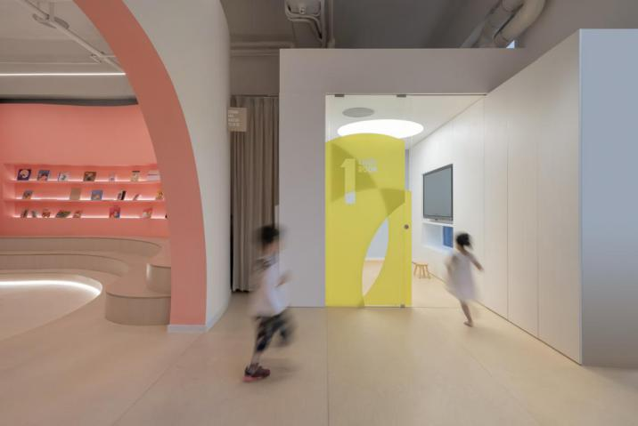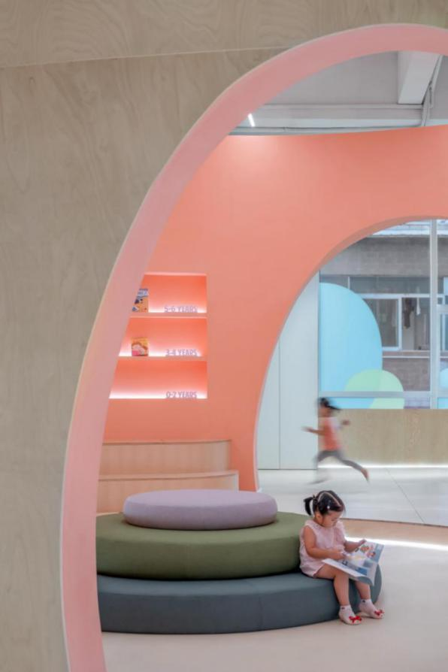
FREE READING PICTURE BOOKS 三月绘本阅读空间

