CONCAVO CONVESSO Collection
Marble Collection
design Iosa Ghini

Designed by: Massimo Iosa Ghini
Manufacturer: Guarda Marbles & Stones Srl
Pavilion 3, Stand L23

Concavo Convesso Collection
On the occasion of the 54th “i Saloni” Milan International Furniture Fair to be staged from 14 to 19 April 2015, Architect Massimo Iosa Ghini will present the world premiere of a brand new line “Concavo Convesso Collection” in partnership with Brescia-based and MGM-branded Italian company Guarda Marbles & Stones Srl.
Composed of table, coffee table, vase, chair and book shelf, all entirely made in marble, this new collection line is aimed to combine the creativity of Massimo Iosa Ghini and the bespoke craftsmanship excellence of MGM.
As an integral and fundamental element of this collection, each product is characterized by a strong personality and uniqueness through color designation.
Iosa Ghini for MGM
When MGM has asked us to design this new marble collection line, we have regarded MGM as a company with great potentials.
Today what can be achieved from marble has enabled us to make this partnership happen between us in order to make the most of our capacities.
We have understood that it shall be the shape and naturalness of human being other than the technology which shall determine the product shape.
This new line with as close shape as to our nature is easy to recall the classic shapes which are combined into an innovative contemporary design in order to create a harmonious and elegant ambience.

A glance at some of the products:

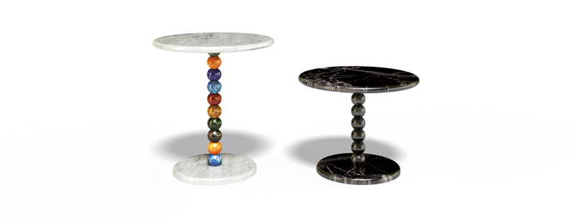 | PEARLS  Small table with round marble top and base.  Shaft made by marble balls connecting the top and base by combining shape and elegance.
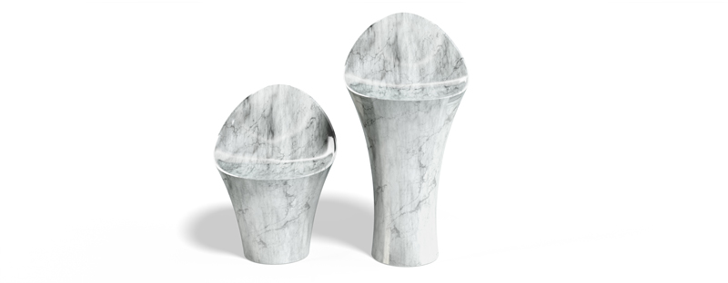 | TULIPANO  Monolith chair set by two with backrest & soft and balanced curved seat.
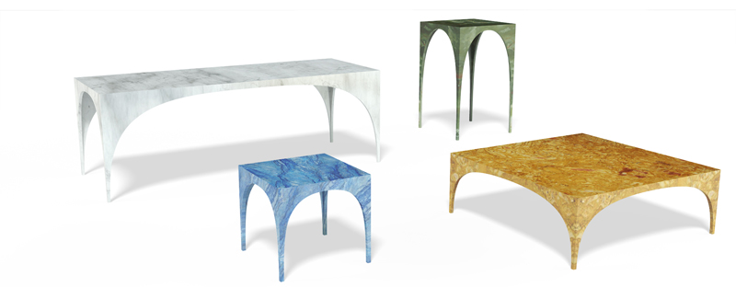 | VOLTA  Multifunctional monolith table set with different shape, color and size.

Press Office

comunicazione@iosaghini.it
Francesca Perniciaro tel. + 39 051 236563
www.iosaghini.it

