CFMOTO Motorcycle Culture Center

Background
Founded in 1989, CFMOTO is edging into the advanced ranks in the world’s powersports industry with their ambition on Technology and Quality focused.
The brand-new CFMOTO R&D building is located in Hangzhou, the capital city of Zhejiang province.
With rich experience in brand display strategy and interior design, Cityinno got the opportunity to involve to this project --- working with the professional team of CFMOTO together to design and build an unique Motorcycle Culture Showroom.
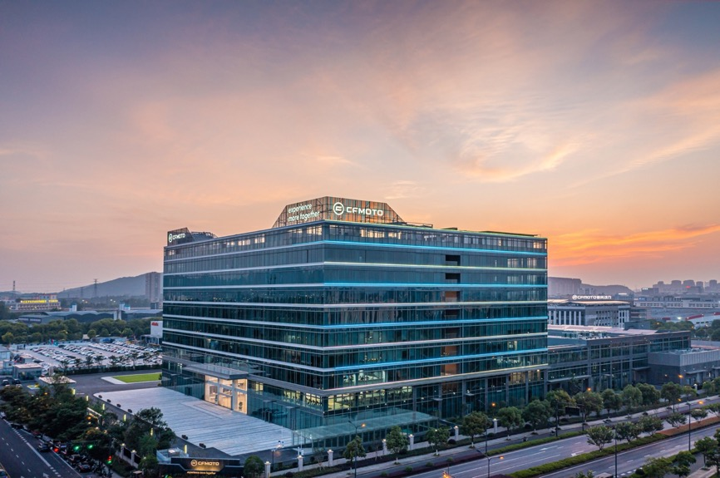

Overview
So when we were involved in the project we began to think: How to represent such a company, which never change its first mind and keep moving forward with no fear? We developed the core idea based on a large amount of powersports industry research and insight into the culture of motorcycle: When the motor cyclists chase the freedom and explore the boundaries with their nature, CFMOTO will always be with you.

Following exhibition logic, the moving line separate the showroom into several zones, from lobby, history telling, diversified scenarios display, technology display, smart future, boutique and cafe, showing the strength and characters of CFMOTO.
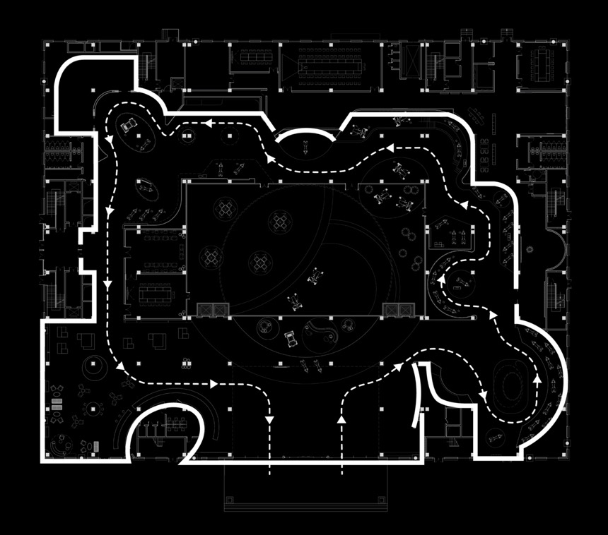

And we improve user experience as well. In this project, we focus on emotion changing of the visitors, using different methods such as simulation environment or interactive exploration to guide their mood.

INTRO: The First Impression

We consider the lobby is not only the first place to show CFMOTO’s image and spirit, but also a space to set the base tone of design language. After deep discussions with the clients, we got inspired by the traditional Chinese space concept“round sky and square earth”, and decided to bring the connotation of balance and symmetry to our design.
In the meantime, the CFMOTO culture of “determined, progressive and more fun” encourages CFMOTOers to work towards to their shared goals and be brave to broaden the horizons, which also match our design concept.
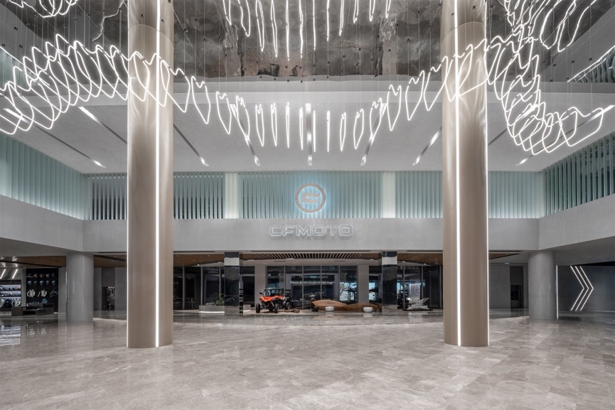
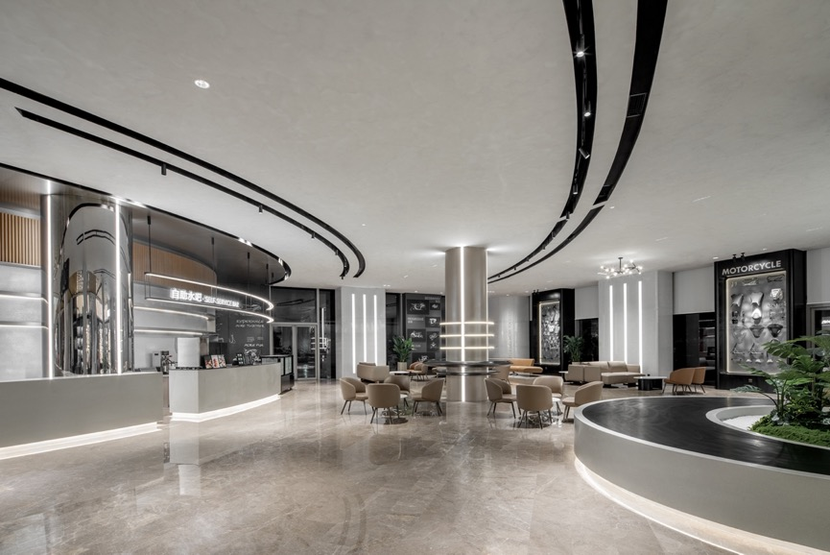

Walking no boundaries in the broader world.
We combined natural geology, streamlined furniture and circular arc ceiling to set the vehicles area and reception, which aims to show up the theme of motorcycle. Consider of CFMOTO’s brand positioning, we chose wood and cement veneer combining crystal-clear glass to embody its style.
More than that we used a big luminous ring to connect indoor and outdoor, which become the shining point of this space. The philosophy meaning of the main concept is enhanced by all these details.
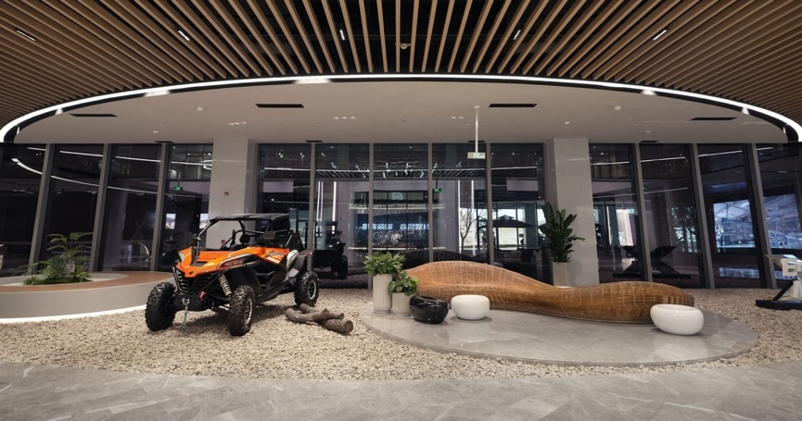

Scenario Display
We hope to telling CFMOTO’s story in an extraordinary and dynamic way that we build a ramp track to display historical models in a semi-suspended manner, bringing to feeling of moving and non-stop.

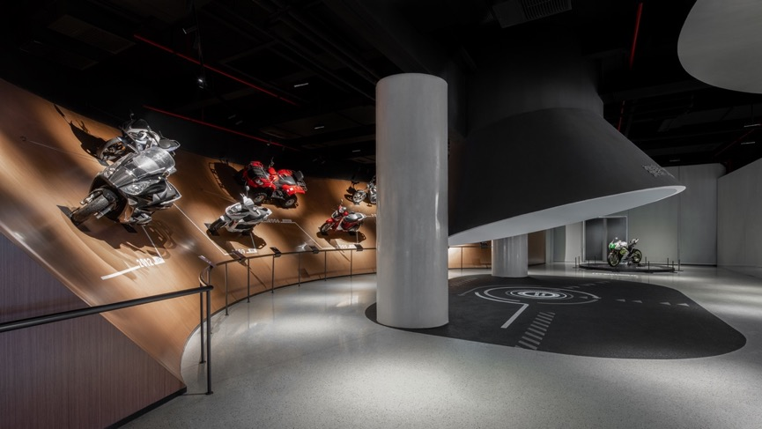
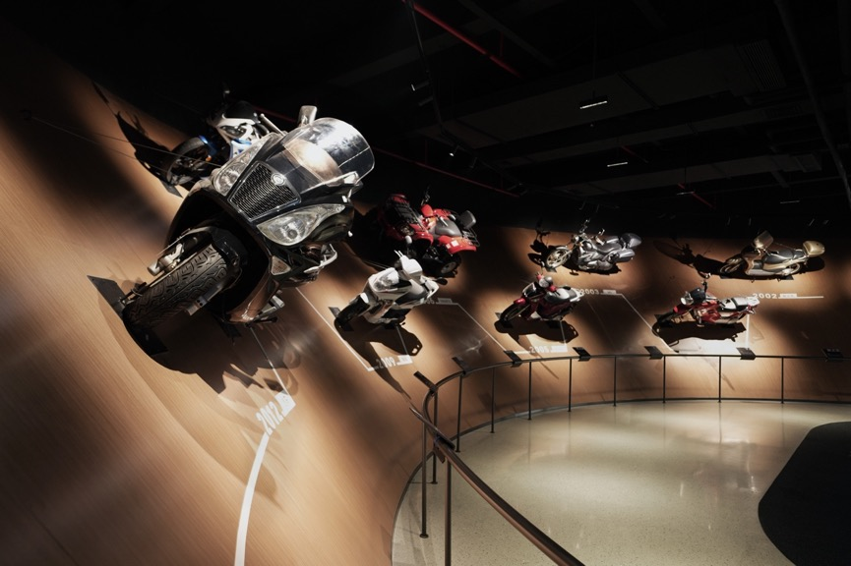
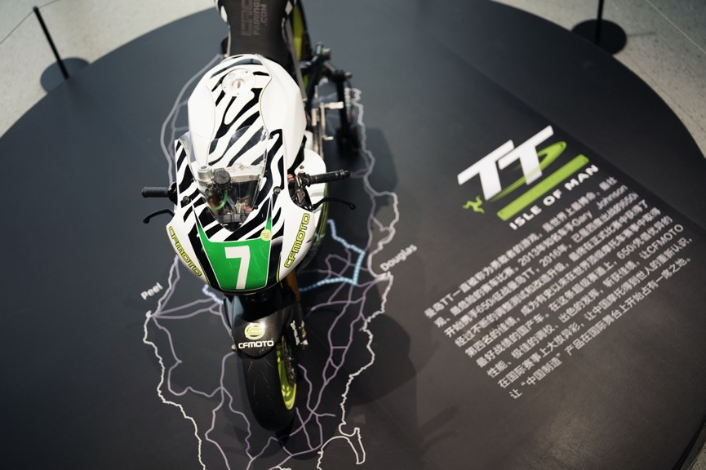

Scene hall for products display
Leaving the history hall, we enter the scene hall. Here we created 6 scenarios and 2 brand areas to display different products lines of CFMOTO.

Street scenario for NK family
——Enjoy fast & furious feeling through city streets when night falls and lights up.
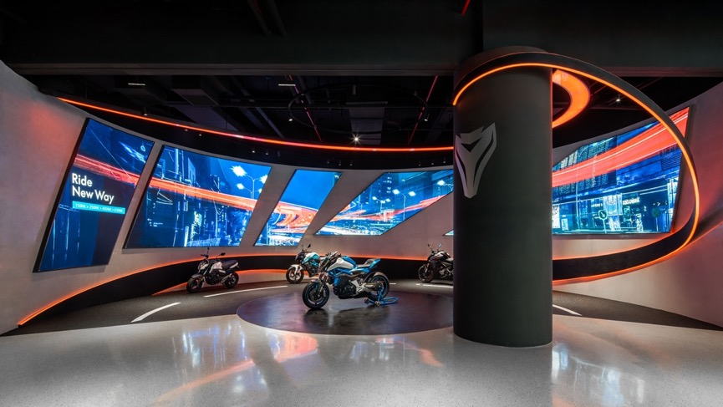

Touring scenario for road-trip and rally series
——Enjoy the happiness of driving over every unknown condition with courage and no fear
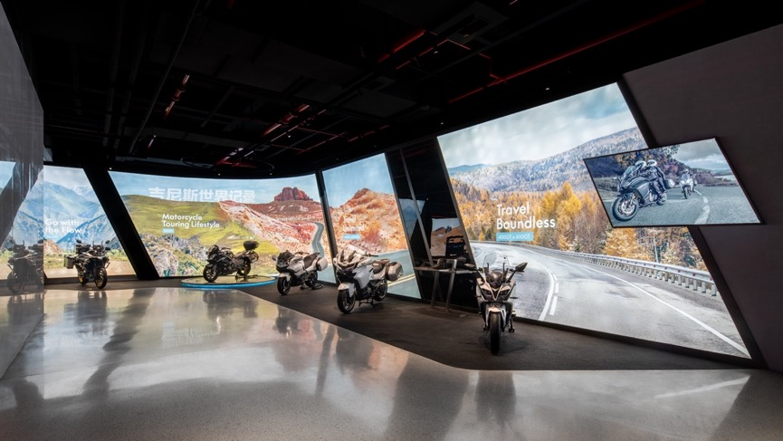

Vintage scenario for X Heritage
——Find the threshold of possibility and enjoy the moment.
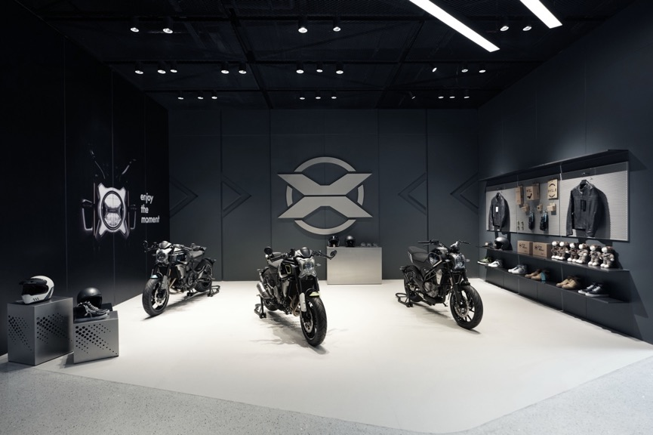
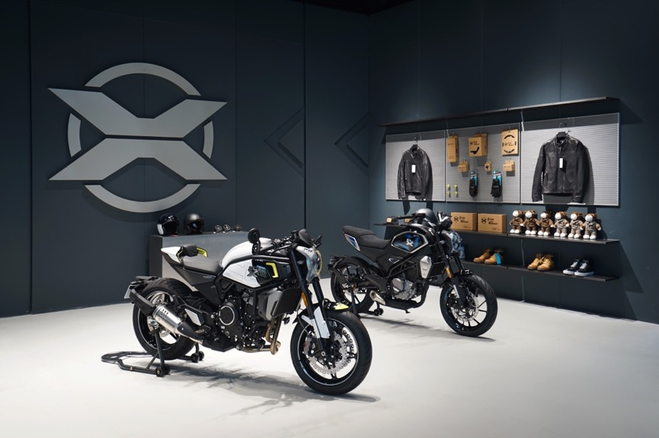

Racing scenario for sport racing series
——Speedy ride with bravo engine soundtrack on the field
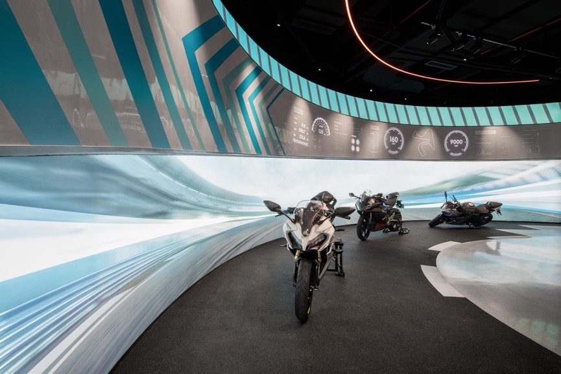
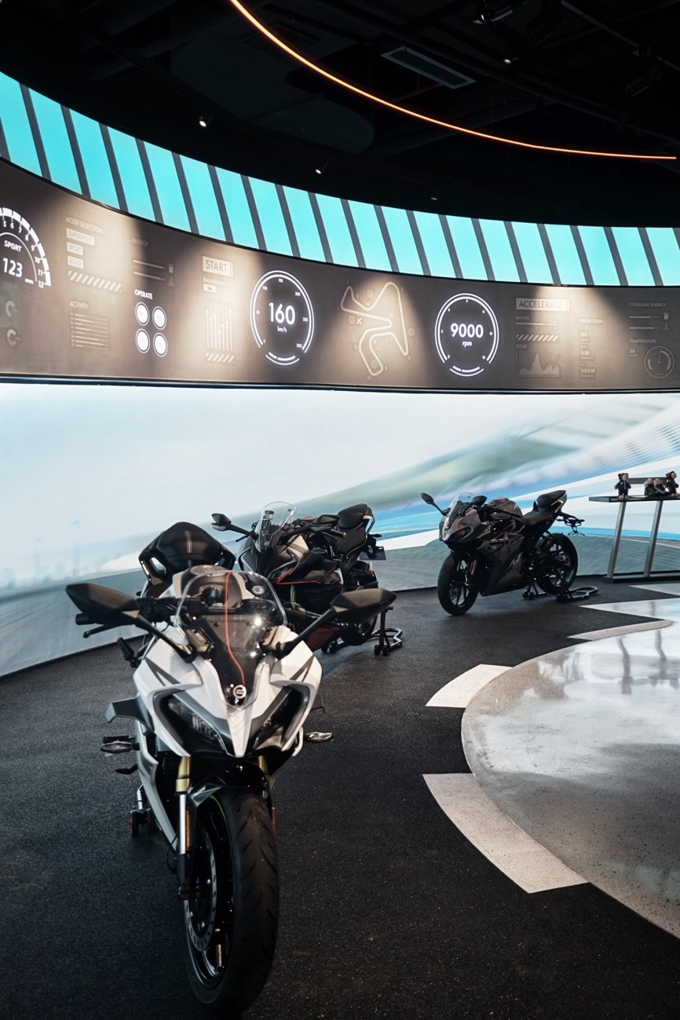

Discovery scenario for ATV family
——It’s a warrior game of Adventure in all-terrain
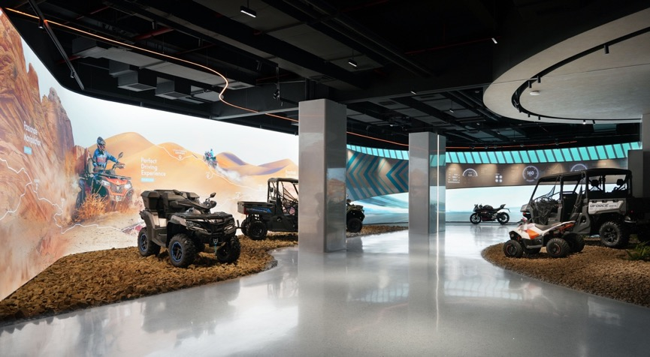
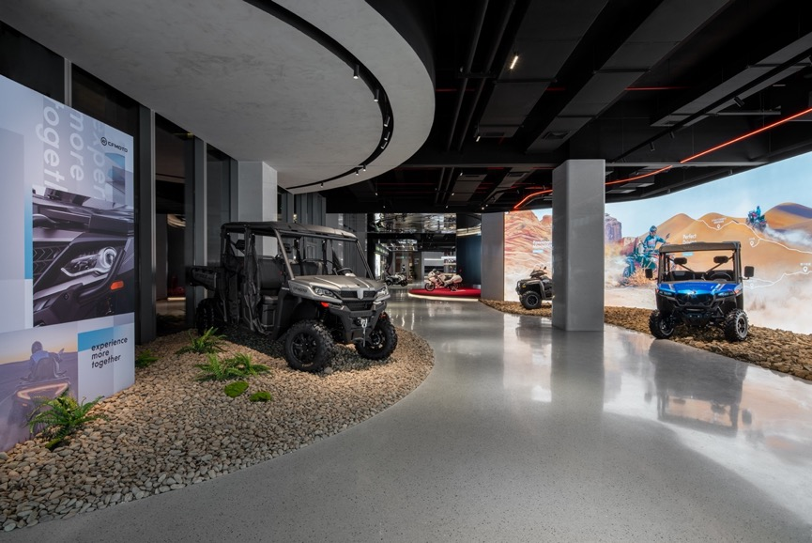

Ambassador scenario for CF650G
——Red carpet and huge LED screen build a grand and ceremonious atmosphere
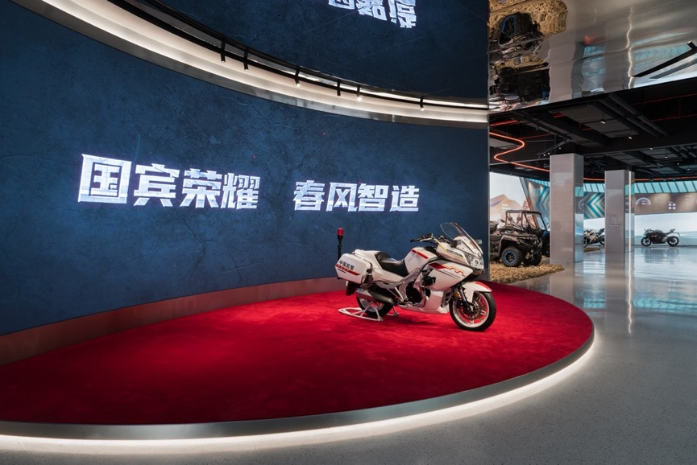

ZEEHO brand area for new energy moto series
——Trendy and fashion style meet Z era
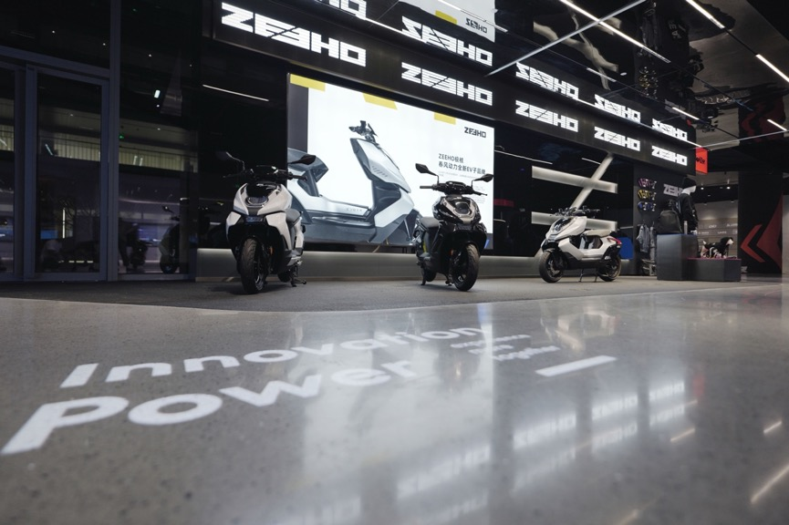
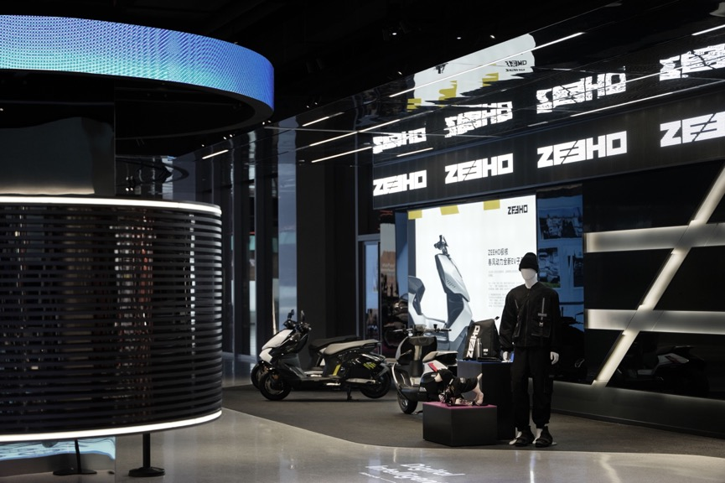

KTM area for high-end brand KTM and Husqvarna
——KTM and Husqvarna products like roaring beasts on the road in symbolic wild colors decorations
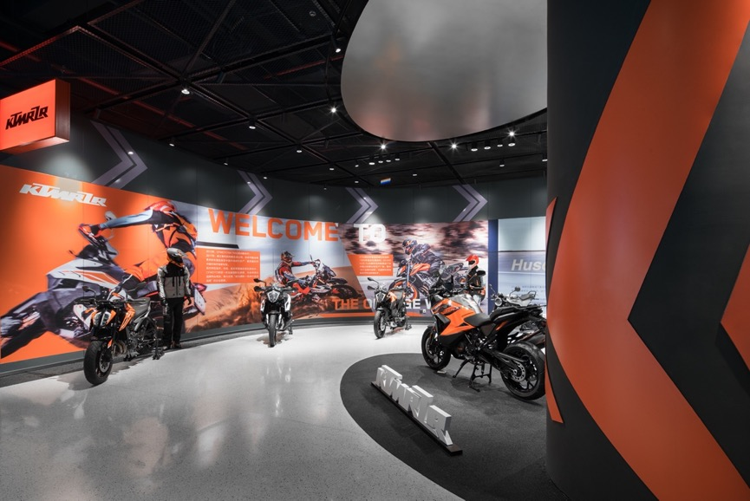
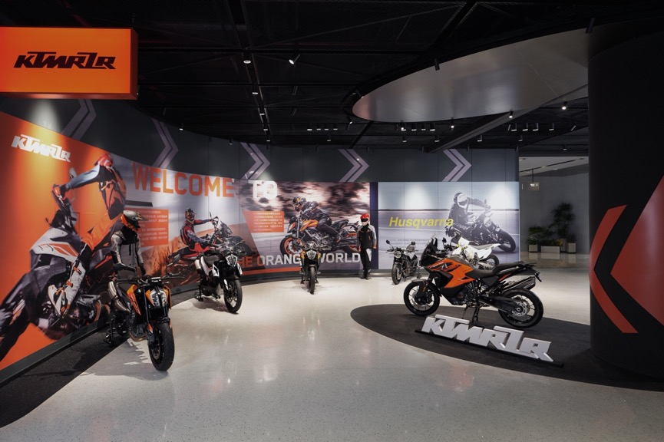

Technology & Smart Future
Technology and Innovation are the DNA of CFMOTO，which has driven CFMOTO to own more than 540 registered patents and independent intellectual rights. Combined with the concept 「science lab」and CFMOTO blue color，this area is more cutting-edge and contracted.
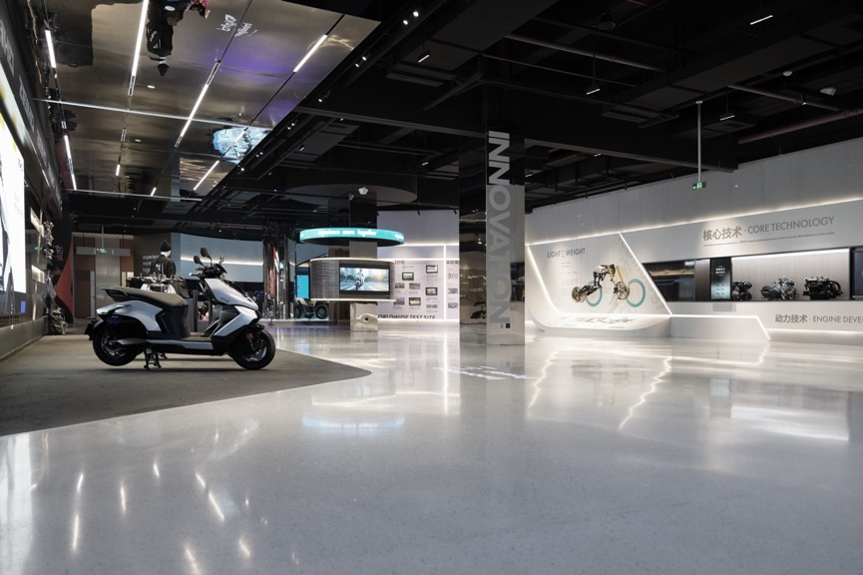
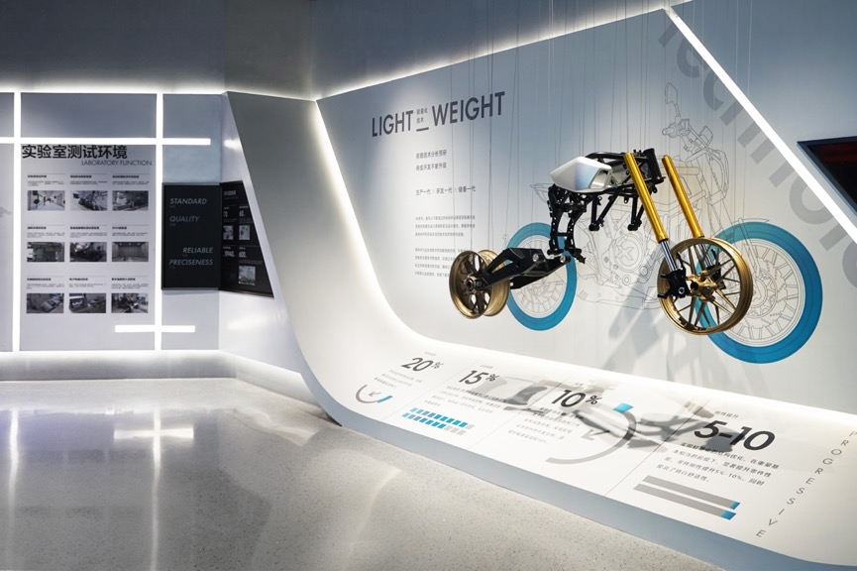
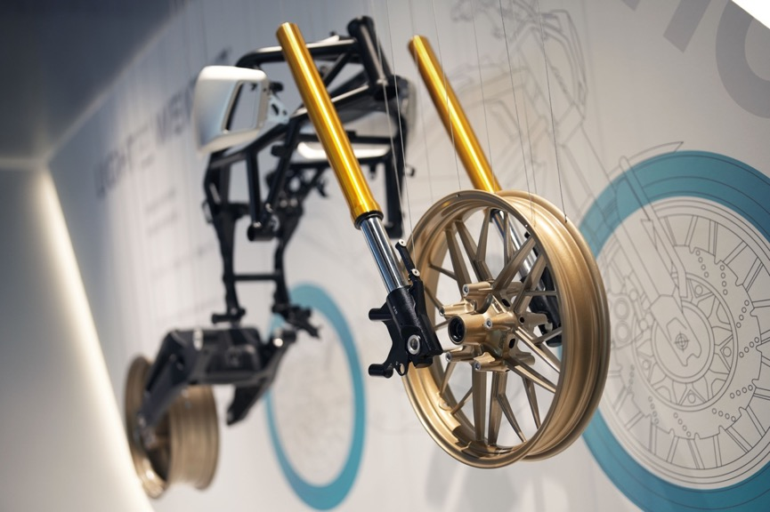

Intelligent future
Human being always search for a better mode of transport. We use future mechanical elements and huge curve screen for the main vision center of this scenario, to emphasize the future transport model and intelligent manufacture system of CFMOTO.

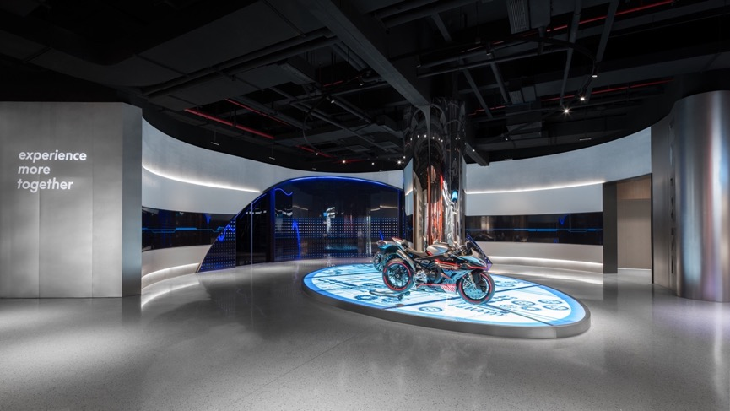
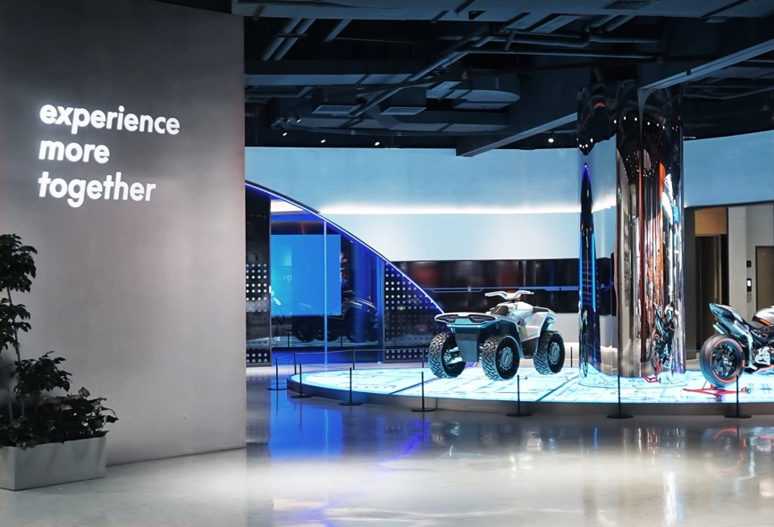

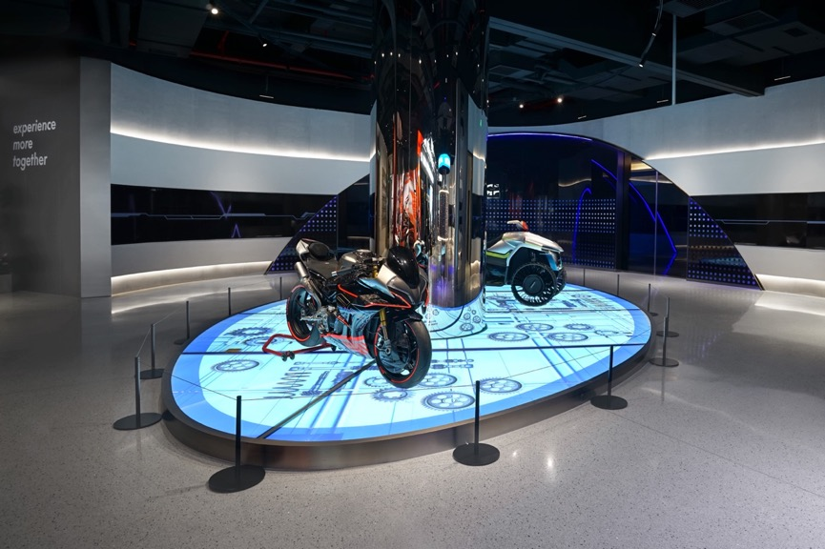
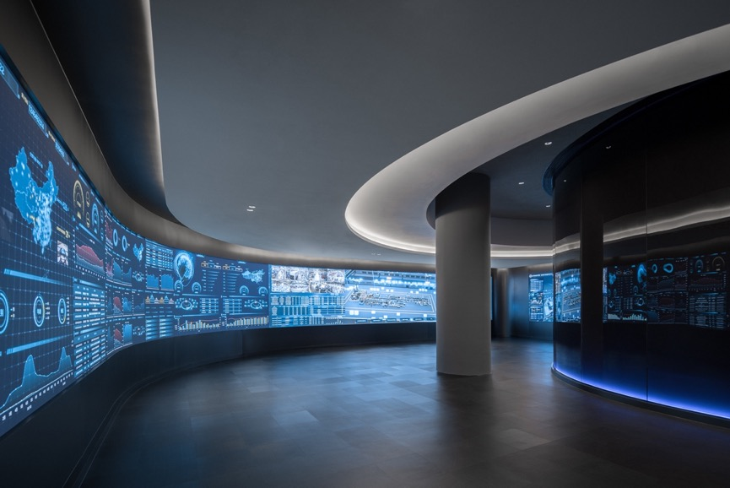

OUTRO：experience more together

Joy of motorcycle culture
At the end of the showroom is a business lounge with diverse functions —— it has a boutique and café, which making the atmosphere relaxed and interesting. The visitors could share a good time here, grab a coffee, buy professional accessories & customized brand souvenir and etc.
We hope every visitors could gain a lot here, enjoying the joy of motorcycle culture as well as being convince of the brand value of CFMOTO: experience more together.

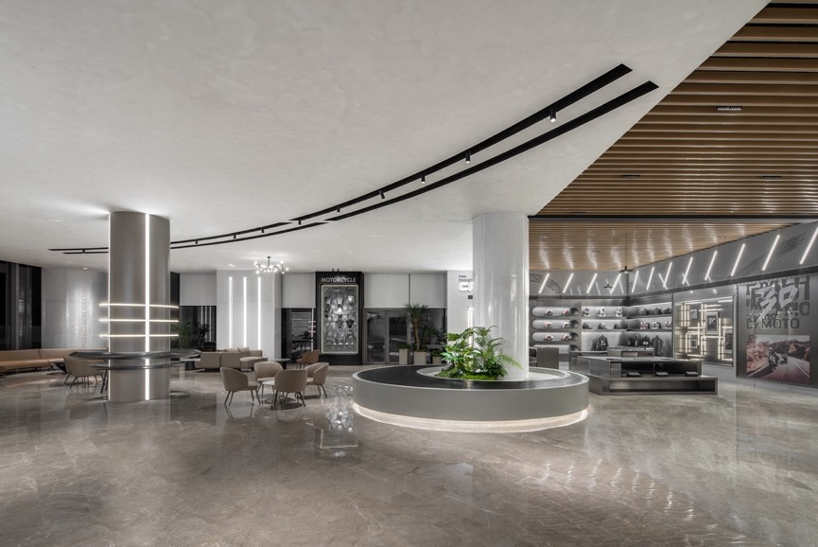
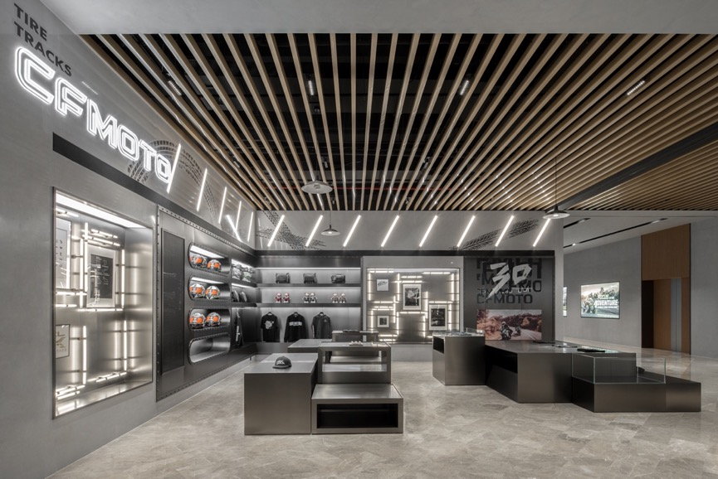
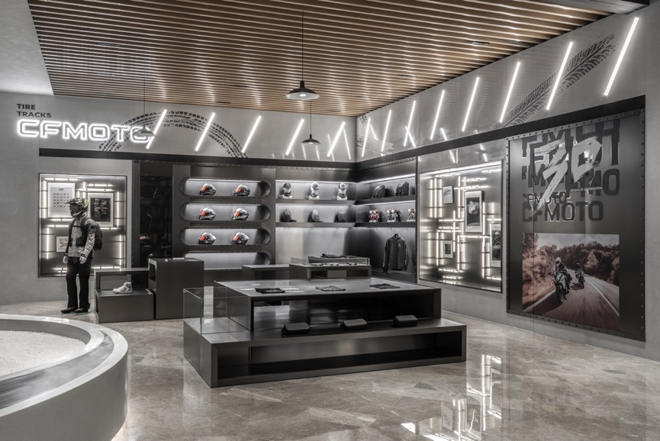
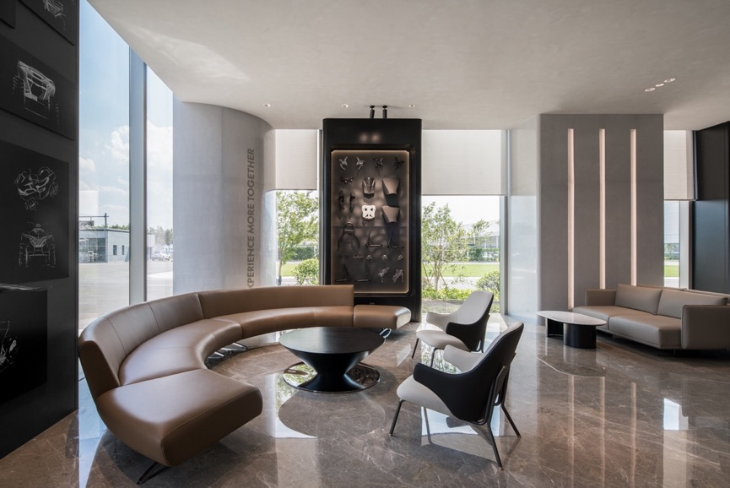

Project Information
Client | CFMOTO
Experience Strategy | Frank Huang, Effie Liang, Maple Liang
Spatial Design | Vanessa Wang,Leo Yang, Hardy Chen,Venco Wang
Deepen Design | Ares Zhong, Kristy Huang, Catherin Yan
Digital Interaction | HelloMagic, Kelly, Flora
Vision Design | Kara Chen, Suggy Bu
Project Management | Ares Zhong, Jim Xu
Photographer | Wang Minjie & CFMOTO support

