Project Name: Aurora Design Office in Kunming
Project Location: Kunming, Yunnan, China
Project Area: 240㎡
Design Firm: Aurora Design (www.aurora22design.com)
Chief Designer: Yang Xuewan
Participating Designers: Wang Da, Zhang Sijie
Design Time: 2022.10
Completion Time: 2023.04
Construction Team: Rebuilding Space Lab
Photography: Na Xin from INSPACE

Aurora Design Office in Kunming
Innovative Adventure in the "City of Spring"

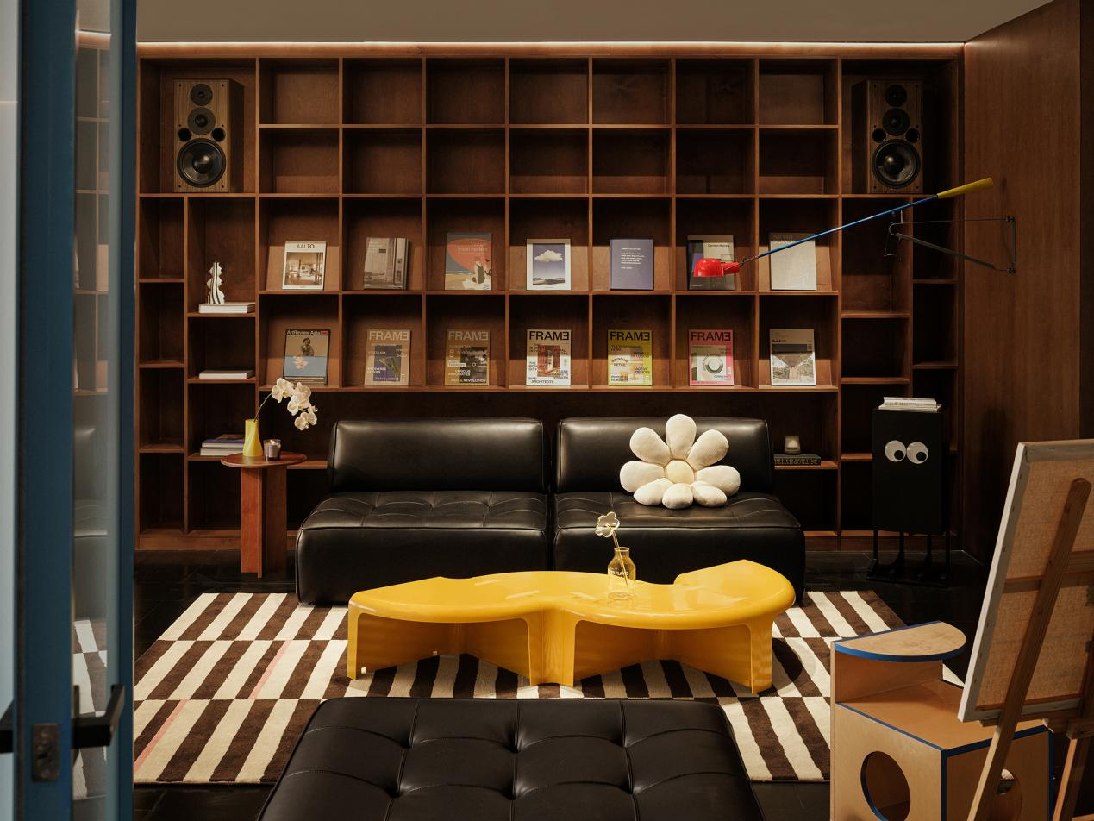

This is a city full of color and magic, just as the adventure experienced in Alice’s rabbit hole. You can freely explore a dreamlike future by following your heart from the colors to shapes, from sensual feelings to an immersive experience.

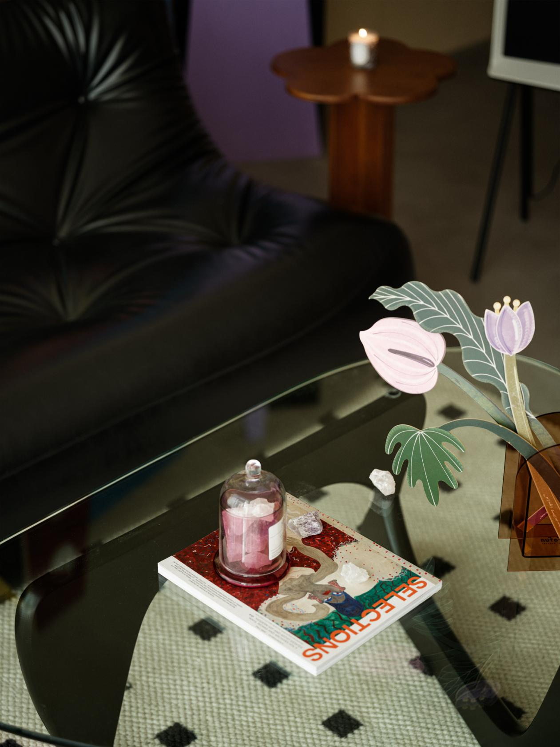

Aurora Design is a high-end interior design firm that focuses on space design. It is committed to creating empathetic and aesthetic spaces for consumers, which interprets the current consumption trends.

Adhering to the design philosophy of "creating fantasy and beauty," Aurora Design has provided comprehensive and ultimate design consulting services for elite clients in various fields such as custom wedding photography spaces, commercial retail shops, independent/chain restaurants, exhibition spaces, high-end residences, and art installations. Through years of brand services and project implementation, Aurora Design has reinterpreted the inherent brand business model, offering clients a fresh perspective on design.

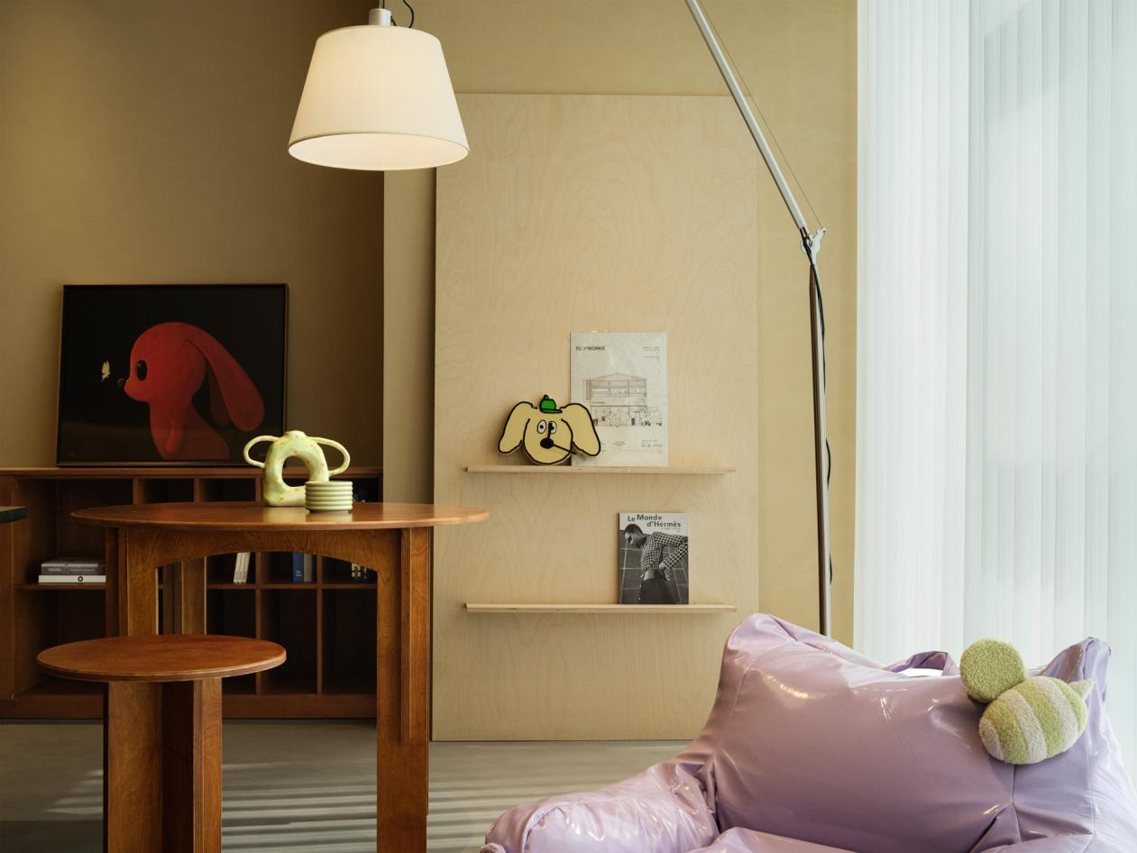

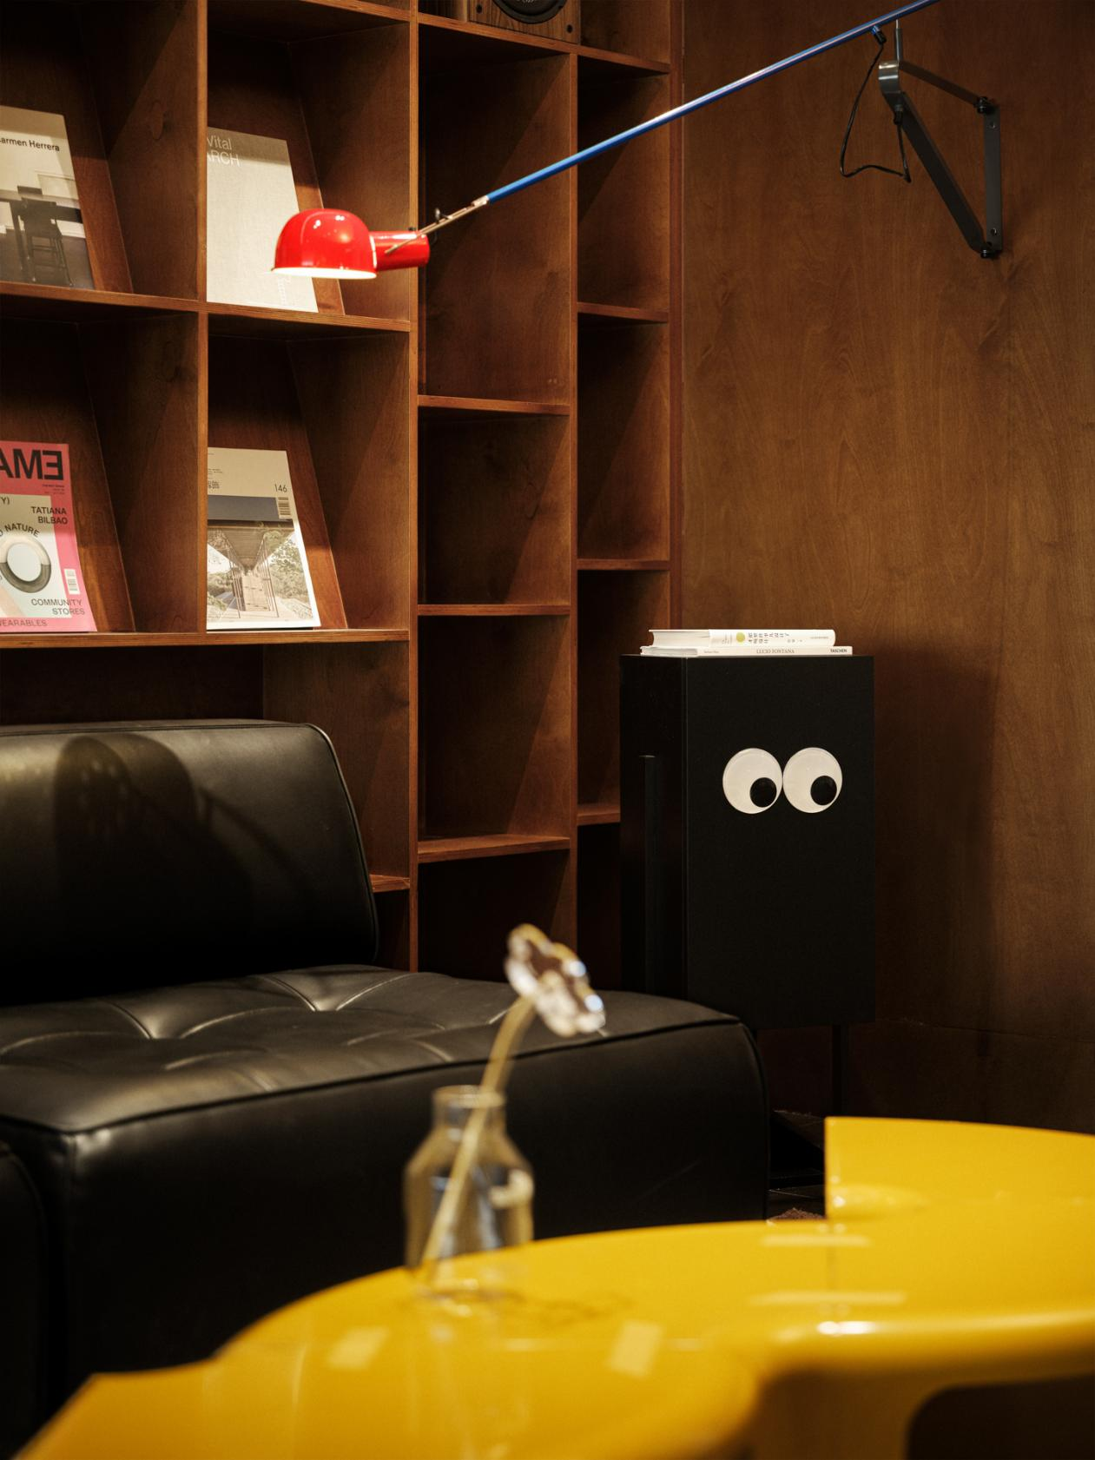
The inherent contrasting colors of the city have given the new office of Aurora Design a natural language system. The new office, located in Kunming, is a mix of novelty, adventure and antiquity. In this city that is always full of interesting adventures, we follow the innovative intuition of designers and cast away the serious image and inherent rules of office spaces. Inspired by the brand philosophy of "creating fantasy and beauty," we create a unique "Aurora rabbit hole." It is diverse and relaxing, efficient but free, and full of youthful enthusiasm. It is the freshness and strangeness you encountered in the city during your adventure.

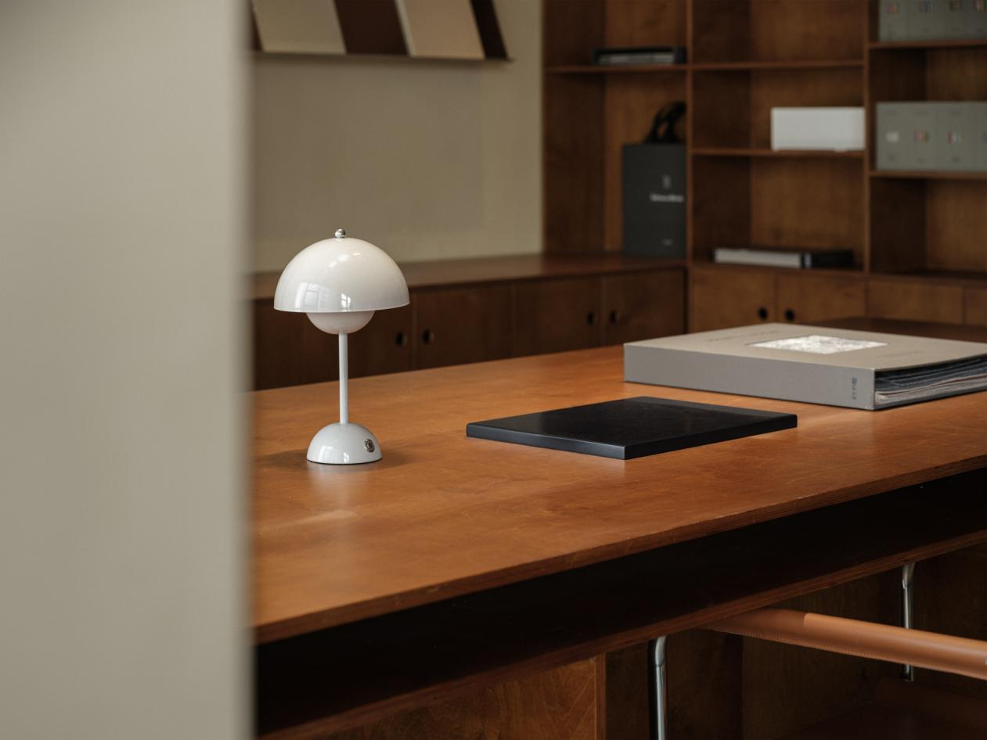

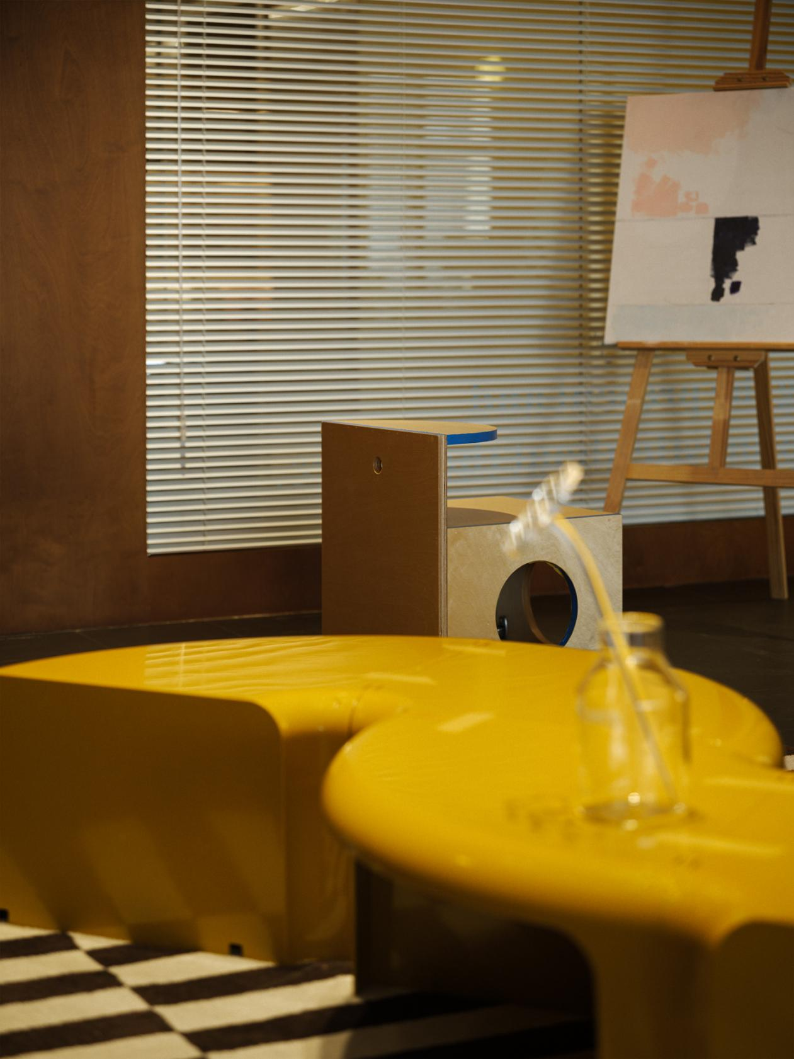

Right next to the entrance, the linear space guides us into a small area surrounded by soft colors, and there is a feeling of wanting to keep moving forward and exploring the next adventure. A tranquil experience unfolds in the foreground where the green paintings hanging on the wall are combined with gentle colors. Welcome to "Aurora's Dreamland"!

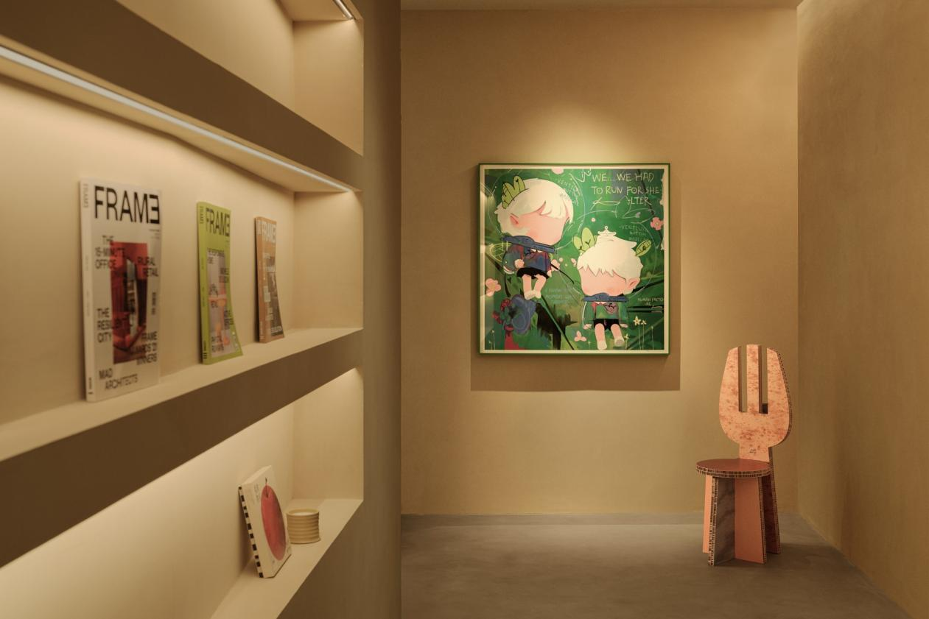

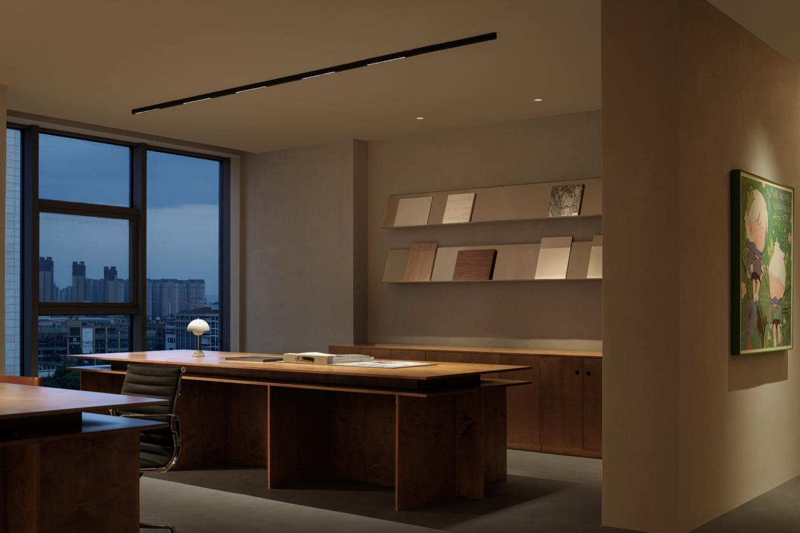

At the end of the long corridor, the sudden burst of natural light reveals the space in front of our eyes. The gentle interweaving of wood and metal guides us towards an open space that is inclusive and diverse. Whether leaning on the corner of a table or lying on the floor, you are free to come up with new ideas and let your mind explore fresh thoughts.

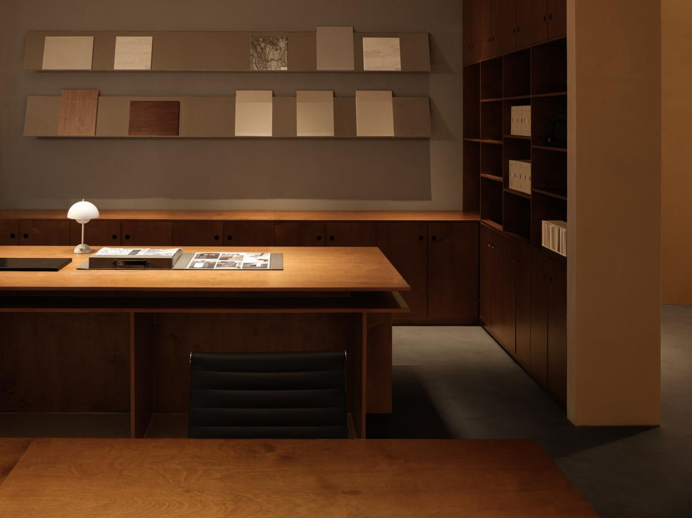

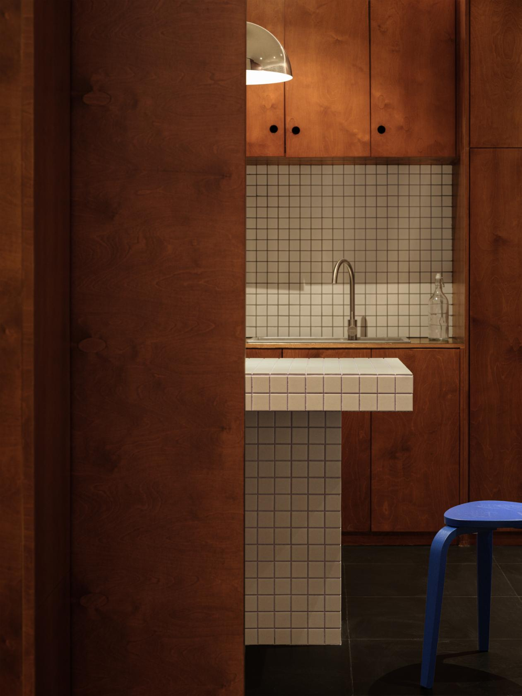

With the diverse configuration of space functions, people are no longer confined to seriousness at work. They can sit quietly, communicate, discuss, and await fresh ideas to come up in this space.

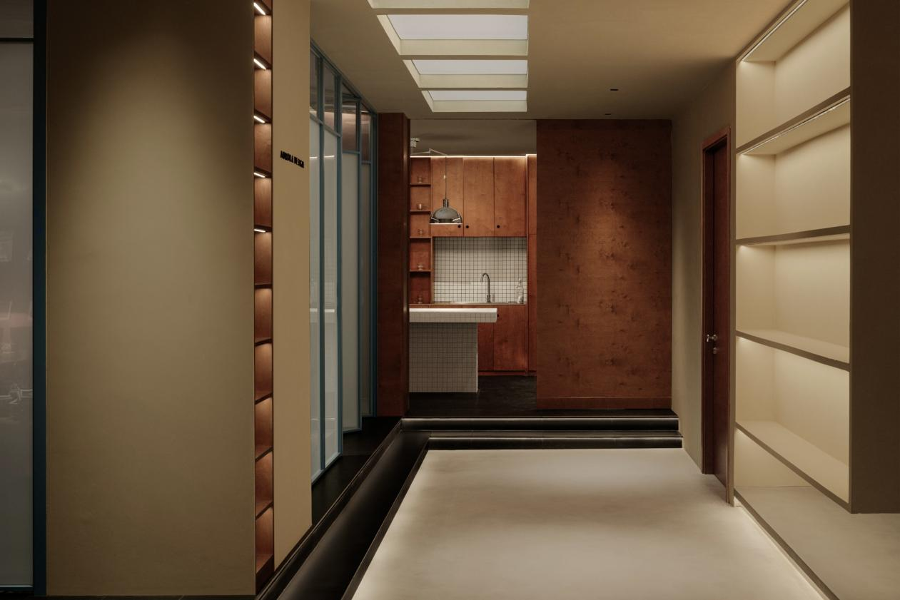
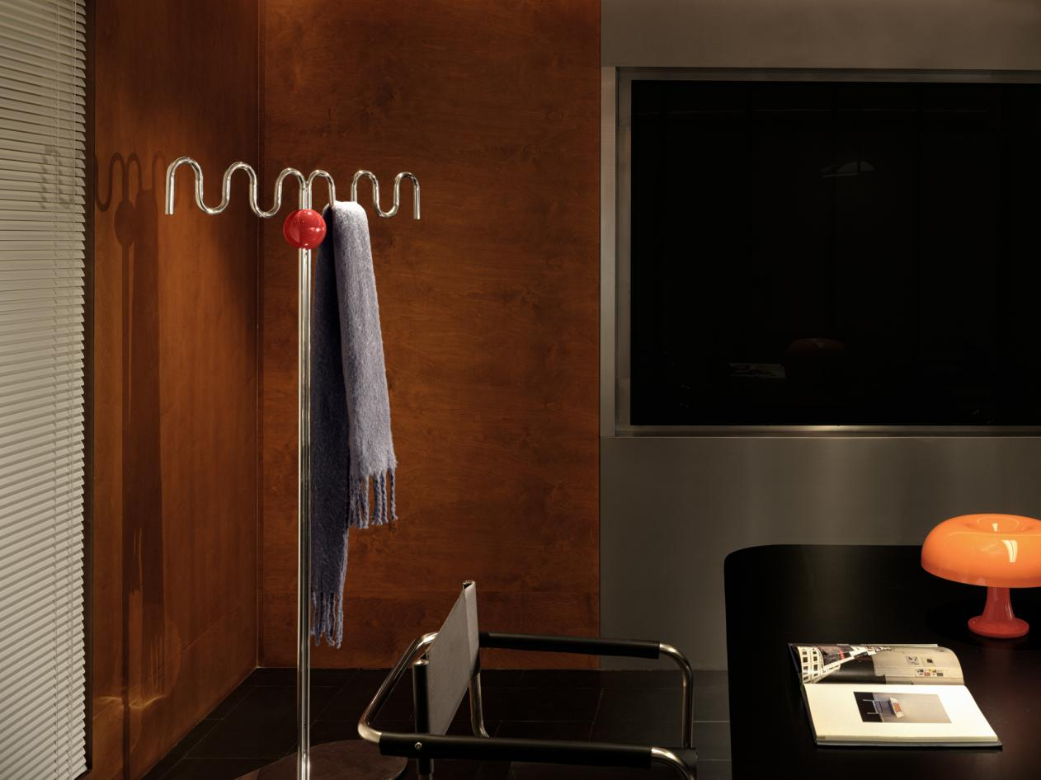

As we follow this gentle narration forward, a brighter and more diverse space unfolds in front of us. The ups and downs of the flooring create a sense of freedom and variation in silence, allowing seamless and efficient transitions between different functions. Only those who are sensitive can discover the emotion hidden within the space, which is also a part of the adventure.

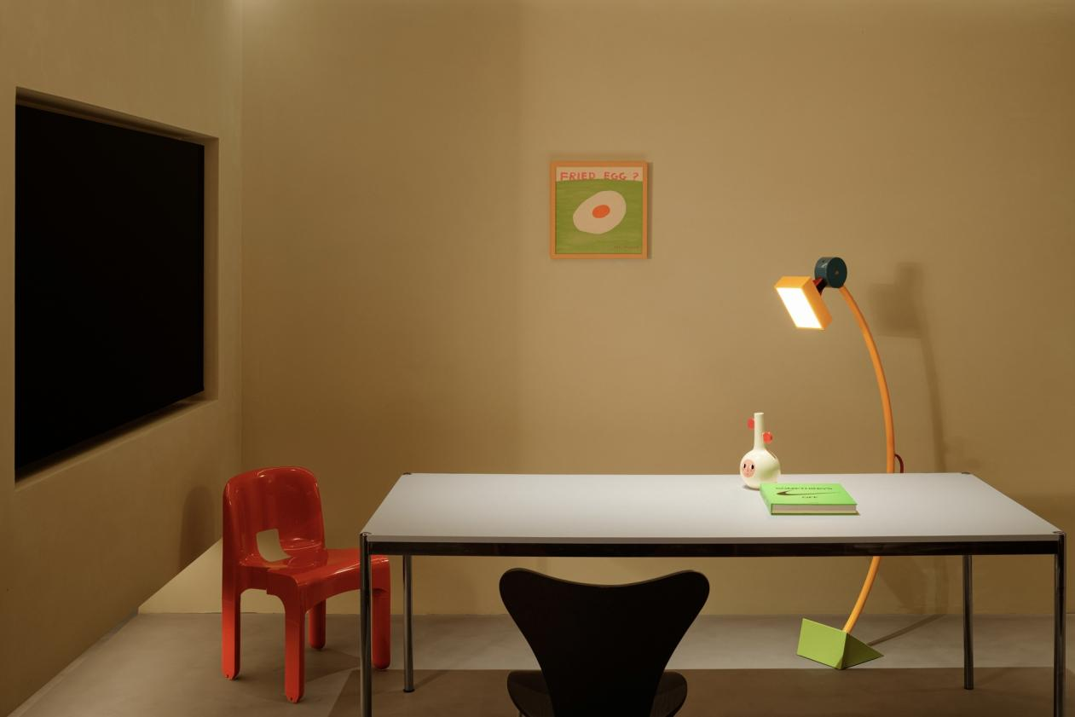

Stepping onto the stairs, a balance between openness and privacy is achieved within the space. Large warm-colored areas and orderly patterns leave a large blank space, while the liveliness and restraint interweaves with each other in this space where the innovative color combines with the semi-open spatial forms. The vibrant color that represents youth and energy can trigger more new and exciting ideas.

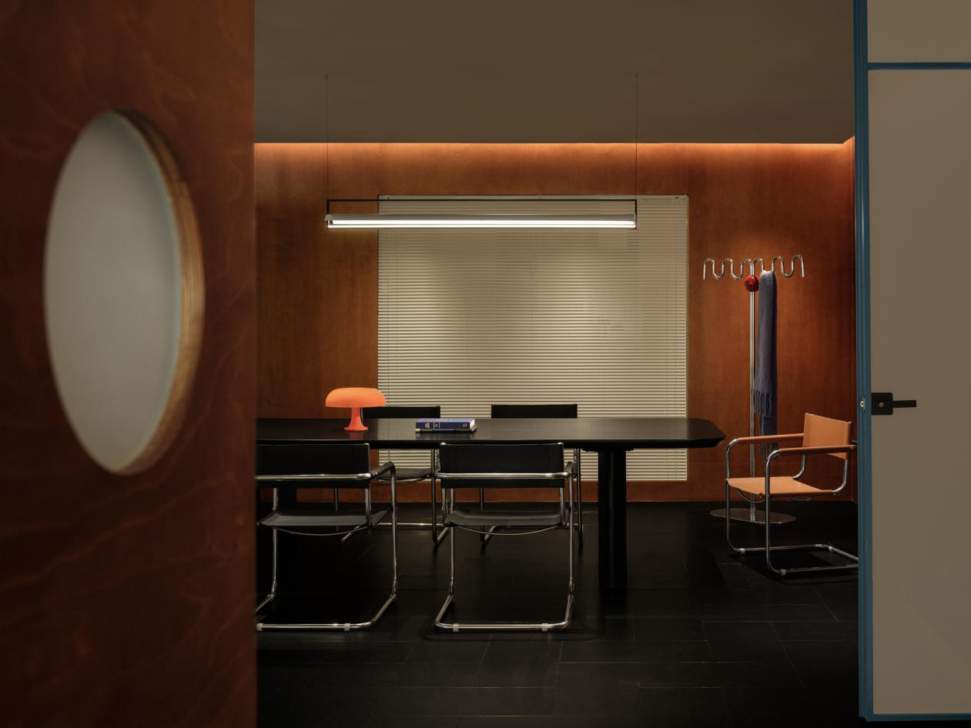

Different colors and forms create a surreal dreamlike space, like the inexplicable adventures in the fantasy dream. Every surprise in each corner triggers different creative ideas, leading to the creation of even more captivating and enchanting scenes.

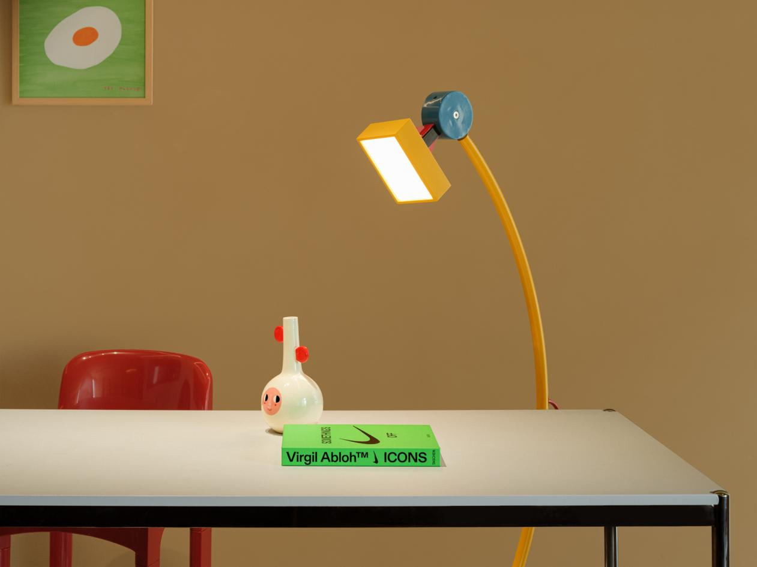

As we move through the changing scenery and chasing the emotional fluctuations of the space, we arrive at a space filled with "moments of inspiration". The use of blue window frames highlights the attributes of the space, where rationality and calmness coexist with a lively and playful atmosphere, always ready to encounter the next burst of inspiration.

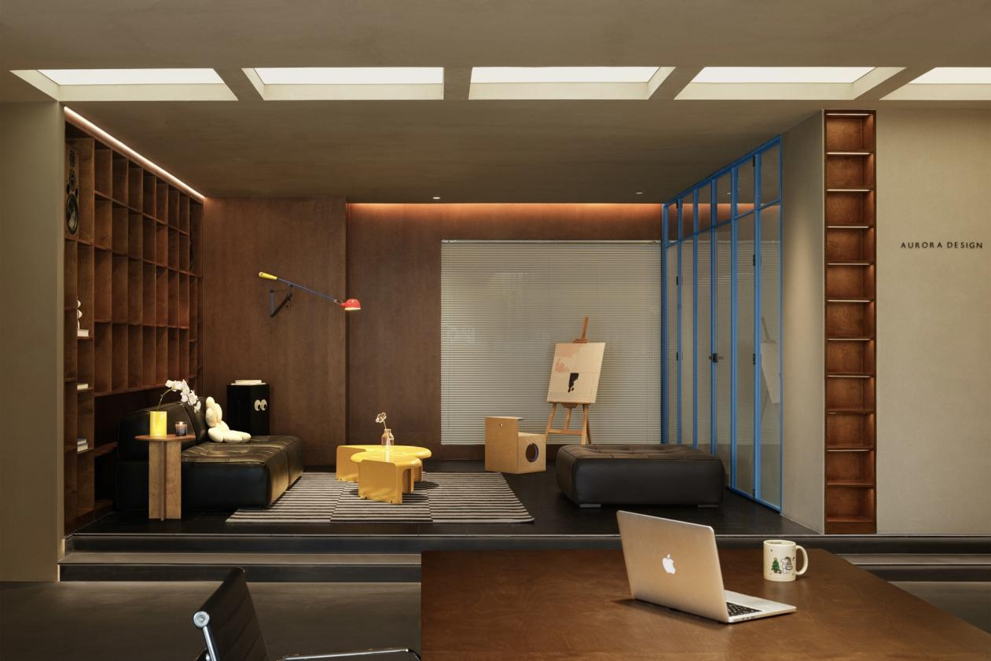
The designer has incorporated bookshelf into the wall, placing every "moment of inspiration" in this space. Various installations and artworks stimulate the senses and ignite the mind, allowing every burst of inspiration to be touched through reading and communication.

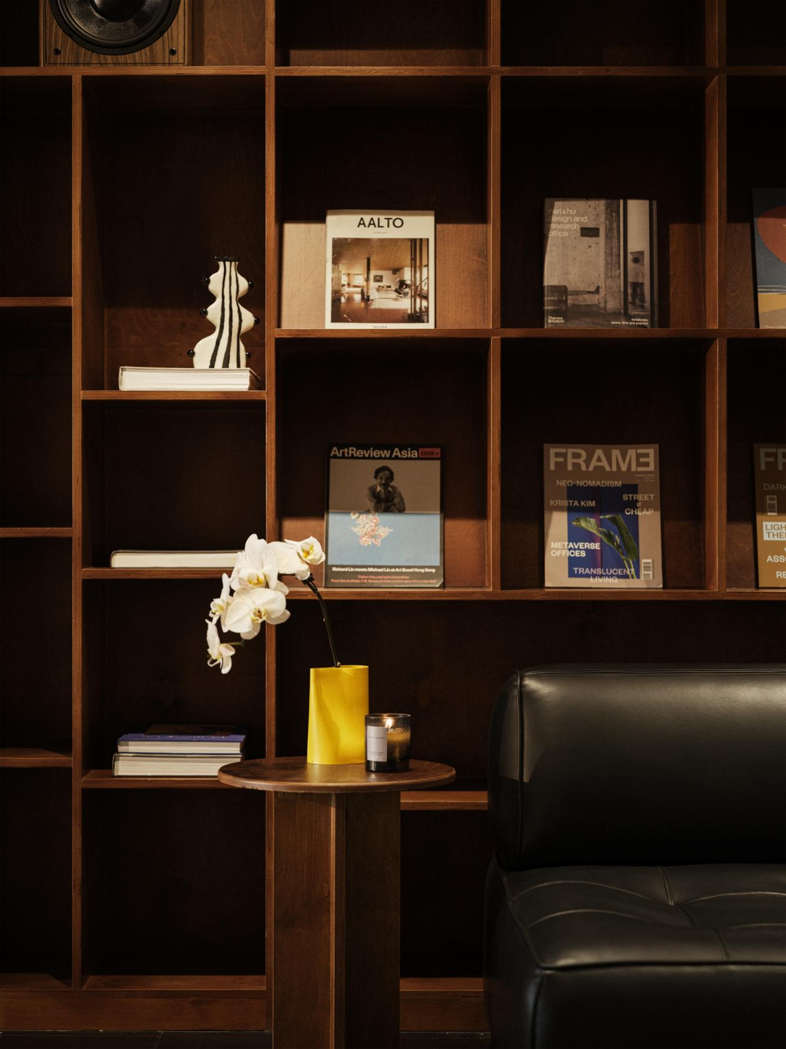

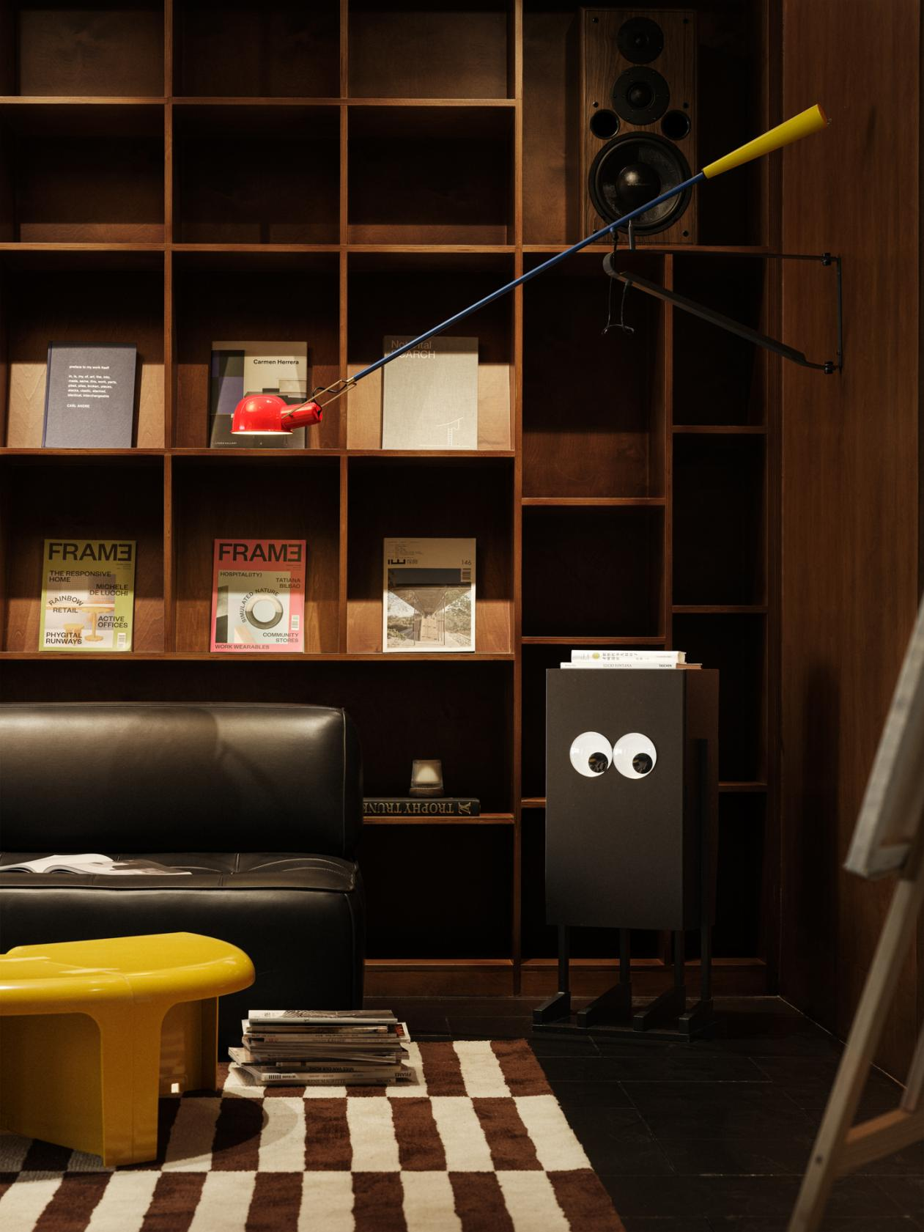

When you are contemplating what you might see at the next crossroad, don’t rush, instead, slowly open the wooden door with the circular window. The white louvered windows, vintage warm wooden tones, and some unusual shaped furniture compose this unique and peculiar meeting space that contrasts with the often depressing and dull atmosphere of meetings and the rigidity of rules. Perhaps this is the sense of humor that the designer wants to express through the space.

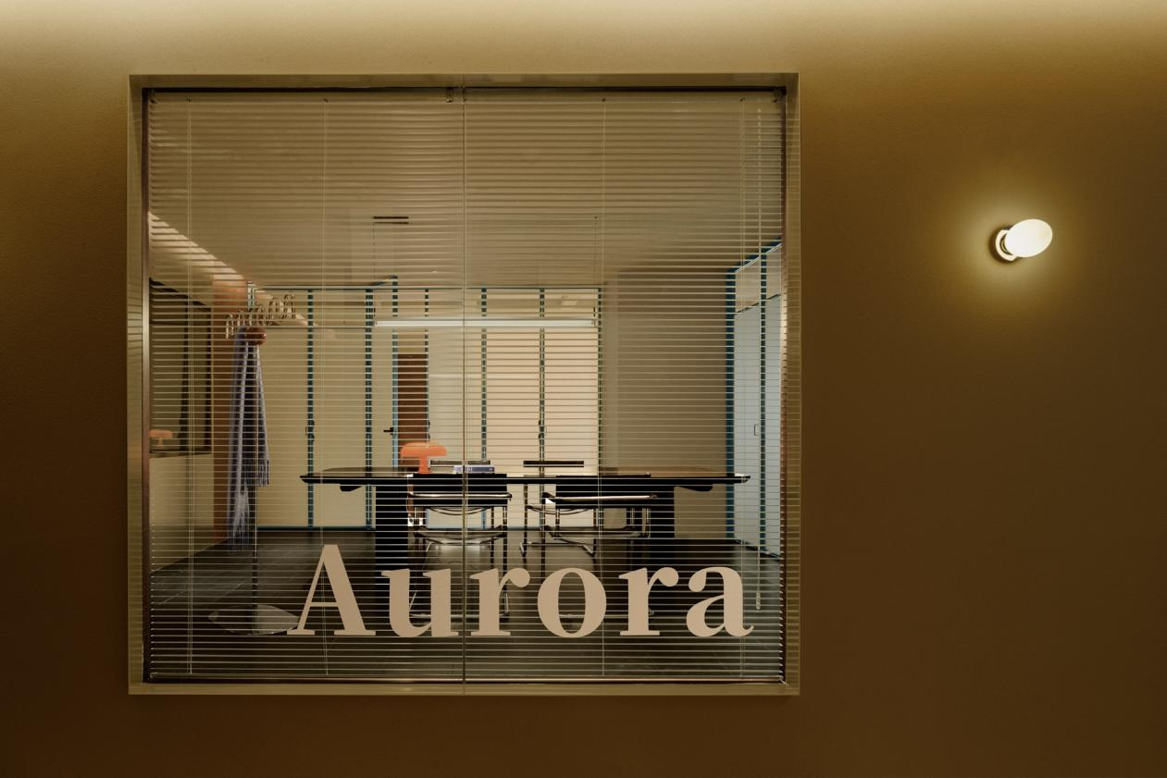
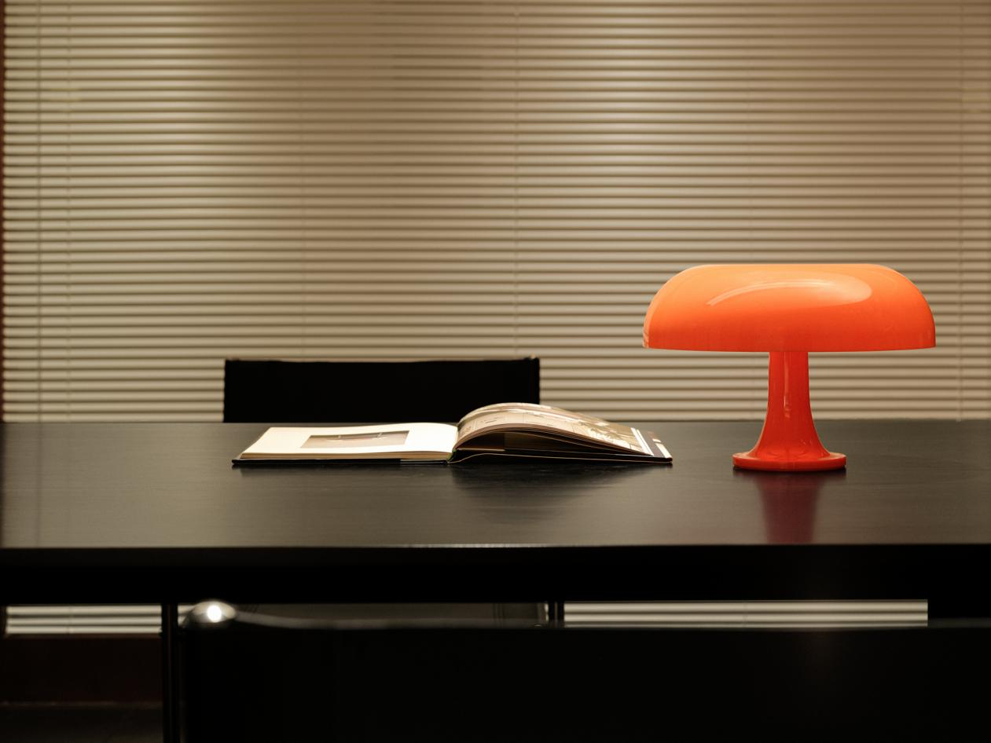
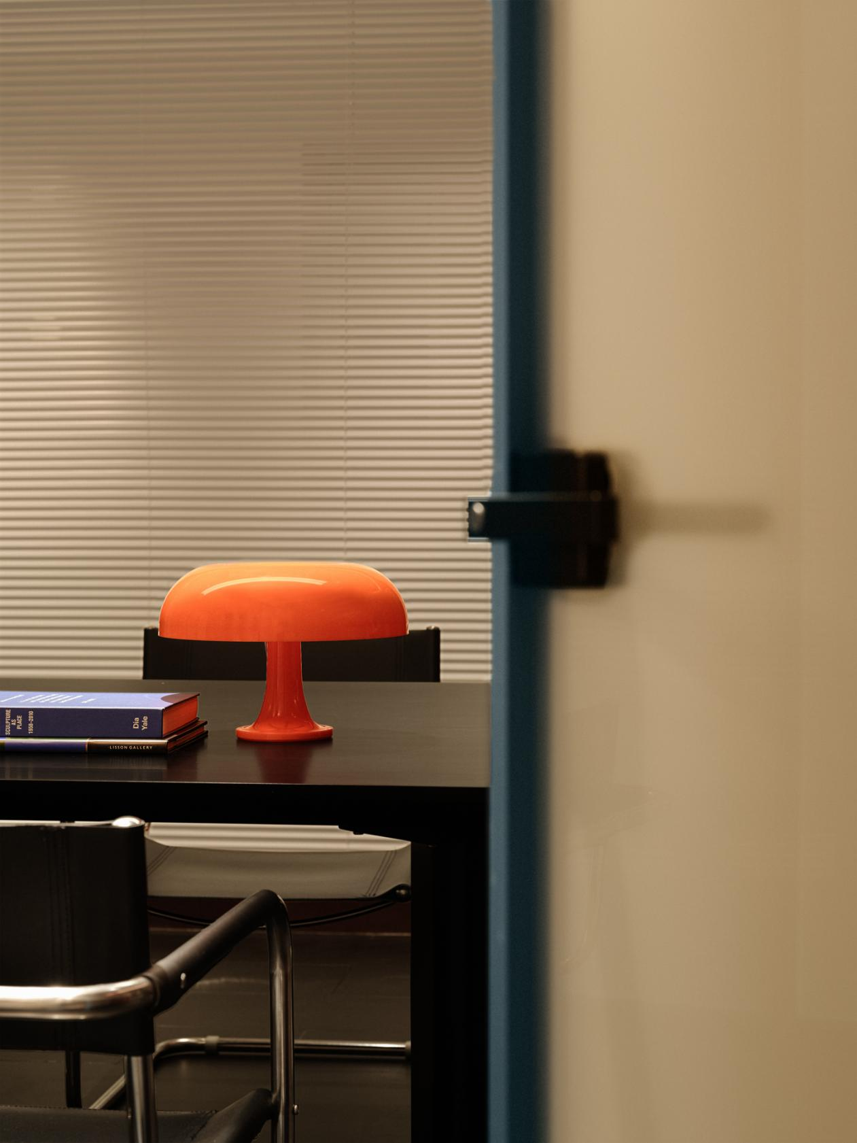

Pushing the "blue door", you are greeted with warm wooden tones that naturally leads you into another enchanting dreamland. The warmth of food soothes your heart, and the warm yellow light shines on the mosaic tabletop, with every piece of mosaic reflecting the imagination of cuisine. The harmony between the mosaic table and the orderly storage cabinets extends the beauty of the space's rules and aesthetics.

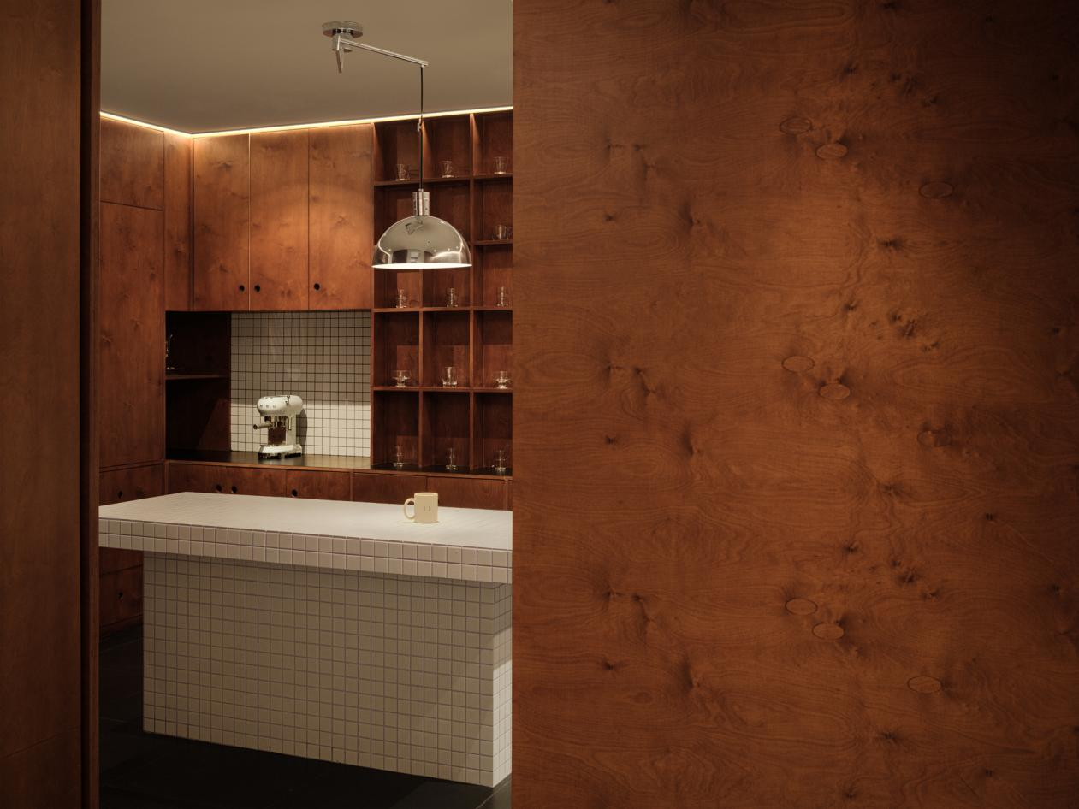

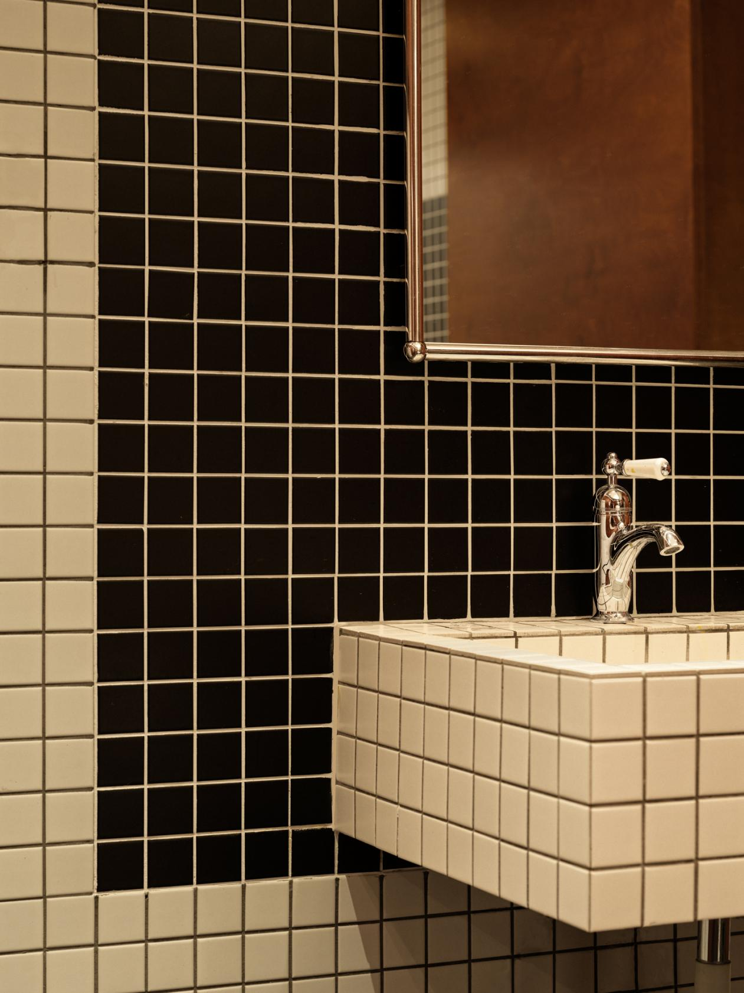

The strong metallic reflections contrast harmoniously with the scattered reflections of light on the glass, while the combination of point light sources and linear lighting enhances the sense of privacy within the space.

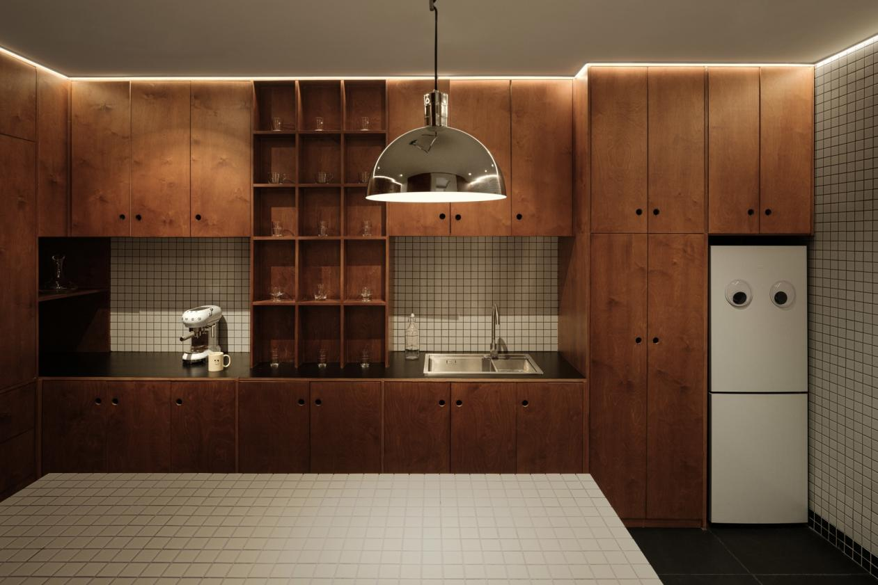
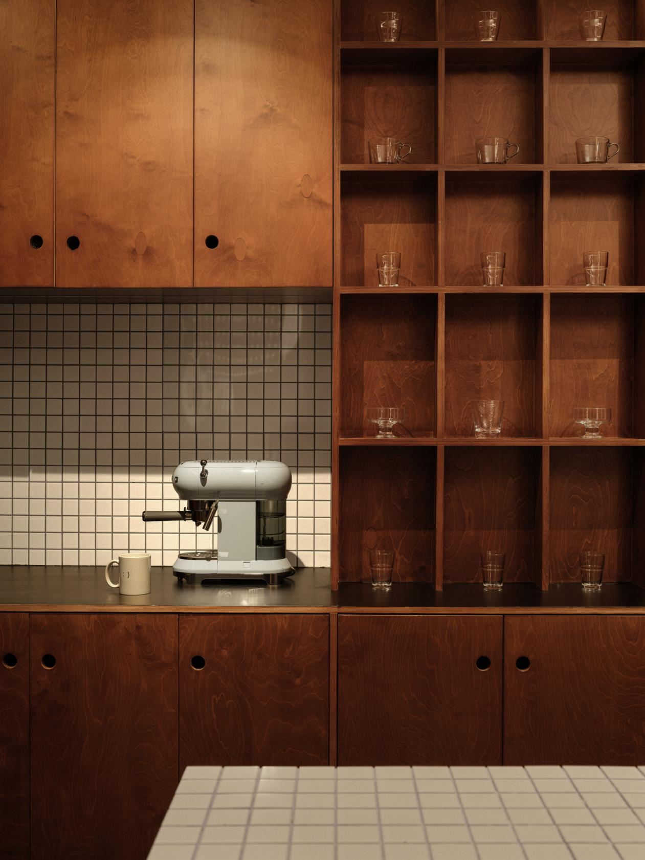

In the living room, ideas and inspirations are everywhere, and you happily pick them up one by one, arranging and presenting them in your own way. You tell each visitor about their origins, discoveries, and the stories waiting for an ending. Regarding color and form, they each have their own free way to develop and continue.

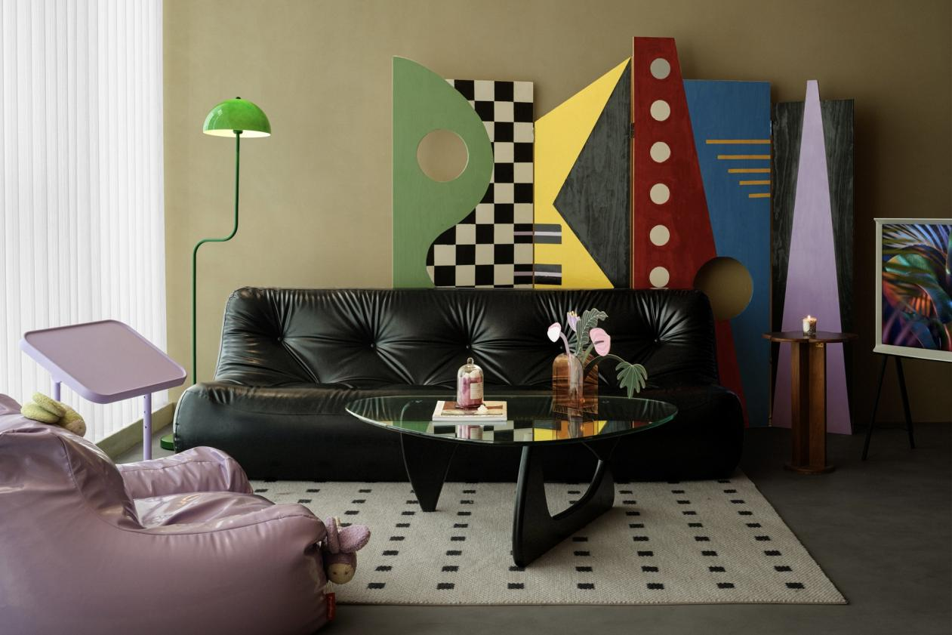
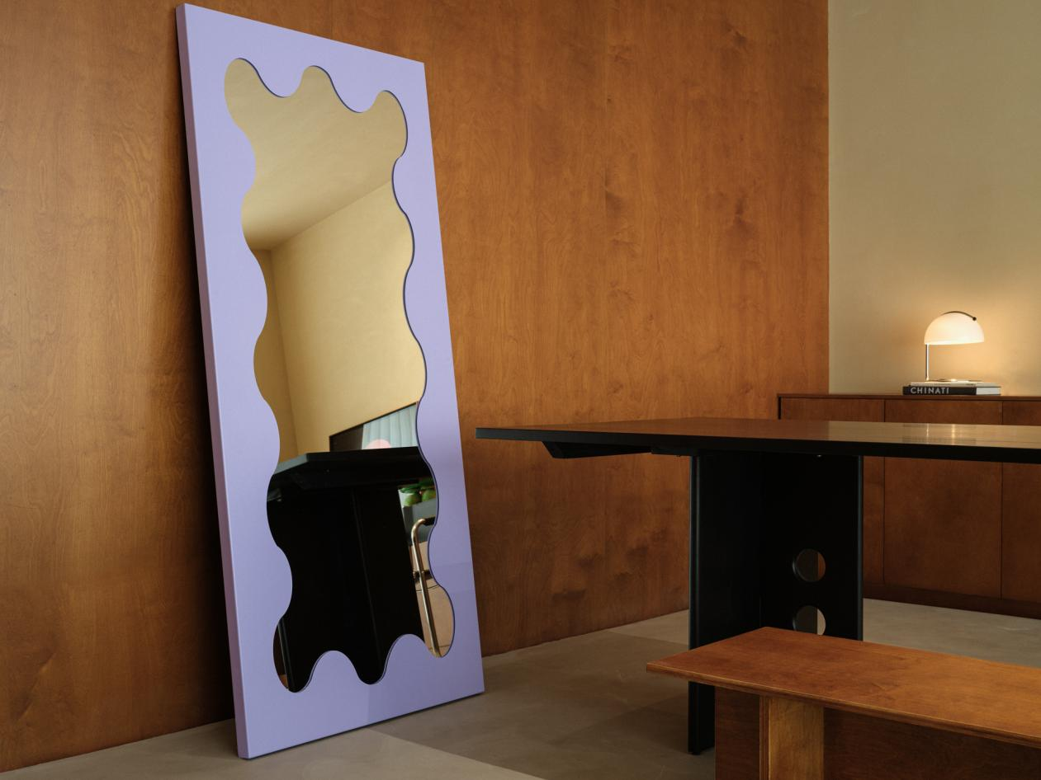

The entire office space is immersed in a free and relaxing atmosphere, without the serious and rigid image of a traditional office, nor the boredom during repetitive workdays. From functional layout to atmosphere, we care about the diverse needs of every partner in the workspace. This shared office space represents youthfulness and encourages the free flow of creativity.

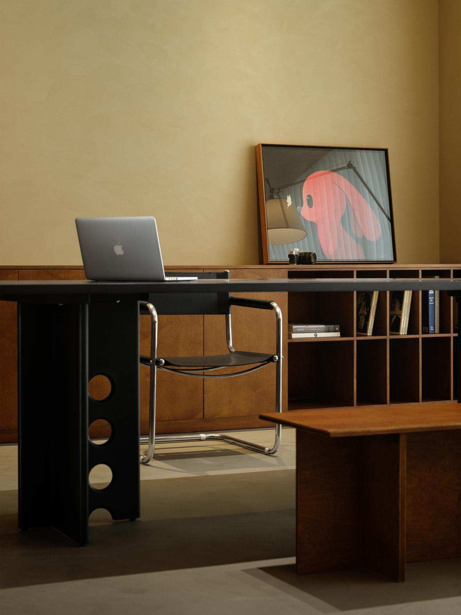

AURORA DESIGN's new office in Kunming shuttles through the city that is full of adventure and fresh experiences with its elegance and dreamlike features, capturing the freshness of every moment with beauty that seems to come from the imagination.

With raw wood, metal, stones, and unique shapes, and a variety of bold colors, we create a physical presence in a dreamlike environment, constructing a new type of office concept that is both free and efficient, inclusive and diverse, as well as youthful and fresh. We hope to embody AURORA DESIGN's design philosophy of "creating fantastic beauty" in our new office, while preserving these moments of inspiration, and looking forward to every innovative adventure in this "City of Spring."

